*Q:* *The Sales - Superstore dataset contains detailed information about your company’s sales. Your manager, Sylvia, has made a decision to cut the three worst performing sub-categories in their region in terms of Sales. To do this, she has asked you to create one data visualization that will identify which three sub-categories are the worst performers by region, and show how much worse they perform than other sub-categories. Sylvia will use this visualization to inform which product categories to cut, and in which regions.*

Link to the visualization:

<https://public.tableau.com/profile/uday.t4900#!/vizhome/SalesdataSuperstore/ProfitandLoss?publish=yes>

The Central Region:

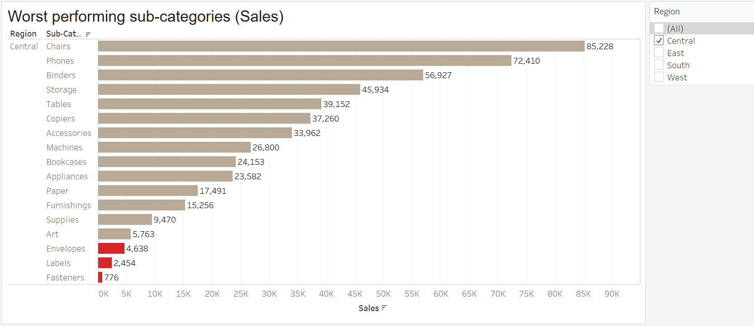

East Region:

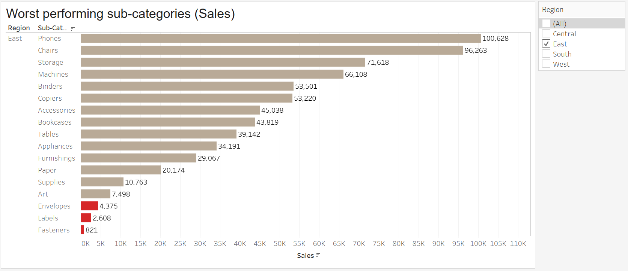

South Region:

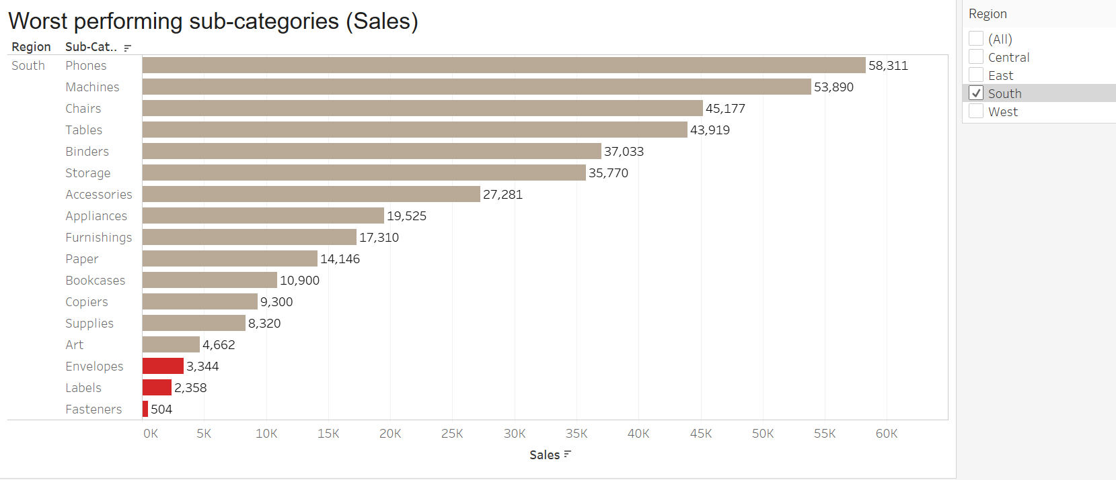

West Region:

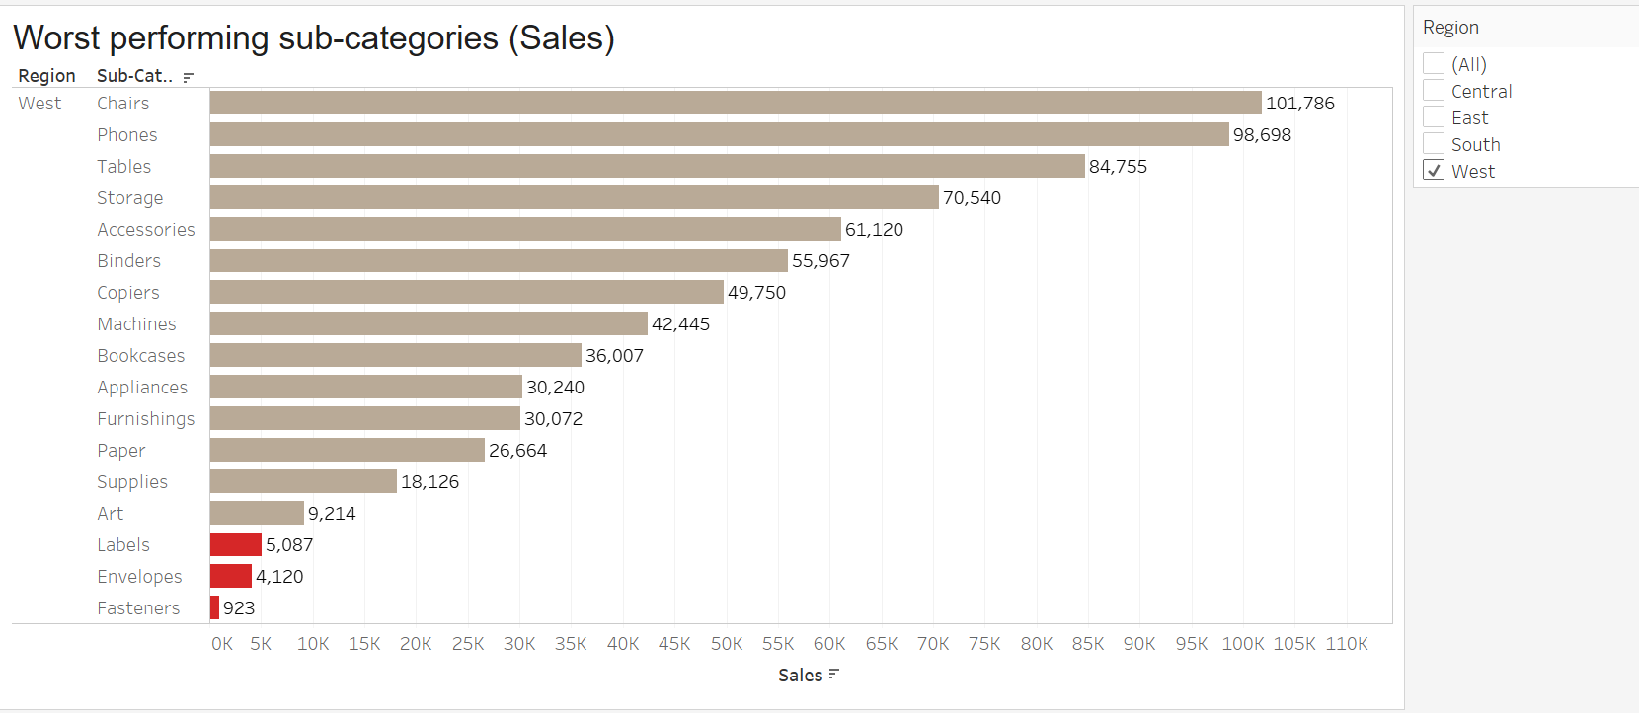

In all the four regions the three worst performing sub-categories (each region and overall) are:

* Envelopes
* Labels
* Fasteners
* How does your visualization leverage at least one “pop-out effect” or “pre-attentive attribute?” Which one(s) was (were) chosen and why?

*Color and contrast are the pre-attentive attributes I have chosen as it is the most efficient differentiator in our data. Color has been used strategically in the plot to highlight the key data points.*

* How does your visualization utilize at least one Gestalt principle? Which principle(s) is (are) being reflected, and how?

*Similarity and Closure are the principles you can witness in the above visualizations, the data of Subcategories are grouped together based on the region and highlighting the data by differentiating it using color gives enough essential information.*

* How does your design reflect an understanding of cognitive load and clutter?

*Again, its with the help of color and contrast in visualizing the data. Using a contrast of light and dark shades of red/maroon the user can easily use iconic memory to read the visualization. The clutter however is negligible but essential to understand the data.*

* Is your visualization static or interactive? Why did you choose that format?

*This is a static visualization as there is a specific requirement, user wants to know only the 3 worst sub categories by region. There is a filter that can enable the user to view data of a particular region. We could make the plot interactive by adding more filters and dimensions if only necessary.*

* What need does this visualization address that words or numbers alone cannot fill?

*Grouping the data by region, category and subregion could be done even without a visualization but the fact that this visualization helps understand the data in an intrinsic way without spending a lot of time (iconic memory) with right aesthetics and principles ensures that visual perception of data is more effective and efficient that words and numbers.*