|  |
| --- |
| Hospiasset |
| Asset Tracking Application |
| [Type the abstract of the document here. The abstract is typically a short summary of the contents of the document. Type the abstract of the document here. The abstract is typically a short summary of the contents of the document.] |
|  |



Hospiasset Application contains the following roles

1.Hospiasset Admin(HA_ADMIN): This role belongs to Renown Organization and it is the main role.

Hospiasset Admin adds a Organization(Hospital/Vendor/General) initially

**Add Organization:** This action involves the following fields

|  |  |  |  |  |
| --- | --- | --- | --- | --- |
| **Field Name** | **Description** | **Present Validation** | **Validation Required** | **Input Type** |
| Organization Name | Name given to the organization | Required | Length | Any |
| Organization Type | It describes the type of Organization(Hospital/Vendor/General) | Required |  | Any |
| Organization Code | It describes the Code of the Organization which is used in creation of Branch | Required |  | Any |
| Organization Module | It describes the type of module(Bio Medical/IT/General) |  |  | Any |
| Contact Person | It describes the name of the person who is the head of the organization | Required | Length | Any |
| Contact Number | It describes the contact number name of the person who is the head of the organization | Required |  | Any |
| Email ID | It describes the email ID of the person who is the head of the organization | Required |  | Any |
| No Of Branches | It describes the maximum number of branches in the whole organization |  |  | Any |
| No Of Users | It describes the maximum number of users in the whole organization |  |  | Any |
| No Of Equipments | It describes the maximum number of equipments in the whole organization |  |  | Any |
| Country | It describes the list of countries in which Hospiasset is operatable |  |  | Any |
| States | It describes the list of states in a country selected |  |  | Any |
| Address | It describes the address of the organization |  |  | Any |
| Expire | It describes the expiry day/month/year of the organization | Required/AllowsOnly Numbers |  | Any |
| Date | It describes the duration(day/month/year) of the organization |  |  | Any |
| Logo | It is the Logo Image of the Hospiasset |  |  | Any |
| Menu | It is the menu given to the Organization Head when he logins |  |  | Any |
| Add Contact Person | It is an action given to the add persons and their details who are responsible next to the head |  |  | Any |
| Contact Person | It describes the name of the person who is the next to head of the organization | Required | Length | Any | |
| Contact Number | It describes the contact number name of the person who is the next to head of the organization | Required |  | Any |
| Email ID | It describes the email ID of the person who is the next to head of the organization | Required |  | Any |

An organization with a User of Role Code HMADMIN is created with 5 digit Employee Code using given mobile number and default password asset123.

**User Login :** The User Login Process is as follows

|  |  |  |  |  |  |
| --- | --- | --- | --- | --- | --- |
| **Field Name** | **Description** | **Present Validation** | **Validation Required** | **Input Type** | |
| Employee ID | It is the employee no given as username | Required |  | Number |
| Password | It describes the password of the user | Required |  | Any |

After Login, the user can add

1.Branch

2.Role

3.User

**Add Branch :** This action involves the following fields

|  |  |  |  |  |  |
| --- | --- | --- | --- | --- | --- |
| **Field Name** | **Description** | **Present Validation** | **Validation Required** | Input Type | |
| Branch Name | It describes the name given to the branch in organization | Required |  | Any |
| Branch Code | It describes short code for the branch | Required |  | Any |
| ERP code |  | Required |  | Any |
| City | It describes the city in which the branch can be present | Required |  | Any |
| Address | It describes the exact location of the branch | Required |  | Any |

**Add Role :** This action involves the following fields

|  |  |  |  |  |  |
| --- | --- | --- | --- | --- | --- |
| **Field Name** | **Description** | **Present Validation** | **Validation Required** | Input  Type | |
| Role Type | It describes Type of Role     |  |  | | --- | --- | | Role Type | Role Code | | Unit Admin | HBHOD | | Under Unit Admin | HBBME | | Purchase | PURCHASE | | User | HBUSER | | Vendor | VENDOR |   On Selecting on the role type, the corresponding Role Code is created by default | Required |  | Any |
| Role Code | It describes the Erole Code | Required |  | Any |
| Role Name | It is the name given to the role type | Required |  | Any |
| Menu | It describes the menu and this menu is followed for all the users of the role code | Required |  | Any |

**Add User :** This action involves the following fields

|  |  |  |  |  |  |
| --- | --- | --- | --- | --- | --- |
| **Field Name** | **Description** | **Present Validation** | **Validation Required** | Input Type | |
| Name | It describes the name given to the user | Required |  | Any |
| Mobile Number | It describes the number of the user | Required |  | Any |
| Contact Number | It describes the contact number of the user | Required |  | Any |
| Email ID | It describes the Email ID of the user | Required |  | Any |
| Branch | It allows the user to select any role type present in the Organization | Required |  | Any |
| User Type | It allows the user to select any branch present in the Organization | Required |  | Any |

**HMADMIN** created a user of role code HBHOD ,Username is 60020 and password is asset123

**HBHOD** User Role :

**User Login :** The User Login Process is as follows

|  |  |  |  |  |  |
| --- | --- | --- | --- | --- | --- |
| **Field Name** | **Description** | **Present Validation** | **Validation Required** | **Input Type** | |
| Employee ID | It is the employee no given as username | Required |  | Number |
| Password | It describes the password of the user | Required |  | Any |

**Equipment :**

**Indent :** It is a request raised when there is need to purchase Equipment/Spare/Accessory

|  |  |  |  |  |
| --- | --- | --- | --- | --- |
| **Field Name** | **Description** | **Present Validation** | **Validation Required** | **Input Type** |
| Branch | A Select field which displays all the branches in an organization |  | Length |  |
| Indent Request for | A Select field which displays the type of request(Indent/Spares/Accessories) |  |  |  |
| Equipment Name | It describes the name of the equipment | Required |  | Any |
| Equipment Category | A select field which displays all the categories of the equipment |  |  |  |
| Department | A select field which displays all the Departments in an organization |  |  |  |
| Quantity | It describes the number | Required | Length | Any |
| Company Name | A select field which displays all the companies |  |  |  |
| Contract Vendor | A select field which displays all the contract vendors |  |  | Any |
| Contact Number | It describes the contact number of the Vendor selected |  |  | Disabled |
| Email ID | It describes the email ID of the vendor selected |  |  | Disabled |
| Contact Person | It describes the Name of the contact person of the Vendor Selected |  |  | Disabled |
| Contact Person Number | It describes the Contact number of the contact person of the Vendor Selected |  |  | Disabled |
| Contact Person Email ID | It describes the email Id of the contact person of the Vendor Selected |  |  | Disabled |
| Vendor Address | It describes the address of the vendor organization selected |  |  | Disabled |
| Estimated Cost | It describes the cost estimated to purchase Equipment/spare/Accessory | Required/Allows only Number |  | Number |
| Approx Revenue Generation |  | Allows only Numbers |  | Number |
| Bio-Medical Receipt Date | It displays calendar to select date |  |  | Date |
| Brief Description | It is like summary of our requirement of Equipment/Spare/Accessory |  |  | Text Editor |
| Basic/Essential Features | It describes the basic features required |  |  | Text Editor |
| Optimal/Desirous Features | It describes the Desirous features required |  |  | Text Editor |
| Optimal/Luxurious Features | It describes the Luxurious features |  |  | Text Editor |
| Standard Accessories | It describes the standard accessories required |  |  | Text Editor |
| Optional Accessories | It describes the Optional accessories if any |  |  | Text Editor |
| Benefits with Desirous Features | It describes the benefits of Desirous  Features |  |  | Text Editor |
| Benefits with Luxurious Features | It describes the benefits of Luxurious Features |  |  | Text Editor |
| Reasons | It describes the reasons for purchasing |  |  | Text Editor |
| Remarks | It describes the remarks of the purchase |  |  | Text Editor |

**GatePass :** GatePass is generated for an equipment which is used when an equipment is transferred.

|  |  |  |  |  |
| --- | --- | --- | --- | --- |
| **Field Name** | **Description** | **Present Validation** | **Validation Required** | **Input Type** |
| Branch | A Select field which displays all the branches in an organization |  | Length |  |
| To Whom | It describes the Branch Name to which the equipment is transferred | Required |  | Any |
| Department | A select field which displays the list of all departments present in the organization |  |  | Any |
| Equipment ID | A select field which displays all the Equipment ID’s present in the department selected | Required |  |  |
| Equipment Name | It describes the name of the equipment selected |  |  | Disabled |
| Equipment Serial No | It describes the Serial number of the equipment selected |  |  | Disabled |
| Physical Location | It describes the Physical Location of the equipment selected |  |  | Disabled |
| Gate Pass Type | A select field which displays the type of gatepass(Returnable/Non-Returnable) |  |  | Disabled |
| Spares | A Multi select field which displays the names of spares(Random Access Memory/Processor) |  |  |  |
| Spare Count | It displays the count of Spares | Allows Only Number | Required | Integer |
| Accessories | A Multi select field which displays the names of Accessories(Battery /Keyboard) |  |  |  |
| Accessories Count | It displays the count of accessories | Allows Only Number | Required | Integer |
| Reasons | It describes the reasons for transferring the equipment | Required |  | Any |

**Add Equipment :**

|  |  |  |  |  |
| --- | --- | --- | --- | --- |
| **Field Name** | **Description** | **Present Validation** | **Validation Required** | **Input Type** |
| Branch | A Select field which displays all the branches in an organization |  | Length |  |
| General Equipment | A select field with YES/NO Condition |  |  |  |
| Equipment Name | It describes the name of the equipment | Required |  | Any |
| Equipment Category | A select field which displays all the categories in the organization |  |  |  |
| Company Name | A select field which displays all the companies |  |  |  |
| Department | A select field which displays the list of all departments present in the organization |  |  | Any |
| Equipment Model | It describes the model of the equipment | Required |  | Any |
| Equipment Cost | It describes the cost of the Equipment |  |  | Any |
| Present Condition | A select field which describes the present condition of the equipment |  |  |  |
| Utilization | A select field which describes the level of utilization |  |  |  |
| Equipment class | A select field which describes the class of the equipment |  |  |  |
| Status | A select field which describes the status of the equipment |  |  |  |
| Accessories | It describes the count of Accessories |  | Integer | Any |
| Critical Spares | It describes the count of Spare |  | Integer | Any |
| Equipment Type | A select field which describes the type of the equipment |  |  |  |
| Physical Location | It describes the location of the equipment |  |  |  |
| Distributor | A select field which displays the list of distributors |  |  |  |
| Hospital Asset Code | It describes the Code which is used in the generation of Equipment |  |  | Any |
| Date of Install | It describes the date of installation of the equipment |  |  | Date |
| Manufacture Date | It describes the Manufacture date and year of the equipment |  |  |  |
| End of Life | It describes the expiry month and year of the equipment |  |  | Date |
| End of Support | It describes the end month and year of the support |  |  | Any |
| Serial Number | It describes the serial number of the equipment |  |  | Any |
| Contract Type | It describes the type of contract |  |  |  |
| Contract Value | It describes the cost estimated for the contract | Integer |  | Integer |
| Contract from | It describes the starting date of the contract |  |  | Date |
| Contract to | It describes the ending date of the contract |  |  | Date |
| Contract Vendor | A field displays all the list of vendors |  |  |  |
| Contact Number | It describes the contact number of the Vendor selected |  |  | Disabled |
| Email ID | It describes the email ID of the vendor selected |  |  | Disabled |
| Contact Person | It describes the Name of the contact person of the Vendor Selected |  |  | Disabled |
| Contact Person Number | It describes the Contact number of the contact person of the Vendor Selected |  |  | Disabled |
| Contact Person Email ID | It describes the email Id of the contact person of the Vendor Selected |  |  | Disabled |
| Address | It describes the vendor address |  |  | Any |
| PO NO | It describes the purchase order number of the equipment |  | Integer | Any |
| PO Date | It describes purchase Date |  |  | Date |
| GRN No | It describes the Goods Receive Note Number |  | Integer |  |
| GRN Date | It describes the GRN date |  |  | Date |
| PMS per year | It describes the count of PMS that should be done in a year |  |  | Integer |
| Last PMS Date | It describes the last PMS done date |  |  | Date |
| No of Calibrations | It describes the count of QC that should be done in a Year/Month |  |  | Integer |
| Per Month/Year | It describes the QC that should be done per month/year |  |  |  |
| Last Calibration | It describes the last QC done |  |  | Date |
| Upload Manuals | It uploads the manual files |  |  |  |
| Upload PO | It uploads the Purchase Order |  |  |  |
| Other documents | It uploads other documents |  |  |  |

**View Equipment :**

|  |  |
| --- | --- |
| **Field Name** | **Description** |
| Equipment ID | We can do equipment search by entering equipment ID |
| Serial No | We can do equipment search by entering Serial No |
| Equipment Name | We can do equipment search by entering equipment name |
| Department | A select field which displays list of all departments |
| Excel Report | An execl sheet is downloaded with the viewing details on click of the button |
| Download Eq’s PDF | A PDF view is created for all equipments |
| ID | It displays the Unique Id given to equipment |
| Name | It displays the name of the equipment |
| Location | It displays the location of the equipment |
| Type | It displays the type of equipment |
| Model | It displays the model of the equipment |
| Serial No | It displays the serial No of the equipment |
| End of Life | It displays end date and year of the quipment |
| End of Support | It displays the end date and year of support |
| Action | These are the actions performed on the equipment(Edit/Transfer/Full View) |

**Print labels :** In this department dropdown is present and based on the department a QR Code along with some equipment details will be displayed**.**

|  |  |
| --- | --- |
| Department | Fields click on search |
| BME | Equipment ID,Department,Equipment Name,Serial No,Model |

|  |  |
| --- | --- |
| **Field Name** | **Description** |
| ID | It displays the Unique Id given to equipment |
| Name | It displays the name of the equipment |
| Model | It displays the model of the equipment |
| Serial No | It displays the serial No of the equipment |
| Department | It displays the Code of the Department |

And we can take print out of the selected QR Codes by using print button.

**PMS/CAL Print Labels :** In this department dropdown is present and based on the department, PMS and QC details of the equipment along with Equipment Id,Department Code are displayed**.**

And we can take print out of the selected QR Codes by using print button.

|  |  |
| --- | --- |
| Department | Fields click on search |
| BME | Equipment ID,Department,PMS Done Date,PMS Due Date, QC Done Date,QC Due Date |

|  |  |
| --- | --- |
| **Field Name** | **Description** |
| ID | It displays the Unique Id given to equipment |
| Department | It displays the Code of the equipment |
| PMS Done Date | It displays the PMS Done Date |
| PMS Due Date | It displays the PMS Due Date |
| QC Done Date | It displays the QC Done Date |
| QC Due Date | It displays the QC Due Date |

**Transfer :** Transfers displays the details of the equipments which are transferred within branch or other branch

|  |  |  |  |  |
| --- | --- | --- | --- | --- |
| From Date | To Date | Transfer Status | Transfer Type | Fields click on search |
| 14-07-17 | 14-09-17 | Approved | With in Unit | Equipment Id,Equipment Name,Serial No,Transfer Branch,Physical location,Person Name,Reason,Department,Transfer Type,Date,Status |

|  |  |
| --- | --- |
| **Field Name** | **Description** |
| ID | It displays the Unique Id given to equipment |
| Name | It displays the name of the equipment |
| Serial No | It displays the serial No of the equipment |
| Transfer Branch | It displays the name of the transferred branch |
| Location | It displays the location of the equipment |
| Person Name | It displays the name of the person who transferred the device |
| Reason | It displays the reason for transferring the device |
| Department | It displays the department code of the device |
| Transfer type | It displays the type of the transfer |
| Date | It displays the date on which the device is transferred |
| Status | It displays the status of the transfer |

**Condemnation :** If equipment is not working and cannot be repaired,a condemnation call is generated.

|  |  |  |  |
| --- | --- | --- | --- |
| From Date | To Date | Reasons | Fields click on search |
| 14-07-17 | 14-09-17 | Parts Exchange | ID,Name,Reason, Feedback, Admin Feed Back, Equipment Cost, Expected Cost, Resold cost, Reusable parts, Date and Time |

|  |  |
| --- | --- |
| **Field Name** | **Description** |
| ID | It displays the Unique Id given to equipment |
| Name | It displays the name of the equipment |
| Reason | It displays the reason for condemnation the device |
| Feedback | It displays the feedback on the condemnation |
| Admin Feed Back | It displays the Admin Feedback |
| Equipment Cost | It displays the cost of the device |
| Expected Cost | It displays the expected cost |
| Resold cost | It displays the resold cost of the equipment |
| Reusable parts | It displays the reusable parts if any |
| Date and Time | It displays the date and time condemnation raised |
| Actions | It displays the actions performed on the condemnation call |

**Contracts :** Contract type is generally added when an equipment is added to the Organization.If the Contract of the equipment ends,we can again add the contract.

|  |  |  |  |  |  |
| --- | --- | --- | --- | --- | --- |
| Contract Expiry From | Contract Expiry To | Search Vendor Name | Search Equipment ID | Contract Type | Fields click on search |
| 31-10-2016 | 30-10-2023 | Philips Electronics | BBR-BME-1016-CB-BBE-DEE-0632 | Warranty | Equipment ID,Equipment Name,Serial No,Vendor Name,Contract Type,Contract From,Contract To,Status |

|  |  |
| --- | --- |
| **Field Name** | **Description** |
| Equipment ID | It displays the Unique Id given to equipment |
| Name | It displays the name of the equipment |
| Serial No | It displays the Serial No of the equipment |
| Vendor Name | It displays the name of the vendor |
| Contract Type | It displays the Warranty Type |
| Contract From | It displays the starting date of the contract |
| Contract To | It displays the end date of the contract |
| Status | It displays the status of the contract |

|  |  |  |  |  |
| --- | --- | --- | --- | --- |
| **Field Name** | **Description** | **Present Validation** | **Validation Required** | **Input Type** |
| Branch | A Select field which displays all the branches in an organization |  |  |  |
| Search Equipment ID | Based on the branch selection,equipments are displayed on search | NO | NO | NO |
| Contract Vendor | A field displays all the list of vendors |  |  |  |
| Contact Number | It describes the contact number of the Vendor selected |  |  | Disabled |
| Email ID | It describes the email ID of the vendor selected |  |  | Disabled |
| Contact Person | It describes the Name of the contact person of the Vendor Selected |  |  | Disabled |
| Contact Person Number | It describes the Contact number of the contact person of the Vendor Selected |  |  | Disabled |
| Contact Person Email ID | It describes the email Id of the contact person of the Vendor Selected |  |  | Disabled |
| Address | It describes the vendor address |  |  | Disabled |
| Contract Type | It describes the type of contract |  |  |  |
| Contract Value | It describes the cost estimated for the contract | Integer |  | Integer |
| Contract from | It describes the starting date of the contract |  |  | Date |
| Contract to | It describes the ending date of the contract |  |  | Date |
| Remarks | It describes the remarks of the contract |  |  | ANY |

**Viability :** Any equipment got repaired and the cost of repair is approximately equal to the the cost of purchase of the equipment then a viability request is raised.In this there is chance to the existing equipment with a new one

|  |  |  |  |  |
| --- | --- | --- | --- | --- |
| **Field Name** | **Description** | **Present Validation** | **Validation Required** | **Input Type** |
| Branch | A Select field which displays all the branches in an organization |  |  |  |
| Department | A select field which displays all the Departments in an organization |  |  |  |
| Equipment ID | A select field which displays all the Equipment ID’s |  |  |  |
| Cost of Consumables | It describes the cost of remaining parts of the equipment which are not damaged | Integer |  | Integer |
| Disposable Cost |  | Integer |  | Integer |
| Number of cases done daily | It describes the number of examinations done on the equipment | Integer |  | Integer |
| Charges for Operation | It describes the charges done for examine the equipment | Integer |  | Integer |
| No of Operations per Year | It describes the number of operations done in a year | Integer |  | Integer |
| Revenue per year |  | Integer |  | Integer |
| Profit Over One year |  | Integer |  | Integer |
| Profit Over three years |  | Integer |  | Integer |
| Code of Operation |  | Integer |  | Integer |
| Justification | It describes the final decision taken on the equipment | Text |  | Text Editor |
| Advantages | It describes the advantages over the decision taken on device | Text |  | Text Editor |
| Technical Specifications of the Equipment being purchased |  | Text |  | Text Editor |

**CMS:** CMS means Complete Management System. A call is raised when an equipment is damaged or not working or for any other reason.

There are 2 types of calls

1.Scheduled calls

2.Non-Scheduled Calls

**1.Scheduled Calls** : Only PMS and QC comes under Scheduled calls.PMS is Scheduled for per month and QC is Scheduled for an year.

**2**.**Non-Scheduled Calls** : The calls which are not scheduled are called non-scheduled calls which means they can be raised at any time.

**Non**-Scheduled calls are of 4 types.

**1**.Assigned

**2**.In-Progress

**3**.On-Hold

**4**.Completed

**1**. Assigned Calls: A call is raised by an user and he can complete the call or he can assign that call to other.Those calls comes under Assigned calls.

**2**.In-Progress calls: A call is raised and the user is responded and currently attending the call but not completed the call.Those calls comes under In-Progress Calls.

**3**.On-Hold calls : A call is raised and user responded to the call and also attended the call but not completed the call due to some reasons.Such type of calls comes under On-Hold Calls.

**4**.Completed Calls: A call which is completed comes under completed calls.

**Generate A Call** : Generating call is of 4 types.

**1**.Incident

**2**.Transfer

**3**.Non-Scheduled

**4**.Condemnation

**Incident Call** : An Incident call is raised mainly in 3 conditions.(Mismatch/Damaged/Replaced).

**Transfer Call**: A Transfer call is generated when an equipment is transferred from one physical location to other location within in same branch or from one branch to other branch.

**Condemnation Call** : A condemnation call is created when an equipment is damaged and it cannot be repaired.

|  |  |  |  |  |
| --- | --- | --- | --- | --- |
| **Field Name** | **Description** | **Present Validation** | **Validation Required** | **Input Type** |
| Employee ID | It describes the employee ID of the user logged in | NOT REQUIRED | NOT REQUIRED | Diasbled |
| Name | It describes the Name of the user logged in | NOT REQUIRED | NOT REQUIRED | Diasbled |
| Branch | A Select field which displays all the branches in an organization |  |  |  |
| Nature Of Call | It describes the Nature of Call(Incident/Transfer/Non-Scheduled/Condemnation) |  |  |  |
| Type | It describes the type of call which is displayed only on the selection of Incident/Transfer Call   |  |  | | --- | --- | | Call | Type | | Incident Call | 3 Types  1.Mismatch  2.Damaged  3.Replaced | | Transfer Call | 2 Types  1.Within Unit  2.Other Unit | |  |  |  |
| Department | It displays the departments |  |  |  |
| Equipment ID | It displays the Unique Id of the equipment which are displayed on selection of department | NOT REQUIRED | NOT REQUIRED | Diasbled |
| Equipment Name | It displays the name of the equipment on selection of equipment ID | NOT REQUIRED | NOT REQUIRED | Diasbled |
| Equipment Model | It displays the Model of the equipment on selection of equipment ID | NOT REQUIRED | NOT REQUIRED | Diasbled |
| Equipment Serial No | It displays the Serial No of the equipment on selection of equipment ID | NOT REQUIRED | NOT REQUIRED | Diasbled |
| Physical Location | It displays the Physical Location of the equipment on selection of equipment ID | NOT REQUIRED | NOT REQUIRED | Diasbled |
| Priority | A select field(Low/High/Medium) displays the priority of the call |  |  |  |
| Remarks | It displays the remarks of the call | Required |  | ANY |

**Open Calls** : All Calls comes under Open Calls.

**Total Calls** : It displays the count of total calls.

**Non**-**Scheduled Calls** : It displays the count of non-scheduled calls The calls which are not scheduled are called non-scheduled calls which means they can be raised at any time.

**Non**-Scheduled calls are of 4 types.

**1**.Assigned

**2**.In-Progress

**3**.On-Hold

**4**.Completed

**Assigned Calls**: A call is raised by an user and he can complete the call or he can assign that call to other.Those calls comes under Assigned calls.It displays the count of all assigned calls

**In-Progress calls**: A call is raised and the user is responded and currently attending the call but not completed the call.Those calls comes under In-Progress Calls. It displays the count of all in-progress calls

**On-Hold calls** : A call is raised and user responded to the call and also attended the call but not completed the call due to some reasons.Such type of calls comes under On-Hold Calls.

It displays the count of all on-hold calls.

**Completed Calls**: A call which is completed comes under completed calls.It displays the count of all completed calls

**PMS Calls** : PMS calls are scheduled calls and it displays the count of PMS Calls of present in the Month.

**QC Calls** : QC calls are scheduled calls and it displays the count of QC Calls of present in the Month.

**Adverse Calls** : If any device is damaged and it can be repaired then an adverse call is raised. It displays the count of all adverse calls.

**Transfer Calls**: A Transfer call is generated when an equipment is transferred from one physical location to other location within in same branch or from one branch to other branch. It displays the count of all transfer calls.

**Condemnation Call** : A condemnation call is created when an equipment is damaged and it cannot be repaired.It displays the count of all condemnation calls.

**Completed Calls** : It displays the count of all completed calls.

|  |  |
| --- | --- |
| **Field Name** | **Description** |
| Equipment ID | It describes the Unique ID of the Device |
| Equipment Name | It describes the Name of the Device |
| Serial No | It describes the Serial no of the Device |
| Raised By | It describes the name of the user who raised the call |
| Complaint | It describes the complaint of the call |
| Department | It describes the code of the department |
| Type | It describes the type of the call |
| Call Date | It describes the date on which the call is raised |
| Status | It describes the status of the call |
| Assign to | It is the action done to assign the call to other |
| Attended By | It describes the User ID of the user who attended the call |
| OnHoldBy | It describes the User Id of the user who kept the call on hold |
| Completed By | It describes the User ID of the user who completed the call |

All Calls displays all the calls in the organization.

My calls displays all the calls of the User Logged in.

**Home Page :** All Calls comes under Open Calls.

**Total Calls** : It displays the count of total calls.

**Non**-**Scheduled Calls** : It displays the count of non-scheduled calls The calls which are not scheduled are called non-scheduled calls which means they can be raised at any time.

**Non**-Scheduled calls are of 4 types.

**1**.Assigned

**2**.In-Progress

**3**.On-Hold

**4**.Completed

**Assigned Calls**: A call is raised by an user and he can complete the call or he can assign that call to other.Those calls comes under Assigned calls.It displays the count of all assigned calls

**In-Progress calls**: A call is raised and the user is responded and currently attending the call but not completed the call.Those calls comes under In-Progress Calls. It displays the count of all in-progress calls

**On-Hold calls** : A call is raised and user responded to the call and also attended the call but not completed the call due to some reasons.Such type of calls comes under On-Hold Calls.

It displays the count of all on-hold calls.

**Completed Calls**: A call which is completed comes under completed calls.It displays the count of all completed calls

**PMS Calls** : PMS calls are scheduled calls and it displays the count of PMS Calls of present in the Month.

**QC Calls** : QC calls are scheduled calls and it displays the count of QC Calls of present in the Month.

**Adverse Calls** : If any device is damaged and it can be repaired then an adverse call is raised. It displays the count of all adverse calls.

**Transfer Calls**: A Transfer call is generated when an equipment is transferred from one physical location to other location within in same branch or from one branch to other branch. It displays the count of all transfer calls.

**Condemnation Call** : A condemnation call is created when an equipment is damaged and it cannot be repaired.It displays the count of all condemnation calls.

**Completed Calls** : It displays the count of all completed calls.

|  |  |
| --- | --- |
| **Field Name** | **Description** |
| Equipment ID | It describes the Unique ID of the Device |
| Equipment Name | It describes the Name of the Device |
| Serial No | It describes the Serial no of the Device |
| Raised By | It describes the name of the user who raised the call |
| Complaint | It describes the complaint of the call |
| Department | It describes the code of the department |
| Type | It describes the type of the call |
| Call Date | It describes the date on which the call is raised |
| Status | It describes the status of the call |
| Assign to | It is the action done to assign the call to other |
| Attended By | It describes the User ID of the user who attended the call |
| OnHoldBy | It describes the User Id of the user who kept the call on hold |
| Completed By | It describes the User ID of the user who completed the call |

All Calls displays all the calls in the organization.

My calls displays all the calls of the User Logged in.

**Scheduled Calls :-** In this Scheduled Calls to display Data All Scheduled Calls Count With An Image .

Scheduled Calls are

1. Pending PMS Calls --> In this Scheduled Call the Complete Pending PMS Count Displayed
2. Pending Calibration Calls --> Pending Calibration Calls Count displayed
3. Completed PMS Calls 🡪Completed PMS Calls Count displayed
4. Completed Calibration Calls 🡪 Completed Calibration Calls Count displayed.

**Trainings: -** Training for Organisation HOd giving for new employees training, BME for giving training for new Bio Medical Engineer. The Trainers Data showing in this page and also approving for trainers to in this table action

|  |  |  |  |
| --- | --- | --- | --- |
| From Date | To Date | Training Status | **Click on search** |
| 22-09-2016 | 22-09-2018 | Approved | Subject, Username, Training Type, Trainer, Training Date, Trainees |

|  |  |
| --- | --- |
| **Fields** | **Description** |
| Subject | Training in which subject |
| Username | Trainer user |
| Training Type | Trainer Type |
| Trainer | Trainer Name |
| Training Date | Training Dates |
| Trainees | Member of trainies |

**Adverse Incidents: -** In adverse incidents the adverse calls like the Equipment is (Damaged/Mismatched/Replaced) this calls under adverse incidents.

|  |  |  |  |  |
| --- | --- | --- | --- | --- |
| From Date | To Date | Search Equipment ID | Incident Type | Fields click on search |
| 22-09-2016 | 22-09-2018 | HYD-BME-0413-NP-LPT-CEN-0564 | Mismatch | Date of Occurance,Incident Type,Feedback,Department ID,Equipment ID |

|  |  |
| --- | --- |
| **Field Name** | **Description** |
| Equipment ID | It describes the Unique ID of the Device |
| Department ID | It describes the Code of the Device |
| Date Of Occurance | It describes the Date of incident call raised |
| Incident Type | It describes the type of incident raised |
| Feedback | It describes feedback on the incident call |

**Rounds Assign:-**

|  |  |  |  |  |  |
| --- | --- | --- | --- | --- | --- |
| **Field Name** | **Description** | **Present Validation** | **Validation Required** | **Input Type** | |
| Select Branch | It describes the Branch of Organization | Required must and should select any one branch |  | No Input Choose dropdown |
| Type | It describes the Type of Round | It default disabled mode field as Temporary |  | No Input  Default value given |
| Date | It describes the Date of when round assigned | It default disabled mode field as today’s date |  | No Input  Default value given |
| Assign to | Assigned round to remaining users | Required choose any one user |  | No Input choose dropdown |
| Department | Choose departments as multiples | No Required |  | No Input choose dropdown |
| Remarks | It describes user complaints | No Required |  | Any |

**Main Menu- Reports :**

**Equipment Summary: -** Equipment summary displays the data about individual branch equipment’s count and contract equipment’s count and their % value in the total equipment it represent as graph and print pdf. Based on search conditions.

|  |  |  |  |  |  |
| --- | --- | --- | --- | --- | --- |
| From date | To date | Equipment ID | Department | Branch | Click onFields |
| 14-07-2018 | 19-07-2018 | HYD-BME-0811-OP-PHY-WAX-0001 | Ambulance | Banjara IP | Units,Eq.count,Total value of Eq.,count,value or contracts,Number(%),T-value(%),C-value(%),C/T-value(%) |

|  |  |
| --- | --- |
| Fields | Description |
| Total branch Equipment’s Units | It describes branch name |
| Equipment Count in individual units | It describes Unit equipment count |
| equipment’s contracts count | It describes contract’s count |
| equipment’s total value of contracts | It describes total value of contracts |
| total of under contracts equipment’s | It describes under contract’s equipment’s |
| number of equipment’s under contracts-out of total number of equipment’s | It describes Out of contracts Under Equipment |
| Total contract value over the value of equipment in the unit | It describes Contract value equipment unit count |

**Equipment down Time: -** Equipment down Time Report It displays the data about Equipment Call Time in between call Generation to call closing time period data.

|  |  |  |  |  |  |
| --- | --- | --- | --- | --- | --- |
| From date | To date | Equipment ID | Department | Branch | Click onFields |
| 14-07-2018 | 19-07-2018 | HYD-BME-0115-BN-SIU-PWM-1118 | AcuteMedicalCare | Banjara IP | Date of Failure, Department, Equipment, OEM, Serial Number, Date of installation, Action Taken, Problems, Standard By Status, Total number of equipment same time, Total Down time(Hrs.) |

|  |  |
| --- | --- |
| **Fields** | **Description** |
| Date of Failure | It describes the Failure date of equipment |
| Department | It describes the Department of Equipment |
| Equipment | It describes the Equipment Name |
| OEM(Original Equipment Manufacturing) | It describes the original manufacturing date |
| Serial Number | It describes the equipment serial no. |
| Date of installation | It describes the installation of equipment |
| Action Taken | It describes the equipment some one action |
| Problems | It describes the equipment problem |
| Standard By Status | It describes the standard by status |
| Total number of equipment same time | It describes the total no.of equipment same time |
| Total Down time(Hrs.) | It describes the total down time in hrs. |
| Finally Equipment’s Repaired Date   |  |  |  | | --- | --- | --- | | Repaired Dates | Delay(days) | Delay (hrs.) | | It describes the Equipment Repaired Date |

**Equipment History Report: -** Equipment Brief History based on search Criteria. And PDF Generated. In this report it shows the complete equipment history individual equipment brief history if it is previous calls and presented calls and closed calls details also based on searched data. And it represent the graph and pdf.

|  |  |  |  |  |  |
| --- | --- | --- | --- | --- | --- |
| From date | To date | Equipment ID | Department | Branch | Click onFields |
| 14-07-2018 | 19-07-2018 | HYD-BME-0811-OP-PHY-WAX-0001 | Ambulance | Banjara IP | Equipment, Model, Serial No, Equipment Id , Manufacture Date, Dealer, Equipment Cost , Life Cycle Cost, User Department, Contracts, From,To |

|  |  |
| --- | --- |
| **Fields** | **Description** |
| Equipment | It description the Equipment name |
| Model | It describes the Equipment Model name |
| Serial No | It describes the Serial No |
| Equipment Id | It describes the Equipment Id |
| Manufacture Date | It describes the Equipment Manufacture Date |
| Dealer | It describes the distributer of the equipment |
| Equipment Cost | It describes the Equipment Cost |
| Life Cycle Cost | It describes the Equipment Life cycle cost |
| User Department | It describes the Equipment Department |
| Contracts | It describes the Equipment Contract |
| From | It describes the Equipment From Date to |
| TO | It describes the Equipment To date |
| Contract Cost | It describes the Contract Person Cost |
| action | Action Generate as pdf |

**Service Report: -** In Equipment Service Report displays all the equipment’s in service condition. The equipment when the employee is service is for the equipment cost price. In this service report it represent as graph and pdf.

|  |  |  |  |  |  |  |  |
| --- | --- | --- | --- | --- | --- | --- | --- |
| From date | To date | Equipment ID | Department | Branch | Serail.No | Eq.Name | Click onFields |
| 14-07-2018 | 19-07-2018 | HYD-BME-0811-OP-PHY-WAX-0001 | Ambulance | Banjara IP | 97694 | Infusion Pump | Equipment ID, Department ID, Equipment Name, Model, Serial No, Contract Type, Action |

|  |  |
| --- | --- |
| **Fields** | **Description** |
| Equipment ID | It describes the Equipment Id |
| Department ID | It describes the Department Id |
| Equipment Name | It describes the Equipment Name |
| Model | It describes the Equipment Model |
| Serial No | It describes the Serial no of Equipment Id |
| Contract Type | It describes the Contract Type of Equipment Id |
| Action | It describes action for pdf generation |

**CMS Report: -** In this CMS Report Complete Calls Data In between call generation to Call Complete status. When call is responded state how much time responded and attended state how much taken for attending a call. Eg like that going all calls with time period and Contract types data should be cleae with search as from date to Todate.

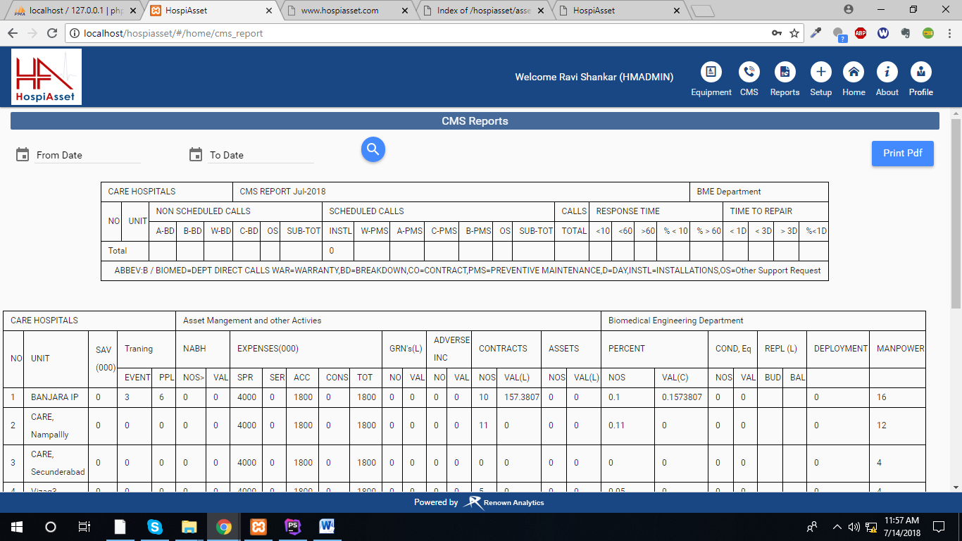

**Viability Report: -** Viability Report it displays the repaired equipment’s replacement equipment’s . It represent as graph and complete PDF. And individual PDF.

|  |
| --- |
| **VIABILITY DATA** |
| Equipment ID, Equipment Name, Serial No, Contract Type, Department, Contract Type, Action, Cost of Consumables, Disposable Cost, No.Of Cases Per Day, Code Operation, Advantages, Action |

|  |  |
| --- | --- |
| **FIelds** | Description |
| Equipment ID | It describes the Equipment ID |
| Equipment Name | It describes the Equipment Name |
| Serial No | It describes the Equipment Serial No. |
| Contract Type | It describes the Contract Type of Equipment |
| Department | It describes the Department of Equipment |
| Cost of Consumables | It describes the Cost of Equipment  Spares |
| Disposable Cost | It describes the Cost of Equipment  Disposable (Repair) |
| No.Of Cases Per Day | It describes the Repair cases per day of Equipment |
| Code Operation | It describes the Code of Equipment operation |
| Advantages | It describes the Advantage of Equipment |
| Action | It describes the particular action for PDF Generation. |

**Indent Report: -** It displays the new equipment’s order or requested equipment’s showing the list data. It represents whole print out of Indents as PDF.

|  |
| --- |
| **INDENT DATA** |
| Indent ID, Department ID, Equipment Name, Serial No, Contract Type, Quantity, Essential Features, Desirous Features, Luxurious Features Standard Accessories Optional Accessories, Estimated Cost, Action |

|  |  |
| --- | --- |
| **Fields** | **Description** |
| Indent ID | It describes the new indent equipment raised ID |
| Department ID | It describes the new indent Department ID |
| Equipment Name | It described the Equipment Name |
| Serial No | It described the Serial Number of Equipment |
| Contract Type | It describes the Contract Type of Equipment |
| Quantity | It described the Quantity of an Equipment |
| Essential Features | It describes the Features of Essentials |
| Desirous Features | It describes the Features of Desirous |
| Luxurious Features | It describes the Features of Luxurious |
| Standard Accessories | It describes the Accessories of Standard |
| Optional Accessories | It describes the Accessories of Optional |
| Estimated Cost | It describes the Cost of Indent Equipment Estimation |
| Action | It describes the action PDF generation of Indent |

**CEAR REPORT: -** Accept the requested indent equipment’s detailed list showing. It represent as a PDF Print.

|  |
| --- |
| **CEAR DATA** |
| Cear Number, Project Number, Project Title, Requesting Unit, Requesting Category,Requesting Department, Action |

|  |  |
| --- | --- |
| **Fields** | Description |
| Cear Number | Creating a number of cear |
| Project Number | Creating a project number |
| Project Title | Creating a project Title |
| Requesting Unit | We are calling unit as a requesting |
| Requesting Category | We are calling category |
| Requesting Department | We are calling Department |
| Action | It describes as PDF print Generation |

**Gate pass Report:-** It displays the gate pass for new ordered equipment’s entry it is two types returnable and non-returnable it showing data for both.

|  |
| --- |
| **GATE PASS DATA** |
| Equipment ID, Gatepass ID, Department, Branch, Equipment Name, Serial No, Contract Type, Location , Spares, Accessories, Action |

|  |  |
| --- | --- |
| **Fields** | Description |
| Equipment ID | It describes the Equipment ID |
| Gate pass ID | It describes the Equipment Gate pass |
| Department | It describes the Equipment Department |
| Branch | It describes the Equipment Branch |
| Equipment Name | It describes the Equipment Name |
| Serial No | It describes the Equipment Serial No |
| Contract Type | It describes the Equipment Contract Type |
| Location | It describes the Equipment Location |
| Spares | It describes the Equipment Spares |
| Accessories | It describes the Equipment Accessories |
| Action | It describes the Generation of the PDF |

**Call Log Report:-** All call generation equipment’s with all states based search criteria details.

|  |  |  |  |  |  |  |  |  |  |
| --- | --- | --- | --- | --- | --- | --- | --- | --- | --- |
| From date | To date | Equipment ID | Department | Branch | Call cost | Contract-type | Respond  Time | Completed  Time | Click on search |
| 14-07-2018 | 19-07-2018 | HYD-BME-0811-OP-PHY-WAX-0001 | Ambulance | Banjara IP | 10000 | Biomedical | 16:21 PM | 16:55 PM | Equipment ID, Equipment Name, Vendor, Reasons , Call Date and Time , Raised , Responded By, Pending, Call Cost, Responded Time, Completed Time |

|  |  |
| --- | --- |
| **Fields** | **Description** |
| Equipment ID | It describes the Equipment ID |
| Equipment Name | It describes the Equipment Name |
| Vendor | It describes the Equipment Vendor |
| Reasons | It describes the Equipment Reason |
| Call Date and Time | It describes the Equipment Call Date and Time |
| Raised | It describes the Equipment Call Raised |
| Responded By | It describes the Equipment who responded call |
| Pending | It describes the Equipment pending call |
| Closed | It describes the Equipment closed call |
| Call Cost | It describes the Equipment call cost |
| Responded Time | It describes the Equipment responded call time |
| Completed Time | It describes the Equipment completed call time |

**PMS Report: - (**PREVENTIVE MAINTENANCE Report) It is known as one type of Scheduled Call. In this scheduled call only present month pending calls only displayed Based on search Criteria representing as graph and pdf.

|  |  |  |  |  |  |  |  |
| --- | --- | --- | --- | --- | --- | --- | --- |
| Equipment ID | Serial No | Equipment Name | Department | Branch | Due Date | Call Type | Click onFields |
| 14-07-2018 | 19-07-2018 | HYD-BME-0811-OP-PHY-WAX-0001 | Ambulance | Banjara IP | 97694 | Infusion Pump | Equipment ID , Department ID , Equipment Name, MODEL, Serial Number, Contract Type, Action |

|  |  |
| --- | --- |
| **Fields** | **Description** |
| Equipment ID | It describes the EquipmentID |
| Department ID | It describes the Department ID |
| Equipment Name | It describes the Equipment Name |
| MODEL | It describes the Equipment MODEL |
| Serial Number | It describes the Equipment Serial Number |
| Contract Type | It describes the Equipment Contract Type |
| Action | It describes the Generation of PDF |

**Calibration Report: -** This is also known as one type of scheduled calls in this calls complete for 1 year scheduled calls due in pending to display data . Based on search criteria. It display as graph and print as pdf

|  |  |  |  |  |  |  |  |
| --- | --- | --- | --- | --- | --- | --- | --- |
| Equipment ID | Serial No | Equipment Name | Department | Branch | Due Date | Call Type | Click onFields |
| 14-07-2018 | 19-07-2018 | HYD-BME-0811-OP-PHY-WAX-0001 | Ambulance | Banjara IP | 97694 | Infusion Pump | Equipment ID , Department ID , Equipment Name, MODEL, Serial Number, Contract Type, Action |

|  |  |
| --- | --- |
| **Fields** | **Description** |
| Equipment ID | It describes the EquipmentID |
| Department ID | It describes the Department ID |
| Equipment Name | It describes the Equipment Name |
| MODEL | It describes the Equipment MODEL |
| Serial Number | It describes the Equipment Serial Number |
| Contract Type | It describes the Equipment Contract Type |
| Action | It describes the Generation of PDF |

**Other Reports:-**

**Adverse Report :** All Adverse incident Report if Equipment damaged, repaired and e.g. based on search criteria And it represent as graph and printed as pdf data**.**

|  |  |  |  |  |
| --- | --- | --- | --- | --- |
| Serial No | Equipment Name | Search Equipment ID | Department | Fields click on search |
| CN11639666 | Syringe Pump | HYD-BME-0413-NP-LPT-CEN-0564 | BME | Equipment ID,Equipment Name,Department ID,Location,Type,Model,Serial No,Date & time,Incident Type |

|  |  |
| --- | --- |
| **Field Name** | **Description** |
| Equipment ID | It describes the Unique ID of the Device |
| Equipment Name | It describes the Name of the Device |
| Department | It describes the code of the Department |
| Location | It describes the Location |
| Type | It describes the type of call |
| Model | It describes the model of the Device |
| Serial No | It describes the Serial No of the Device |
| Date and Time | It describes the date and time of the call raised |
| Incident Type | It describes the type of Incident call |

**Deployment Report : -** All equipment Id not generated data it showing it will create new equipment ID generation when its create deployment mode. Based on search data and it represent graph and print as pdf.

|  |  |  |  |  |
| --- | --- | --- | --- | --- |
| Serial No | Equipment Name | Search Equipment ID | Department | Fields click on search |
| CN11639666 | Syringe Pump | HYD-BME-0413-NP-LPT-CEN-0564 | BME | Equipment ID,Equipment Name,Department ID, Model,Serial No, |

|  |  |
| --- | --- |
| **Field Name** | **Description** |
| Equipment ID | It describes the Unique ID of the Device |
| Equipment Name | It describes the Name of the Device |
| Department | It describes the code of the Department |
| Model | It describes the model of the Device |
| Serial No | It describes the Serial No of the Device |

**ReDeployment Report: -** All equipment Id not generated data it showing it will create new equipment ID generation when its create deployment mode which is second time deployment. Based on search data and it represent graph and print as pdf.

|  |  |  |  |  |
| --- | --- | --- | --- | --- |
| Serial No | Equipment Name | Search Equipment ID | Department | Fields click on search |
| CN11639666 | Syringe Pump | HYD-BME-0413-NP-LPT-CEN-0564 | BME | Equipment ID,Equipment Name,Department ID, Model,Serial No, |

|  |  |
| --- | --- |
| **Field Name** | **Description** |
| Equipment ID | It describes the Unique ID of the Device |
| Equipment Name | It describes the Name of the Device |
| Department | It describes the code of the Department |
| Model | It describes the model of the Device |
| Serial No | It describes the Serial No of the Device |

**Condemnation Report : -** All Condemnation Equipment’s it means in dead state equipment’s. Based On search criteria and also it represent as graph and pdf.

|  |  |  |  |  |
| --- | --- | --- | --- | --- |
| Serial No | Equipment Name | Search Equipment ID | Department | Fields click on search |
| CN11639666 | Syringe Pump | HYD-BME-0413-NP-LPT-CEN-0564 | BME | Equipment ID,Equipment Name,Department ID, Model,Serial No, |

|  |  |
| --- | --- |
| **Field Name** | **Description** |
| Equipment ID | It describes the Unique ID of the Device |
| Equipment Name | It describes the Name of the Device |
| Department | It describes the code of the Department |
| Model | It describes the model of the Device |
| Serial No | It describes the Serial No of the Device |

**Monthly Performance Graph:-**

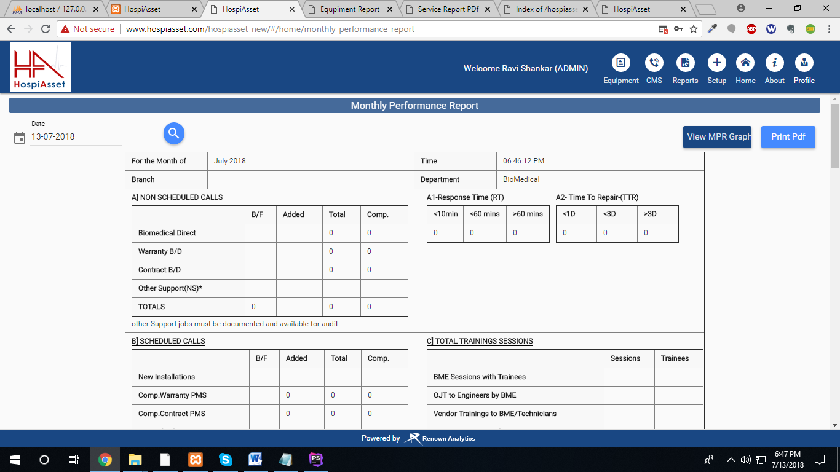

**All Graphs:-**

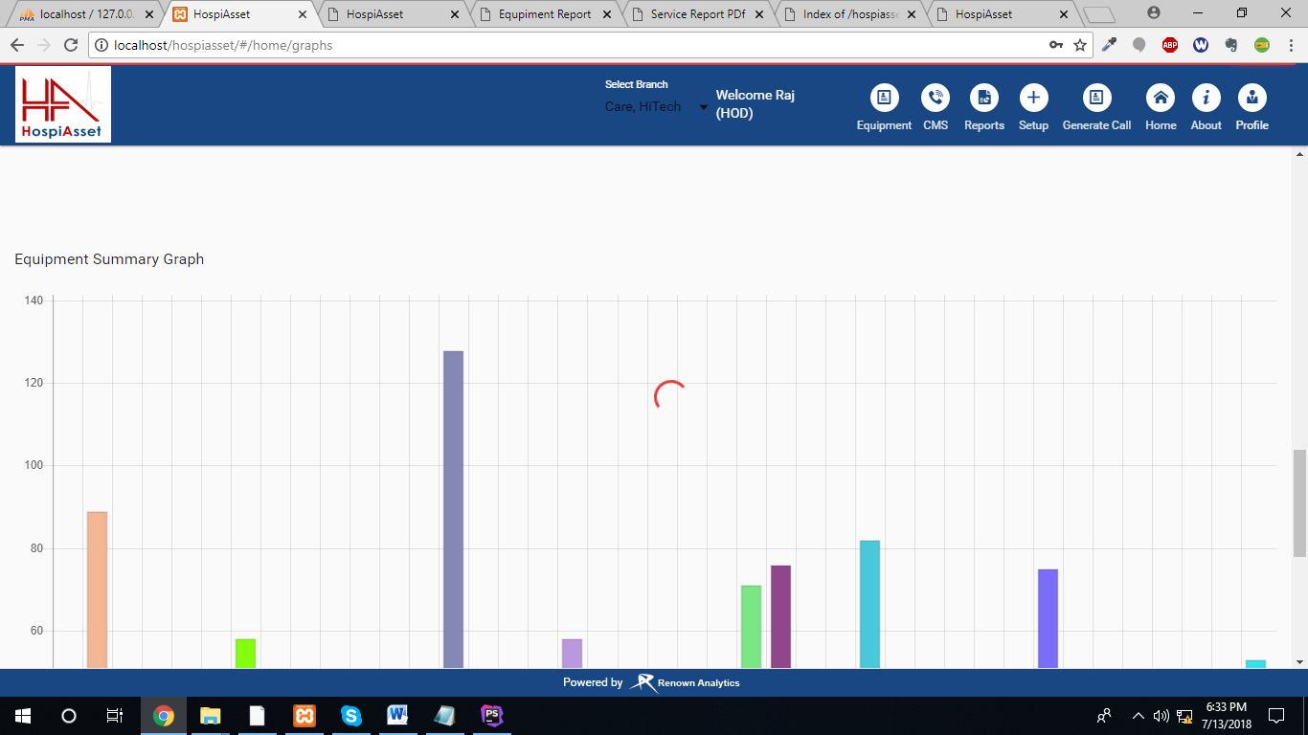

**Monthly Performance Graph:-**

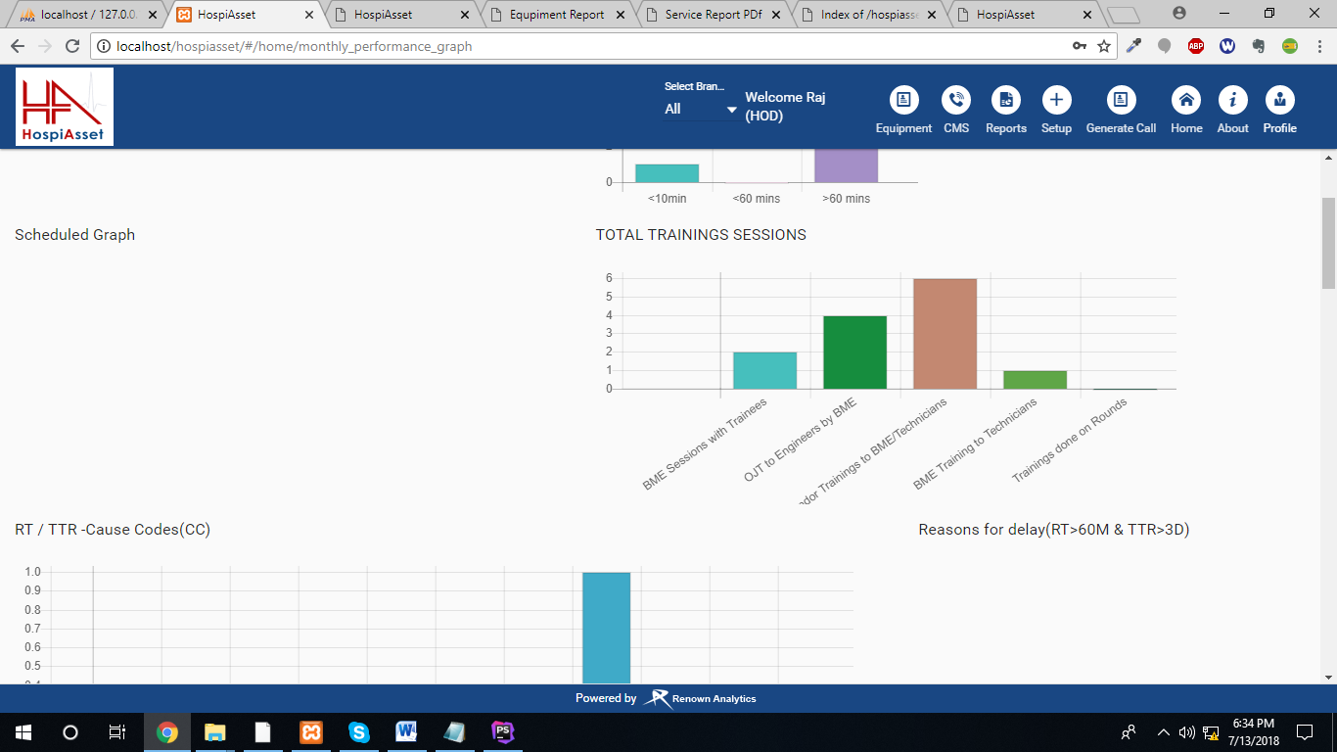

**Overview :**

|  |  |  |  |
| --- | --- | --- | --- |
| From Date | To Date | Department | Fields click on search |
| Syringe Pump | HYD-BME-0413-NP-LPT-CEN-0564 | BME | Total Branches,Total Equipments,Working,Not Working,transferred,PMS Pending,PMS Done,Calibration Pending,Calibration Done,Adverse Incident,Condemnation |

|  |  |
| --- | --- |
| **Field Name** | **Description** |
| Total Branches | It displays the names of branches |
| Total Equipments | It displays the count of total number of equipments |
| Working | It displays the count of total equipments working |
| Not Working | It displays the count of total equipments not working |
| Transferred | It displays the count of total equipments transferred |
| PMS Pending | It displays the count of total PMS pending |
| PMS Done | It displays the count of total PMS done |
| Calibration Pending | It displays the count of total Calibration pending |
| Calibration Done | It displays the count of total Calibration done |
| Adverse Incident | It displays the count of Adverse incident calls |
| Condemnation | It displays the count of Condemnation calls |

**Calls :**

**Non-Scheduled :**

|  |  |
| --- | --- |
| **Field Name** | **Description** |
| Branch | It displays the names of branches |
| Total | It displays the count of total calls |
| Completed | It displays the count of total completed calls |
| In Progress | It displays the count of total in progress calls |
| Assigned | It displays the count of total Assigned calls |

**PMS :**

|  |  |
| --- | --- |
| **Field Name** | **Description** |
| Branch | It displays the names of branches |
| Pending | It displays the count of Pending PMS calls |
| Completed | It displays the count of total completed PMS calls |

**Transfers :**

|  |  |
| --- | --- |
| **Field Name** | **Description** |
| Branch | It displays the names of branches |
| From | It displays the count of total equipments transferred from the branch |
| To | It displays the count of total equipments transferred to the branch |

**Rounds:**

|  |  |
| --- | --- |
| **Field Name** | **Description** |
| Branch | It displays the names of branches |
| Pending | It displays the count of Pending rounds |
| Completed | It displays the count of total completed rounds |

**Condemnation:**

|  |  |
| --- | --- |
| **Field Name** | **Description** |
| Branch | It displays the names of branches |
| Pending | It displays the count of Pending Condemnation calls |
| Completed | It displays the count of total completed Condemnation calls |

**Adverse:**

|  |  |
| --- | --- |
| **Field Name** | **Description** |
| Branch | It displays the names of branches |
| Pending | It displays the count of Pending Adverse calls |
| Completed | It displays the count of total completed Adverse calls |

**Setup: - (Main Menu)**

**Add Vendor**:-

|  |  |  |  |  |  |
| --- | --- | --- | --- | --- | --- |
| **Field Name** | **Description** | **Present Validation** | **Validation Required** | **Input Type** | |
| Choose Branch | It is the employee no given as username | Required |  | Number |
| Name | It describes the password of the user | Required |  | Any |
| Vendor Type | This is used types of vendors like(OEM, Distributor ,Support) | Required Choose minimum one Vendor Type |  |  |
| Contact Number | It describes the contact person number | Required Fixed 10 numbers but not showing it display red line |  | Number |
| Email | It describes the email of Vendor | Required |  |  |
| Vendor Address | Address about Vendor | no |  |  |
| Add More contact Persons | It is clickable button it will be opened as popup when open | Click button disable enable when contact number is not there it disabled otherwise enabled |  |  |
| Contact Person | It is describes the Contact persons | Required when its open popup | **-** | Any |
| Contact Person Number | It is describes the contact person number | Only numbers | Minimum and maximum numbers | Only numbers |
| Contact Person Email | It describes the contact person of the email of Vendor | Email format otherwise it showing red line of the field |  | Email |
| Priority | It describes the priority or contact persons like positions | Required |  | Dropdown |

**Add Escalation: -** It describes the Escalation time period calls by using call levels we are creating automatic notification for equipment.

|  |  |  |  |  |  |
| --- | --- | --- | --- | --- | --- |
| **Field Name** | **Description** | **Present Validation** | **Validation Required** | **Input Type** | |
| Equipment Type | It describes the which type of equipment | Required |  | Dropdown choose selection |
| Call Type | It describes the call type of the equipment | Required |  | Dropdown  Choose selection |
| Utilization | This is used to priority level of | Required |  | Dropdown Choose selection |
| Level 1 | It describes the level 1 field | Required and numbers only |  | Number |
| Type 1 | It describes the Type of level 1 value | Required |  | Dropdown  Choose selection |
| Level 2 | It describes the Type of level 2 field | Required and numbers only |  | number |
| Type 2 | It describes the Type of level 2 value | Required |  | Dropdown  Choose selection |
| Level 3 | It describes the Type of level 3 field | Required and numbers only | **-** | number |
| Type 3 | It describes the Type of level 3 value | Required |  | Dropdown  Choose selection |

**Add Escalation Levels: -** It describes the Escalation levels (call levels) are known as Escalation Levels like levels as L1, L2, and L3. Time period schedules as levels.

|  |  |  |  |  |  |
| --- | --- | --- | --- | --- | --- |
| **Field Name** | **Description** | **Present Validation** | **Validation Required** | **Input Type** | |
| Levels | It describes the Escalation Levels | Required |  | Any |

**Add Escalation Types: -** It describes the Escalation types (call types) are known as Escalation Types.

|  |  |  |  |  |  |
| --- | --- | --- | --- | --- | --- |
| **Field Name** | **Description** | **Present Validation** | **Validation Required** | **Input Type** | |
| Escalations | It describes the Escalation Types | Required |  | Any |

**Add Cear Category: -** It describes the CEAR (Capital Expenditure Authorization Request) type.

|  |  |  |  |  |  |
| --- | --- | --- | --- | --- | --- |
| **Field Name** | **Description** | **Present Validation** | **Validation Required** | **Input Type** | |
| Cear Category Name | It describes the Cear Category type | Required |  | Any |
| Cear Category Code | It describes the Cear Category Code | Required |  | Any |

**Add Training Types: -** It describes the different types of Training types we created the training type like ex… as BME (Bio Medical Engineer) given to training for technical person this is known as training type.

|  |  |  |  |  |  |
| --- | --- | --- | --- | --- | --- |
| **Field Name** | **Description** | **Present Validation** | **Validation Required** | **Input Type** | |
| Training Type | It describes the training type of equipment | Required |  | Any |
| Equipment | It describes the Equipment code | Required |  | Any |

**Add Utilization: -** This describes Usage of the Equipment like low, medium, high.

|  |  |  |  |  |  |
| --- | --- | --- | --- | --- | --- |
| **Field Name** | **Description** | **Present Validation** | **Validation Required** | **Input Type** | |
| Type | It describes the Usage of Equipment | Required |  | Any |
| Code | It describes the Code of Equipment Utilization | Required |  | Any |

**Add Status: -** It describes the status of the Equipment like working, not working.

|  |  |  |  |  |  |
| --- | --- | --- | --- | --- | --- |
| **Field Name** | **Description** | **Present Validation** | **Validation Required** | **Input Type** | |
| Status | It describes the status of Equipment in which state | Required |  | Any |
| Code | It describes the Code of Equipment Status | Required |  | Any |

**Add Equipment Condition: -** It describes the condition of the Equipment like Good, bad.

|  |  |  |  |  |  |
| --- | --- | --- | --- | --- | --- |
| **Field Name** | **Description** | **Present Validation** | **Validation Required** | **Input Type** | |
| Equipment Condition | It describes the Usage of Equipment condition | Required |  | Any |
| Code | It describes Equipment condition Code | Required |  | Any |

**Add Equipment Types:-**

|  |  |  |  |  |  |
| --- | --- | --- | --- | --- | --- |
| **Field Name** | **Description** | **Present Validation** | **Validation Required** | **Input Type** | |
| Type | It describes which type of equipment we are creating | Required |  | Any |
| Code | It describes the Code of Equipment Type | Required |  | Any |

**Equipment:-**

**Add Contract Types**: - It describes the Equipment Contract types like as contract based rental, warranty ex...

|  |  |  |  |  |  |
| --- | --- | --- | --- | --- | --- |
| **Field Name** | **Description** | **Present Validation** | **Validation Required** | **Input Type** | |
| Contract Type | It describes the Equipment Contract Type | Required |  | Any |
| Code | It describes the Equipment Contract Type | Required |  | Any |

**Add Reasons: -** It describes the Equipment Reason like it is damaged or already existed in the unit this type of reasons we are requesting.

|  |  |  |  |  |  |
| --- | --- | --- | --- | --- | --- |
| **Field Name** | **Description** | **Present Validation** | **Validation Required** | **Input Type** | |
| Complaint | It describes the Equipment complaint | Required |  | Any |

**Add Department**: - It describes the Equipment is which type of department like as ambulance, Blood bank ex…

|  |  |  |  |  |  |
| --- | --- | --- | --- | --- | --- |
| **Field Name** | **Description** | **Present Validation** | **Validation Required** | **Input Type** | |
| Department | It describes the Department of Equipment | Required |  | Any |
| Code | It describes the code of department Equipment | Required |  | Any |

**Add Equipment Categories: -** It describes the Equipment Category which type of category.

|  |  |  |  |  |  |
| --- | --- | --- | --- | --- | --- |
| **Field Name** | **Description** | **Present Validation** | **Validation Required** | **Input Type** | |
| Name | It describes the Name of Equipment | Required |  | Any |
| Code | It describes the code of equipment name | Required |  | Any |
| Priority | It describes the priority level of equipment | Required |  | Any |
|  |  |  |  |  |

**Add Equipment Class: -** It describes the Equipment Class like in equipment number of classes we are simplifying creation we are using equipment class

|  |  |  |  |  |  |
| --- | --- | --- | --- | --- | --- |
| **Field Name** | **Description** | **Present Validation** | **Validation Required** | **Input Type** | |
| Equipment Class | It describes the Equipment class like numbers 1, 2, 3. | Required |  | Any |
| Code | It describes the code of Equipment class | Required |  | Any |

**Add Equipment Classification: -** It describes the Master class of equipment department. This class responded by department

|  |  |  |  |  |  |
| --- | --- | --- | --- | --- | --- |
| **Field Name** | **Description** | **Present Validation** | **Validation Required** | **Input Type** | |
| Master Class | It describes the Master class of equipment department. This class responded by department | Required |  | Any |
| Responsible Dept. | It describes the department of Equipment | Required |  | Any |
| Code | It describes the code of responsible department |  |  |  |

**Deployment: -** Deployment view it displays the equipment’s not generated equipment Id’s view. Then we are searching Serial number and PO(Purchase Order) number after that we generated Fresh Equipment Id.

|  |  |
| --- | --- |
| **Display Data** | **Search Data** |
| Equipment Name | PO.NO or Serial No and Branch |
| Equipment Model | PO.NO or Serial No and Branch |
| PO.NO | PO.NO or Serial No and Branch |
| Serial No | PO.NO or Serial No and Branch |
| Vendor | PO.NO or Serial No and Branch |
| Contract Type | PO.NO or Serial No and Branch |