**Picture 1:-**

The below picture shows the welcome page for the application .Furthermore giving three different options to perform three different operations.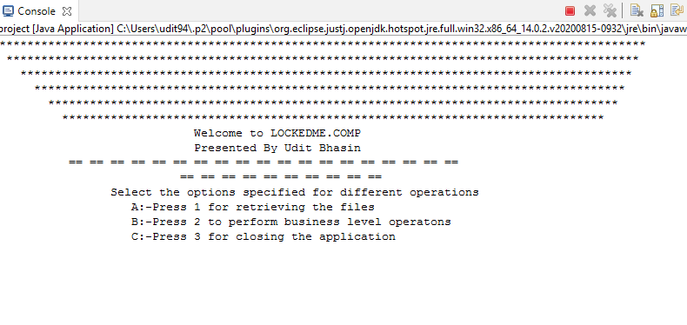

**Picture 2:-**

The below picture shows the output which is displaying the files present in the path D:\\ of the local System in an ascending order.

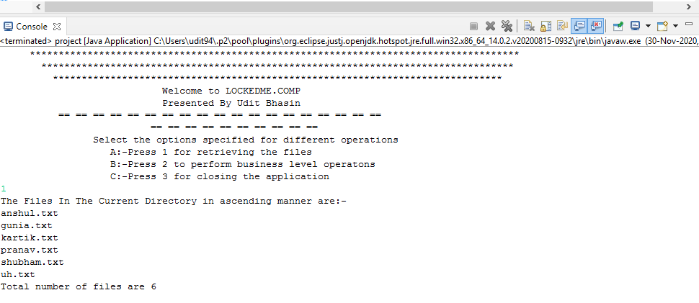

**Picture 3:**

The below pictures displays the option(to perform different operations) when we select 2 from the main menu.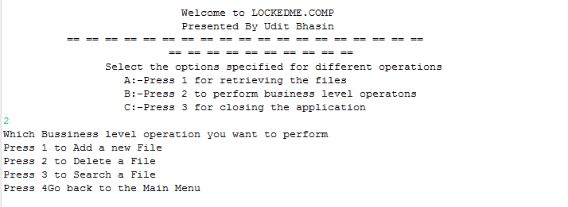

**=================================================**

**Picture 4:**

**The below picture displays the output when we select first option to add a new file. The program gives us a feature to add multiple number of files by taking the name of the file from the console.**

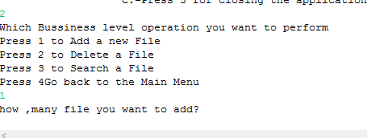

**Picture 5:-**

**The below picture shows the program asking the user the name of each file.**

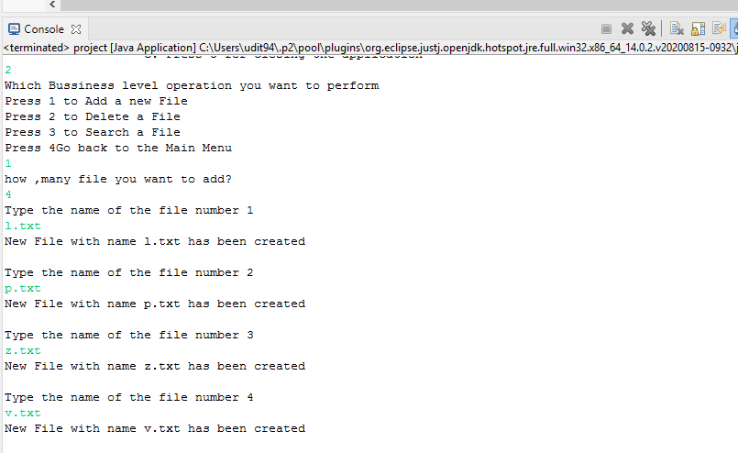

**==================================================**

**Picture 6:-**

**The below pictures shows the output when the user tries to add a file with the same name of a pre-existing file.**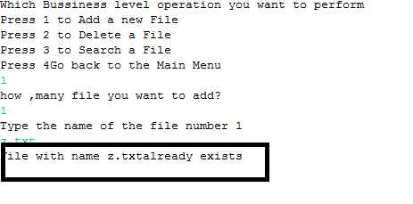

**Output:- File with name z.txt already exists.**

**Picture 7:-**

**The below output shows the functionality to delete multiple files at the same time .**

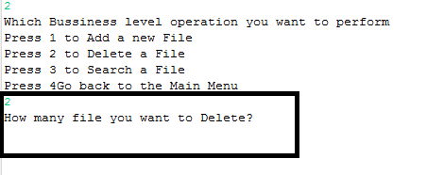

**===============================================**

**Picture 8:-**

**The below picture displaying the functionality to delete file by taking file’s name form the user.**

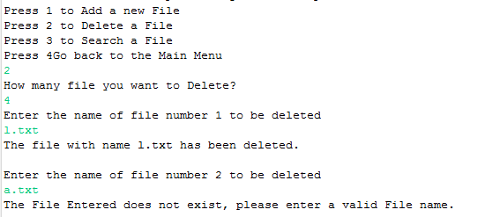

**The program displays a message if user tries to delete a file which does not exist.**

**Picture 9:-**

**The pictures displays the search results with the location of the file search exists with its location. It returns a message that the file doesn’t exist if user tries to search a non – existing file.**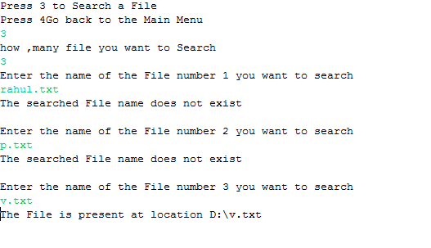

**=======================================================**

**Picture 10:- The picture display the result if user choose to return back to main menu by selecting option 4**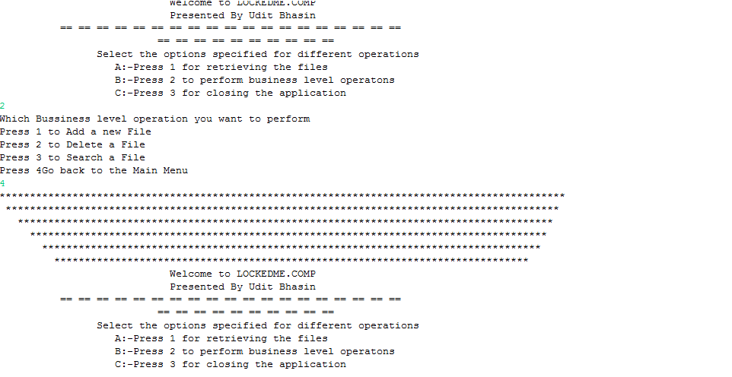

**Picture 11:-**

**The application closes if user selects 4 from main menu.**

