**Q – 5**

**Part - (a)**

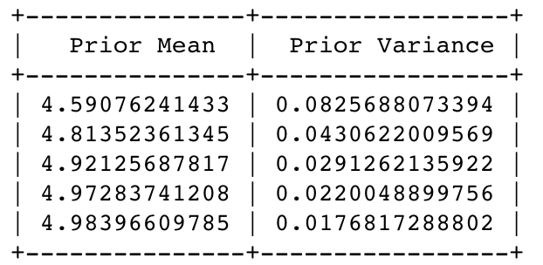

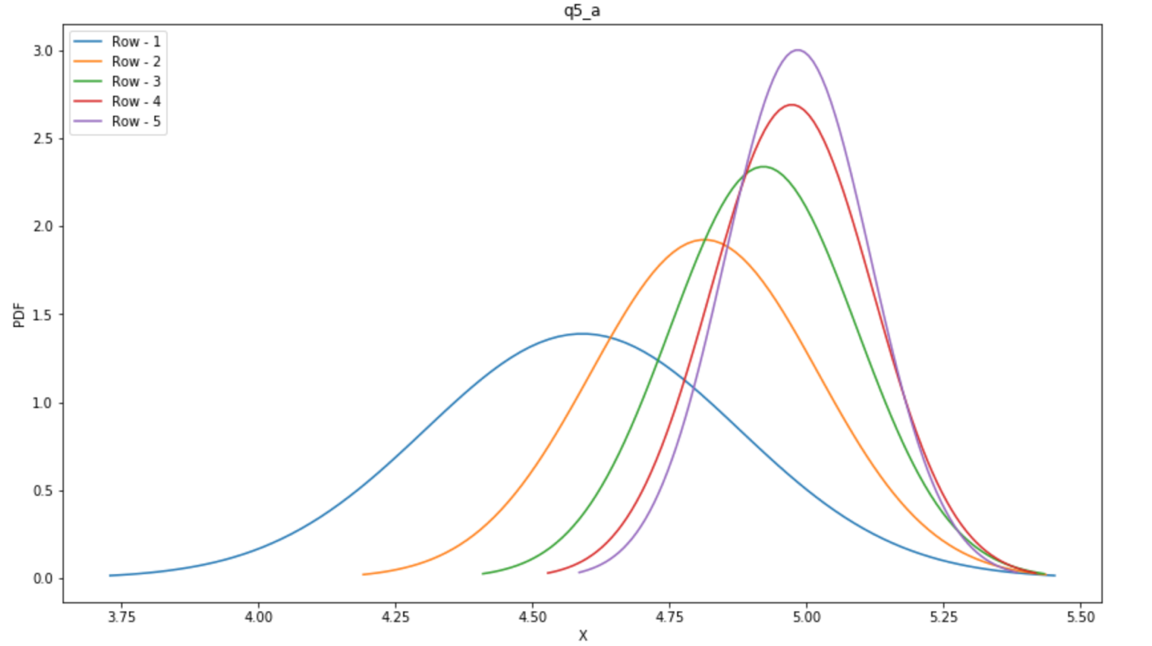

**What do we observe?**

Ans - We observe that the posterior distributions are shifting right i.e. converging towards the true value of the mean. Variance is decreasing therefore distribution is getting compressed around the mean.

**Part - (b)**

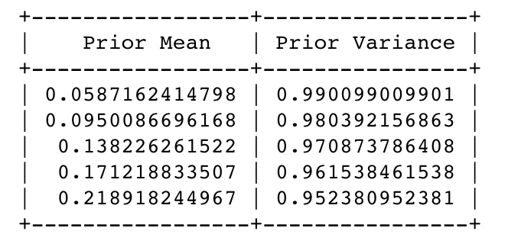

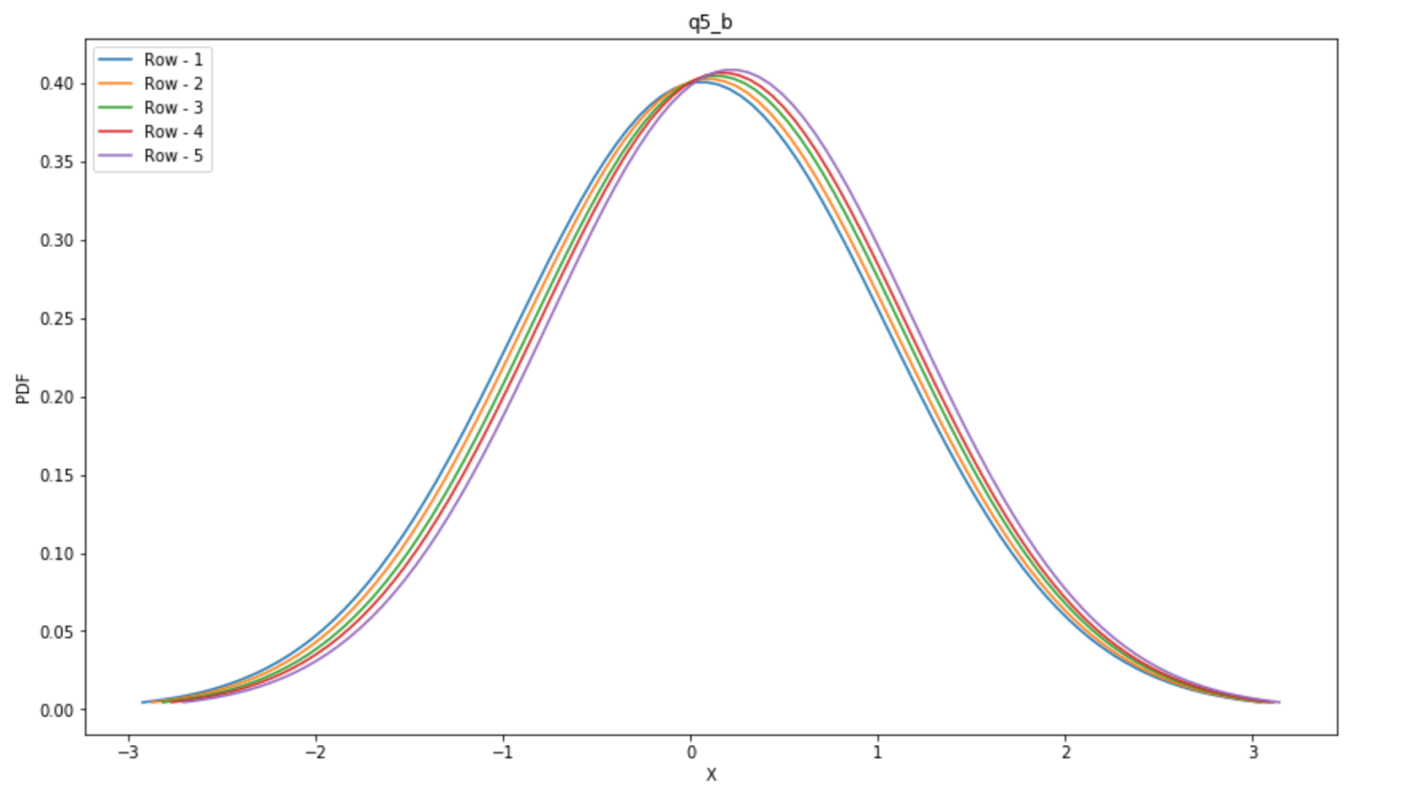

**What do we observe?**

Ans - We observe that the posterior distributions are shifting right very slowly i.e. converging towards the true value of the mean but very slowly.

**Part - (c)**

**What do we conclude?**

Ans – We conclude if we have a larger starting sigma then the posterior distribution will converge slowly towards the true value of the mean.