STRESS-TESTING a Credit-Approval Model on the German Data.

In this we will cover the Linear vs Logistic scoring.The Simpsons’s paradox, the omitted variables,adversarial failures and fairness trade-offs.

Student name —------------------ Udbhav
Enrollment number —------------ s24cseu0095
Dataset assigned(last digit 5)----German Credit Data,UCI stating(1000 applicants, 20 attributes)

Random Seed(last 3 digits)---------random_state=95;70/30 split→700 train/300 test

Reproducible code—------jupyter notebook
Submission date—------------19 oct 2026.

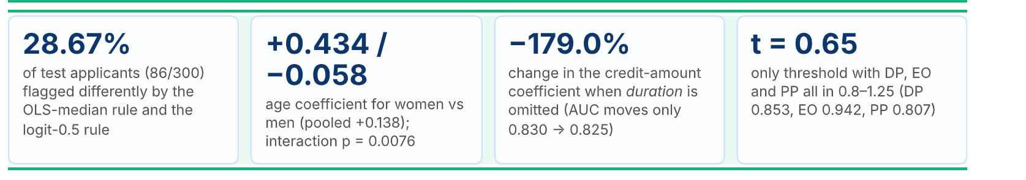

1. Data Preprocessing:-

Before doing any of the operations to determine in the results what we are in need of the doing the preprocessing operations such as the we will do the all of the
:-cleaning such as removing the null values.
:-removing the duplicate values.
:-doing the transformation of the data such as the (finding in the mean, median and mode for the data).We have to do the normalisation and the standardisation of the data. Also all these things are working on the training part but not on the testing part.There is no leak issue of the data from the testing set.

:- There are also categorical columns we have and there is a need to do the red-hot encoding and the other types of encodings there.

:-we also need to find out the various types of the outliers for which we should do the various types of the techniques such as the finding of the box plot,scatter plot etc.

:-we also need to do the re-scaling of all of the things such as the values which are non comparables.

:-At last we will apply for a train-test split here.

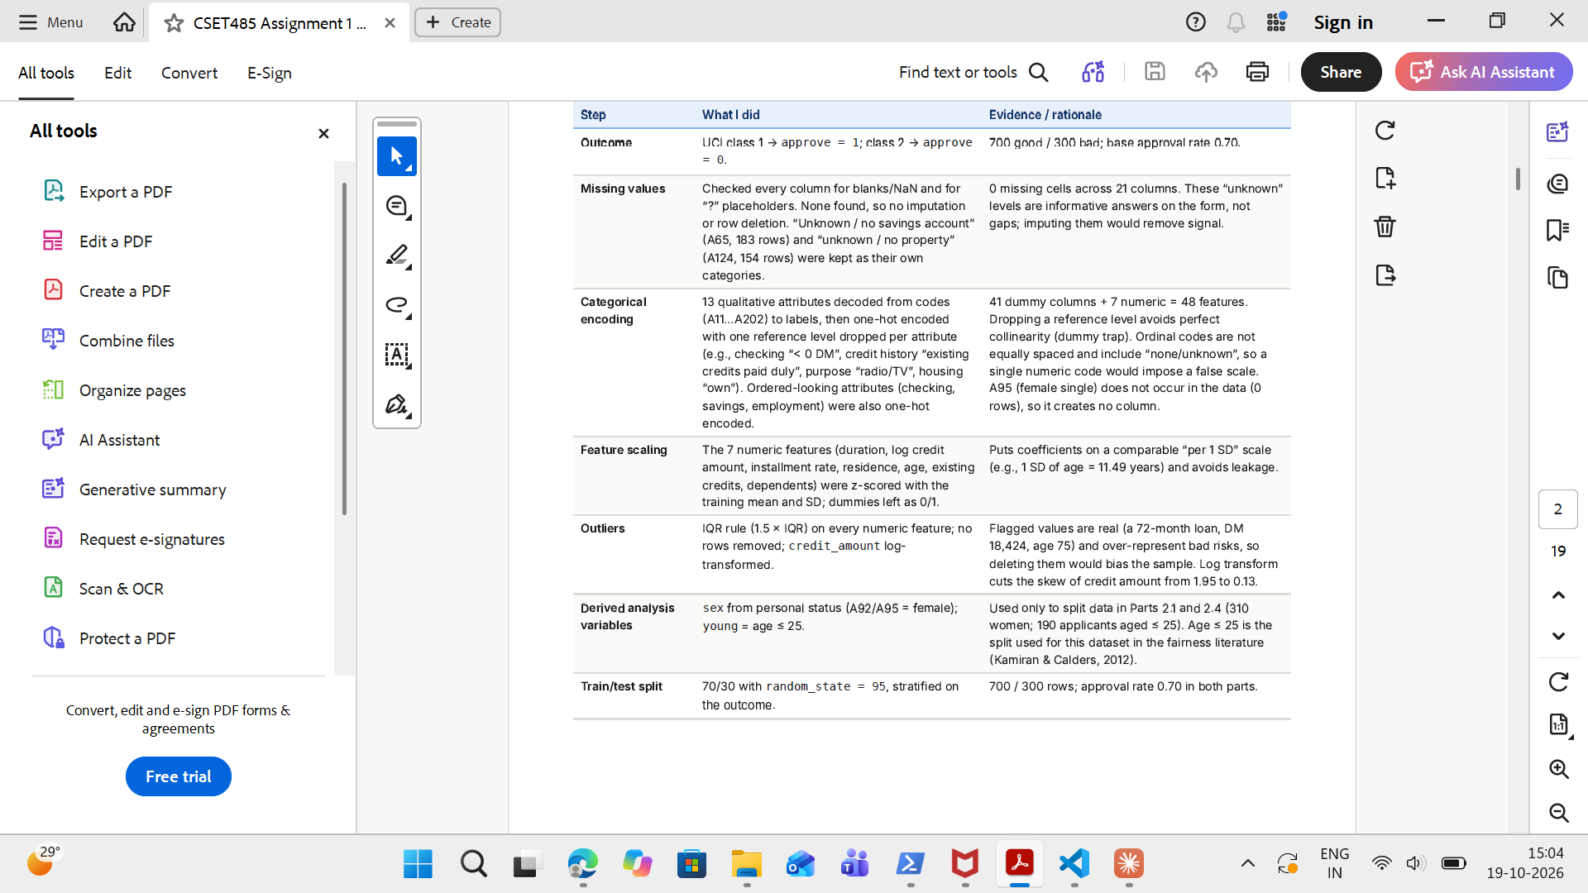

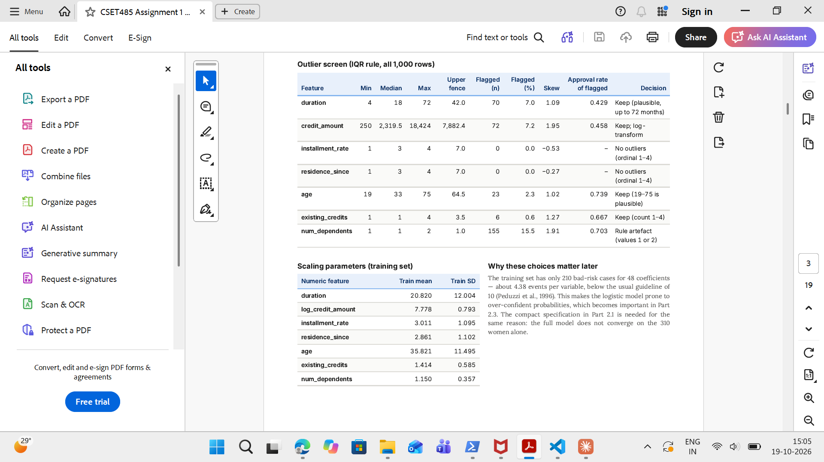

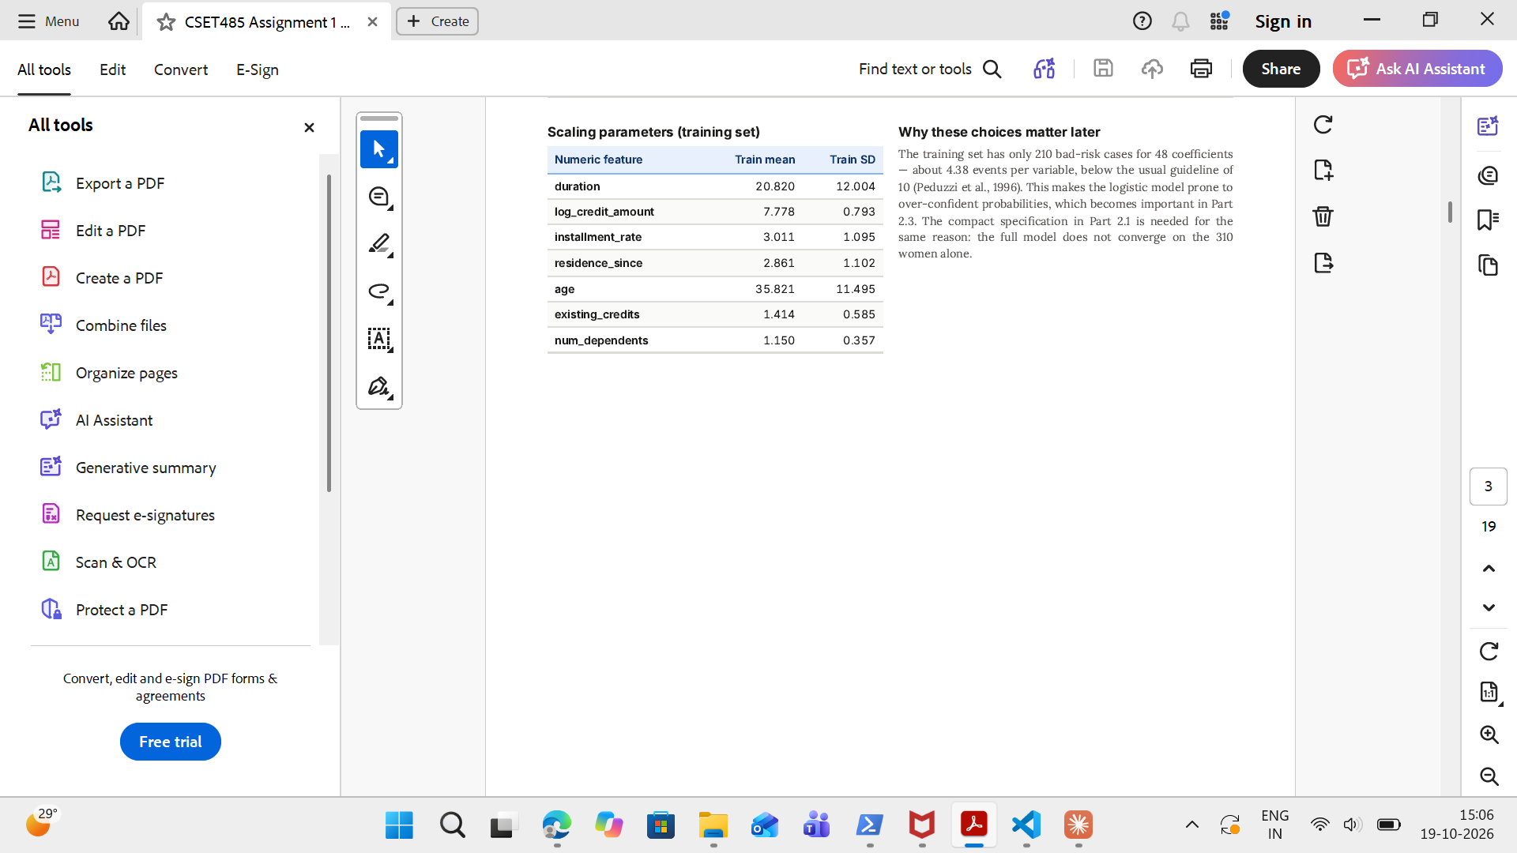

Why these choices matter later:-

In the training set we have the 210 bad risk cases for 48 coefficients- so that will sum up to 4.38 events per variable.
So these all things lead to the making up of our model prone to the over-confident probabilities.Which is important for part 2.3.

So we are in need of the compact specification for the Part 2.1 because of this very reason.The full model does not converge on the 310 womens alone.

Part 1:-Build and Compare.

Model A and Model B descriptions:-
Model A:- It is known as the ordinary least squares regression with the outcome of the 0/1 and it will work like on the 48 features since it is a linear probability model.

The Model B:- it is a logistic regression on the same set of features and it has the same 700 rows.

Both were in testing on the different set of the test size data like we have here Model’s A will get in flag=1 when it will predict more than the >= the median of its test predictions(0.7222)

Similarly the model B’s flag will go to =1 if it’s P(approve)>=0.5.

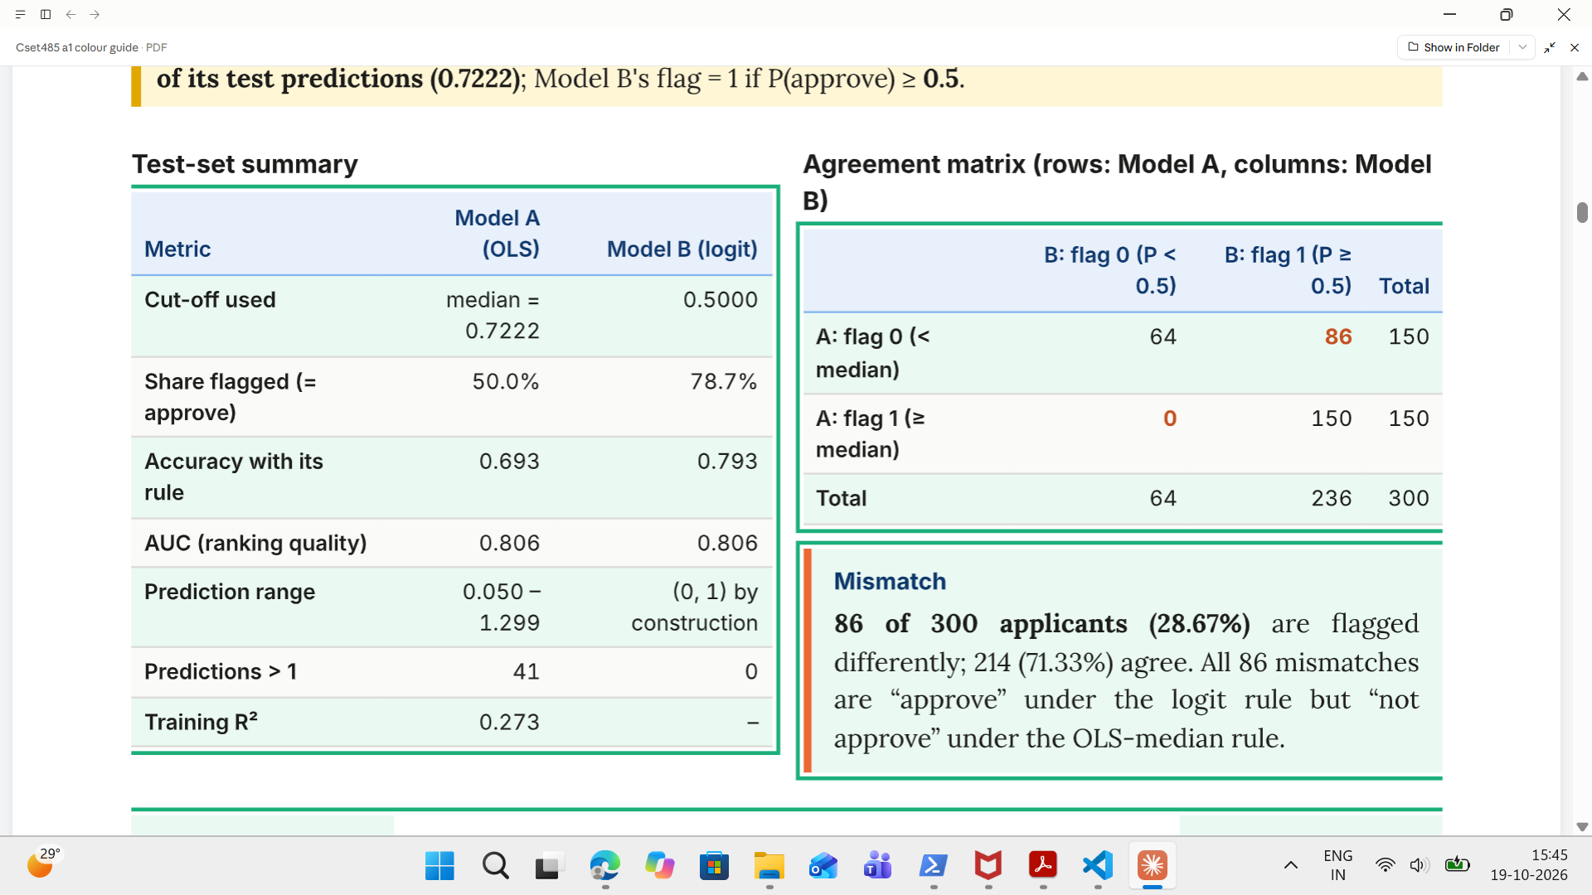

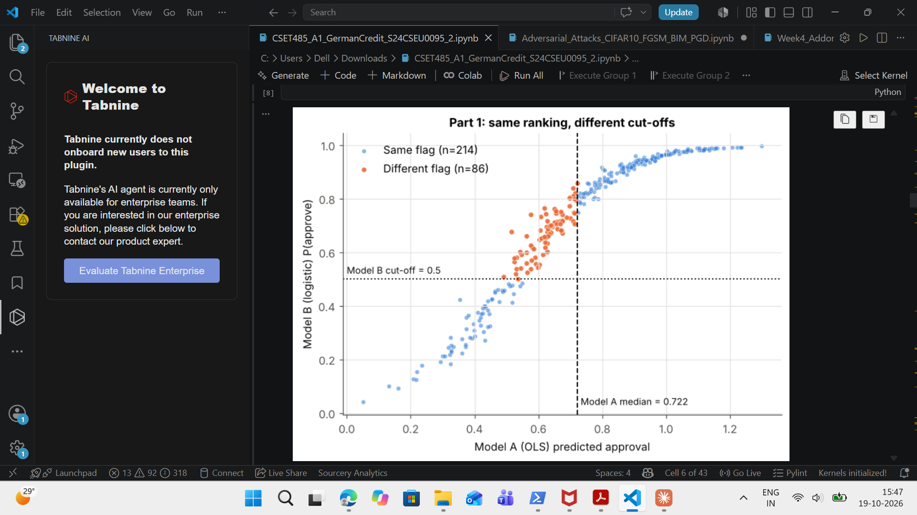
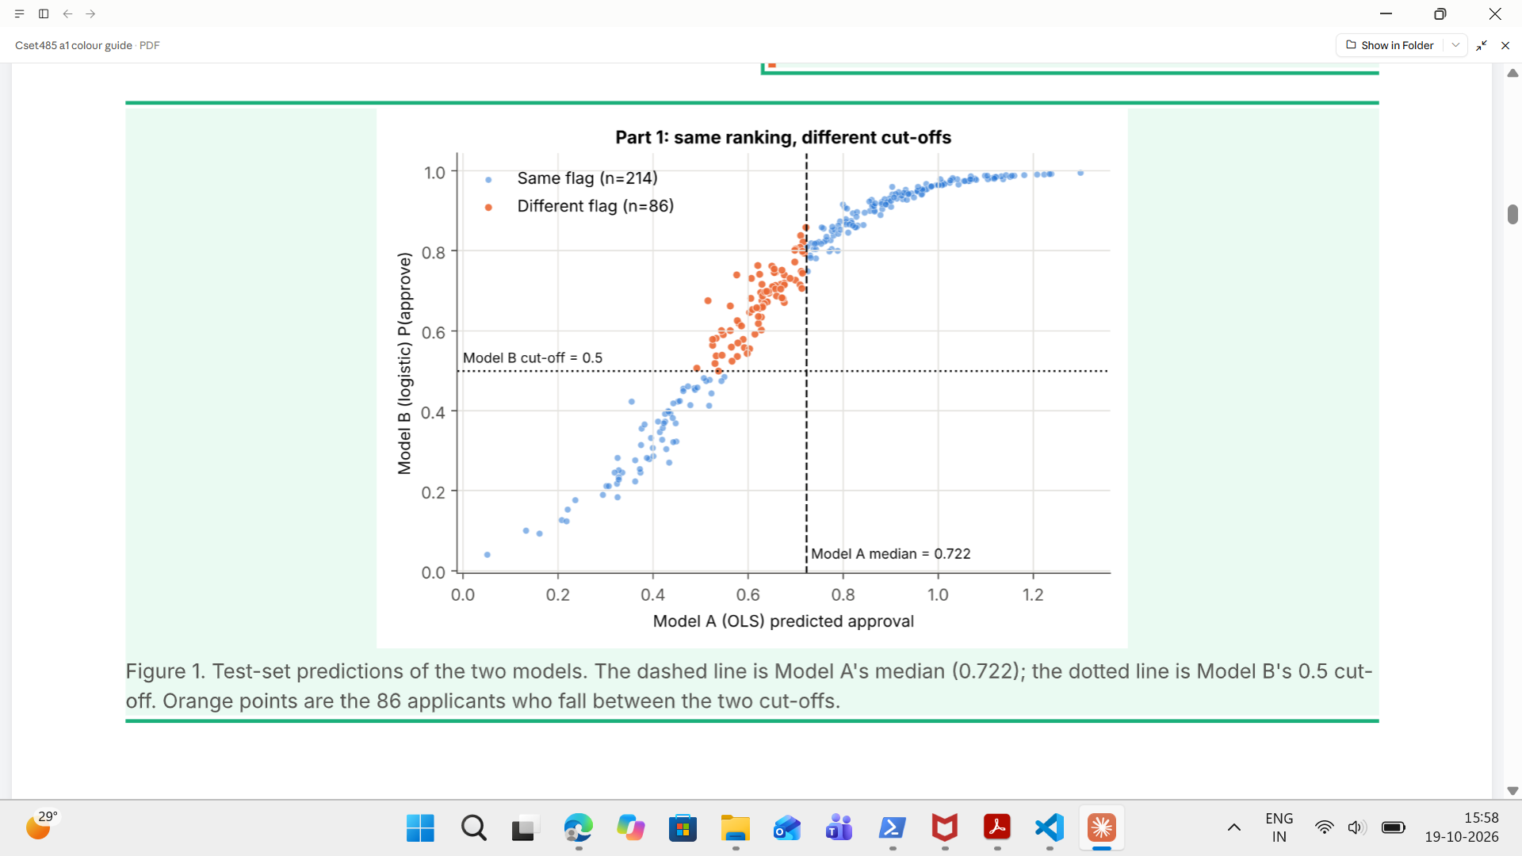

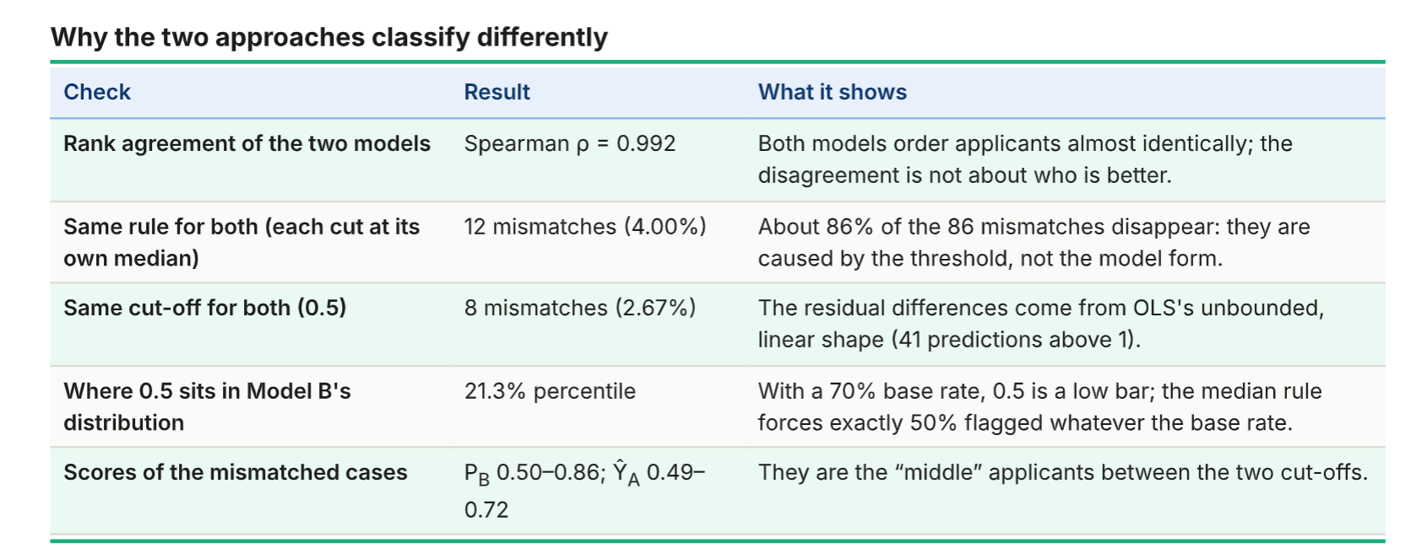

- What is Mismatch?

The classification of the mismatch happens when the 2 models assign the different class labels to the same in the set of the same applicant, but there is an irony that their predicted scores or the ranking are similar.

- Understanding the agreement matrix:- The agreement matrix will measure the classification of both models 300 applicants.

Classification outcome:-

Both models flag 0,
Model A flag 0 but the model B flag 1,
Model A flags 1,Model B flags 0,
Both models flag 1.

Here we will calculate the total agreement and the total mismatch.

- Understanding the two models:-

Model A:-

It is based on the Ordinary Least Squares regression; it is employing the linear regression because of this its range falls outside the limit of the 0-1.

Model B:-
(Logistic regression)
Estimates the probabilities between the 0 to 1.

- What are the 2 thresholding rules?:-\

Rule A:- Median Threshold:-

It is a type of the rule which will approve the 50 per cent of applicants based on their scores.

It is based on the quantile.
It is not using the fixed probability of the repayment.

Rule B:-
Fixed threshold of 0.5:-

It will be based on the probability rule where we have the approval of the candidate for which he/she will need at least the 0.5 of the probability.

. It is a probability rule.
.The distribution of the predicted probabilities will decide the approval.

Why do the approval dates differ?

This is for the obvious reason that the model A is using the median based which will take in only the top tiers but our model B is based on the probability.

PART 2:- THE TRAP:-

It is the study of determining whether the age will affect loan approval differently for the men and for the women.

Here we will split the Sex into the sections of the men and the women. We have observed that logistic regression is used for the fitting of all the women and the men.
The problem that we have faced is that since we have the 48 models it has failed to converge on our 310 spatial in the variables since due to the error of the quasi separation.

So we have arrived at the solution of using a model with the nine predictors from the pool of the age x female where we have the task to test whether the age effect will show the different results for the different sex.

The Simpsons paradox:-

It will be based on the effect of the observations where when we are observing the 2 groups they will show some nature but when we pooled them in the together they will show in the reverse signs that will due to a co-founding factor.

So we need to always compare the aggregate with the subgroups result since if we take only the aggregate it will hide in the overall.

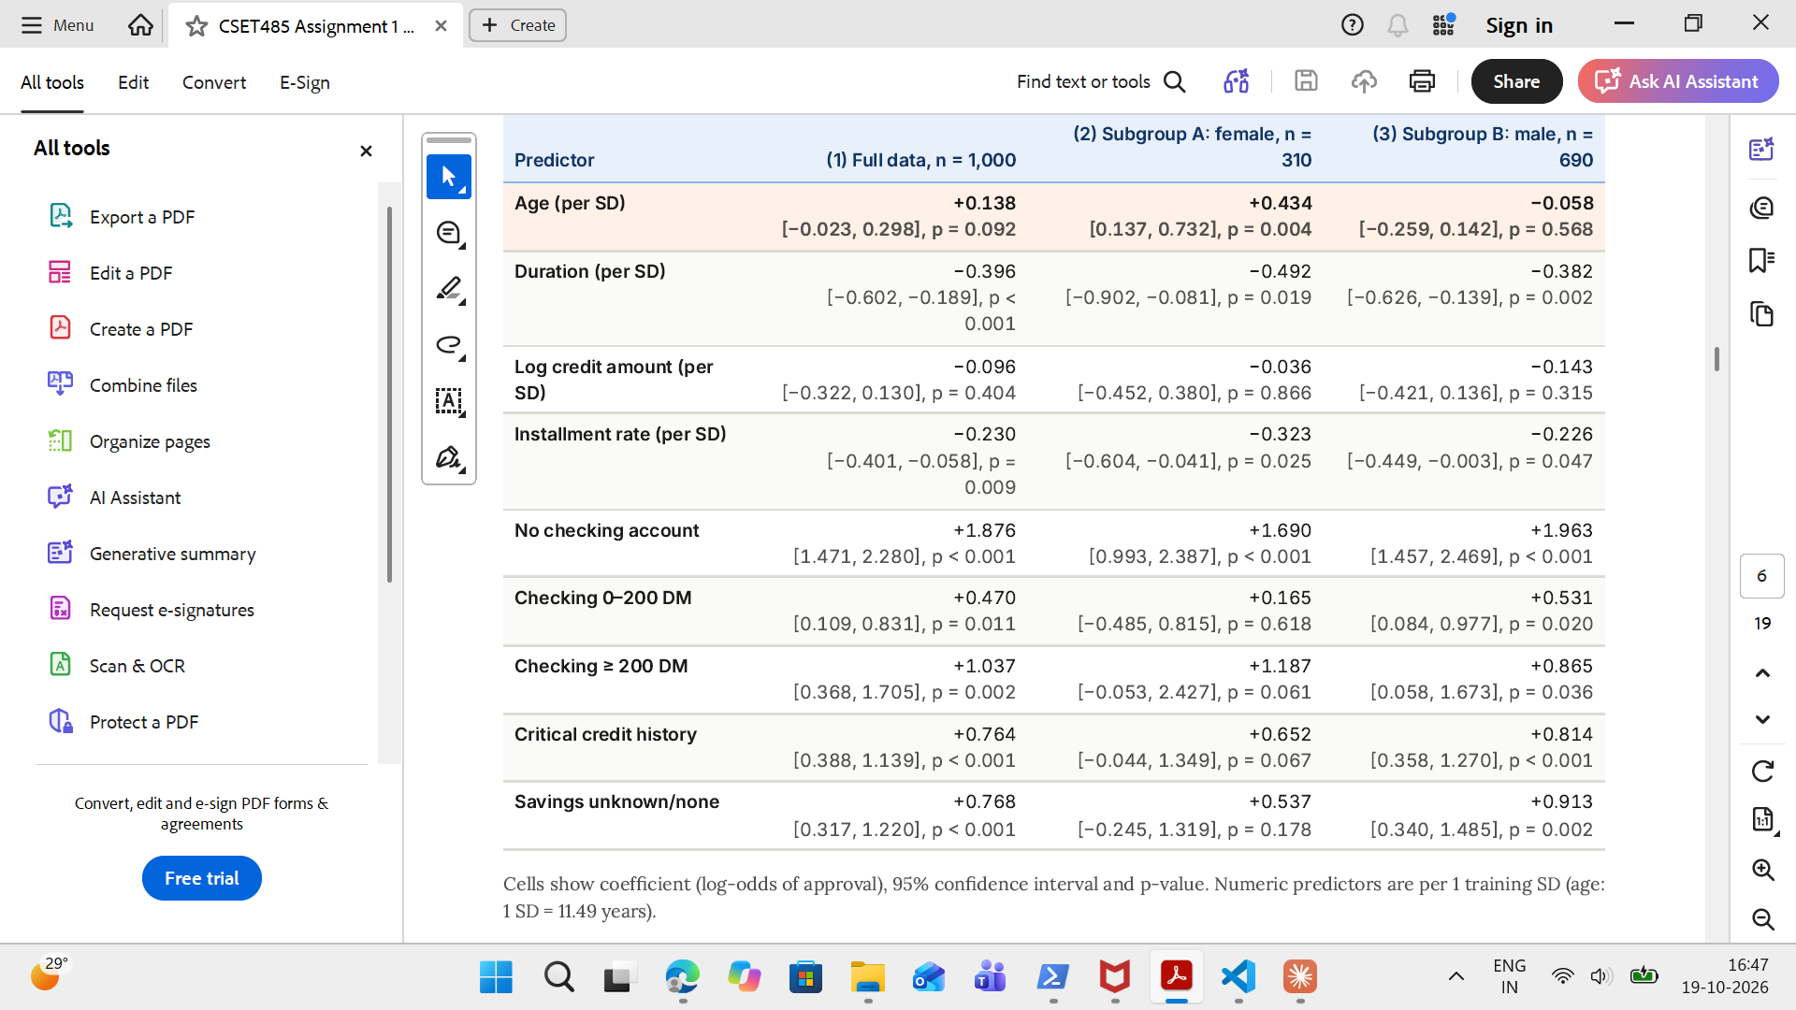

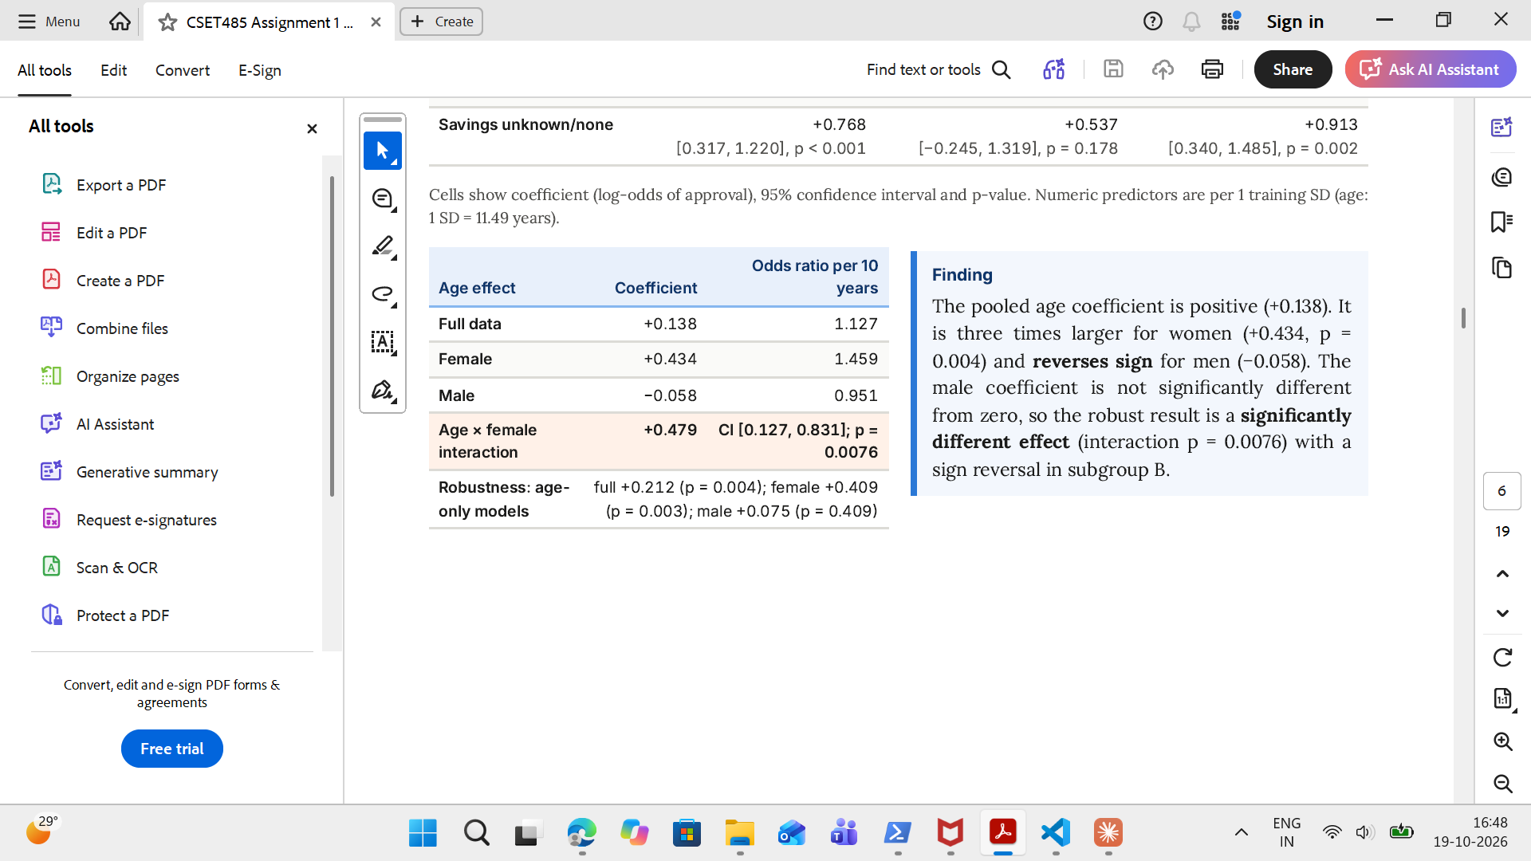

The Interpretation of the Results:-

Here we are having the table which shows us that there is an effect of the age on the loan approval and what we have observed is the.

For the overall aggregate of the data the age has a +0.138 so the things that can be observed from it is that for the increasing age there is an increase in the chances of loan approval.

For the women what we have seen is +0.434 since what it means as the age increases the ability and the capacity for the loan approval increases means the chance.

For the men it is -0.058 since as the age increases there is a slight decrease in the approval odds but it is not much significant.

But when we have taken the pooling result what we have seen is that +0.479 and the p=0.0076 therefore it will affect the women and men differently.

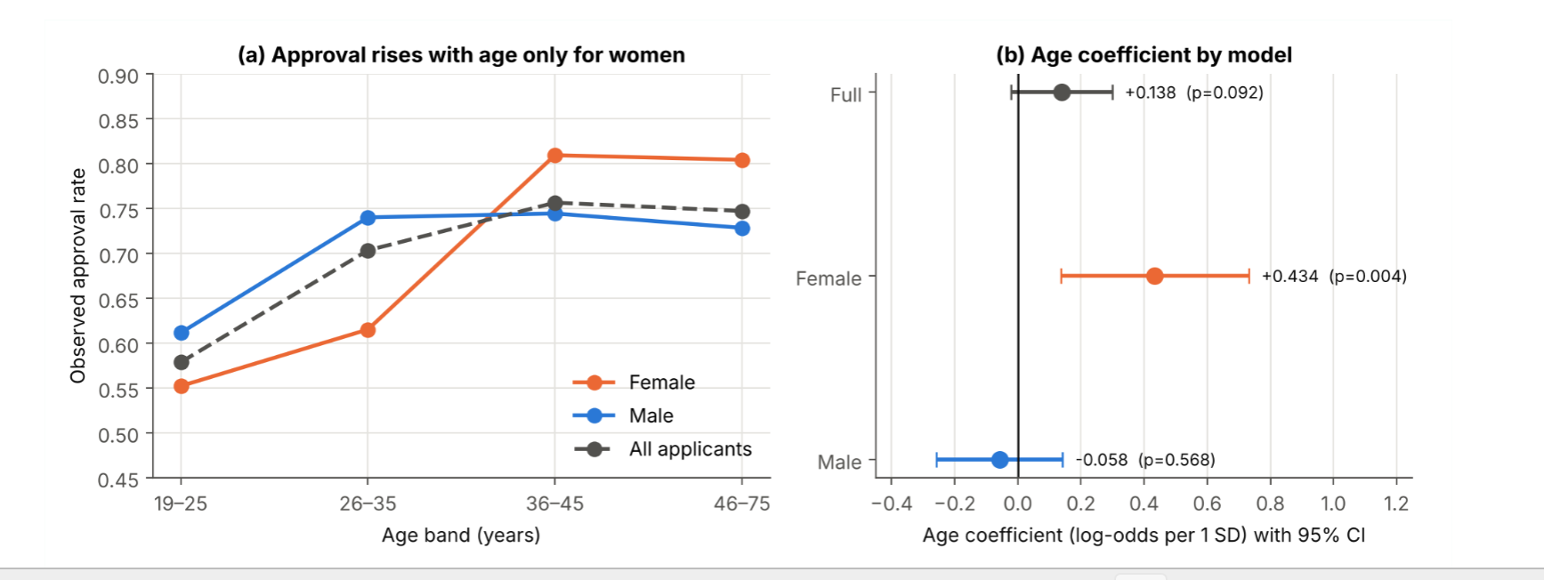
Why there is a difference in the Trends:-
There is a difference in the trends since there is a growing of the approval of the women from the compared to the age 19-25 where it is around 55.2 percent to around 80 percent when they grew in the older but the in the case of the male it will get stagnant around the 71-72 percent at higher age.

When we are pooling then the p what we get is hidden by several key points so if we are observing them separately there are the different characteristics that will be shown up by both of them.

There is one more observation that the number of females are more of the young age and there we will find out that there are some cases like whether the woman is financially dependent or independent is not covered.

2.2 omitted variable bias:-

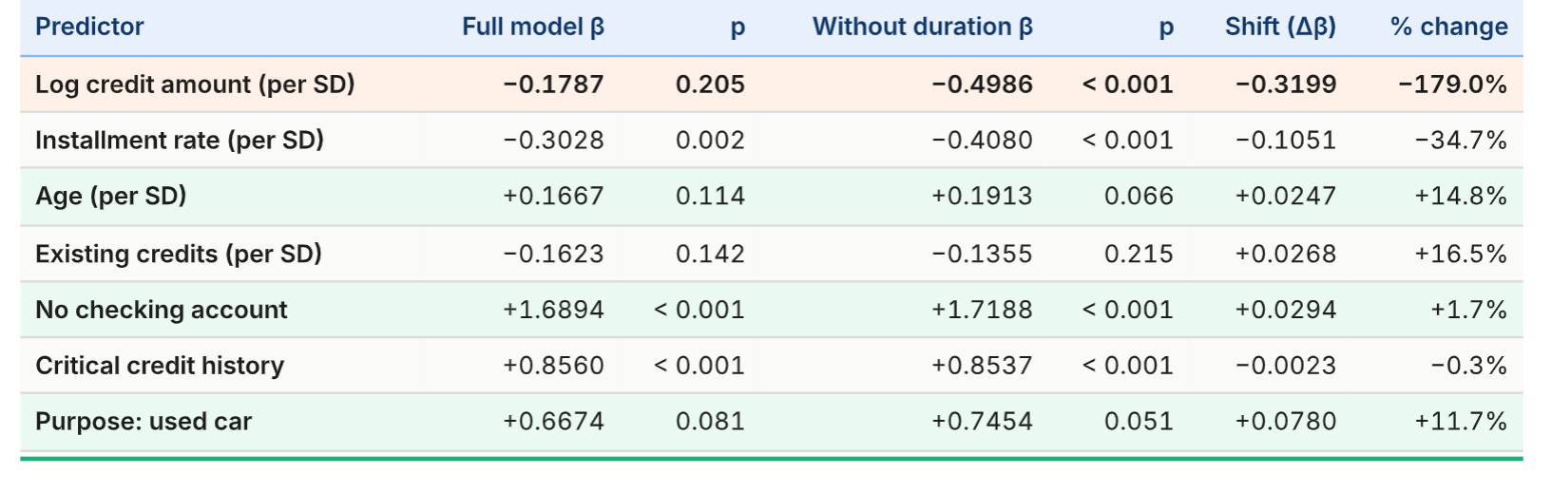

The thing that is vital to observe is that the loan credit amount shifted the most. Its coefficient changes from the -0.179 to -0.499 which is after we have removed the loan duration.

The omission of the loan duration can be explained for the very reason that when we have the long duration of the loans there is the accumulation of the lot of the amounts so there is a trend we have seen that the large loans are the more riskier.

2. What does this say about trusting an untested model?

The model’s AUC will be reduced from 0.830 to 0.825 but now we will interpret it differently like we have that the coefficient of the credit amount becomes the more negative there we will see in that the large loans are the riskier.

- Can we detect a hidden co-founder:-

So what we can see that the we can take the duration of the loan as the sensitivity analysis benchmark but when we are in collecting the extra informations such as the income, debt-income ratio and the credit bureau there in that what we have to find that the important coefficients will in change or they will not change.

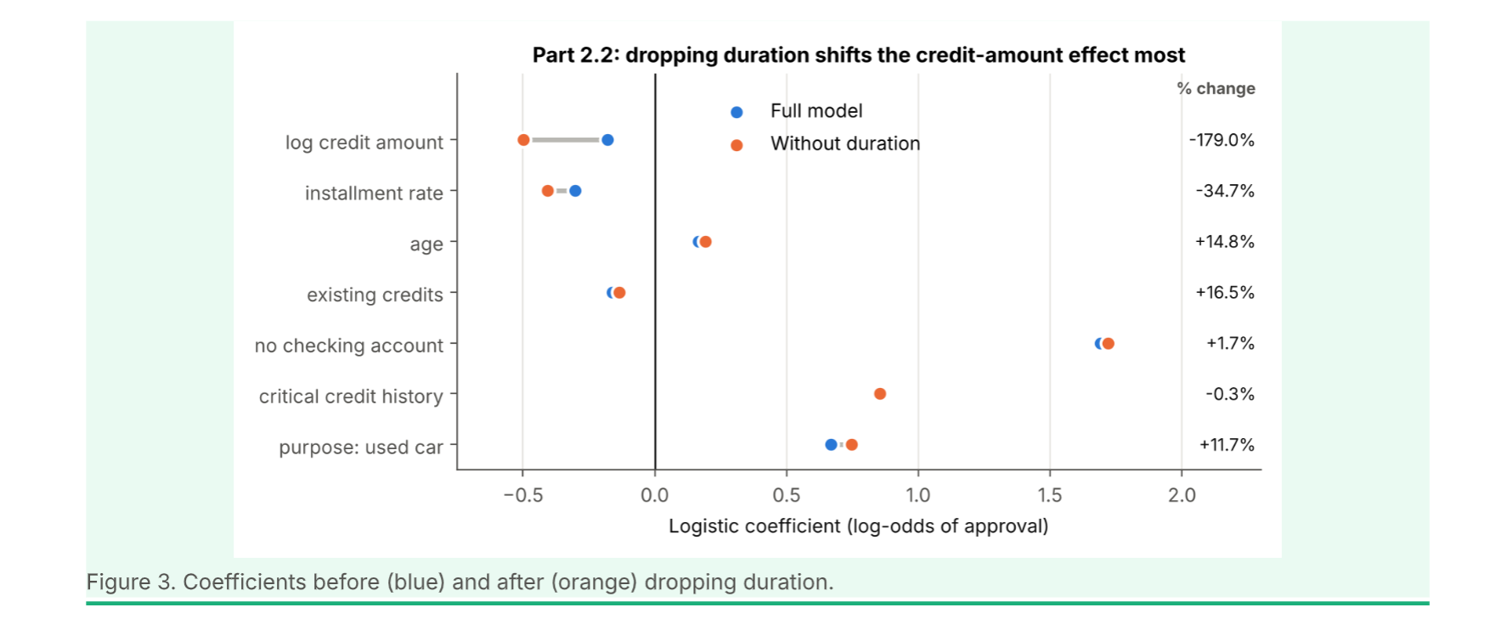

2.3 Adversarial Subset Prediction.
It refers to the cases where the models will make the predictions and that also with confidence but they are in the incorrect predictions.

There is a model that will train on the model 700 applicants and then we will test it on the 300.

Confidence false approval:- P(approval)>=0.75 but the applicant is actually a bad risk.

Confidence false rejection:- P(rejection) <=0.25 but the applicant is actually a good risk.

There are confident wrong predictions, 20 false approvals and 4 false rejections.

So why is this important? This helps us to find the profiles for which our model is giving in the predictions and that also with confidence but it is giving it wrong.

Why the 24 predictions are wrong:-

All of the failed things are due to the fact that the account status and the loan duration.We have 15 to 20 false approvals so where there is we have the loan lasting in the 24 months or less or account not overdrawn.

The very reason for this is that our model is to rely on the familiar combinations of the features and fail to capture in the complicated relationships.

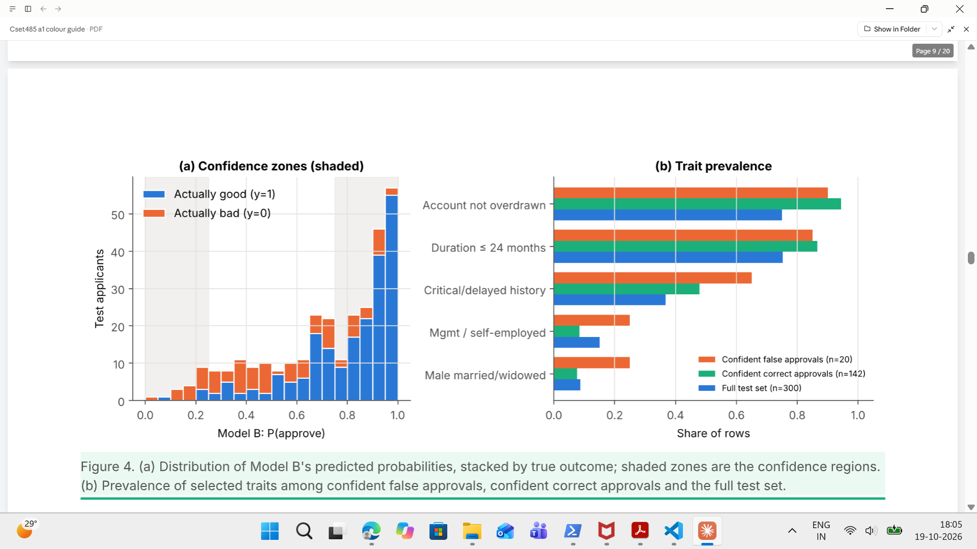
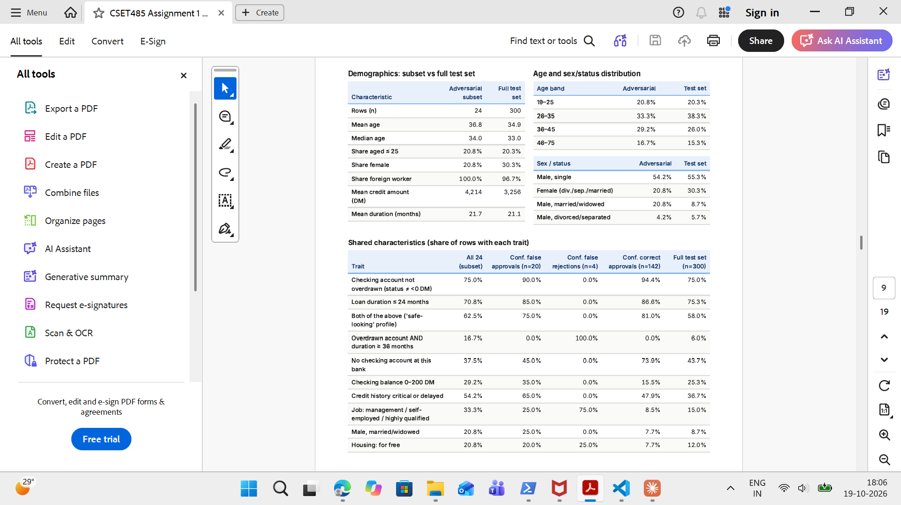
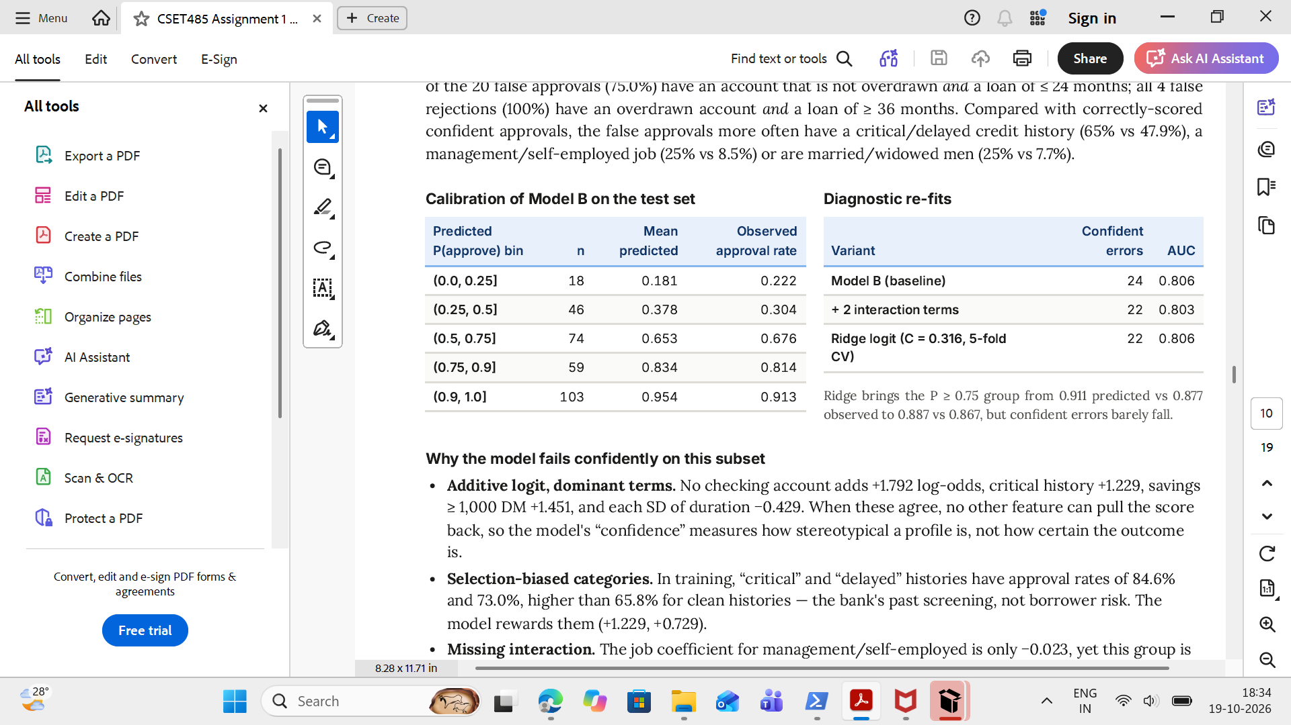

Why does the model fail on this subset?

- Additive Logit and Dominant Terms.
- Selection bias in Historical Categories.
- Missing Features Interaction.
- Overfitting and Overconfidence.

2.4 Fairness Trade off Analysis:-
The fairness trade off analysis evaluates how to balance fairness between the demographics groups,model accuracies and financial cost when making AI decisions.

Here we are predicting the loan applicants creditworthiness using the two groups.

Young and the Old applicants we get divided into.

Types of the important fairness metrics:-

:-Accuracy
:-Demographics Parity
:-Equalized Odds
:-Predictive Parity
:-Cost per Applicant

2. Decision threshold:-

A decision threshold will convert the predicted probabilities into the accepting and the rejecting.

At t=0.65 applicants are predicted to be good credit risks with the probability of 0.65 approved.

When we change the threshold there will be a direct effect on the accuracy,cost,approval rates,fairness etc.

3. Why is Perfect Fairness Difficult:-

We have the 2 risk-base rate 54.1 for the young and the 74.1 for the older applicants. So when we change the base rate the demographic parity,equalized odds, and the predictive parity is not at all achievable in one go simultaneously.

Conclusion:-

So in this very assignment what we have got is the t=0.65 as the practical balance between the fairness,uncertainty, and the consequences of the incorrect decisions.

Part 3:- Descriptive Analysis Questions:-

Q1. Why did the threshold-based (OLS-median) and logistic (0.5) approaches flag different individuals?

Solution:-

What we have observed in the whole assignment is that the every 86 out of the 100 applicants will triggered in a disagreement 28.67% it is that level and what is shocking is that it is not depends on the how we rank them it is depending on the how we rank them but it will depends on the whether they are crossing that particular line or not.

The thresholds are the real culprits for these:-

Let me explain how they are:-

For the modals A we have the 0.722 the model will hover around this is higher than the logistic cut off of the 0.5.Because of this we have the genuinely high number of the applicants who are at the high credit risks that is actually at a level of the above in the 70 per cent out OLS who is follower of the median rule will eventually flag half of them.
But our model B is using in the Logistic as the model which is using the 0.5 as the cut off limit therefore we have the it sat exactly at the 21.3th per-centile of the predicted probabilities.
So what we have observed is that the 78.7 around it got the green flag by allowing it to go.The misclassify group will lie in between these 2 cutoffs by the 2 models.

The most of the problems in the 2 i.e the conflict in the came in from the threshold choice and not the model approach what we are choosing. We have the Spearman's correlation which stood at 0.992 and the Test AUC which stood at 0.806.

When we used in both 0.5 the number drops from 12 which is when we are using their respective median to 8 .Also there is a vital issue which needed to be get covered OLS model is have the no boundedness means there is no boundary and the constrained in them there are predictions which past 1 and some of them also passed 1.30. These are the outliers and they are the vital force in the skew in the ranking. Also as the numbers suggested in the inaccuracies the threshold is the basis of the selection of the models.

Q2. The subgroup with a different effect: coefficients, intervals and the policy conclusion?

Sol2:- The classification of the group into subgroups like the male and the female is the way to see whether the coefficient like what we consider for an example like the age is actually influenced by the different groups or not whether they will hit these groups or not. The classification of the data into the 2 subgroups will show us the results which will get inside the mask when we are taking the casing of the as a whole so lot of things will go inside the pit and we are only able to see what is outside.

First we are taking in the whole group. What we found is the age coefficient will sit at the +0.138 and the p value is given as 0.092 this is a very weak positive trend which shows as the age increases the success rate of the loan approval will increase. There is one 5 per cent significance test and our tests will fail on them and now this will act as a noise and not as the signal.

Now if we now look at the case of the women what we have observed that the +0.434 and the p value drops from the 0.004 so what we are seeing that the older women have the high in the success of the loan approval and the reason of this is the what we are seeing is the approval rates from 55 climb to 81 from 19-25 age to 36-45. So there is a link of the age with the women the age factor is influencing the loan approval for the case of the women.

But for the men what we are seeing is that there p is 0.568 and there is -0.058 therefore it is not very significant in this case what we are seeing is that there is a stagnant growth in this case of the men.

Now we are pooling them but +0.479 with p value 0.0076 but there is a sharp contrast in how the age affects the men and women.

The actual reason for this is that when we pool them together there is the destruction of the median of the women 29 which is young and the men which is 35 so the relative age if the women is young. So pooling them together destroys these.
So what the lenders will look into is the not in the only the age they will in the also look at the income, and the other factors.

Q3. Omitted-variable test: dropping duration?

Sol:-

In this very project i have in the dropped the loan duration because when the duration of the loan will be longer there will be the more accumulation of the money and the more difficulty the borrower have to face to repay in the loan so in the case of the our logistic regression model we have stripped off this to check in how will the other factors will influence the loan approval and it will in check 1,000 applicants.

The change what we have seen is the log credit amount coefficients where we have observed that the for the full model we have the -0.179 and for the p=0.205 and after we have removed the duration from it what we have seen is the p become in the significant and the coefficient changes to -0.499 so this tells us that there is some wrong judgements when we are removing in the loan duration period.

Why it is so is that there is a strong correlation in the loan duration and the credit amount 0.641 so when we are removing it there is a risk of the omitted-variable bias so the other factors become more influential or less.

So there is a non uniform effect if there is negative going of the installment rate coefficient. Age and the existing credits changed moderately and the accounts status and the credit history do not change.

But there is a very low AUC decrease from the 0.830 to 0.825. This means it cannot distinguish between the bad and the good credits.

So even when we remove the insignificant coefficients our capacity of the model in determining the approvals do not change much but we must not remove the significant coefficients.

Q4. How would I detect a hidden confound I cannot currently see?

SOl 4:-

A hidden cofounder is missing from the dataset so it will influence both the things both the predictor and the outcome. So it will make the results of the model misleading so we are not able to see this factor directly but we can see whether it changes the model results directly or not.

Earlier what we have seen is the we have observed that the loan duration is the one of the hidden factor and it was also one of the very much important factor in the there so when we have tried to remove it what we have seen is that there is a change in the coefficient by the term of the 0.32 therefore leaving out the important variable can change the result significantly and also our next goal is to find in the next set of the hidden coefficients.

So the credit experts other than the age and the loan duration must also see the other factors such as the income of the person and the debt to the credit ratio, interest rates and as well as the existing debts.These factors will affect whether a person is able to repay the loan or not.

So now i am going to collect the mas 1000 more peoples data and now i am going in to record and take in the important information like other variables from their interest and income and use them in our model and now we will see whether is is influencing our result or not like the age and whether the age will determine them or not. But there is now a problem of privacy and we should also maintain them. It may be also possible there may be the appearances of the more hidden factors.

So the cofounders are the things that cannot always be identified and now we have the testing of the models, the comparisons of their results and that can help us to lead to them and how they are influencing our model but in a way they are hidden from other things.

Q5. The adversarial subset and why the model fails confidently?

In this scenario what we are doing is we are try to incorporated in the principles of the adversarial like of the RAG we are using where we have something like the discriminator and the generator and they will try to fool into each other and what we will try to have in the a equilibrium level where we have the both will perform better.

Now here we have made a set of the 24 applicants that will make up 8 per cent of our test data i.e the for these our models will make up the incorrect predictions where we have in spite of having high confidence. There are the 20 false approvals there we have the despite in the having the high chances and the probabilities of the approvals the model do not approved and we have the 4 cases of the false rejections means they have the very much less chances of the repay of their loan but they somehow repaid their loan despite the approval probabilities that are predicted for them are very much less and are very much minute.

There is a particular key thing that can be noticed in these kinds of applicants in their loan duration and the loan account status. There are 15 accounts where what we found out that their accounts were not overdrawn and there is also the loan duration of them is less than 24 months or less all these 4 false rejections had in the overdrawn accounts and the duration of the loans are more than the 36 months so the features are influencing the choices of our model and these features will in the influence the choice.

Also during the training time the model will learn from the past history of the data of the applicants if they have the critical history or delay rate but when in the training they have the high approval rate so our model will in the consider them as the low risks fellows even later on they are the ones who are the defaulters.

Q6. What does the fairness trade-off cost mean for real people?

Sol 6- The fairness trade off will influence in the people in very different way like for example consider the case of the mia who is 23 years old and the klaus who is having the age of the 41 both are in the state to repay in their loans but their power to repay in the loans and what we can say that their chance will in the entirely will depends on the bank rules what is the limit that the bank is setting.

When at the threshold of the 0.65 there is a minute difference of 5 between both in the approval of the loans but when the bank is creating high bar of the 0.85 to in the minimising in their loss there is a gap extends to the 18.8 between these 2 and now mia is not able to get the loan and now she is rejected.

Now the bank officers again reduced the bar to the 0.65 for making the ground not biassed and equal for everyone now what we are seeing is that there is a significant increase in the chances of the mia in the approval of the loans which was not so when the threshold was high. But there is the increase in the risk of the false approvals from 2 to 8 in percentage from approx from 7.1 to 28 so some of these newer ones are not able to repay in their loans and now there is an issue in the bank where they had the in the past suppose out of the approved ones 91 per cent are able to repay their loans but now only the 78% of them are able to do so.

So what we have seen is that there is a fairness but it is not always about the numbers now we are seeing that the what is fair for the mia is not fair for the other and it is right so that there is the increase in the interest for the others when the banks are reducing in their threshold so it depends on the financial wellness of the banks and the lending ethics and the past records also for the equal opportunities.

Q7. Defending the threshold t =0.65?

Ans : for the defence of this we need to keep the things very simple and easy and now we have to start from first. What we have seen is that there is a demographic disparity of about 0.853, like the for the young applicants we have the loan approval rate is 60.7 and for the older we have the loan approval rate of the 71.1 and this by passes the 4-5th rule which will used to check in the unfairness in the system whether the anyone is treating in the unfair way. There is also the equal opportunity ratio high between the 2 groups like for the young and the old both we had the they have the equal in the chances of having their loan approvals and the false approval rates are now also more or less is the same in the between them the predictive parity ratio is also around in the 0.807. Among the approved ones now we have to check how much percentage of them are able to repay their loan. 70.3 percent of the young people are able to repay their loan which is less than 81.1 people so all these 3 ratios are balanced and the accuracy is also 0.770 which is very close to the highest accuracy of the 0.773 and thus this threshold provides a useful balance.

But the UCI dataset gives us a very in the different image there we have seen that the threshold which are more the cost of per applicant is less compared to when the threshold is less so if a person is not able to repay the loan there is a more loss to the bank in that case compared to the ones where we have the situation where we have rejected a good applicant now this is a complex situation and it depends on the multiple factors what should we choose in that case.

Q8. Demographic parity or equalized odds for credit approval?

Sol:-
I will choose in the equalized odds against the demographic parity for the loan approval since what I have found out is that the people whether they are young or they are old if they have the same repayment of the loan rate their chances of the approval of the loans must be the same.

In the case of demographic equality what we have found out is that there is a difference in the percentage of the repayment of the loans from the both in the groups traditionally we had younger ones are less able to repay the loan than the older ones in the per-centage. Now if the bank follows the strategy to allow the approval at the same rate to both the groups what we had left is that there will be some persons who are not able to repay getting approval and the some peoples who are able are not and this will lead to a clash. And there will be issues for the banks and for the borrowers.

Now when we reduce the threshold from the 0.65 to 0.55 there is a very slight increase in the demographics parity but in the equalized odds there is a decrease and this will challenge our fairness and we can conclude that giving the equal approval rates may always support the fairness.

But when we are increasing the threshold from the 0.55 to the 0.65 there are a lot of chances that a percentage of the young population are not in the state of getting loans and therefore what we have now is that we must make a system that must be fair for everyone .

Also the past history and records of the applicants who are younger are not good and that will create more bias if we made a system that is considering the past records. So we need to look beyond.

Part 4 — Reflection: Should We Deploy This Model?

- Direct Answer:-

I will deploy this model of the loan approval only after the careful human review and after the regular check of the fairness. The model will help and assist the banks in the making of the decisions but there is also a chance of the mistakes committed by them and also there are the chances of the unequal treatment of the young and the old applicants.

- Why does the single number fail?

There is high chances that the single number do not give the full and the complete picture about a thing suppose we have an model and it is also giving very high accuracies but still we have the the bias in the young and the old population where we have many people who are from the old are not getting loans and some of the defaulters are getting from the young.

So to choose a threshold we must not look only at the mathematical in chances we must look at the very overall picture of it. When we keep our threshold high it can make the financial loss of the banks less but there will be some people who are worthy of taking in the loans but they are not in the chances of getting the loans. So the bank now has to maintain the fairness and the financial risk balance.

The main issue is that the measures of the fairness is also conflicting like in for the case the Demographic parity is giving the equal chances to both the old and the young in the approval but the equal odds is based on the concept of that there is an equal chances between the peoples who are having in the equal capability of the repayment of the loans . Therefore the model choice is not limited to only fairness.

The fourth issue is the sometimes the model can be wrong like the there can be some of the applicants who may not get a chance for their loan approval even if they have the good record and the capability while the ones who are having the bad capability and the record are able to get it and this will eventually lead to the loss of the banks profits. So the model in these scenarios are confidently wrong.

Finally the model may not include all of the important features like the for the getting in the loans we must include the income, existing debt and the record past and the terms and conditions and as well as the applicants behaviour. These are the important factors that are often ignored.

- Evidence from my analysis:-

At the threshold of the 0.65 we had the accuracy of the 0.770 compared to the accuracy of the 0.773 which is the highest. Also young applicants have the approval rate of 60.7% compared to 71.1% . I also found out some of the around 24 confidently misclassified applicants who might cause troubles. So there is a balance of all of the things the accuracy, fairness and as well as of the financial cost and all these must be considered. We should also have to check during a good period of the time all of the things where we can make in the choice on kept this or not.

- Closing Reflection:-

At last i would like to tell in that for the fully able to deploy this model what we should think is that there should be the testing and the continuous monitoring of all the things the thing is we are not dependent on one number only creating a numerical fairness will surely not able to create an effect in overall terms there are other important factors also which are needed to be considered and for the full and the vital working of this model we have to keep a human intervention also the goal is to assist the person not to replace them.

