A MINI PROJECT REPORT ON
EXPLAINABLE MULTILINGUAL LEGAL MEANING
PRESERVATION USING JUDGEBERT
Scoring, Deciding and Explaining Whether Simplified English and Hindi Legal Text Keeps Its Legal Meaning
Submitted in partial fulfilment of the requirements of the course
CSET346: Natural Language Processing
Bachelor of Technology in Computer Science and Engineering
Submitted by
No. | Name | Roll number | Role
1 | Student Name 1 | S24CSEU____ | Project Lead, Data and Annotation
2 | Student Name 2 | S24CSEU____ | NLP / Machine Learning Engineer
3 | Student Name 3 | S24CSEU____ | Evaluation, Explainability and Documentation
Project ID (PID): __
Under the guidance of:
Dr. Surabhi Solanki
Project Instructor, SCSET
School of Computer Science Engineering and Technology
Bennett University, Greater Noida
October 2026

ABSTRACT
Insurance policies, rent agreements and other legal documents are increasingly rewritten in plain language, often with the help of AI, so that ordinary citizens can understand them. A simplified sentence is useful only if it keeps the legal meaning of the original: who must do what, under which conditions, with which exceptions, by when and for how much. A single-word edit can silently reverse that meaning. In our motivating example, a faithful rewrite and a rewrite that drops the word “not” receive almost identical sentence-embedding similarity (0.85 and 0.84), although one preserves the law and the other contradicts it.
The reference paper, JUDGEBERT (EMNLP 2025), defined this task as Legal Meaning Preservation (LMP) and trained a model on 297 French insurance sentence pairs. It covers only one language and one legal domain, uses a small dataset, has no out-of-domain test and gives no explanation of its scores. This project extends it to English and Hindi and to tenancy law. We built EnHi-LMP, 320 parallel English–Hindi pairs with ten typed legal errors and 320 sanity pairs; LegalDiff, 19 bilingual legal-difference features with a rule-based explainer; and ML-JudgeBERT, a JUDGEBERT-style cross-encoder regressor that predicts an LMP score from 1 to 10, a three-way decision and an error type with a one-line rationale.
Across five experiments, generic similarity correlates weakly with legal meaning (best Pearson r = 0.37) and degrades on Hindi, while the legal-aware model reaches r = 0.60, transfers across languages (0.48–0.54) and domains (0.55–0.57), scores 0.56–0.59 on human-labelled French data without seeing any French training pair, passes both sanity checks and detects legal errors with F1 = 0.79. A transformer trained from scratch is weak on its own (r = 0.12), which motivates the planned fine-tuning of pretrained multilingual encoders (XLM-R, MuRIL). Labels in this version are rubric-based silver labels; a two-annotator protocol and toolkit are ready for the final submission.
Keywords: legal meaning preservation, text simplification, JUDGEBERT, Hindi NLP, explainable evaluation, cross-lingual transfer.

CHAPTER 1: INTRODUCTION

1.1 Background
Legal language is long, formal and full of conditions, exceptions and cross-references. In India, most people read and speak Indian languages, and Hindi alone was reported by about 52.8 crore people as their mother tongue in the 2011 Census. Plain-language versions of insurance policies, loan documents and rent agreements are therefore essential for access to justice, and AI tools are now commonly used to produce them.
The danger is that AI-generated or human-written simplifications can change the law while looking almost the same as the original. Turning “must” into “may” converts a duty into an option; removing “not” turns an exclusion into coverage; changing “7 days” into “30 days” moves a deadline. Generic similarity measures, which compare surface words or general meaning, are almost blind to these edits. A dedicated legal-meaning metric is needed, and it must work in Indian languages and explain what changed.

1.2 Problem Statement
To reliably assess whether a simplified legal sentence preserves the legal meaning of its original when the JUDGEBERT approach is extended beyond French insurance text to English, Hindi and a new legal domain, and to explain every judgement by naming the legal change and giving a short rationale.
Research question: How effectively can a JUDGEBERT-based model assess legal meaning preservation in a new language (Hindi) and a new legal domain (tenancy), and does it outperform generic semantic-similarity approaches?

1.3 Scope
- Languages: English and Hindi (Devanagari script), as parallel versions of the same clauses.
- Legal domains: insurance (motor, health, property) and tenancy (residential rent agreements).
- Data: 80 source clauses × 2 languages × 2 simplifications (one faithful, one with a single legal error) = 320 pairs, plus 320 held-out sanity pairs; FrJUDGE (French, human-labelled) for transfer.
- Outputs per pair: LMP score (1–10), decision (Preserved / Partially Preserved / Not Preserved), legal error type and a one-line explanation.
- Out of scope (this milestone): document-level context, multi-error simplifications, and fine-tuning of large pretrained encoders, which are planned next.

1.4 Report Map to the Rubric
Table 1.1: Where each rubric criterion is covered
Criterion | Section
Problem domain identification and analysis | 2.1 to 2.3
Review of existing systems and feasibility | 2.4 to 2.6, Chapter 3
Objectives and methodology | 4.1, 4.2
Relevance of algorithms and techniques | 4.3, 4.4
Synchronization of design and implementation | 5.2
Implementation and demonstration of modules | 5.3, 5.4, Chapter 6
Contribution by each team member | Chapter 9
Presentation plan | Appendix A

CHAPTER 2: PROBLEM ANALYSIS

2.1 Problem Domain Analysis
Domain: the project sits where natural language processing, legal informatics and multilingual computing meet. It treats legal meaning as a set of checkable elements (parties, duties, permissions, conditions, exceptions, amounts and time limits) rather than as general similarity.
Scale: plain-language legal content is produced for millions of policyholders and tenants, increasingly by AI. Manual legal review of every rewritten sentence does not scale, so an automatic checker is needed to flag risky rewrites for a human.
Hidden danger: the errors that matter most are the smallest. A one-word negation or modal change keeps more than 90% of the words, so both people skimming and similarity tools miss it.
Language gap: existing legal-meaning work is French-only. English-centric tools also break Hindi into single characters, which makes unrelated Hindi sentences look similar.
Table 2.1: Key figures behind the problem
Figure | Value
Embedding similarity: faithful vs contradictory rewrite (English) | 0.85 vs 0.84 (legal score 10 vs 1)
Same pair in Hindi | 0.92 vs 0.92
Size of the only legal-meaning dataset (FrJUDGE) | 297 French pairs, 5 annotators each [1]
Hindi mother-tongue speakers, Census 2011 | about 52.8 crore

2.2 Sociotechnical Analysis
1. Access to justice
Citizens sign insurance and rent contracts they cannot fully read. Simplification helps only if it is faithful; an unfaithful simplification can make people give up rights they do not know they have.
2. Mis-selling and liability
If a simplified policy says something is covered when the legal text excludes it, the customer is misled and the provider faces disputes. Automatic checks reduce this risk before documents are published.
3. Language equity
Tools that work well only in English leave Hindi readers with weaker protection. A checker must perform equally well in both languages.
4. Trust in automation
A bare score is hard to trust. Reviewers need to see which legal element changed, so every judgement must come with an explanation that a non-expert can verify.

2.3 Stakeholders
- Citizens: policyholders, tenants and borrowers
- Insurers, landlords and lenders who publish plain-language documents
- Legal reviewers and compliance teams
- Regulators and consumer-protection bodies
- Developers of AI simplification tools

2.4 Review of Existing Systems
Existing evaluation methods either measure surface overlap, measure general meaning, or (in one case) measure legal meaning only for French. None of them explains its scores in legal terms or covers Hindi.
Table 2.2: Existing systems and their gaps
System | Method | Gap for legal meaning
BLEU (2002) [2] | n-gram precision vs reference | Rewards copying; ignores a lost “not”
chrF (2015) [3] | Character n-gram F-score | Surface only; no legal awareness
SARI (2016) [4] | Add/keep/delete vs references | Measures simplicity, needs references
SBERT, BERTScore (2019–20) [5,6] | Contextual embedding similarity | “covers” ≈ “does not cover”
MeaningBERT (2023) [7] | Learned meaning regressor | General domain; no legal categories
LLM-as-judge, G-Eval (2023) [8] | Prompted LLM rating | Costly, uncalibrated, not reproducible
JUDGEBERT (2025) [1] | BERT regressor on FrJUDGE | French insurance only; no explanations

2.5 Research Gaps
- Single language: legal meaning preservation has only been studied for French.
- Single domain: only property-damage insurance is covered.
- Small data: 297 annotated pairs are too few to train or test a robust model.
- No context: sentences are judged without the surrounding document.
- No out-of-domain test: generalisation beyond the training data is unknown.
- Score only: no explanation of what changed.
- No typed legal errors: negation, modality or number changes cannot be measured separately.
- No Hindi test of generic metrics: their failure on Indian-language legal text was not measured.
- No English–Hindi legal dataset exists for this task.

2.6 Project Feasibility
Technical: all experiments run on an ordinary laptop CPU; the full E1–E5 suite completed in about 1.5 hours on two CPU cores. Pretrained encoders (XLM-R, MuRIL) can be fine-tuned on a free Google Colab T4 GPU.
Economic: the project uses only open-source software (Python, PyTorch, scikit-learn) and free compute. No paid API or licensed dataset is needed.
Risks: labels are currently rubric-based silver labels, and the dataset is small. Both are mitigated by the two-annotator protocol, augmentation, grouped cross-validation and testing on independent human-labelled French data.
Legal and ethical: the clauses are written for this project in standard contract style and contain no personal data. FrJUDGE is used under its CC BY-NC-SA 4.0 licence for non-commercial research. The system is a reviewer aid, not legal advice.
Operational: one PowerShell script sets up and trains everything on Windows, a Colab notebook runs the GPU models, and all code, data and results are versioned on GitHub.

CHAPTER 3: DATASETS
The project needed parallel English–Hindi legal sentence pairs with known legal errors, which did not exist. We therefore built EnHi-LMP and combined it with the public FrJUDGE dataset for out-of-language testing.
Table 3.1: Datasets used
Dataset | Used for | Size
EnHi-LMP – English insurance | Training and testing | 80 pairs (40 clauses × 2)
EnHi-LMP – English tenancy | Training and testing; new domain | 80 pairs
EnHi-LMP – Hindi insurance | Training and testing; new language | 80 pairs
EnHi-LMP – Hindi tenancy | Training and testing | 80 pairs
Sanity – identical pairs | Sanity check (gold 10); never trained on | 160 pairs
Sanity – unrelated pairs | Sanity check (gold 1); never trained on | 160 pairs
FrJUDGE [1] (train + dev / test) | Out-of-language transfer, human labels | 207 / 90 pairs

3.1 Construction
We wrote 80 source clauses in standard Indian insurance and rent-agreement wording and translated each into Hindi. For every clause and language we wrote one faithful plain-language simplification and one simplification with exactly one legally significant change from a ten-type taxonomy.
Table 3.2: Legal error types (EN + HI)
Error type | Example | Pairs
None (faithful) | meaning kept, wording simplified | 160
Scope change | third party → anyone | 22
Omitted condition | “if licensed” removed | 20
Date / time limit | 7 days → 30 days | 20
Modality | must → may | 16
Minor omission | non-essential detail dropped | 16
Hallucination | adds a new penalty | 16
Party swap | tenant pays → landlord pays | 16
Negation | does not cover → covers | 14
Exception removed | “except day-care” removed | 12
Number | Rs 5,000 → Rs 50,000 | 8

3.2 Labelling Rubric
Table 3.3: LMP scoring rubric (1–10)
Score | Meaning | Decision
9–10 | Identical legal effect; only wording changed | Preserved
8 | Preserved; trivial non-legal nuance lost | Preserved
6–7 | Minor secondary detail omitted | Partially preserved
4–5 | Secondary condition dropped or scope shifted | Partially / Not preserved
2–3 | Core condition, exception, number, date, party or modality changed | Not preserved
1 | Rule reversed or unrelated | Not preserved

The final split is 160 Preserved, 20 Partially Preserved and 140 Not Preserved pairs. In this version the scores are rubric-based silver labels. For the final version, two annotators score all 320 pairs independently in blinded, shuffled workbooks; differences of three points or more are adjudicated and agreement is reported with Krippendorff’s α [11].

3.3 Data Quality and Leakage Control
- Grouped splits: the English and Hindi versions of a clause and both of its simplifications always stay in the same fold, so no test clause is seen in training in either language.
- Held-out sanity sets: identical and unrelated pairs are used only for testing.
- Blind annotation: workbooks show shuffled codes, never the error type or the silver score.
- Normalisation: Unicode NFC, Devanagari digits and Indian formats (“15,00,000”, “15 lakh”) are normalised before comparison.

CHAPTER 4: REQUIREMENTS AND DESIGN OF THE PROJECT

4.1 Measurable Objectives
Table 4.1: Measurable objectives
No. | Objective | Target | Result
O1 | Build EnHi-LMP dataset | ≥ 300 pairs, 2 domains | 320 pairs + 320 sanity pairs
O2 | Benchmark generic baselines | ≥ 2 baselines | 3 baselines (best r 0.37)
O3 | Beat generic similarity | r above best baseline | r 0.60 (LegalDiff-GBR)
O4 | Transfer to new language | within 0.10 of in-language | EN→HI 0.48 vs HI→HI 0.50
O5 | Transfer to new domain | small drop | ≤ 0.06 drop (0.55 / 0.57)
O6 | Pass sanity checks | identical ≥ 9, unrelated ≤ 2 | 9.99 and 1.22
O7 | Explain each score | error-detection F1 ≥ 0.70 | F1 0.79; type correct 40%
O8 | Run without a GPU | laptop CPU | E1–E5 in about 1.5 h on 2 cores
O9 | Human double annotation | Krippendorff α ≥ 0.67 | Toolkit ready; scoring pending

4.2 Methodology
Each original–simplified pair passes through the pipeline in Figure 4.1. The pair is normalised, compared by LegalDiff and encoded jointly by the cross-encoder; the fusion head outputs a 1–10 score, the decision rule assigns a class, and the explainer names the error and writes a rationale. Models are trained offline with mean-squared error and JUDGEBERT’s identical/unrelated augmentation, and evaluated with grouped five-fold cross-validation and three random seeds.
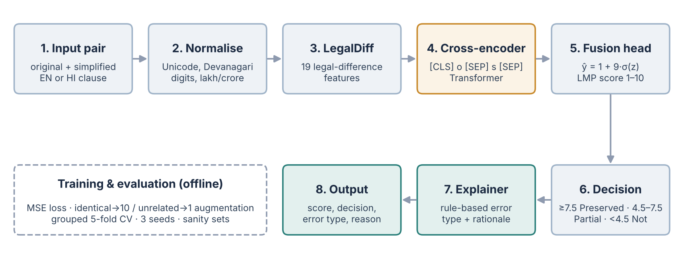
Figure 4.1: Per-pair processing pipeline

4.3 Algorithms and Techniques
Table 4.2: Techniques and why they were chosen
Task | Technique | Why
Lexical baseline | chrF | Character level, robust to Hindi inflection
Semantic baselines | Embedding cosine, BERTScore-style F1 | Standard generic similarity the brief asks us to beat
Legal signals | LegalDiff (19 features, EN/HI lexicons) | Typed, auditable evidence for each error category
Best regressor | Gradient-boosted trees on LegalDiff | Learns non-linear feature interactions from few examples
JUDGEBERT-style model | Cross-encoder Transformer + fusion head | Attention aligns the two sentences token by token
Scale anchoring | Identical → 10, unrelated → 1 augmentation | Method of the base paper; enables sanity tests
Explanations | Priority-ordered rule explainer | Turns features into an error type and a rationale
Evaluation | Grouped 5-fold CV, 3 seeds | No leakage between language twins; stable estimates

Selection protocol
All systems are compared on identical out-of-fold predictions. Baselines are calibrated to the 1–10 scale on training folds only. Hyperparameters were fixed before the final runs, every learned model is reported as the mean and standard deviation over three seeds, and test folds are never used for fitting.
Key formulas
ŷ = 1 + 9 · σ(z) (fusion head output on the 1–10 LMP scale)
Loss = (1/n) Σ (ŷᵢ − yᵢ)² (mean-squared error)
Decision: Preserved if ŷ ≥ 7.5; Partially Preserved if 4.5 ≤ ŷ < 7.5; Not Preserved if ŷ < 4.5
Pearson r = cov(ŷ, y) / (σŷ σy); RMSE = [ Σ (ŷᵢ − yᵢ)² / n ]^(1/2); F1 = 2PR / (P + R)
Krippendorff’s α = 1 − Dₒ / Dₑ (observed vs expected disagreement between annotators)

4.4 System Architecture
Figure 4.2 shows the three layers of the system: the data layer (EnHi-LMP, sanity sets, FrJUDGE and the annotation kit), the model layer (baselines, LegalDiff, ML-JudgeBERT and LegalDiff-GBR) and the evaluation layer that produces scores, explanations, result files and the project deliverables.
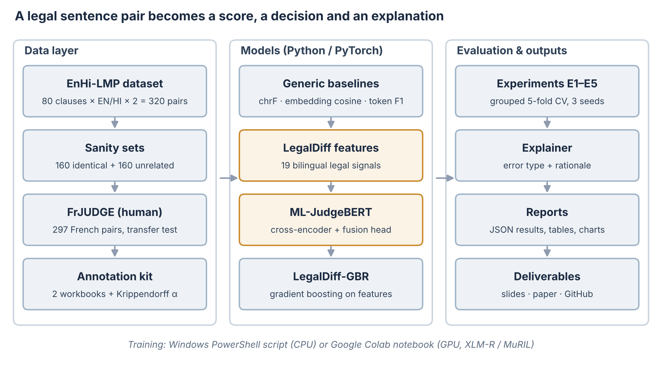
Figure 4.2: System architecture

CHAPTER 5: PROJECT IMPLEMENTATION

5.1 Tools and Technologies
The system is written in Python 3.12. PyTorch implements the cross-encoder and its training loop; Hugging Face tokenizers builds the shared English–Hindi BPE vocabulary; scikit-learn provides gradient boosting and metrics; sacrebleu computes chrF; and WordLlama supplies the static embeddings used by the generic baselines. Hugging Face Transformers is used for the pretrained XLM-R and MuRIL version.
For reproducibility, the repository includes a Windows PowerShell script that creates the environment and runs all experiments on a CPU, a Google Colab notebook for GPU fine-tuning, openpyxl-based annotation workbooks, and LaTeX and docx builders for the paper. All code, data, results and deliverables are versioned on GitHub.

5.2 Synchronization of Design and Implementation
Table 5.1: Design element, code and evidence
Design element | Code | Evidence
Dataset and sanity sets (O1) | data/*.py, src/build_dataset.py | 320 + 320 pairs
Generic baselines (O2) | src/lmp_models.py (chrf, wl_cosine, wl_tokenscore) | Table 6.1
LegalDiff + explainer (O3, O7) | src/legal_features.py | r 0.60; F1 0.79
ML-JudgeBERT (O3) | src/lmp_models.py (CrossEncoder, MLJudgeBERT) | Table 6.1
Experiments E1–E5 (O3–O7) | src/run_experiments.py, src/select_cases.py | results/*.json
Pretrained encoders | src/finetune_pretrained.py, Colab notebook | end-to-end tested
Human annotation (O9) | src/make_annotation_kit.py, src/merge_annotations.py | α script tested
One-command training (O8) | train_enhi_lmp.ps1 | tested end to end

5.3 Implemented Modules
- Dataset builder (src/build_dataset.py): assembles 320 pairs, sanity sets and FrJUDGE splits.
- LegalDiff (src/legal_features.py): bilingual legal-difference features and the rule-based explainer.
- Models (src/lmp_models.py): calibrated baselines, the ML-JudgeBERT cross-encoder and LegalDiff-GBR.
- Experiment runner (src/run_experiments.py): experiments E1–E5 with grouped cross-validation.
- Demo (src/demo.py): scores any new sentence pair from the command line.
- Annotation kit (src/make_annotation_kit.py, src/merge_annotations.py): blinded workbooks, agreement and adjudication.
- Pretrained fine-tuning (src/finetune_pretrained.py and the Colab notebook): XLM-R / MuRIL with late fusion.
- Automation (train_enhi_lmp.ps1, push_to_github.ps1): setup, training, summary and publishing on Windows.

5.4 Demonstration of the Modules
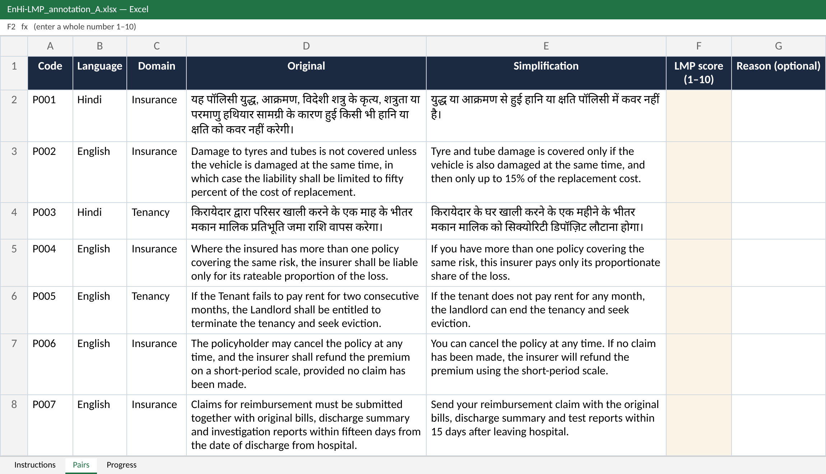
Figure 5.1: Blinded annotation workbook given to each annotator (score column F, 1–10)
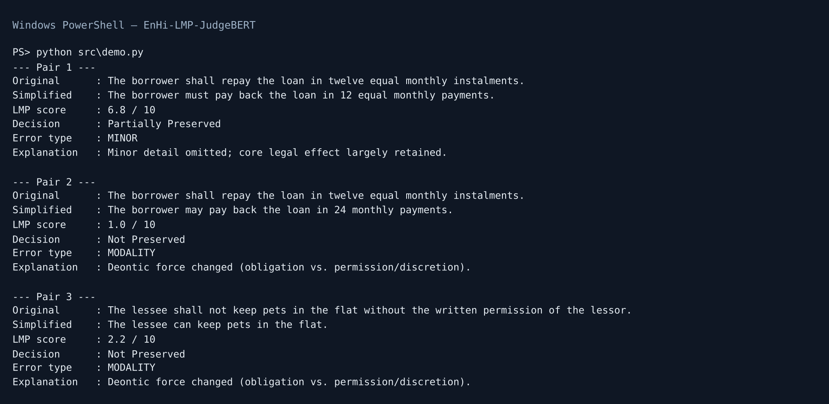
Figure 5.2: Demo scoring three new loan and lease clauses (score, decision, error type, explanation)
The demo uses clauses from a loan and a lease, a domain that is not in the training data. It correctly rejects the obligation-to-permission change (1.0/10) and the lifted pet ban (2.2/10). It scores the faithful loan rewrite only 6.8, because “instalments” → “payments” and “twelve” → “12” look like omissions to the lexicon, which shows why a pretrained encoder is the next step.
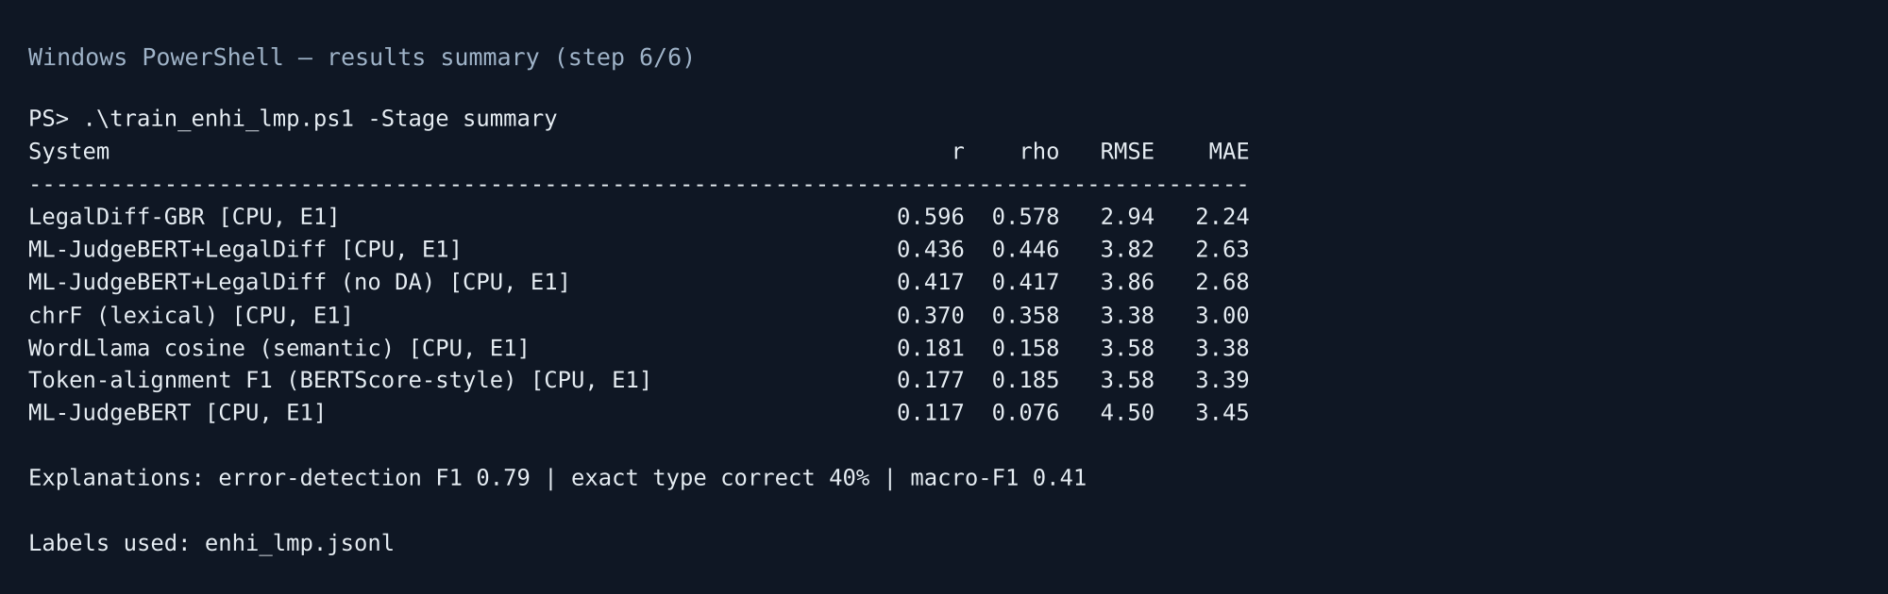
Figure 5.3: Results summary printed by the training script (step 6/6)

5.5 Testing
Testing covered the experiments and the tooling. Sanity sets test the scale ends in every run. Grouped folds were checked so that no clause appears on both sides of a split. The annotation-merging script was tested with simulated annotators (α = 0.95 on noisy copies of the labels). The pretrained fine-tuning script was tested end to end with a small local model, and the PowerShell training script was parsed and executed through the merge, fine-tune and summary stages. Every script reads and writes UTF-8 so that Hindi text is preserved on Windows.

CHAPTER 6: RESULTS AND DISCUSSION

6.1 E1 – Generic Similarity vs LMP Models
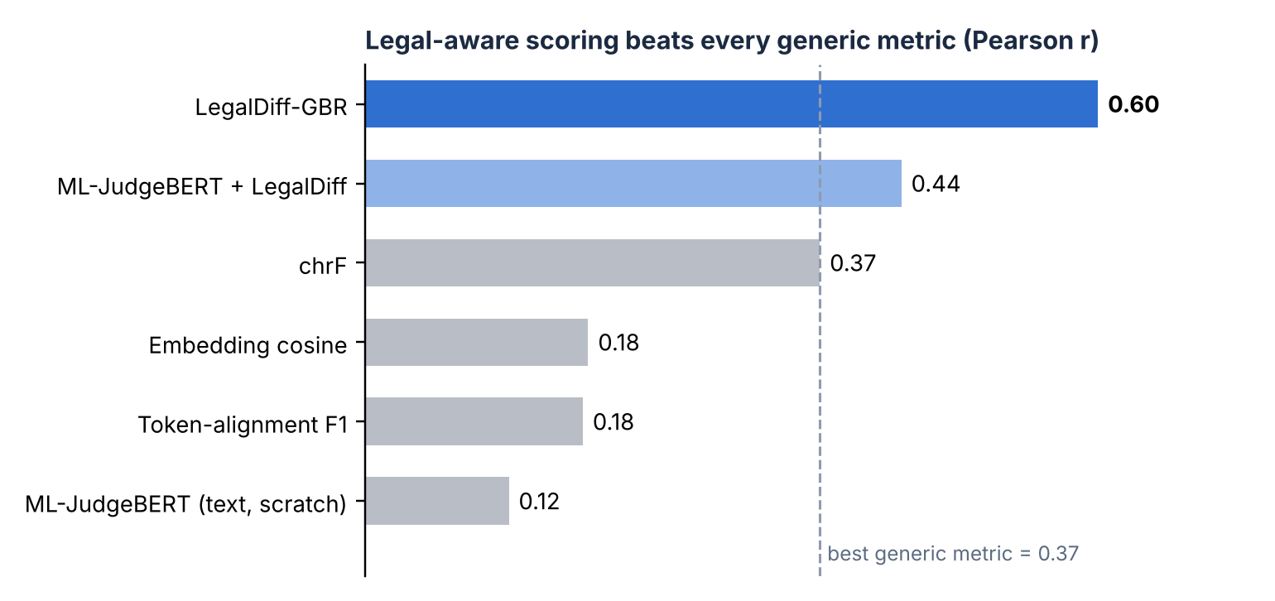
Figure 6.1: Pearson correlation with LMP labels (5-fold grouped CV, n = 320)
Table 6.1: E1 – full comparison (learned models: mean ± s.d. over 3 seeds)
System | Pearson r | Spearman ρ | RMSE | MAE | Decision F1 | NP-F1
chrF | 0.37 | 0.36 | 3.38 | 3.00 | 0.28 | 0.25
Embedding cosine | 0.18 | 0.16 | 3.58 | 3.38 | 0.06 | 0.06
Token-align. F1 | 0.18 | 0.19 | 3.58 | 3.39 | 0.04 | 0.00
LegalDiff-GBR | 0.60 ±0.01 | 0.58 | 2.94 | 2.24 | 0.53 | 0.61
ML-JudgeBERT (text) | 0.12 ±0.01 | 0.08 | 4.50 | 3.45 | 0.35 | 0.37
ML-JudgeBERT+LegalDiff | 0.44 ±0.02 | 0.45 | 3.82 | 2.63 | 0.42 | 0.46

LegalDiff-GBR is the best system on every metric. Generic metrics vary little between faithful and corrupted rewrites, so after calibration their predictions sit in the middle of the scale and rarely cross the “Not Preserved” threshold (NP-F1 ≤ 0.25). The cross-encoder trained from scratch learns little from 256 training pairs on its own (r = 0.12), but fusing LegalDiff raises it to 0.44.

6.2 E2 – English vs Hindi
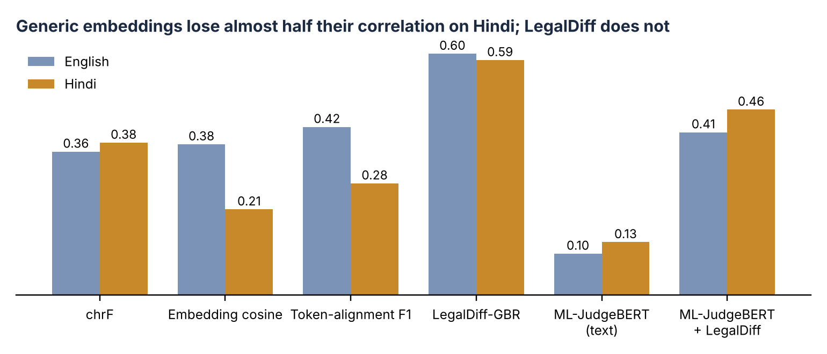
Figure 6.2: Pearson r by language
Table 6.2: E2/E3 – transfer across language, domain and to human-labelled FrJUDGE (Pearson r)
Train → test | chrF | Emb. cosine | LegalDiff-GBR | ML-JudgeBERT + LegalDiff
EN→HI | 0.39 | 0.04 | 0.48 | 0.36
HI→EN | 0.37 | 0.26 | 0.54 | 0.42
EN→EN | 0.37 | 0.35 | 0.55 | 0.39
HI→HI | 0.37 | 0.25 | 0.50 | 0.34
Ins.→Ten. | 0.40 | 0.20 | 0.55 | 0.51
Ten.→Ins. | 0.36 | 0.17 | 0.57 | 0.38
EnHi→FrJUDGE | 0.47 | -0.17 | 0.56 | 0.59
FrJUDGE→FrJUDGE | 0.47 | -0.17 | 0.60 | 0.48

Embedding similarity loses almost half its correlation on Hindi (0.38 → 0.21) because its English-centric tokenizer splits Devanagari into characters. LegalDiff-GBR is language-stable (0.60 English, 0.59 Hindi) and transfers across languages with little loss: trained on English it scores 0.48 on Hindi, and trained on Hindi it scores 0.54 on English.

6.3 E3 – New Domain and Human-Labelled French Data
Moving from insurance to tenancy, or the reverse, costs LegalDiff-GBR at most 0.06. The strongest evidence comes from FrJUDGE, whose labels are genuine human judgements: models trained only on EnHi-LMP reach r = 0.56 (LegalDiff-GBR) and 0.59 (ML-JudgeBERT + LegalDiff), while embedding cosine is negatively correlated (−0.17). Trained on FrJUDGE itself, LegalDiff-GBR reaches r = 0.60 with RMSE 1.96.

6.4 E4 – Sanity Checks
Table 6.3: E4 – mean prediction on identical (gold 10) and unrelated (gold 1) pairs
System | Identical | ≥ 9 | Unrelated | ≤ 2
chrF | 10.00 | 100% | 2.89 | 4%
Embedding cosine | 7.10 | 0% | 4.36 | 20%
Token-align. F1 | 7.15 | 0% | 5.20 | 0%
LegalDiff-GBR | 9.99 | 100% | 1.22 | 94%
ML-JudgeBERT (text) | 9.41 | 80% | 4.78 | 19%
ML-JudgeBERT+LegalDiff | 9.98 | 100% | 1.70 | 82%
ML-JudgeBERT+LegalDiff (no augmentation) | 9.92 | 99% | 1.88 | 74%

Models trained with augmentation place identical pairs at about 10 and unrelated pairs at 1.2–1.7. Embedding similarity fails both checks: identical pairs get only 7.1 after calibration, and unrelated Hindi pairs get 6.6 out of 10.

6.5 E5 – Error Analysis and Explanations
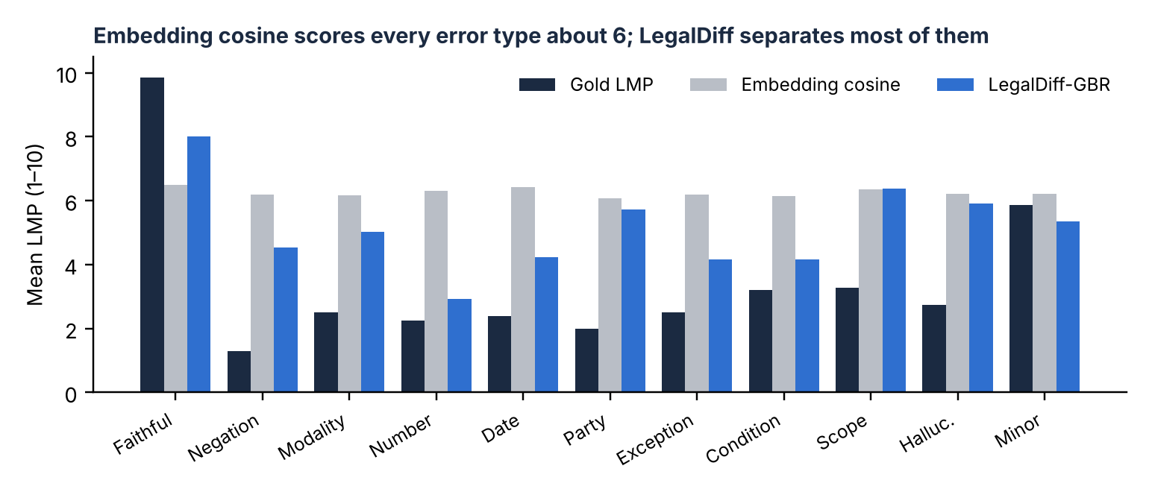
Figure 6.3: Mean predicted LMP by gold error type
Table 6.4: Explanation quality per error type (LegalDiff-GBR scores)
Type | n | Precision | Recall | F1
NONE | 160 | 0.82 | 0.69 | 0.75
SCOPE | 22 | 0.00 | 0.00 | 0.00
DATE | 20 | 0.61 | 0.55 | 0.58
OMIT_COND | 20 | 0.32 | 0.30 | 0.31
ENTITY | 16 | 0.37 | 0.81 | 0.51
HALLUC | 16 | 0.18 | 0.12 | 0.15
MINOR | 16 | 0.23 | 0.44 | 0.30
MODALITY | 16 | 0.43 | 0.56 | 0.49
NEGATION | 14 | 0.20 | 0.50 | 0.29
EXC_REMOVED | 12 | 1.00 | 0.50 | 0.67
NUMBER | 8 | 0.75 | 0.38 | 0.50

The explainer detects that a legal error is present with precision 0.74, recall 0.85 and F1 0.79, and names the exact error type for 40% of corrupted pairs (11-class macro-F1 0.41). Exceptions, dates, parties, numbers and modality are explained best; scope changes and hallucinated content are hardest because they have no single marker word.
Table 6.5: Qualitative analysis of 18 legally difficult cases (× = wrong predicted type)
# | Lang | Gold type | Legal change | Gold | chrF | Emb. | GBR | Hybrid | Predicted
1 | HI | MODALITY | “must not” use for hire unless covered → “may” use unless excluded | 1 | 6.2 | 7.1 | 4.2 | 9.2 | SCOPE×
2 | HI | ENTITY | benefit goes to nominee on policyholder's death → roles swapped | 1 | 7.6 | 7.0 | 5.2 | 6.2 | ENTITY
3 | HI | NEGATION | landlord shall not cut water/power → may cut if rent unpaid | 1 | 7.2 | 7.0 | 4.5 | 9.3 | NEGATION
4 | HI | OMIT_COND | entry after 24-h notice, 8 a.m.–8 p.m. → any time, no notice | 1 | 4.2 | 6.9 | 2.7 | 1.3 | NEGATION×
5 | HI | HALLUC | eviction only by legal procedure → after 7 days' notice | 1 | 5.0 | 6.8 | 6.0 | 1.4 | ENTITY×
6 | EN | ENTITY | benefit goes to nominee on policyholder's death → roles swapped | 1 | 8.3 | 6.5 | 7.9 | 9.9 | NONE×
7 | EN | NEGATION | “does not cover” wear and tear → “pays for” it | 1 | 8.8 | 6.1 | 8.9 | 9.9 | NONE×
8 | HI | DATE | newborn covered from 91st day → from day of birth | 2 | 5.6 | 7.1 | 5.1 | 8.1 | DATE
9 | HI | EXC_REMOVED | liable for damage, wear and tear excepted → including wear and tear | 2 | 5.7 | 7.0 | 5.4 | 5.3 | EXC_REMOVED
10 | HI | SCOPE | insurer pays rateable share → pays entire loss | 2 | 5.4 | 7.0 | 5.9 | 9.1 | MINOR×
11 | HI | NUMBER | deposit ≤ 2 months' rent → ≤ 6 months' rent | 2 | 4.9 | 6.9 | 2.3 | 1.1 | DATE×
12 | EN | DATE | six-month lock-in → three-month lock-in | 2 | 7.2 | 6.6 | 5.5 | 10.0 | DATE
13 | EN | NUMBER | deductible Rs 5,000 → Rs 50,000 | 2 | 8.4 | 6.6 | 5.3 | 9.4 | NUMBER
14 | EN | OMIT_COND | entry after 24-h notice, 8 a.m.–8 p.m. → any time, no notice | 1 | 4.6 | 5.4 | 3.5 | 1.1 | DATE×
15 | EN | HALLUC | eviction only by legal procedure → after 7 days' notice | 1 | 5.0 | 5.4 | 3.6 | 1.0 | MODALITY×
16 | EN | EXC_REMOVED | no hazardous goods except cooking gas → including cooking gas | 2 | 7.7 | 6.1 | 7.6 | 9.8 | NONE×
17 | HI | NONE | faithful: rent +5% after every 11 months | 10 | 2.0 | 6.2 | 1.8 | 5.4 | HALLUC×
18 | EN | NONE | faithful: rent +5% after every 11 months | 10 | 3.2 | 5.2 | 9.0 | 7.1 | NONE

Discussion
The results answer the research question. A model that represents legal differences explicitly captures legal meaning far better than generic similarity, in both languages, across domains and on independent human judgements. The JUDGEBERT-style cross-encoder is competitive only once it receives legal features, which is consistent with the base paper’s use of a pretrained encoder: our encoder had to learn English, Hindi and legal semantics from 256 pairs. Typical failures are polarity flips through a verb (“does not cover” → “pays for”), party swaps that keep the same role words, and faithful Hindi paraphrases that reorder the clause. The main caveat is that EnHi-LMP scores are silver labels; the FrJUDGE results, based on human labels, provide independent support.

CHAPTER 7: ETHICAL AND SOCIETAL CONSIDERATIONS
Fairness and language equity: the system is evaluated separately for English and Hindi, and the selected model performs equally in both (0.60 vs 0.59), unlike generic metrics, which are much weaker in Hindi.
Reliability: sanity checks, grouped cross-validation and three seeds guard against overconfident numbers. Out-of-domain inputs, such as the loan clauses in the demo, are a known weakness and are reported openly.
Privacy: the dataset contains template-style clauses written for the project, with no personal or client data. Real deployments should process documents locally or under a data-processing agreement.
Inclusiveness: the whole system runs on a laptop CPU with free software, so universities, legal-aid groups and small firms can use it without paid infrastructure.
Transparency: every score comes with an error type and a plain-language rationale, and all code, data and results are public on GitHub.
Accountability: the tool is a reviewer aid, not legal advice. A qualified person must approve any simplified legal text, and the decision rule is set conservatively so that risky rewrites are flagged for review.

CHAPTER 8: CONCLUSION AND FUTURE SCOPE
We extended JUDGEBERT’s legal meaning preservation task to English and Hindi and to tenancy law, built a 320-pair parallel dataset with typed legal errors and 320 sanity pairs, and developed a system that scores, decides and explains. Generic similarity is not a reliable legal-meaning metric (r ≤ 0.37). Explicit bilingual legal-difference modelling gives the strongest and most transferable signal: r = 0.60 on our data, 0.56–0.59 on human-labelled French data without French training, and error-detection F1 = 0.79 with readable explanations.
Future scope
- Complete double human annotation of all 320 pairs, report Krippendorff’s α and re-run all experiments on human labels.
- Fine-tune pretrained multilingual encoders (XLM-R, MuRIL) on a GPU using the ready Colab notebook.
- Test on real AI-generated simplifications that may contain several errors at once.
- Add document context so that clauses can be judged against definitions and exceptions elsewhere in the contract.
- Extend to more Indian languages (Bengali, Tamil, Marathi) and domains (loans, employment, consumer law).

CHAPTER 9: CONTRIBUTION BY EACH TEAM MEMBER
Table 9.1: Roles and contributions
Member | Role | Work done | Enrollment No.
Student Name 1 | Project Lead, Data and Annotation | Scope, planning, clause writing, Hindi translation, rubric, annotation kit, GitHub, demo | S24CSEU____
Student Name 2 | NLP / ML Engineer | Baselines, LegalDiff features, ML-JudgeBERT, training scripts, pretrained fine-tuning | S24CSEU____
Student Name 3 | Evaluation and Documentation | Experiments E1–E5, error analysis, explanations, paper, slides, report | S24CSEU____

REFERENCES
[1] D. Beauchemin, M. Albert-Rochette, R. Khoury, and P.-L. Déziel, “JUDGEBERT: Assessing legal meaning preservation between sentences,” in Proc. EMNLP, 2025, pp. 92–118. Code and data: github.com/GRAAL-Research/JUDGEBERT.
[2] K. Papineni, S. Roukos, T. Ward, and W.-J. Zhu, “BLEU: A method for automatic evaluation of machine translation,” in Proc. ACL, 2002, pp. 311–318.
[3] M. Popović, “chrF: Character n-gram F-score for automatic MT evaluation,” in Proc. WMT, 2015, pp. 392–395.
[4] W. Xu, C. Napoles, E. Pavlick, Q. Chen, and C. Callison-Burch, “Optimizing statistical machine translation for text simplification,” TACL, vol. 4, pp. 401–415, 2016.
[5] N. Reimers and I. Gurevych, “Sentence-BERT: Sentence embeddings using Siamese BERT-networks,” in Proc. EMNLP-IJCNLP, 2019, pp. 3982–3992.
[6] T. Zhang, V. Kishore, F. Wu, K. Q. Weinberger, and Y. Artzi, “BERTScore: Evaluating text generation with BERT,” in Proc. ICLR, 2020.
[7] D. Beauchemin, H. Saggion, and R. Khoury, “MeaningBERT: Assessing meaning preservation between sentences,” Frontiers in Artificial Intelligence, vol. 6, 2023.
[8] Y. Liu, D. Iter, Y. Xu, S. Wang, R. Xu, and C. Zhu, “G-Eval: NLG evaluation using GPT-4 with better human alignment,” in Proc. EMNLP, 2023, pp. 2511–2522.
[9] A. Conneau et al., “Unsupervised cross-lingual representation learning at scale,” in Proc. ACL, 2020, pp. 8440–8451.
[10] S. Khanuja et al., “MuRIL: Multilingual representations for Indian languages,” arXiv:2103.10730, 2021.
[11] K. Krippendorff, Content Analysis: An Introduction to Its Methodology, 4th ed. Thousand Oaks, CA: SAGE, 2018.
[12] Office of the Registrar General & Census Commissioner, India, “Census of India 2011 – Language: Statement 1, Abstract of speakers’ strength of languages and mother tongues,” 2018.

APPENDIX A: PRESENTATION PLAN
Table A.1: 10-slide presentation (about 11 minutes)
Slide | Content | Time
1 | Title, team, three headline results | 0.5 min
2 | Problem domain and the one-word example | 1 min
3 | Error taxonomy and formal task definition | 1 min
4 | Review of existing systems and research gap | 1 min
5 | Base paper, gaps → extensions, research question, objectives | 1 min
6 | Methodology: data, model, training | 1.5 min
7 | Algorithms and evaluation metrics | 1 min
8 | E1 results and per-language results | 1.5 min
9 | E2–E4: transfer, FrJUDGE and sanity checks | 1 min
10 | E5 explanations, conclusion and next steps | 1.5 min

Appendix B: How to Reproduce
git clone https://github.com/udbhav968-creator/NLP_RESERACH_WORK.git
cd NLP_RESERACH_WORK
Set-ExecutionPolicy -Scope Process -ExecutionPolicy Bypass -Force
.\train_enhi_lmp.ps1 -Stage cpu # experiments E1–E5 on CPU
python src\demo.py "<original>" "<simplified>" # score any pair
# GPU: open ML_JudgeBERT_pretrained_Colab.ipynb in Google Colab (T4) and Run all

