CSET 346 · NATURAL LANGUAGE PROCESSING · MILESTONE 1
Explainable Multilingual Legal Meaning
Preservation Using JUDGEBERT
Slide-by-Slide Explanation and Technical Terms Guide
Companion to the presentation LMP_Milestone1_v2.pptx (10 slides, v2 results)
Item | Details
Team | Student Name 1 · Student Name 2 · Student Name 3
Project ID | PID-__
Evaluators | Dr. Surabhi Solanki · Dr. Ankur
Review slot | Lab BLA-211-B · 14 October 2026, 10:00 AM
Code | github.com/udbhav968-creator/NLP_RESERACH_WORK
School of Computer Science Engineering and Technology · Bennett University · October 2026

How to use this guide
For every slide this guide gives, in order: (1) an image of the slide; (2) the purpose of the slide; (3) an explanation of everything on the slide, element by element, in the order you would point to it; (4) the key message to say aloud; (5) likely evaluator questions with short answers; and (6) a table of the technical terms used on that slide, with a plain meaning and how the term is used in our project.
All numbers are the v2 results (after our own code review and full re-run of experiments E1–E5). Labels are rubric-based silver labels; FrJUDGE results use the base paper’s human labels.

Contents
Slide | Title | Time | Terms
1 | Title slide — what the project is | 30 seconds | 13
2 | Problem domain: plain-language law | 1 minute | 10
3 | Problem analysis and task formulation | 1 minute | 13
4 | Review of existing systems | 1 minute | 14
5 | Base paper, research gaps and objectives | 1 minute | 12
6 | Methodology: data, model and training | 1.5 minutes | 21
7 | Relevance of algorithms and evaluation metrics | 1 minute | 13
8 | E1: legal-aware models beat generic metrics | 1.5 minutes | 12
9 | E2–E4: transfer and sanity checks | 1 minute | 11
10 | E5: error analysis, explanations, conclusion | 1.5 minutes | 10

Numbers to remember
What | Value | Where
Dataset size | 320 pairs = 80 clauses × EN/HI × (faithful + 1 error); + 320 sanity pairs | Slides 1, 6
Best model vs best generic metric (Pearson r) | LegalDiff-GBR 0.60 vs chrF 0.37 | Slides 1, 8
Best model by language | English 0.63 · Hindi 0.56 | Slide 8
JUDGEBERT-style encoder (from scratch) | 0.12 alone → 0.49 with LegalDiff | Slides 8, 10
Cross-lingual (LegalDiff-GBR) | EN → HI 0.52 · HI → EN 0.60 | Slide 9
Cross-domain (LegalDiff-GBR) | Insurance → tenancy 0.57 · Tenancy → insurance 0.51 | Slide 9
Human-labelled French (FrJUDGE) | Zero-shot 0.61 (GBR), 0.60 (hybrid); in-language 0.56 | Slides 1, 9
Sanity checks (LegalDiff-GBR) | Identical 10.00 · Unrelated 1.18 (embedding: 7.10 / 4.36) | Slide 9
Explanations | Detection F1 0.79 · type correct 42% · macro-F1 0.44 | Slide 10
Decision thresholds | Preserved ≥ 7.5 · Partial 4.5–7.5 · Not preserved < 4.5 | Slide 3

Slide 1 · Title slide — what the project is
Speaking time: 30 seconds
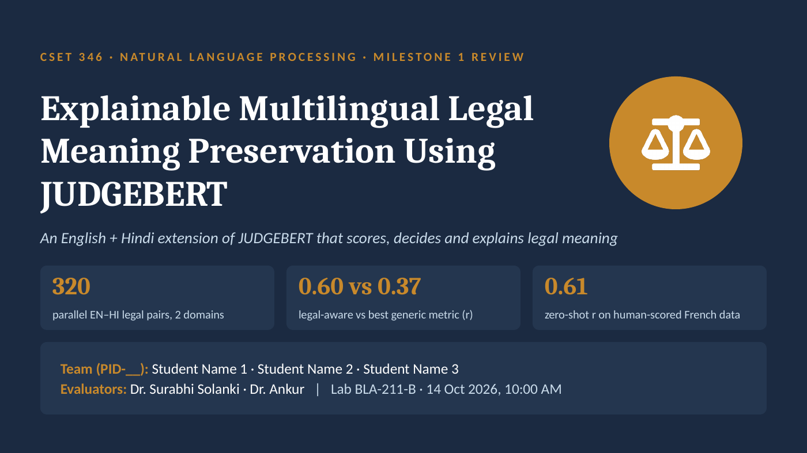
Figure 1. Slide 1 as presented
Purpose of this slide
Introduce the project in one sentence and show the three numbers that prove it works, before any detail.

Explanation of slide 1
Course banner
“CSET 346 · Natural Language Processing · Milestone 1 Review” tells the evaluators which course and which review this is. Milestone 1 covers problem identification, review of existing systems, feasibility, objectives, methodology and relevance of algorithms.
Project title
Explainable Multilingual Legal Meaning Preservation Using JUDGEBERT. Each word has a job:
- Legal Meaning Preservation (LMP) — when a legal sentence is rewritten in simpler words, does it still create exactly the same rights, duties, conditions and limits?
- JUDGEBERT — the base paper (EMNLP 2025). It built the first neural metric that scores LMP on a 1–10 scale, but only for French insurance text.
- Multilingual — we extend it to English and Hindi (Devanagari script).
- Explainable — our system does not stop at a number; it also gives a decision (Preserved / Partially / Not preserved), the type of legal error and a one-line reason.
Subtitle
“An English + Hindi extension of JUDGEBERT that scores, decides and explains legal meaning” — the three verbs are the three outputs of our system: a score (1–10), a decision (three classes) and an explanation (error type + reason).
Three headline numbers (KPI tiles)
- 320 — the size of our new dataset, EnHi-LMP: 80 legal clauses (40 insurance, 40 tenancy) × 2 languages (English and its parallel Hindi version) × 2 simplifications (one faithful, one with exactly one legal error) = 320 scored pairs.
- 0.60 vs 0.37 — Pearson correlation with the LMP labels. Our legal-aware model (LegalDiff-GBR) reaches 0.60; the best generic similarity metric (chrF) reaches only 0.37. Higher is better; 1.0 would be perfect agreement.
- 0.61 — the strongest evidence. We trained only on our English–Hindi data and tested on the French FrJUDGE test set, which was scored by human annotators in the base paper. The model never saw a French training pair (“zero-shot”) and still reached r = 0.61.
Team and evaluator box
Shows the team, Project ID, evaluators (Dr. Surabhi Solanki, Dr. Ankur), lab BLA-211-B and the slot (14 Oct 2026, 10:00 AM). Replace “Student Name 1/2/3” and “PID-__” with real names and the project ID before presenting.
Key message to say
We measure whether simplified legal text keeps its legal meaning, in English and Hindi, and explain what changed. Our legal-aware model clearly beats generic similarity (0.60 vs 0.37) and even works on human-scored French data (0.61).

Likely evaluator questions
Q. Why is this an NLP problem and not just a legal one?
Deciding whether two sentences have the same legal effect is a semantic text-pair task, like paraphrase detection or machine-translation evaluation, but with legal categories (duties, conditions, numbers). It needs tokenisation, cross-lingual representation and learned scoring — core NLP.
Q. What does 0.61 on FrJUDGE prove?
That what our model learned from English and Hindi transfers to a third language with genuine human labels. It is independent evidence, because our own labels are rubric-based silver labels.

Slide 1 · technical terms
Technical term | Meaning in plain words | How it is used in our project
NLP (Natural Language Processing) | Computer methods for understanding and generating human language. | The whole project: comparing two legal sentences automatically.
Legal Meaning Preservation (LMP) | Whether a rewritten legal text keeps the same legal effect as the original. | Scored 1 (meaning destroyed) to 10 (identical legal effect).
JUDGEBERT | A BERT-based model from EMNLP 2025 that predicts the LMP score for French insurance text. | Our base paper; we extend it to English, Hindi and tenancy law.
EMNLP | Empirical Methods in Natural Language Processing — a top international NLP conference. | Venue of the base paper (2025).
Text simplification | Rewriting text in easier words and shorter sentences for non-experts. | The rewritten versions of legal clauses we evaluate.
Multilingual / Devanagari | Working in more than one language / the script used to write Hindi. | English + Hindi; Hindi text uses Devanagari, including Hindi digits (०–९).
Parallel pairs | The same content prepared in two languages, one-to-one. | Every English pair has an equivalent Hindi pair (same clause, same error).
Domain | The subject area of the text. | Two legal domains: insurance policies and tenancy (rent) agreements.
Pearson correlation (r) | How strongly two lists of numbers rise and fall together; −1 to +1. | Agreement between predicted and true LMP scores; our headline metric.
Generic metric | A similarity score not designed for law (e.g. chrF, embeddings). | The baselines we must beat (best: chrF, r = 0.37).
Zero-shot | Testing on a language or domain with no training examples from it. | Trained on English+Hindi, tested on French: r = 0.61.
FrJUDGE | The French dataset of the base paper: 297 insurance pairs, each scored by 5 human annotators. | Our independent, human-labelled test of transfer.
Explainable (XAI) | A system that can say why it gave its output. | We output an error type and a one-line reason with each score.

Slide 2 · Problem domain: plain-language law
Speaking time: 1 minute
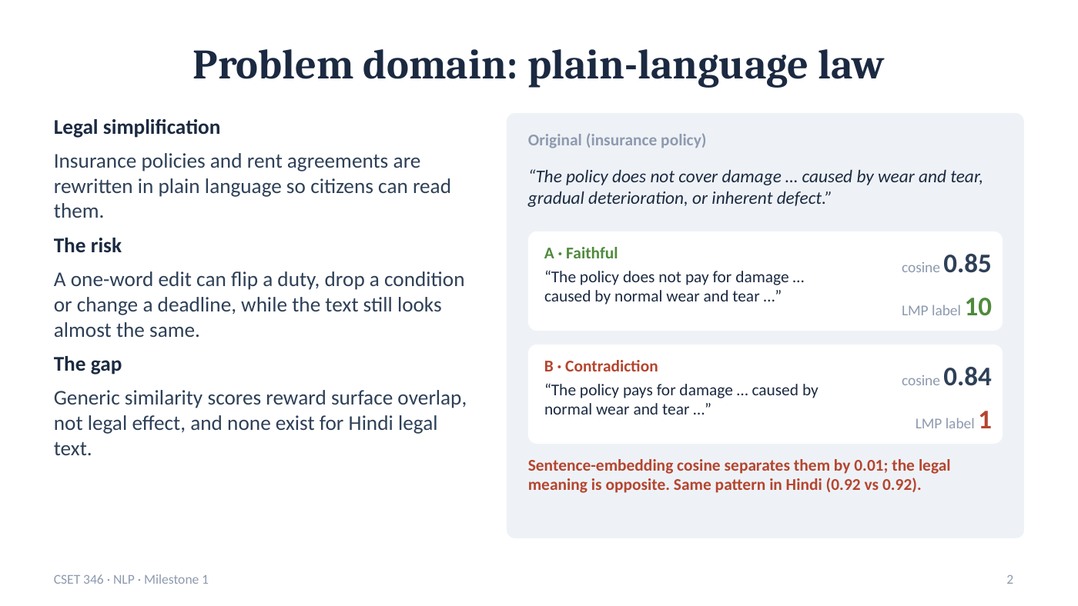
Figure 2. Slide 2 as presented
Purpose of this slide
Show, with one real example, why the problem matters and why existing similarity scores cannot solve it.

Explanation of slide 2
Left column — Legal simplification
Insurers, landlords, banks and government bodies increasingly rewrite contracts and policies in plain language, often with AI tools, so that ordinary citizens can understand them. In India this matters even more because many readers are more comfortable in Hindi than in formal legal English.
Left column — The risk
A one-word edit can flip a duty (“must” → “may”), drop a condition (“if licensed”), or change a deadline (“7 days” → “30 days”). The rewritten sentence still looks almost the same, so a reader — or a reviewer — may not notice that their rights have changed.
Left column — The gap
Generic similarity scores reward surface overlap (shared words, similar topic) rather than legal effect. No such checker exists for Hindi legal text at all.
Right side — the worked example
Original (insurance exclusion): “The policy does not cover damage … caused by wear and tear, gradual deterioration, or inherent defect.” This is an exclusion clause: the insurer will not pay for this kind of damage.
A · Faithful (“does not pay for damage … caused by normal wear and tear …”) keeps the exclusion. LMP label = 10.
B · Contradiction (“pays for damage … caused by normal wear and tear …”) removes one word and turns the exclusion into coverage — the opposite legal meaning. LMP label = 1.
Yet the sentence-embedding cosine similarity is 0.85 for A and 0.84 for B — a difference of only 0.01. In Hindi the two versions both get 0.92. This single example is the motivation of the whole project.
Key message to say
Similarity is not meaning. A generic score sees A and B as almost identical, while legally they are opposites. We need a metric that understands legal effect, in English and in Hindi.

Likely evaluator questions
Q. Is this example real or constructed?
It is a real pair from our EnHi-LMP dataset (clause INS06). The cosine values were computed with the same embedding model used as a baseline in our experiments.
Q. Why not just ask an LLM?
LLM judges are costly, not reproducible (outputs vary run to run), not calibrated to a fixed scale, and weaker on Hindi legal text. We include LLM-as-judge in the review of existing systems (slide 4).

Slide 2 · technical terms
Technical term | Meaning in plain words | How it is used in our project
Plain-language law | Movement to write legal documents in simple, readable language. | The setting that creates our simplification pairs.
Exclusion clause | A clause that lists what an insurance policy does not cover. | The example clause; removing “not” turns an exclusion into coverage.
Wear and tear / inherent defect | Damage from normal use over time / a fault present from manufacture. | Typical exclusions in insurance policies.
LLM (Large Language Model) | A very large neural model trained on text, e.g. GPT-style models. | Often used to simplify legal text — the risk we check for.
Sentence embedding | A vector (list of numbers) representing the meaning of a sentence. | WordLlama embeddings form one of our baselines.
Cosine similarity | The angle-based similarity of two vectors; 1 = same direction. | 0.85 vs 0.84 for the faithful and the contradictory rewrite.
WordLlama | A light multilingual embedding model derived from Llama-2 token vectors. | Used for the embedding-cosine and token-alignment baselines.
LMP label | The reference score (1–10) for how well legal meaning is preserved. | A = 10, B = 1 in the example.
Surface overlap | How many words or characters two texts share. | What generic metrics mostly measure, and why they fail here.
Faithful vs contradiction | A rewrite with the same legal effect vs one with the opposite effect. | Each clause has one faithful and one erroneous simplification.

Slide 3 · Problem analysis and task formulation
Speaking time: 1 minute
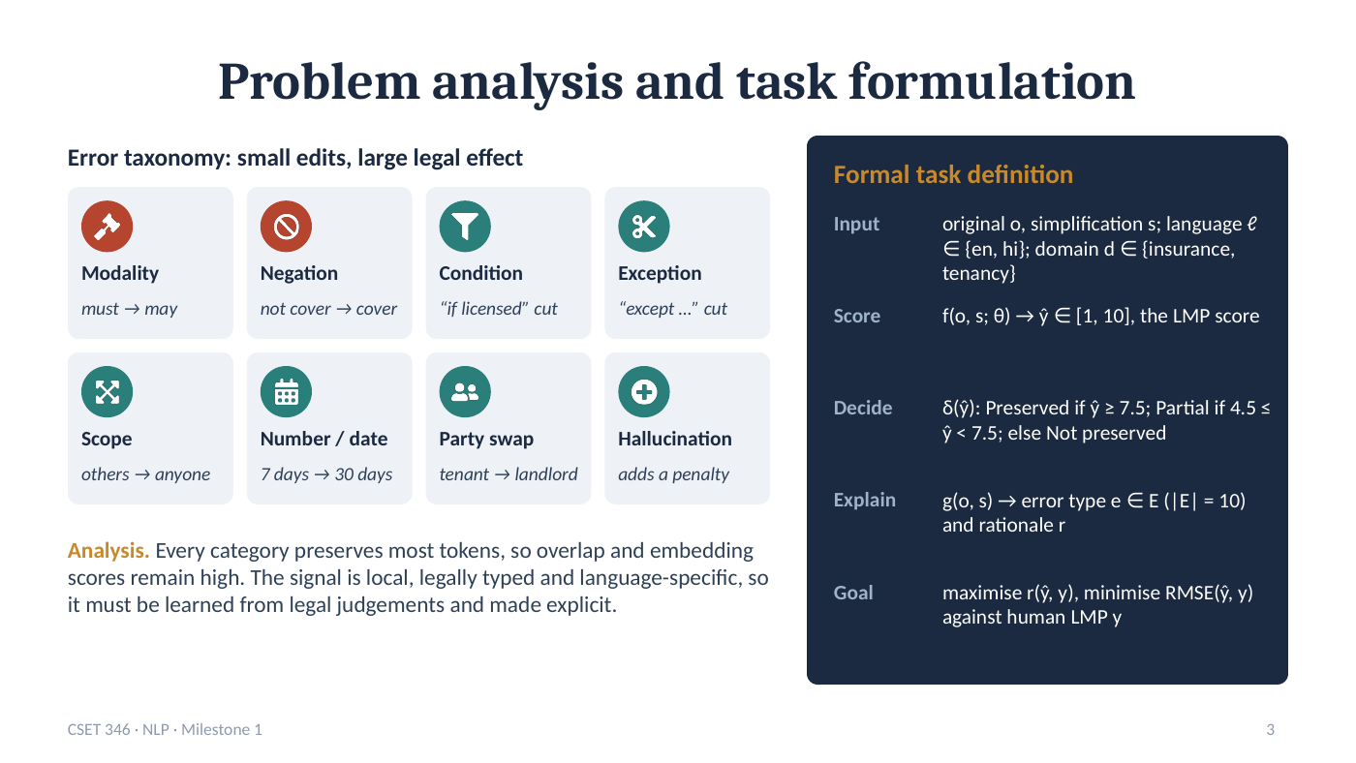
Figure 3. Slide 3 as presented
Purpose of this slide
Analyse how legal meaning gets lost (error taxonomy) and define the task precisely as inputs, outputs and a goal.

Explanation of slide 3
Error taxonomy: small edits, large legal effect (eight cards)
Each card is one way a simplification can change legal meaning, with a short example:
- Modality (must → may): an obligation becomes a permission.
- Negation (not cover → cover): the rule is reversed.
- Condition (“if licensed” cut): a condition is dropped, so the rule applies more widely.
- Exception (“except …” cut): a carve-out disappears, widening the rule.
- Scope (others → anyone): who or what the rule covers changes.
- Number / date (7 days → 30 days): amounts, limits or deadlines change.
- Party swap (tenant → landlord): rights or duties move to the wrong party.
- Hallucination (adds a penalty): the rewrite invents content that is not in the original.
In the dataset these become 10 labelled error types: NEGATION, MODALITY, NUMBER, DATE, OMIT_COND, EXC_REMOVED, SCOPE, ENTITY (party), HALLUC and MINOR (a harmless omission), plus NONE for faithful pairs.
Analysis box
Every category keeps most of the original words, so word-overlap and embedding scores stay high. The signal is local (one word or number), legally typed (we know which category it is) and language-specific (Hindi expresses negation and obligation differently from English). So it must be learned from legal judgements and made explicit — that is why we design the LegalDiff features.
Formal task definition (dark card)
- Input: an original sentence o and its simplification s; the language ℓ is English or Hindi; the domain d is insurance or tenancy.
- Score: a function f with learned parameters θ maps (o, s) to a predicted score ŷ between 1 and 10.
- Decide: a decision rule δ turns ŷ into a class — Preserved if ŷ ≥ 7.5, Partially preserved if 4.5 ≤ ŷ < 7.5, Not preserved if ŷ < 4.5.
- Explain: a function g returns the error type e from the set E of 10 types, and a short rationale r.
- Goal: make predictions agree with the labels — maximise the correlation r(ŷ, y) and minimise RMSE(ŷ, y).
Key message to say
Legal errors are small edits with large effects. We define the task as score → decide → explain, and we judge success by correlation and error against the labels.

Likely evaluator questions
Q. Where do the thresholds 7.5 and 4.5 come from?
They split the 1–10 scale into three bands that match the rubric anchors: 8–10 means the legal effect is kept, 5–7 means a secondary detail is lost, and 1–4 means a core rule changed. They are fixed before any experiment.
Q. Why ten error types and eight cards?
The slide merges number and date into one card and leaves out MINOR (harmless omission) for space. The dataset and the explainer use all ten types.

Slide 3 · technical terms
Technical term | Meaning in plain words | How it is used in our project
Error taxonomy | A structured list of error categories. | Our 10 legal error types, derived from the project brief.
Modality (deontic) | Words that express obligation, permission or prohibition (shall, must, may). | MODALITY errors: “must” → “may”.
Negation / polarity | Words that reverse meaning (not, never, नहीं) / whether a statement is positive or negative. | NEGATION errors reverse a rule.
Condition | A requirement that must hold for the rule to apply (if, unless, provided that). | OMIT_COND: a condition is dropped.
Exception / carve-out | Words that exclude certain cases from a rule (except, other than). | EXC_REMOVED: the carve-out disappears.
Scope / quantifier | Words that set how widely a rule applies (any, all, only). | SCOPE errors widen or narrow the rule.
Party / entity | The person or organisation that has the right or duty. | ENTITY errors swap tenant and landlord, insurer and insured.
Hallucination | Content in the output that is not supported by the input. | HALLUC: the rewrite adds a new duty or penalty.
f(o, s; θ) | A scoring function of the two sentences with learned parameters θ (theta). | Our model; θ are the weights learned in training.
ŷ (y-hat) / y | The predicted value / the true (reference) value. | Predicted vs labelled LMP score.
δ (delta) decision rule | A function that converts a score into a class using thresholds. | ≥ 7.5 Preserved, 4.5–7.5 Partial, < 4.5 Not preserved.
Rationale | A short human-readable reason for an output. | e.g. “Time limit changed: 6 → 3.”
RMSE | Root mean squared error: typical size of a prediction error, in score points. | Lower is better; our best model has 2.96.

Slide 4 · Review of existing systems
Speaking time: 1 minute
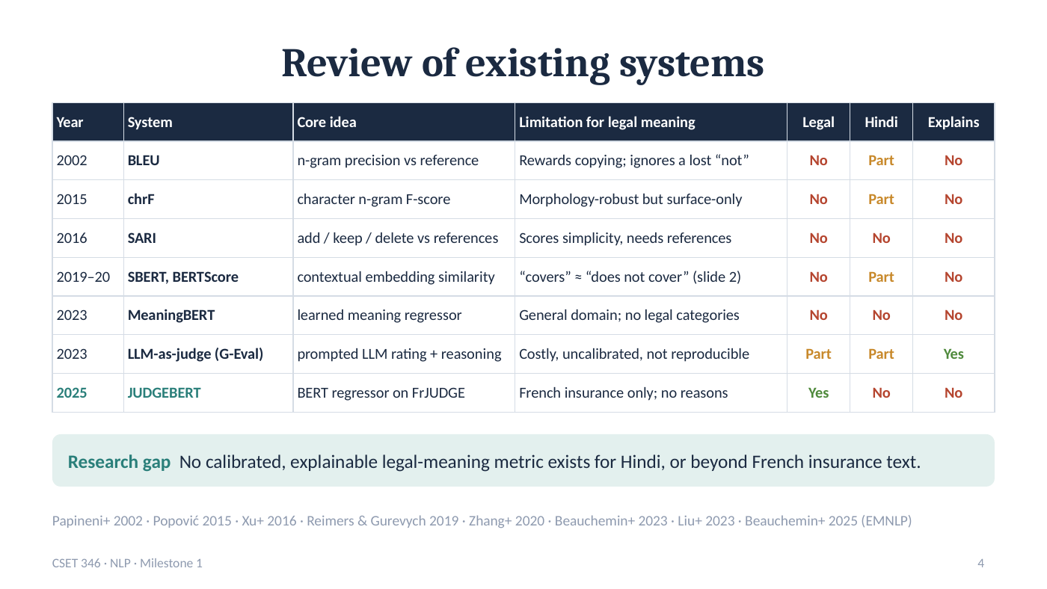
Figure 4. Slide 4 as presented
Purpose of this slide
Compare existing evaluation methods and show precisely what none of them provides.

Explanation of slide 4
How to read the table
Each row is one representative system, in chronological order. Core idea is how it scores two texts; Limitation for legal meaning is why it fails our task. The last three columns check three requirements: is it Legal-aware, does it handle Hindi, and does it Explain its score? “Part” means partial support — for example, a multilingual model that covers Hindi but was never tested on legal Hindi.
Lexical metrics (2002–2016)
- BLEU (2002) counts shared word n-grams with a reference. It rewards copying and ignores a lost “not”.
- chrF (2015) compares character n-grams, so it is robust to word endings (useful in Hindi), but it is still surface-only. It is our strongest baseline.
- SARI (2016) scores what was added, kept and deleted against human reference simplifications. It measures simplicity, not legal correctness, and needs references.
Embedding and learned metrics (2019–2023)
- SBERT / BERTScore (2019–20) compare contextual embeddings. They capture topic and paraphrase, but “covers” and “does not cover” look almost the same (slide 2).
- MeaningBERT (2023) learns to predict meaning preservation, but on general text with no legal categories.
- LLM-as-judge / G-Eval (2023) asks a large language model to rate and explain. It explains, but it is expensive, uncalibrated and not reproducible.
JUDGEBERT (2025) and the research gap
JUDGEBERT is the only legal-aware metric: a BERT regressor trained on FrJUDGE. But it is limited to French insurance and gives no reasons.
Research gap: no calibrated, explainable legal-meaning metric exists for Hindi, or for any legal text beyond French insurance. The footer lists the eight papers behind the table.
Key message to say
Existing metrics are either not legal, not Hindi, or not explainable. JUDGEBERT is legal but French-only and silent about why. That gap is our project.

Likely evaluator questions
Q. Why did you not use SARI as a baseline?
SARI needs human reference simplifications and measures simplicity rather than meaning. Our task compares one original with one simplification without references, so chrF, embedding cosine and BERTScore-style alignment are the right generic baselines.
Q. Feasibility?
Technically feasible: everything runs on a laptop CPU, and pretrained encoders run free on a Colab T4 GPU. Economically: open-source tools only. The main risk, silver labels, is addressed by double human annotation and by testing on FrJUDGE's human labels.

Slide 4 · technical terms
Technical term | Meaning in plain words | How it is used in our project
BLEU | Bilingual Evaluation Understudy: precision of shared word n-grams with a reference. | Reviewed; ignores single-word legal changes.
n-gram | A sequence of n consecutive words or characters. | chrF uses character n-grams up to length 6.
chrF | Character n-gram F-score between two texts. | Our lexical baseline (r = 0.37).
F-score / F1 | Harmonic mean of precision and recall. | Used inside chrF and for our classification metrics.
SARI | Simplification metric scoring added, kept and deleted words against references. | Reviewed, not suitable without references.
Reference | A human-written gold output used for comparison. | Our task has no references: we compare o with s directly.
SBERT | Sentence-BERT: sentence embeddings for similarity search. | Represents the embedding-similarity family.
BERTScore | Matches each token to its most similar token in the other text using embeddings. | Our token-alignment F1 baseline is BERTScore-style.
Contextual embedding | A word vector that depends on the surrounding sentence. | Basis of BERT-family models.
MeaningBERT | A BERT model trained to predict meaning preservation in general text. | Closest non-legal prior work.
LLM-as-judge / G-Eval | Using a prompted LLM to rate outputs and give reasons. | Explains, but costly and not reproducible.
Calibrated | Scores that map consistently onto a fixed scale. | We calibrate all baselines to the 1–10 LMP scale.
Regressor | A model that predicts a continuous number. | JUDGEBERT and our models predict a 1–10 score.
Research gap | What existing work does not yet address. | Explainable LMP for Hindi and new legal domains.

Slide 5 · Base paper, research gaps and objectives
Speaking time: 1 minute
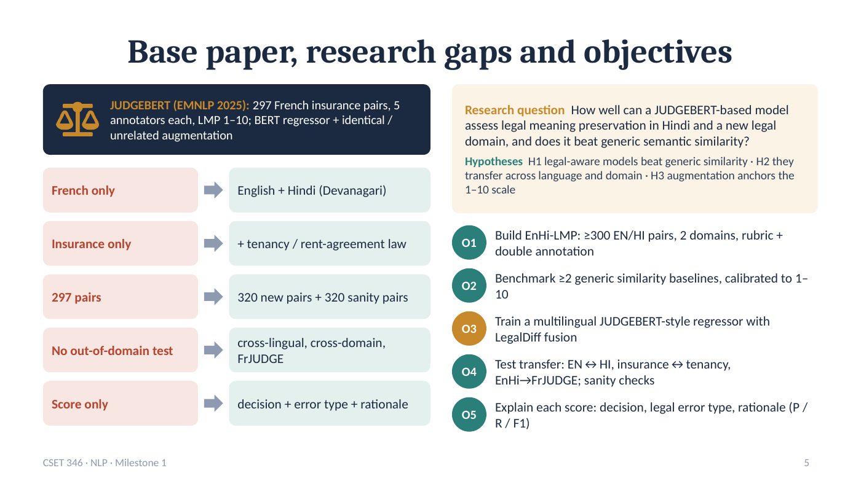
Figure 5. Slide 5 as presented
Purpose of this slide
Summarise the base paper, turn its limitations into our extensions, and state the research question, hypotheses and objectives.

Explanation of slide 5
Top strip — the base paper
JUDGEBERT (EMNLP 2025) released FrJUDGE: 297 French insurance sentence pairs, each scored 1–10 by five annotators. Its model is a BERT regressor trained with two kinds of augmentation: identical pairs (a sentence with itself, labelled 10) and unrelated pairs (a sentence with a random other one, labelled 1). We checked these facts in the released data.
Left — five gaps become five extensions
- French only → English + Hindi (Devanagari).
- Insurance only → + tenancy / rent-agreement law, a second legal domain.
- 297 pairs → 320 new pairs + 320 sanity pairs (160 identical, 160 unrelated).
- No out-of-domain test → cross-lingual, cross-domain and FrJUDGE transfer tests.
- Score only → decision + error type + rationale.
Right top — research question and hypotheses
Research question: How well can a JUDGEBERT-based model assess legal meaning preservation in Hindi and a new legal domain, and does it beat generic semantic similarity?
- H1: legal-aware models beat generic similarity.
- H2: they transfer across language and domain.
- H3: augmentation anchors the 1–10 scale (identical → about 10, unrelated → about 1).
Right bottom — objectives O1–O5
- O1 Build EnHi-LMP: at least 300 English/Hindi pairs, 2 domains, a written rubric and double annotation.
- O2 Benchmark at least two generic similarity baselines, calibrated to 1–10.
- O3 Train a multilingual JUDGEBERT-style regressor with LegalDiff fusion.
- O4 Test transfer (EN↔HI, insurance↔tenancy, EnHi→FrJUDGE) and run sanity checks.
- O5 Explain each score: decision, legal error type and rationale, measured with precision, recall and F1.
Each objective maps to a later result: O1 → slide 6, O2/O3 → slide 8, O4 → slide 9, O5 → slide 10.
Key message to say
Every extension comes directly from a limitation of the base paper, and every objective is measurable and tested later in the deck.

Likely evaluator questions
Q. Are all objectives achieved?
O2–O5 are achieved with results. O1 is achieved for data and rubric; double human annotation is the next milestone (the annotation kit and agreement script are ready). The pretrained-encoder part of O3 runs next on a GPU.
Q. Why tenancy as the new domain?
Rent agreements are among the most common legal documents ordinary Indians sign, they have clear duties, deadlines and parties, and they differ in vocabulary from insurance — a real domain-transfer test.

Slide 5 · technical terms
Technical term | Meaning in plain words | How it is used in our project
Base paper | The published work a project builds on. | JUDGEBERT, EMNLP 2025.
Annotator | A person who assigns labels to data. | FrJUDGE used 5 annotators per pair; we plan 2 per pair.
Data augmentation (DA) | Adding automatically created training examples. | Identical pairs → 10, unrelated pairs → 1.
BERT | A pretrained Transformer language model (Google, 2018). | JUDGEBERT's backbone.
Sanity pairs | Test cases whose correct answer is obvious. | 160 identical and 160 unrelated held-out pairs.
Cross-lingual | Training in one language and testing in another. | EN → HI and HI → EN tests (E2).
Cross-domain / out-of-domain | Testing on a subject area not used for training. | Insurance ↔ tenancy and FrJUDGE tests (E3).
Research question (RQ) | The central question a study answers. | Can a JUDGEBERT-style model judge LMP in Hindi and a new domain?
Hypothesis (H1–H3) | A testable prediction. | Tested by experiments E1–E4.
Rubric | Written scoring guidelines with example anchors. | Our 1–10 LMP rubric for annotators.
Double annotation | Two people label every item independently. | Planned for all 320 pairs, with agreement reported.
Precision / Recall | Of the errors flagged, how many were real / of the real errors, how many were flagged. | Used for the explanation module (O5).

Slide 6 · Methodology: data, model and training
Speaking time: 1.5 minutes
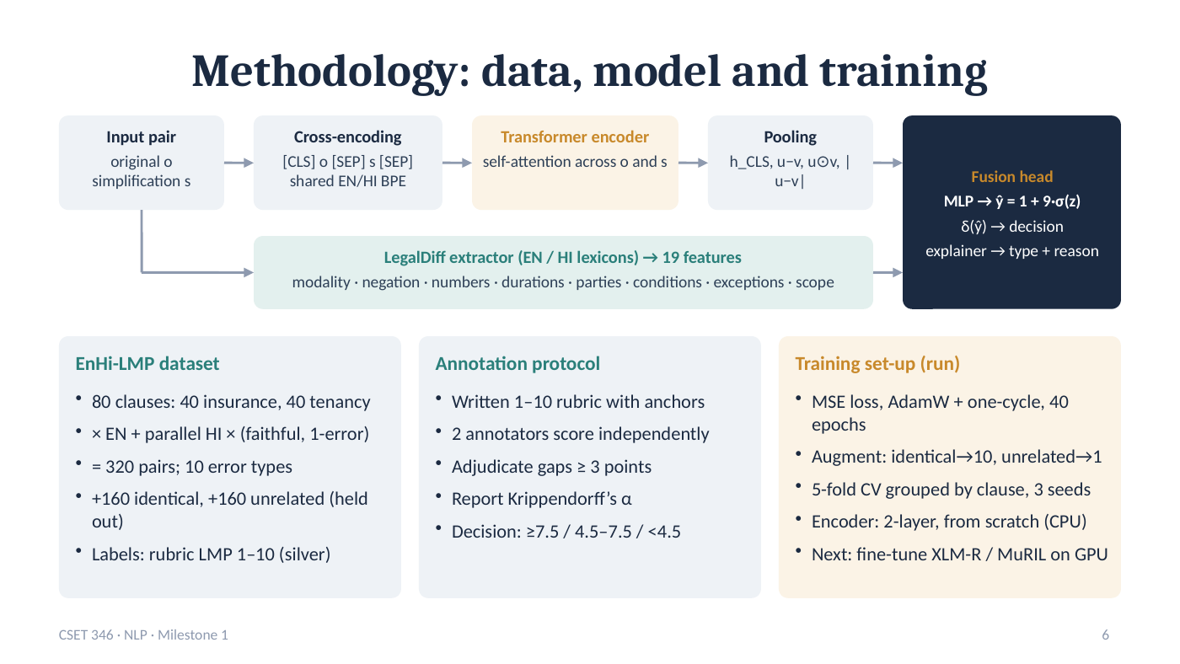
Figure 6. Slide 6 as presented
Purpose of this slide
Show how one sentence pair flows through the system, how the data were built and labelled, and how the models are trained and evaluated.

Explanation of slide 6
Architecture diagram (top) — read left to right
1. Input pair: the original o and the simplification s.
2. Cross-encoding: both are joined into one sequence, “[CLS] o [SEP] s [SEP]”, and split into sub-word pieces with a shared English/Hindi BPE vocabulary. Reading both together lets the model compare them directly, as in JUDGEBERT.
3. Transformer encoder: self-attention lets every token of o look at every token of s, so “not cover” can be aligned with “cover”.
4. Pooling: we summarise the encoder output as the [CLS] vector plus three comparison vectors of the two sentences — difference (u − v), product (u ⊙ v) and absolute difference |u − v|, where u and v are the averaged vectors of o and s.
5. LegalDiff extractor (green bar): in parallel, 19 interpretable features are computed with English and Hindi lexicons — changes in modality, negation, numbers, durations, parties, conditions, exceptions and scope.
6. Fusion head: a small neural network (MLP) combines both and outputs ŷ = 1 + 9·σ(z), which always lies between 1 and 10. The decision rule δ gives the class, and the explainer gives the error type and reason.
EnHi-LMP dataset (left card)
80 clauses (40 insurance, 40 tenancy), each written in English and translated into parallel Hindi, each with one faithful and one single-error simplification: 320 pairs covering 10 error types. In addition, 160 identical and 160 unrelated pairs are held out for sanity checks. The current labels are silver: assigned with the written rubric, not yet by independent human annotators.
Annotation protocol (middle card)
A written 1–10 rubric with anchors; two annotators score every pair independently in blinded, shuffled workbooks; pairs that differ by 3 or more points are adjudicated (discussed and settled); agreement is reported with Krippendorff’s α; the decision thresholds are ≥ 7.5, 4.5–7.5 and < 4.5.
Training set-up (right card)
- Loss and optimiser: mean squared error (MSE), AdamW with a one-cycle learning-rate schedule, 40 epochs.
- Augmentation: identical → 10, unrelated → 1, as in JUDGEBERT.
- Evaluation protocol: 5-fold cross-validation grouped by clause (the English and Hindi versions of a clause are always in the same fold, so the model never sees the translation of a test sentence), repeated with 3 random seeds.
- Encoder: a 2-layer Transformer trained from scratch on a CPU for this milestone. Next: fine-tune pretrained XLM-R or MuRIL on a GPU (the Colab notebook is ready).
Key message to say
Same core design as JUDGEBERT (cross-encoder regressor + augmentation), plus a bilingual legal-difference module that makes predictions stronger and explainable, evaluated with a leakage-free grouped protocol.

Likely evaluator questions
Q. Why train the encoder from scratch instead of using BERT?
Downloading pretrained models was not possible in our initial environment. The from-scratch model shows the pipeline works end to end; the pretrained XLM-R/MuRIL version is ready to run on a GPU in Colab and is the next step.
Q. What are silver labels and why are they acceptable now?
Labels assigned by rule from a written rubric rather than by independent annotators. They are acceptable for a first milestone because we validate on FrJUDGE's real human labels (r = 0.61) and the double-annotation kit is ready.
Q. How do you prevent data leakage?
Folds are grouped by clause, so the English and Hindi twins of a test clause are never in training; calibrators and tokenizers are fitted only on training folds; sanity pairs are taken only from test clauses.

Slide 6 · technical terms
Technical term | Meaning in plain words | How it is used in our project
Cross-encoder | A model that reads both texts together in one input. | o and s are encoded jointly, as in JUDGEBERT.
[CLS] / [SEP] | Special tokens: start-of-sequence summary token / separator between texts. | Input format “[CLS] o [SEP] s [SEP]”.
Tokenizer / BPE | Splits text into pieces / Byte-Pair Encoding, which builds a sub-word vocabulary from frequent character pairs. | Shared 3,000-piece English–Hindi BPE vocabulary.
Transformer encoder | Neural network built from self-attention layers. | 2 layers, 128 dimensions, trained from scratch.
Self-attention | Each token weighs every other token to build its representation. | Aligns words of o with words of s.
Pooling | Turning many token vectors into one fixed-size vector. | [CLS] + u − v, u ⊙ v, |u − v|.
u ⊙ v | Element-wise (Hadamard) product of two vectors. | Captures where the two sentences agree.
LegalDiff | Our 19 bilingual legal-difference features plus rule-based explainer. | Modality, negation, numbers, durations, parties, conditions, exceptions, scope.
Feature | A measurable property used as model input. | e.g. number of figures missing from the simplification.
Lexicon | A word list for a category. | English and Hindi lists for negation, obligation, permission, etc.
MLP / fusion head | Multi-layer perceptron: small fully connected network / the part that merges inputs. | Combines encoder output and LegalDiff features.
Sigmoid σ | Function that squashes any number into (0, 1). | ŷ = 1 + 9·σ(z) keeps scores in [1, 10].
Silver label | Label produced by rule or rubric, not by independent human judgement. | Current EnHi-LMP labels; human labels come next.
Krippendorff’s α | Agreement coefficient between annotators; 1 = perfect, 0 = chance. | Target α ≥ 0.67 for the human labels.
Adjudication | Resolving annotator disagreements by discussion. | Applied when two scores differ by ≥ 3 points.
MSE loss | Mean of squared prediction errors, minimised during training. | Training objective for all regressors.
AdamW / one-cycle | Adaptive optimiser with weight decay / learning rate that rises then falls once. | Optimiser and schedule for the cross-encoder.
Epoch | One full pass over the training data. | 40 epochs for the from-scratch encoder.
Grouped k-fold CV | Split data into k parts by group; train on k−1, test on 1, rotate. | 5 folds grouped by clause.
Seed | Starting number for randomness, for reproducibility. | 3 seeds; results reported as mean ± s.d.
XLM-R / MuRIL | Pretrained multilingual Transformers: 100 languages / 17 Indian languages. | Next-step encoders on a GPU.

Slide 7 · Relevance of algorithms and evaluation metrics
Speaking time: 1 minute
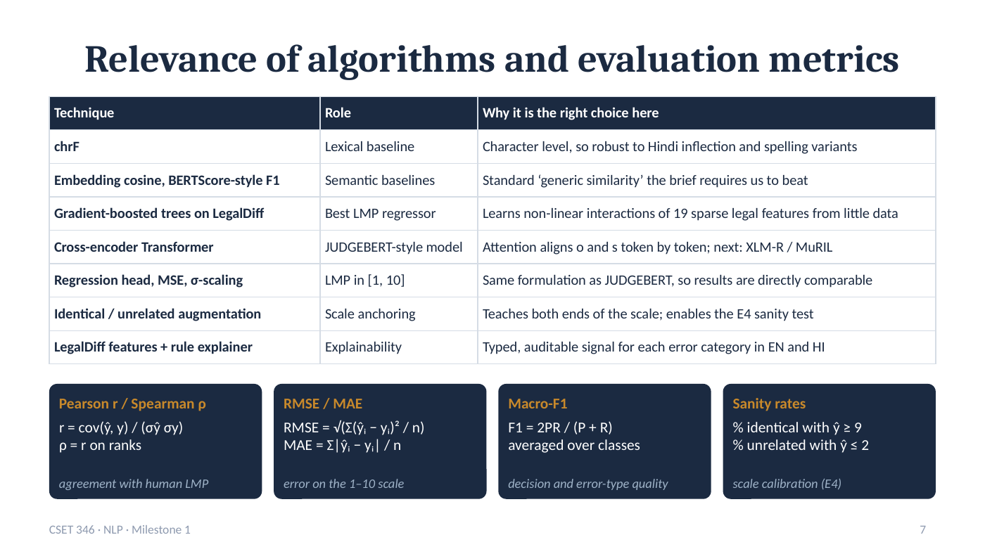
Figure 7. Slide 7 as presented
Purpose of this slide
Justify each algorithm by the problem it solves, and define every metric used in the results.

Explanation of slide 7
Technique table — why each choice fits the problem
- chrF (lexical baseline): works at character level, so it tolerates Hindi word endings and spelling variants.
- Embedding cosine and BERTScore-style F1 (semantic baselines): the standard “generic similarity” the project brief requires us to beat.
- Gradient-boosted trees on LegalDiff (best regressor): learns non-linear combinations of 19 sparse legal features from only a few hundred pairs — ideal for small data.
- Cross-encoder Transformer (JUDGEBERT-style): attention aligns o and s token by token; next step is a pretrained XLM-R or MuRIL encoder.
- Regression head, MSE, σ-scaling: the same formulation as JUDGEBERT, so our numbers are directly comparable with the base paper.
- Identical / unrelated augmentation: teaches the model both ends of the scale and makes the E4 sanity test possible.
- LegalDiff features + rule explainer: a typed, auditable signal for each error category in English and Hindi.
Metric cards (bottom row)
- Pearson r / Spearman ρ: r = cov(ŷ, y) / (σŷ·σy) measures linear agreement; ρ is the same on ranks (ordering only). Both range −1 to +1; higher is better.
- RMSE / MAE: average size of the error in score points; RMSE penalises large mistakes more. Lower is better.
- Macro-F1: F1 = 2PR / (P + R), averaged equally over classes, so rare classes count as much as common ones. Used for the 3-way decision and for error types.
- Sanity rates: the share of identical pairs scored ≥ 9 and of unrelated pairs scored ≤ 2 — checks that the scale is anchored (E4).
Key message to say
Every algorithm is chosen for a reason tied to legal text, Hindi or small data, and every metric answers one question: agreement, error size, decision quality or calibration.

Likely evaluator questions
Q. Why is a tree model stronger than the neural model right now?
With only 256 training pairs per fold, a neural encoder trained from scratch cannot learn language well. Gradient-boosted trees work very well on small tabular feature sets like LegalDiff. A pretrained encoder should close the gap.
Q. Why report both Pearson and Spearman?
Pearson checks linear agreement with the scale values; Spearman checks only the ordering. If both are high, the model ranks and scales pairs correctly. JUDGEBERT reports both.

Slide 7 · technical terms
Technical term | Meaning in plain words | How it is used in our project
Baseline | A simple reference method to compare against. | chrF, embedding cosine, token-alignment F1.
Gradient-boosted trees (GBR) | Many small decision trees added one by one, each correcting the previous errors. | LegalDiff-GBR: 200 trees of depth 3; our best model.
Sparse features | Features that are zero most of the time. | Most LegalDiff features are 0 for a faithful pair.
Non-linear interaction | When the effect of one feature depends on another. | e.g. a number change matters more if a duration also changed.
Regression head | Final layer that outputs one continuous number. | Outputs the LMP score.
σ-scaling | Mapping the network output to a fixed range with the sigmoid. | Keeps every prediction between 1 and 10.
Scale anchoring | Fixing what the ends of a scale mean. | Identical → 10, unrelated → 1.
Rule-based explainer | Hand-written priority rules that map features to an error type. | Turns LegalDiff features into “NEGATION: rule reversed”.
Covariance (cov) | How two variables vary together. | Numerator of Pearson r.
Spearman ρ (rho) | Pearson correlation computed on ranks. | Second agreement metric.
MAE | Mean absolute error. | Average error in score points.
Macro-F1 | F1 computed per class, then averaged equally. | 3-way decision and 11-class error-type quality.
Sanity rate | Share of obvious cases scored correctly. | % identical ≥ 9, % unrelated ≤ 2.

Slide 8 · E1: legal-aware models beat generic metrics
Speaking time: 1.5 minutes
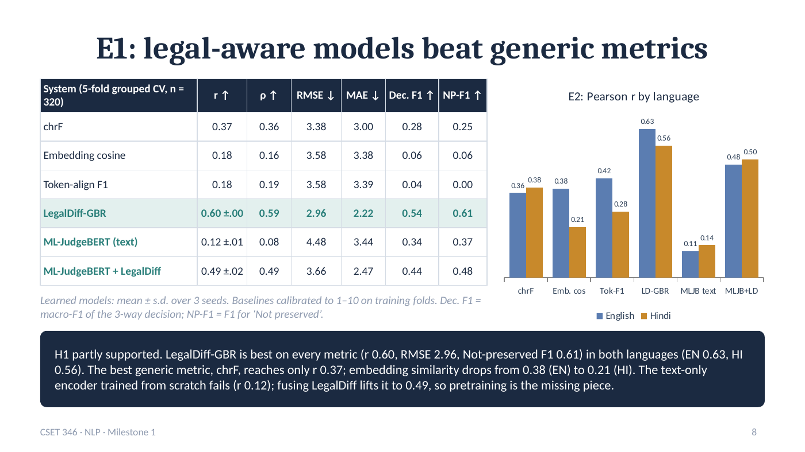
Figure 8. Slide 8 as presented
Purpose of this slide
Report the main experiment: all six systems on all 320 pairs, and the per-language view.

Explanation of slide 8
How the experiment was run
All six systems are evaluated on the same 320 pairs using 5-fold cross-validation grouped by clause (n = 320 test predictions in total). Learned models are averaged over 3 seeds (the ± value is the standard deviation). Baselines produce a similarity, which is mapped to the 1–10 scale by a straight-line calibration fitted on the training folds only.
Columns of the table
r ↑ Pearson correlation; ρ ↑ Spearman correlation; RMSE ↓ and MAE ↓ error in score points; Dec. F1 ↑ macro-F1 of the three-way decision; NP-F1 ↑ F1 for detecting “Not preserved” pairs, the most important class for users. ↑ means higher is better, ↓ lower is better.
Rows — what each result means
- chrF: r 0.37 — the best generic metric, but its predictions sit in the middle of the scale, so it rarely says “Not preserved” (NP-F1 0.25).
- Embedding cosine (0.18) and token-alignment F1 (0.18): weak, and almost never detect a broken meaning (NP-F1 0.06 and 0.00).
- LegalDiff-GBR (highlighted): best on every metric — r 0.60, ρ 0.59, RMSE 2.96, MAE 2.22, decision F1 0.54, NP-F1 0.61 — and very stable across seeds (± 0.00).
- ML-JudgeBERT (text only): the JUDGEBERT-style encoder trained from scratch learns little from 256 training pairs (r 0.12).
- ML-JudgeBERT + LegalDiff: adding the legal features lifts the same model to r 0.49 — the architecture works once it has legal signal.
Chart — Pearson r by language
Blue = English, orange = Hindi. Embedding cosine falls from 0.38 in English to 0.21 in Hindi, and token-alignment from 0.42 to 0.28: generic embeddings handle Hindi legal text poorly. LegalDiff-GBR stays high in both (0.63 / 0.56), and the hybrid model is balanced (0.48 / 0.50).
Verdict box
H1 is partly supported. The legal-aware models beat every generic metric, but the pure text model (without legal features) does not yet — showing that a pretrained multilingual encoder is the missing piece. All numbers are from the v2 code after our own code review.
Key message to say
LegalDiff-GBR reaches r 0.60 against 0.37 for the best generic metric and is the only system that reliably flags broken legal meaning (NP-F1 0.61).

Likely evaluator questions
Q. Why only “partly” supported?
Because H1 is about legal-aware models in general, and our JUDGEBERT-style text-only model (r 0.12) does not beat chrF yet. We report that honestly; with LegalDiff fusion it reaches 0.49, and pretrained encoders are the next step.
Q. Is 0.60 good?
It is a strong correlation for a task with only 320 labelled pairs, and a large improvement over generic metrics (0.18–0.37). On the human-labelled French test set the same approach reaches 0.56 when trained in French and 0.61 zero-shot, so the level is consistent across datasets.
Q. What changed in v2?
We reviewed our own code and fixed 10 issues — for example, the Hindi full stop “।” was glued to the last word, and “six-month” was not read as a number. After re-running, r stayed 0.60 and the hybrid improved from 0.44 to 0.49.

Slide 8 · technical terms
Technical term | Meaning in plain words | How it is used in our project
E1 | Experiment 1: overall comparison on all pairs. | Six systems, 320 pairs.
n = 320 | Number of test predictions evaluated. | Every pair is tested exactly once across the 5 folds.
± s.d. | Standard deviation over repeated runs. | Variation across 3 seeds.
Linear calibration | Fitting a straight line to map a similarity onto the target scale. | Maps baseline similarities to 1–10 using training folds only.
Decision F1 | Macro-F1 of Preserved / Partial / Not preserved. | LegalDiff-GBR 0.54.
NP-F1 | F1 for the “Not preserved” class. | LegalDiff-GBR 0.61; embeddings 0.06.
LegalDiff-GBR | Gradient-boosted trees on the 19 LegalDiff features. | Best model: r 0.60.
ML-JudgeBERT (text) | Our JUDGEBERT-style cross-encoder without legal features. | r 0.12 when trained from scratch.
ML-JudgeBERT + LegalDiff | Cross-encoder with LegalDiff features fused into the head (hybrid). | r 0.49.
Trained from scratch | Weights start random, with no pretraining on large text. | Why the text-only model is weak.
Hypothesis supported | The results agree with the prediction. | H1 partly supported.
v2 (code review) | Second version of our code after fixing defects we found ourselves. | All numbers on slides 8–10 are v2.

Slide 9 · E2–E4: transfer and sanity checks
Speaking time: 1 minute
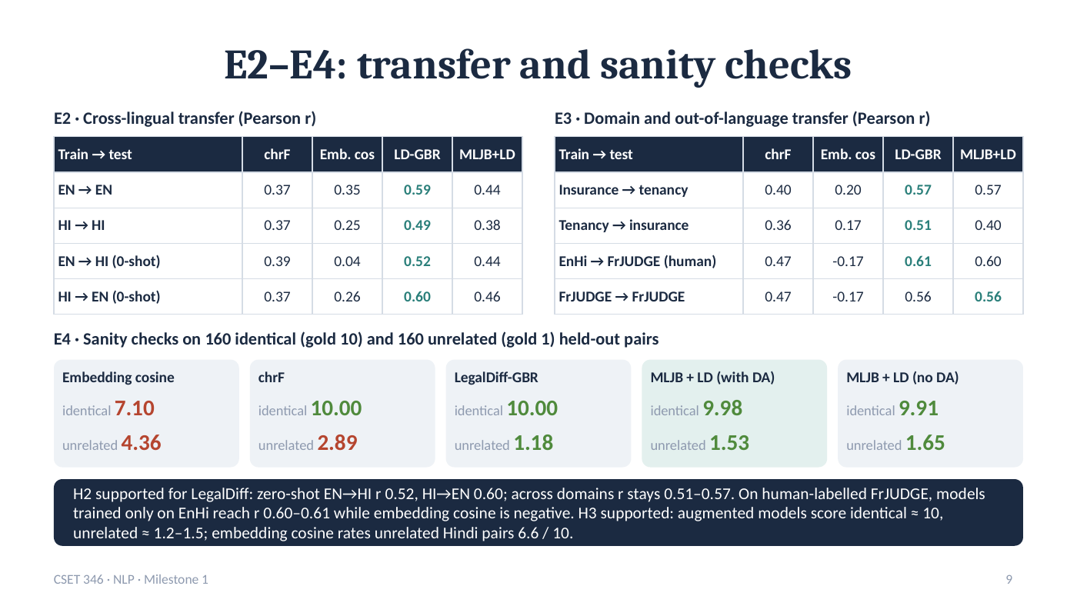
Figure 9. Slide 9 as presented
Purpose of this slide
Test whether the models generalise to another language, another domain and human-labelled French data, and whether the score scale is anchored.

Explanation of slide 9
E2 — cross-lingual transfer (left table)
Rows show train → test language on held-out clauses. EN → EN and HI → HI are within-language; EN → HI (0-shot) means trained only on English, tested on Hindi; HI → EN the reverse. Columns are chrF, embedding cosine, LegalDiff-GBR (LD-GBR) and ML-JudgeBERT + LegalDiff (MLJB+LD).
LegalDiff-GBR transfers well: 0.52 for EN → HI and 0.60 for HI → EN, because its features are defined for both languages. Embedding cosine collapses to 0.04 when moving from English to Hindi.
E3 — domain and out-of-language transfer (right table)
Insurance → tenancy and tenancy → insurance: LegalDiff-GBR keeps r at 0.57 and 0.51.
EnHi → FrJUDGE (human): trained only on our English–Hindi data, tested on French pairs scored by humans: 0.61 (GBR) and 0.60 (hybrid), above every generic metric. Embedding cosine is negative (−0.17), i.e. it ranks pairs in the wrong direction.
FrJUDGE → FrJUDGE: trained and tested on French (in-language reference): 0.56 for both learned models.
E4 — sanity checks (cards)
Each card shows the mean predicted score for 160 identical pairs (should be 10) and 160 unrelated pairs (should be 1). LegalDiff-GBR: 10.00 / 1.18. Hybrid with augmentation: 9.98 / 1.53; without augmentation: 9.91 / 1.65. chrF: 10.00 / 2.89. Embedding cosine fails: identical pairs get only 7.10 and unrelated pairs 4.36 (6.6 for unrelated Hindi pairs).
Verdict box
H2 supported for LegalDiff: it transfers across languages, domains and to human-labelled French data. H3 supported: augmented models anchor the scale (identical ≈ 10, unrelated ≈ 1.2–1.5), while generic embeddings do not.
Key message to say
Our legal-aware models work on a language and a domain they were not trained on, and on real human judgements in French; generic embeddings do not.

Likely evaluator questions
Q. Why is EnHi → FrJUDGE (0.61) higher than FrJUDGE → FrJUDGE (0.56)?
FrJUDGE's training set is small (207 pairs) and has no designed single-error contrasts, while EnHi-LMP gives clean faithful-vs-error pairs. The difference is within the uncertainty of a 90-pair test set, so we read both as “about 0.6”.
Q. Why does augmentation matter if the no-DA model also scores identical pairs near 10?
Augmentation mainly improves the unrelated end (1.53 vs 1.65) and makes the scale explicit; it is also how JUDGEBERT anchors its scale, which keeps our results comparable.

Slide 9 · technical terms
Technical term | Meaning in plain words | How it is used in our project
E2 / E3 / E4 | Experiments on cross-lingual transfer / domain and French transfer / sanity checks. | Slide 9.
Within-language | Train and test in the same language. | EN → EN, HI → HI.
0-shot transfer | Testing on a language never seen in training. | EN → HI 0.52, HI → EN 0.60 (LegalDiff-GBR).
Domain transfer | Testing on a different subject area. | Insurance ↔ tenancy.
Out-of-language | Testing on a third language. | EnHi → French (FrJUDGE).
Human-labelled | Scores given by people, not rules. | FrJUDGE labels (5 annotators per pair).
Negative correlation | Predictions go down when true scores go up. | Embedding cosine on FrJUDGE: −0.17.
Sanity check | Test on cases with an obvious answer. | Identical → 10, unrelated → 1.
Held-out | Never used during training. | Sanity pairs are only from test clauses.
DA / no DA | With / without data augmentation. | 9.98 / 1.53 vs 9.91 / 1.65.
LD-GBR / MLJB+LD | Abbreviations of LegalDiff-GBR / ML-JudgeBERT + LegalDiff. | Column headings in the E2/E3 tables.

Slide 10 · E5: error analysis, explanations, conclusion
Speaking time: 1.5 minutes
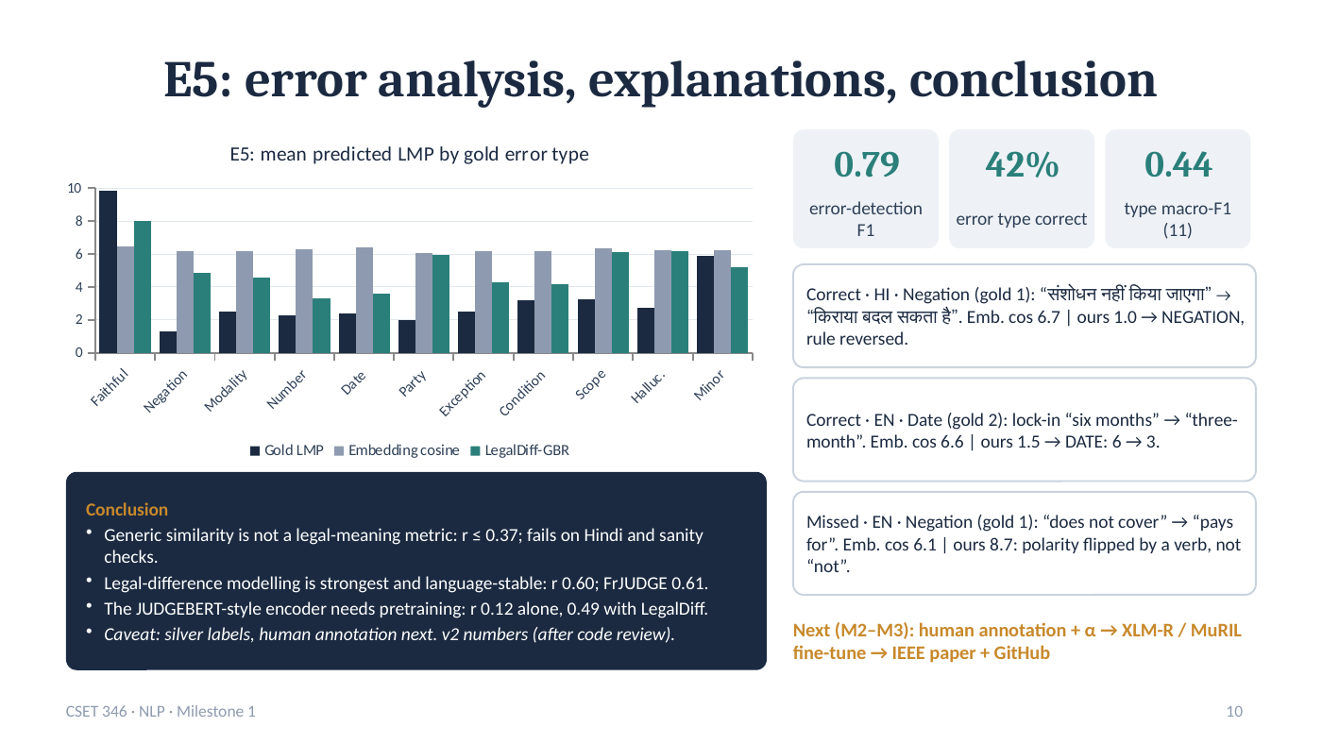
Figure 10. Slide 10 as presented
Purpose of this slide
Show that the system explains its scores, be honest about a failure case, and close with conclusions and next steps.

Explanation of slide 10
Chart — mean predicted LMP by gold error type
For each error type (x-axis) three bars: dark = gold (true) score, grey = embedding cosine, green = LegalDiff-GBR. Gold scores are high for faithful pairs and low for every error type. The embedding score stays around 6 for every type — it cannot tell a faithful rewrite from a negation or a changed number. LegalDiff-GBR follows the gold pattern much more closely (high for faithful, low for negation, modality, number, date). Its weak spots are party swaps, scope and hallucination, where the score stays near 6.
Three tiles — explanation quality
- 0.79 error-detection F1: how well the system detects that a pair contains a legal error at all (precision 0.75, recall 0.84).
- 42% error type correct: for pairs that contain an error, the explainer names the exact type out of 11 classes in 42% of cases (50% of the errors it detects); chance level is about 9%.
- 0.44 type macro-F1 (11): average F1 over the 10 error types plus NONE.
Three example cards
- Correct · Hindi · Negation (gold 1): “संशोधन नहीं किया जाएगा” (rent shall not be revised) → “किराया बदल सकता है” (rent can be changed). Embedding gives 6.7; our model gives 1.0 and explains “NEGATION, rule reversed”.
- Correct · English · Date (gold 2): lock-in “six months” → “three-month”. Embedding 6.6; ours 1.5 with “DATE: 6 → 3”. The v1 code missed this because “three-month” was read as one word — our code review fixed it.
- Missed · English · Negation (gold 1): “does not cover” → “pays for”. Embedding 6.1; ours 8.7. The polarity is flipped by changing the verb, not by removing “not”, which our word lists cannot see. This honest failure shows why a pretrained encoder is needed.
Conclusion card
1. Generic similarity is not a legal-meaning metric: r ≤ 0.37, and it fails on Hindi and on sanity checks.
2. Legal-difference modelling is the strongest and most language-stable signal: r 0.60, and 0.61 on human-labelled French data.
3. The JUDGEBERT-style encoder needs pretraining: r 0.12 alone, 0.49 with LegalDiff.
4. Caveat: current labels are silver; human double annotation is next. All numbers are v2, after our code review.
Next steps (gold text)
Milestones 2–3: human annotation with Krippendorff’s α → fine-tune XLM-R / MuRIL on a GPU → final IEEE paper and GitHub release.
Key message to say
The system not only scores but explains, and we know exactly where it fails. Generic similarity is not enough for law; legal-difference modelling is, and pretrained multilingual encoders are the next step.

Likely evaluator questions
Q. Why is 42% type accuracy acceptable?
It is an 11-class problem, so chance is about 9%. Detection of an error is much higher (F1 0.79). Several types overlap in practice (a dropped condition can also look like a scope change), and the explainer uses simple priority rules; a learned explainer is future work.
Q. How will you fix the “pays for” failure?
A pretrained multilingual encoder (XLM-R/MuRIL) understands that “pays for” contradicts “does not cover” without a word list. We will also add antonym-verb pairs to the lexicons.
Q. What will the final submission add?
Human labels from two annotators with agreement, pretrained encoder results on GPU, updated tables, the IEEE paper and the public GitHub repository.

Slide 10 · technical terms
Technical term | Meaning in plain words | How it is used in our project
E5 / error analysis | Experiment 5: studying which errors the system gets right or wrong. | Per-type scores and explanation quality.
Gold error type | The true error category recorded when the pair was built. | e.g. NEGATION for the “नहीं” example.
Error detection | Deciding whether any legal error is present. | F1 0.79 (P 0.75, R 0.84).
Type accuracy | Share of errors whose exact type is named correctly. | 42% overall; 50% of detected errors.
11 classes | 10 error types + NONE (no error). | Used for macro-F1 0.44.
Polarity flip | Changing a statement from negative to positive or back. | “does not cover” → “pays for”.
Antonym verb | A verb with opposite meaning that reverses polarity without “not”. | Cause of the missed example.
Fine-tuning | Further training a pretrained model on task data. | XLM-R / MuRIL on EnHi-LMP (next step).
Milestones M2–M3 | Next course review stages. | Human labels, GPU models, IEEE paper, GitHub.
IEEE paper | A paper in the IEEE conference format. | Final written deliverable (draft ready).

