RhythmicTunes

# 1.Introduction

• Project Title: RhythmicTunes

• Team ID : NM2025TMID36023

• Team Leader: RANJITHKUMARAN B [–udcu24s1053@gmail.com](mailto:–udcu24s1053@gmail.com)

### • Team Members:

VIGNESH S [–udcu24s1052@gmail.com](mailto:–udcu24s1052@gmail.com)

KIRUBAKARAN P – [udcu24s1074@gmail.com](mailto:udcu24s1074@gmail.com)

YUVARAJ M – [udcu24s1065@gmail.com](mailto:udcu24s1065@gmail.com)

# 2. Project Overview

## • Purpose:

SB Works connects clients and freelancers through project postings, bidding, and real-time communication

## . • Features:

– Project posting and bidding

– Secure chat system

– Feedback and review system

– Admin control panel

# 3. Architecture

## • Frontend:

React.js with Bootstrap and Material UI

## • Backend:

Node.js and Express.js managing server logic and API endpoints

## • Database:

MongoDB stores user data, project information, applications, and chat messages

# 4. Setup Instructions

## • Prerequisites:

– Node.js

– MongoDB 2

– Git

– React.js

– Express.js – Mongoose – Visual Studio Code

## • Installation Steps:

# Clone the repository git clone

# Install client dependencies cd client npm install

# Install server dependencies cd ../server npm install

# 5. Folder Structure

SB-Works/

|-- client/ # React frontend

|__components/

L__ pages/

|__ server/ # Node.js backend

|__routes/

|__ models/

|__ controllers/

# 6. Running the Application

## • Frontend:

Cd client

npm start

## • Backend:

Cd server npm

start

## • Access: Visit <http://localhost:3000>

# 7. API Documentation

## • User:

– /api/user/register

– /api/user/login

## • Projects:

– /api/projects/create

– /api/projects/:id

## • Applications:

/api/apply

## • Chats:

– /api/chat/send

– /api/chat/:userId

## 8. Authentication

• JWT-based authentication for secure login

• Middleware protects private routes

## 9. User Interface

• Landing Page

• Freelancer Dashboard

• Admin Pane

• Project Details Page

## 10. Testing

• Manual testing during milestones

• Tools: Postman, Chrome Dev Tools

## 11. Screenshots or Demo

## WhatsApp Image 2025-09-17 at 2.34.31 PM (1).jpeg

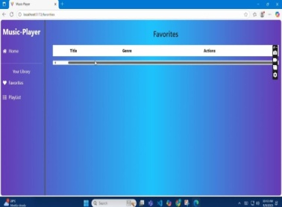

## 12. Known Issues :NILL

## 13. Future Enhancements:

Rhythmic tunes can be enhanced by using digital tools and AI to personalize experiences, developing more sophisticated VR/AR training for rhythm and motor skills, and leveraging rhythmic entrainment for cognitive and motor rehabilitation. Future trends focus on multimodal stimulation, integrating rhythm with light and vibration, and exploring the relationship between rhythm, reward, and social/cognitive development. Digital behavioral analysis and personalized music interventions will also play a significant role in assessing and improving rhythmic abilities across various age groups and conditions.