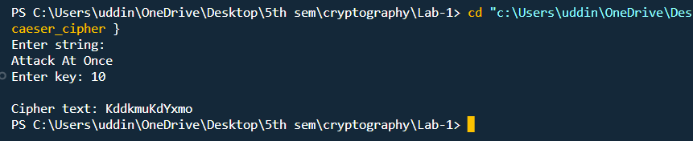**Text Encryption using Ceaser Cipher**

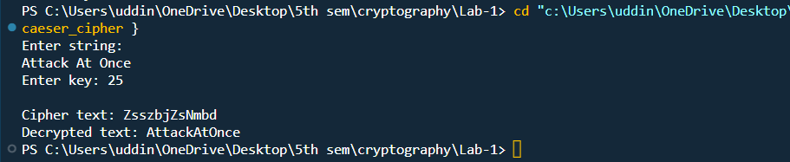**Text Decryption Using Ceaser Cipher**