ADAMANTIUM GAMING HUB
Software Engineering Project Report
War Thunder Mobile Community Hub
By TEAM AKAGAMI

SUBMISSION DETAILS
Team Members | L Surya Uddish, S Rudrakshini, J Aryan
College / department | Data Science Department, Sreenidhi Institute of Science and Technology.
Course / subject | Web Technologies
Faculty guide | B. Vipul Anand Sir
Submission date | xx-10-2026

Contents
Contents 2
Abstract 4
1. Introduction 4
1.1 Project overview 4
1.2 Objectives 4
1.3 Scope 4
2. Software Requirements Specification (SRS) 4
2.1 User classes 4
2.2 Functional requirements 5
2.3 Non-functional requirements 5
3. System Analysis and Design 5
3.1 Architecture 5
3.2 Data model and ER diagram 6
3.3 Use-case analysis 7
4. UML Diagrams 7
4.1 Use-case diagram 7
4.2 Class / domain model 7
4.3 Sequence diagram: request to join 8
4.4 Activity diagram: room creation 8
5. Implementation 9
5.1 Technologies 9
5.2 Application modules 9
5.3 Database and security design 9
6. Software Testing 9
7. Project Planning 10
7.1 SDLC model 10
7.2 Proposed schedule 10
7.3 Risk analysis 11
8. Conclusion 11
9. References 11

Abstract
Adamantium Gaming Hub is a college project that presents a War Thunder Mobile themed community gaming hub. It brings together a landing page, sign-in page, and three mode pages for ground vehicles, aircraft, and naval vessels. The mode pages combine vehicle catalogs and tactical guides with community rooms, join-request workflows, and room scoreboards. The front end is built with HTML, CSS, and JavaScript; Supabase provides hosted authentication and a PostgreSQL database accessed through the Supabase JavaScript client. Row Level Security (RLS) policies control database operations. This report describes the requirements, architecture, data model, implementation, testing plan, schedule, risks, results, limitations, and possible extensions.

1. Introduction

1.1 Project overview
Adamantium Gaming Hub is an independent fan-made web project created for a college assignment. It provides a single place to browse War Thunder Mobile themed ground, air, and naval content. The interface uses a dark visual theme with warm, muted champagne gold layout, image showcases, navigation between mode pages, and Supabase-backed community functions.

1.2 Objectives
- Present ground vehicles, aircraft, and naval vessels in separate browsable catalogs.
- Provide a shared sign-in flow for users who want to create rooms or participate in room workflows.
- Allow signed-in users to create and manage their own rooms and submit join requests to other eligible rooms.
- Show room scoreboards and mode-specific tactical guides.
- Keep access controlled through Supabase authentication and database RLS policies.

1.3 Scope
The project covers a static browser-based front end and a hosted Supabase backend. It includes the home page, login page, and ground, aviation, and naval pages. It does not implement live gameplay, matchmaking with War Thunder servers, payments, native mobile applications, or an official relationship with the game publisher. Showcase media is stored as local project assets or referenced by the page; it is separate from catalog records.

2. Software Requirements Specification (SRS)

2.1 User classes
User class | Typical capabilities
Visitor | Browse public catalog, guides, open rooms, and public scoreboards; sign in to use account features.
Signed-in player | Create a room, request to join another room, view own request state, and use account controls.
Room owner | Manage own room and review/respond to join requests, subject to the mode page and database policies.
Project maintainer | Manage catalog, guide, demo, and security data through the Supabase project.

2.2 Functional requirements
- The system shall provide navigation among Home, Tanks, Aviation, Naval, Rooms, Guides, and Login destinations where present.
- The system shall authenticate users through Supabase Auth and reflect the signed-in state in the interface.
- The system shall read vehicle, aircraft, vessel, and guide records from the database.
- The system shall list rooms by mode and allow an authenticated user to create a room.
- The system shall allow a user to request access to an eligible room and display the request status.
- The system shall allow room owners to respond to requests and manage rooms they own.
- The system shall display scores associated with a selected room and support refreshing the list.
- The system shall display clear loading, empty, and error states when data is unavailable.

2.3 Non-functional requirements
- Usability: consistent navigation, readable contrast, responsive layouts, and clear status feedback.
- Security: database access is protected by Supabase Auth and RLS; browser code must not contain service-role secrets.
- Reliability: data-loading failures should be reported without fabricating database records.
- Maintainability: mode pages and SQL scripts should remain organized and documented.
- Compatibility: pages should work in a modern browser with JavaScript enabled and network access to Supabase.
- Performance: keep local media reasonably sized and avoid unnecessary repeated database requests.

3. System Analysis and Design

3.1 Architecture
The browser loads static HTML, CSS, JavaScript, and media files. The Supabase JavaScript client communicates directly with the hosted Supabase API. Supabase Auth manages account sessions; the Data API applies PostgreSQL permissions and RLS policies before reading or changing public-schema rows. The current local workflow uses a development server. GitHub stores the project source; publishing the static site requires a hosting configuration and a deployed URL.

Figure 1. System context / data-flow overview
From | Relationship / action | To
Visitor or signed-in player | Uses pages, forms, catalog filters, room actions | Browser: index/login/tanks/aviation/ships
Browser pages | Loads HTML, CSS, JavaScript, and local assets | Local development server / static host
Browser JavaScript | Supabase client requests with public browser key and session token | Supabase Auth + Data API
Supabase Data API | Checks grants and RLS policies; reads/writes allowed rows | PostgreSQL public tables
PostgreSQL | Returns catalog, guide, room, request, and score data | Browser renders results

3.2 Data model and ER diagram
The current inventory discussed during database cleanup contains fourteen application tables: profiles, guides, three catalog tables, and three tables for each of the three room modes. Authentication identities are maintained by Supabase Auth in auth.users. Foreign keys connect room ownership and player/request identities to Auth users, while request and score rows reference their corresponding mode room. Some demo scoreboard entries are display-only and use a nullable player identity.

Figure 2. Entity relationships (simplified ER view)
From | Relationship / action | To
auth.users | 1 → many; owner_id | tank_rooms / aviation_rooms / naval_rooms
auth.users | 1 → many; requester_id | tank_room_requests / aviation_room_requests / naval_room_requests
tank_rooms | 1 → many; room_id | tank_room_requests and tank_room_scores
aviation_rooms | 1 → many; room_id | aviation_room_requests and aviation_room_scores
naval_rooms | 1 → many; room_id | naval_room_requests and naval_room_scores
profiles | 1 → 0/1 by matching id | auth.users
guides, vehicles, aircraft, naval_vessels | Catalog/content records; public read | Mode pages

Table group | Tables | Purpose
Identity | Profiles | Optional public profile information keyed to the Auth identity.
Content | Guides | Mode-specific guide text and author display name.
Catalogs | vehicles, aircraft, naval_vessels | Ground, air, and naval catalog entries.
Tank rooms | tank_rooms, tank_room_requests, tank_room_scores | Ground room lifecycle, join workflow, and scores.
Aviation rooms | aviation_rooms, aviation_room_requests, aviation_room_scores | Aviation room lifecycle, join workflow, and scores.
Naval rooms | naval_rooms, naval_room_requests, naval_room_scores | Naval room lifecycle, join workflow, and scores.

3.3 Use-case analysis
Actor | Use cases
Visitor | Browse catalogs and guides; inspect public/open rooms and public scoreboards; go to sign-in.
Signed-in player | Create room; send join request; check request status; view scoreboard; sign out.
Room owner | Review incoming requests; accept or reject; update/delete own real room where supported.
Maintainer | Seed or update catalog, guide, and demo records; maintain security policies.

4. UML Diagrams
The following UML diagrams model representative users, data entities, and room workflows in the current application. They are simplified models of the project’s implementation.

4.1 Use-case diagram
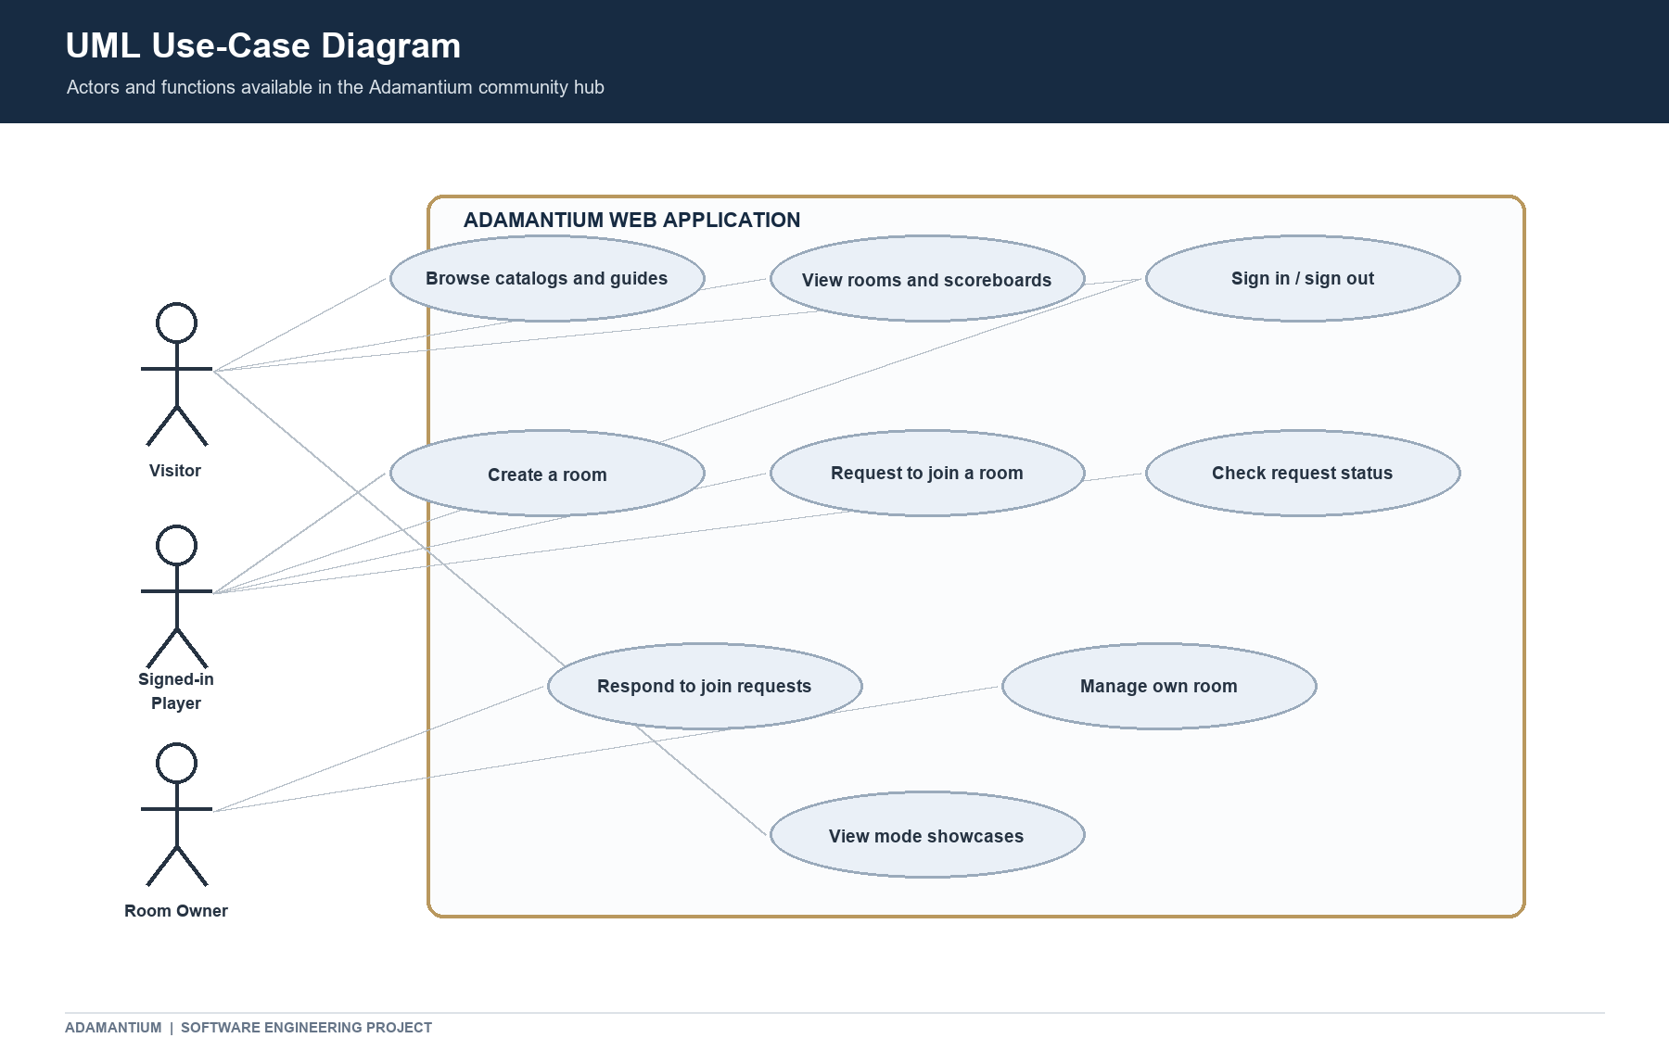

4.2 Class / domain model
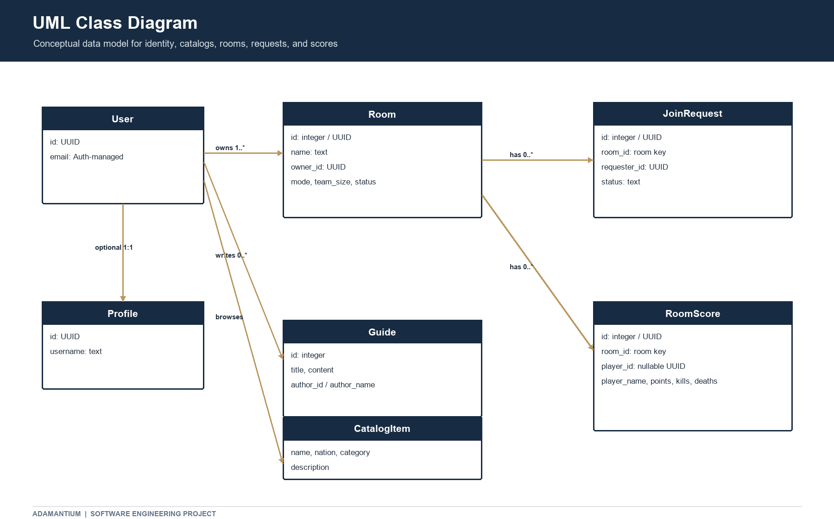

4.3 Sequence diagram: request to join
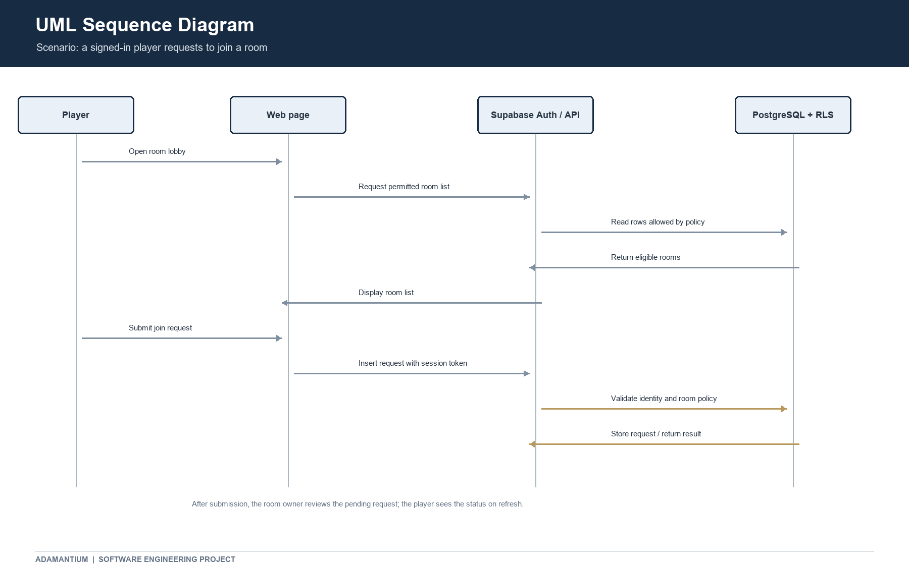

4.4 Activity diagram: room creation
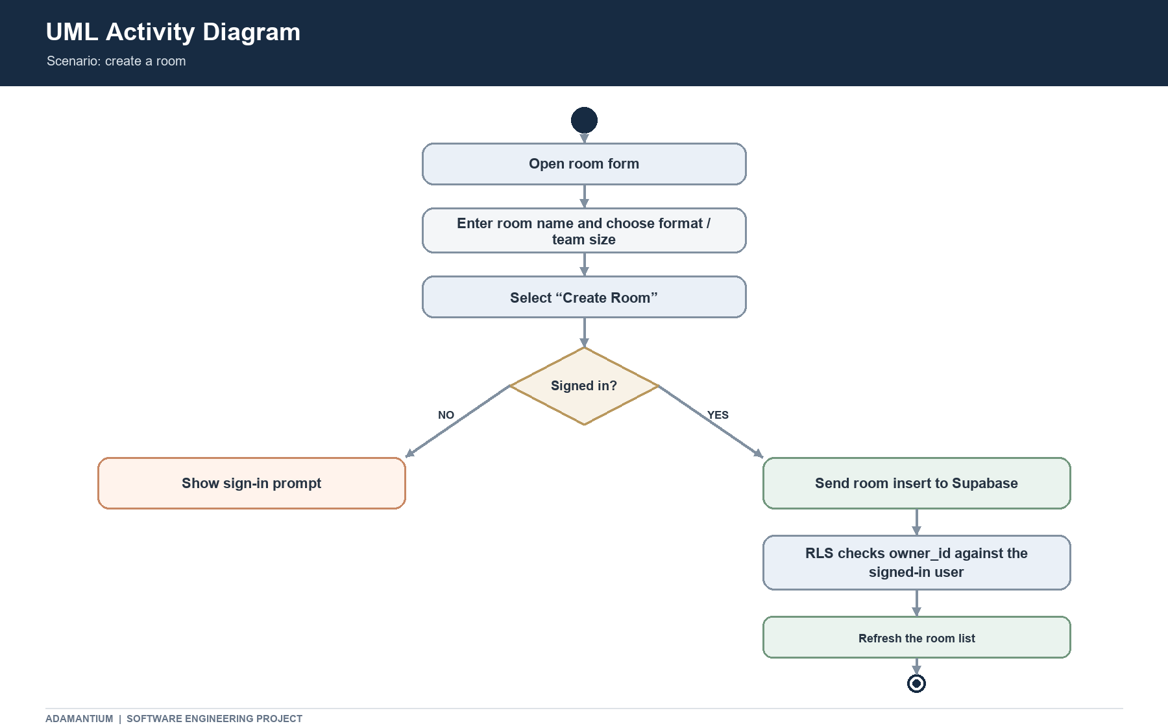

5. Implementation

5.1 Technologies
Layer | Technology / component | Use
Front end | HTML5, CSS3, vanilla JavaScript | Pages, design, interactions, data rendering.
Authentication and data access | Supabase JavaScript client v2 via CDN | Browser sign-in and PostgREST-style database operations.
Backend | Supabase Auth and PostgreSQL | Identity, relational records, access control.
Development | Visual Studio Code and local static server | Edit and preview the multi-page site.
Version control | Git and GitHub | Store and share the source repository.

5.2 Application modules
- Home module: introduces the hub and links to the mode pages.
- Authentication module: login.html uses Supabase Auth and returns users to the relevant page.
- Ground forces module: tanks.html loads vehicles/guides, rooms, requests, and scoreboards.
- Aviation module: aviation.html loads aircraft/guides, aviation rooms, requests, and scoreboards.
- Naval module: ships.html loads vessels/guides, naval rooms, requests, and scoreboards.
- Shared styling and scripts: style.css and script.js support visual consistency and common site behavior.

5.3 Database and security design
The current table inventory consists of profiles, guides, vehicles, aircraft, naval_vessels, and the room/request/score triplets for tanks, aviation, and naval. Saved SQL scripts are grouped under supabase/queries (including mode setup, guides, demo data, and security). The security script enables RLS and defines policies for public catalog/guide reads, room operations, request visibility and owner decisions, and score access as configured for each mode. The browser uses a publishable key; it is not a secret. A service-role key must never be placed in client-side HTML or JavaScript.
Repository note: the SQL currently lives as saved query scripts, while the project does not yet contain a confirmed ordered migration history pulled from the hosted database. Therefore, the scripts are useful project records but a clean, automated database rebuild has not been established by the repository alone.

6. Software Testing
The table below is a test plan. Do not submit invented actual results: run each case on the current local site and deployed site, then replace “To be recorded” with the observed result. The project owner has previously reported that the main features work locally, but this report does not treat that as a formal test log.

ID / scenario | Expected result | Actual result
T01 Open each page | Home, login, tanks, aviation, and ships load without broken layout or console errors. | Pass — all five pages opened in Chrome
T02 Browse catalogs and guides | Database entries render; empty/error states are clear when records are unavailable. | Pass — entries loaded on all three pages.
T03 Visitor attempts protected action | User is directed to sign in or sees an appropriate sign-in prompt. | Pass — sign-in was required.
T04 Sign in / sign out | Auth state updates and navigation returns to the intended page. | Pass — both actions worked.
T05 Create a room while signed in | Room is saved with current user as owner and appears after refresh. | Pass — room appeared in the list after refresh.
T06 Request to join a real room | Request is saved once and the requester sees its status. | Pass — request appeared as pending.
T07 Owner responds to request | Only the room owner can change the request status. | Pass — status changed and displayed correctly.
T08 Scoreboard display | Selected room scores load and refresh correctly, including demo display-only players. | Pass — scores loaded and refresh worked.
T09 Delete room | Owner can delete own eligible real room; demo room restrictions remain enforced. | Pass — my real room deleted; demo room had no delete option.
T10 Unauthorized database operation | RLS rejects requests that do not satisfy the table policy. | Pass — Supabase denied the unauthorized action.

7. Project Planning

7.1 SDLC model
An iterative prototyping approach best describes the project: build a page or feature, preview it locally, compare it with the intended design, connect the feature to Supabase, then refine based on observed behavior. This description is based on the project history and should be adjusted if the course requires a named formal SDLC model.

7.2 Proposed schedule
Phase | Work | Status / evidence
1. Requirements and visual plan | Define pages, mode content, and room actions. | Implemented pages exist; confirm dates.
2. Front-end build | Create shared navigation, page styling, showcases, and forms. | HTML/CSS/JS files are present.
3. Database integration | Connect catalogs, guides, rooms, requests, and scores; configure RLS. | Supabase scripts and page queries are present.
4. Data cleanup | Consolidate tables and remove unused social tables. | Current inventory provided.
5. Verification | Run local and hosted test cases and fix defects. | Fixed the defects of the test cases.
6. Publication | Configure static hosting and verify deployed paths and Supabase access. | Published.

7.3 Risk analysis
Risk | Impact | Mitigation
Incorrect RLS policy | Unauthorized read/write or blocked feature | Test anonymous, requester, owner, and other-user roles separately.
Schema drift between SQL scripts and hosted DB | Pages fail to load or write records | Keep ordered migrations and export/compare schema before changes.
Missing or incorrect asset paths after deployment | Images/video do not display | Use repository-relative paths and check case/spaces on deployed site.
Public client configuration misunderstood | Exposure of privileged credentials | Only publishable key in browser; never expose service-role key; retain RLS.
Large media files | Slow page loads or hosting limits | Compress media and verify repository/host limits before publishing.
Unverified test evidence | Report overstates completion | Record observed results, date, browser, and screenshots/logs.

8. Conclusion
Adamantium combines a multi-page War Thunder Mobile themed interface with Supabase-backed catalogs, guides, authentication, rooms, join requests, and scoreboards. The project demonstrates front-end development, relational data modeling, hosted authentication, and row-level access control. The main remaining report and release tasks are to record formal test outcomes, confirm the deployed hosting setup, verify all assets on the hosted site, and maintain a reproducible ordered database migration history. Potential future enhancements include a moderator/admin interface, stronger input validation and accessibility review, pagination/search for catalogs, and a documented automated deployment workflow.

9. References
- Supabase Documentation, “JavaScript Client Library” and “Authentication.” https://supabase.com/docs/reference/javascript/
- Supabase Documentation, “Row Level Security.” https://supabase.com/docs/guides/database/postgres/row-level-security
- Supabase Documentation, “Database Migrations.” https://supabase.com/docs/guides/deployment/database-migrations
- MDN Web Docs, HTML, CSS, and JavaScript references. https://developer.mozilla.org/
- War Thunder Mobile official website. Cite the exact page used for game descriptions or images: [https://wtmobile.com/en/].
- Adamantium project source files and Supabase SQL scripts, accessed.

