Mathematics Problem Set 4
Problem 1 | • Lorem ipsum dolor sit amet, consectetur adipiscing elit. Ut enim ad minim veniam.
Problem 2 | • Lorem ipsum dolor sit amet, consectetur adipiscing elit. Ut enim ad minim veniam.
Problem 3 | • Lorem ipsum dolor sit amet, consectetur adipiscing elit. Ut enim ad minim veniam.

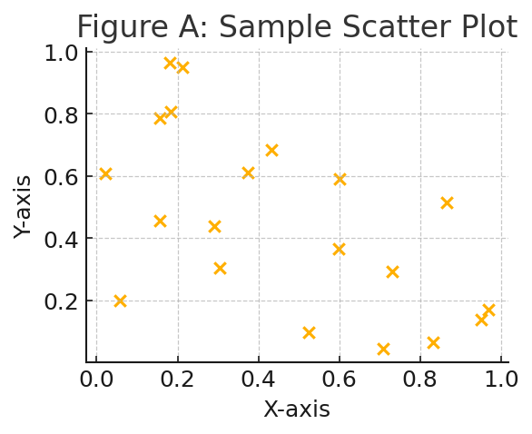
Figure A: Sample Scatter Plot

