# Introduction

* In Java file “java.lang.*” package import automatically
* File name should be same as Class name. In case of class is public It **must be same as Class name**
* **JRE always needs main method signature only as below format**

public static void main(String[] args){ // body here }

* javap tool to see all methods of class

$ javap java.utils.Scanner

## Reading Data from Keyboard:

* Use Scanner class from “java.utils.*” package
* Scanner support following methods to read different data types

1. nextInt()
2. nextFloat()
3. nextDouble()
4. next()
5. nextLine()
6. nextByte()
7. nextShort()
8. nextLong()
9. nextBoolean()
10. hasNextInt()
11. hasNextFloat()

# Data Types

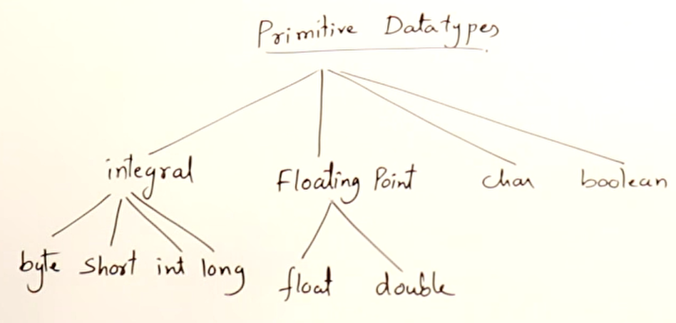

* Every variable in java must be initialize [compile-time error]
* You cannot initialize variable outside the range supported [compile-time error]

## Rules for Variable Names

* Case Sensitive
* Contains Alphabets, Numbers, _ or $
* Start with Alphabet,_ or $
* Should not be a keyword
* Should not be a class name, if class is also in use
* No limit on length of name
* Follow Camel cases

# Reference

<https://www.udemy.com/course/java-se-programming/>