# Introduction

A Spring batch job to consume the source file.

RESTFUL API to retrieve the records.

* Search by customer ID or account number(s) or description
* Pagination

# Class Diagram

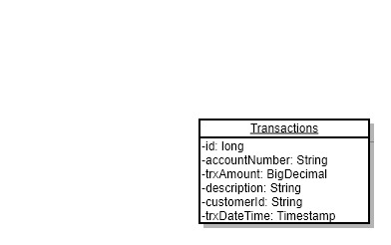

# Activity Diagram

