

SRI LANKA INSTITUTE OF INFORMATION TECHNOLOGY

[**Enterprise Standards and Best Practices for IT Infrastructure**](http://courseweb.sliit.lk/course/view.php?id=137)

**4th Year 2nd Semester 2016**

**VMotion**

|  |  |
| --- | --- |
| Name | ID Number |
| K.L.A.D.Udeshith | IT13149154 |
| S.M.N.K.B.Senanayake | IT13145026 |

SLIIT ID: Practical Session: <WD >

Date of Submission: 2016 - 09 - 09

**What is VMotion?**

Migrate Virtual machine currently run on a hardware to another available hardware or VMware VMotion enable the migration of running virtual machines from one physical server to another. It will help to improve overall hardware utilization, Continues service availability, and also automatically optimize and allocate entire pools of resources for maximum hardware utilization and availability. VMotion allow continued virtual machine operation while accommodating scheduled hardware downtime. Proactively migrate virtual machine away from failing or underperforming servers and allow VSphere distributed resource scheduler (RDS) to balance virtual machine across hosts

**How does VMotion Migration work?**

Virtual machine kernel 1 run on host 1 and migrate virtual machine to host 2 .To do that there should have shared storage between two host. The VM file should be store that storage. From that migration will be very quick because it is not copping any file have to copy from the first host to second host its memory state of the virtual machine .That performed across the network that we call VMotion network. VMware’s clustered virtual machine file system allow multiple installation of VMESXI server to access the same virtual machine file concurrently. Also the hard disk should be access both VMESXI because VM have to follow some repair process other VM can access the hard disk at the same time. All this Baremetal servers connect to a one local area network.

VMotion network is a private, non-routed, Giga bit or faster network connection between the two host enwalled in the VMotion migration. To pass small size data use the production network ethane connection. To pass the large or Mata data (configuration data) we need VMotion network and it shod be high speed one.

Virtual machine on the other hand is the production network. The host should be have identical network configuration including identical spelt labels for the virtual machine progress of the network such as the product network.

**Virtual machine requirements for VMotion migration**

* A virtual machine must not have a connection to a virtual device such as a CD-ROM or floppy drive with a local image mounted
* A virtual machine must note have a connection to an internal VSwitch
* A virtual machine must not have cpu affinity configured

**Host requirement for VMotion migration**

* All use virtual machine storages should be visible
* Fiber channel
* iSCSI or NAS
* Gigabit ethane network
* Access to the same physical network
* Compatible CPUs
* Same naming for virtual port groups
* Sufficient resources on the target host
* At least one VSphere essentials plus license on the corresponding ESXI host
* The virtual machine must be properly configured.
* The host must be licensed for VMotion
* The host must be running ESXI 5.1 or later one

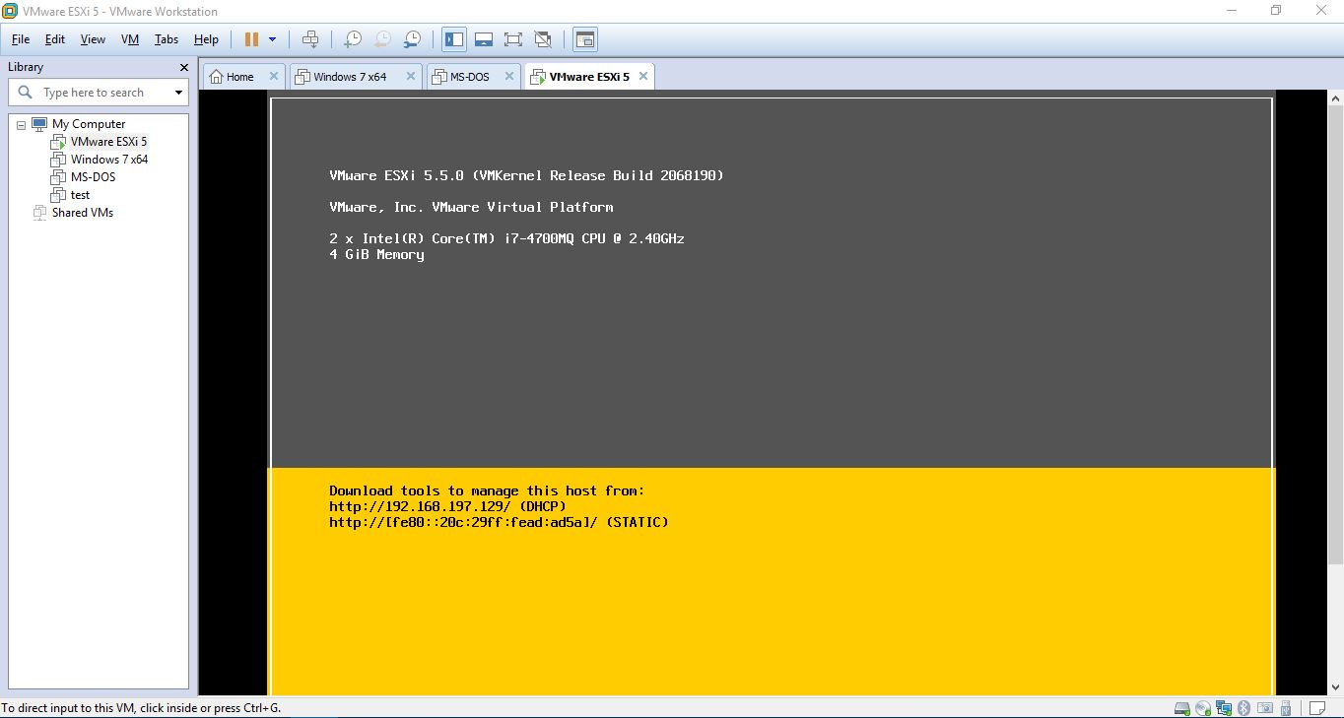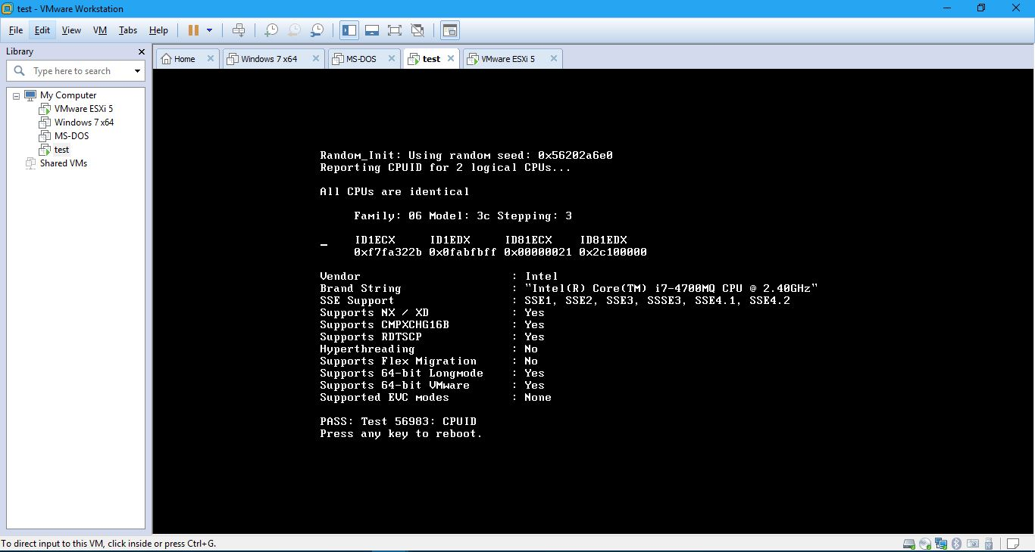**Identifying CPU characteristics**