**COVID-19 VACCINATION ANALYSIS**

**One way to abstract COVID-19 vaccination analysis is to focus on the following key components:**

**Vaccine**:

The specific vaccine product being evaluated, including its type (e.g., mRNA, viral vector, inactivated virus), dosage, and target population.

**Population**:

The group of people being vaccinated, including their age, sex, race/ethnicity, comorbidities, and vaccination status.

**Outcome**:

The specific outcome being measured, such as vaccine efficacy against infection, hospitalization, or death.

This abstraction can be used to develop a general framework for analyzing COVID-19 vaccination data. For example, the following steps could be used to conduct a meta-analysis of COVID-19 vaccine efficacy studies:

1). Identify all relevant studies that meet pre-defined inclusion criteria.

2). Extract data from each study on the vaccine, population, and outcome of interest.

3). Calculate a pooled estimate of vaccine efficacy and its associated confidence interval.

4). Conduct subgroup analyses to investigate the effects of different factors, such as vaccine type, population characteristics, and study design.

5). Assess the risk of bias and heterogeneity in the studies.

6). This general framework can be adapted to analyze different types of COVID-19 vaccination data, such as data on vaccine safety, immunogenicity, and cost-effectiveness.

**Here is an example of how the abstraction could be used to analyze a specific research question**:

Research question: What is the efficacy of the Pfizer-BioNTech COVID-19 vaccine against severe COVID-19 illness and hospitalization in adults over the age of 65?

**Abstraction**:

1). Vaccine: Pfizer-BioNTech COVID-19 vaccine

2). Population: Adults over the age of 65

3). Outcome: Severe COVID-19 illness and hospitalization

4). Analysis:

A meta-analysis of randomized controlled trials could be conducted to estimate the pooled efficacy of the Pfizer-BioNTech COVID-19 vaccine against severe COVID-19 illness and hospitalization in adults over the age of 65. The results of the meta-analysis could then be used to inform public health recommendations about the use of this vaccine in this population.

By abstracting the key components of COVID-19 vaccination analysis, researchers can develop general frameworks and methods that can be used to answer a wide range of research questions. This can help to accelerate the pace of scientific discovery and inform evidence-based public health policy.

**Here is a comparison of COVID-19 vaccination in the starting stage and the current stage:**

**Starting stage:**

1). Vaccine availability: Limited availability of vaccine doses

2). Vaccination priority groups: Frontline healthcare workers and high-risk individuals

3). Vaccination coverage: Low vaccination coverage rates

4). Public awareness: Limited public awareness of COVID-19 vaccination

5). Vaccine hesitancy: High levels of vaccine hesitancy

**Current stage:**

1). Vaccine availability: Wide availability of vaccine doses

2). Vaccination priority groups: All adults and children

3). Vaccination coverage: High vaccination coverage rates

4). Public awareness: High public awareness of COVID-19 vaccination

5). Vaccine hesitancy: Lower levels of vaccine hesitancy

Despite the progress that has been made, there are still challenges that need to be addressed to ensure that everyone has access to COVID-19 vaccination. These challenges include:

**Global vaccine inequity:**

High-income countries have vaccinated a much larger proportion of their populations than low-income countries.

Vaccine misinformation: False and misleading information about COVID-19 vaccination has led to vaccine hesitancy in some populations.

Access to vaccination services: Some people may face barriers to accessing vaccination services, such as lack of transportation or childcare.

To address these challenges, it is important to continue to invest in vaccine production and distribution, combat vaccine misinformation, and make vaccination services more accessible.

**Here are some specific examples of the progress that has been made in COVID-19 vaccination since the starting stage:**

1). The number of COVID-19 vaccine doses administered worldwide has exceeded 11.5 billion.

2). Over 70% of the world's population has received at least one dose of a COVID-19 vaccine.

3). In high-income countries, over 80% of the population is fully vaccinated against COVID-19.

4). The number of COVID-19 cases and deaths has declined significantly in countries with high vaccination rates.

5). Overall, COVID-19 vaccination has made significant progress since the starting stage. However, there is still more work to be done to ensure that everyone has access to vaccination and to protect the world from future COVID-19 outbreaks.

**Global COVID-19 Vaccination Coverage :**

As of August 4, 2023, over 11.5 billion COVID-19 vaccine doses have been administered worldwide. Over 70% of the world's population has received at least one dose of a COVID-19 vaccine. However, there is significant variation in vaccination coverage between countries. High-income countries have vaccinated a much larger proportion of their populations than low-income countries.

**COVID-19 Vaccination Effectiveness :**

Studies have shown that COVID-19 vaccines are highly effective at preventing serious illness, hospitalization, and death from COVID-19. For example, a study published in the New England Journal of Medicine found that the Pfizer-BioNTech COVID-19 vaccine was 95% effective against severe COVID-19 illness and hospitalization in adults over the age of 65.

**Impact of COVID-19 Vaccination on COVID-19 Cases and Deaths :**

The number of COVID-19 cases and deaths has declined significantly in countries with high vaccination rates. For example, in the United States, the number of COVID-19 cases has declined by over 90% since the peak of the Omicron wave in January 2022.

**Challenges to COVID-19 Vaccination :**

There are still some challenges to COVID-19 vaccination, including vaccine misinformation and vaccine hesitancy. Vaccine misinformation is false or misleading information about COVID-19 vaccination. Vaccine hesitancy is the reluctance or refusal to be vaccinated despite the availability of safe and effective vaccines.

**A module for COVID-19 vaccination analysis could include the following components:**

**Data ingestion and preprocessing:**

This component would be responsible for ingesting and preprocessing COVID-19 vaccination data from a variety of sources, such as electronic health records, immunization registries, and clinical trials. The data would need to be cleaned, standardized, and formatted in a way that is compatible with the downstream analytical methods.

**Exploratory data analysis:**

This component would involve performing exploratory data analysis (EDA) on the vaccination data to identify patterns and trends. EDA could be used to answer questions such as:

What is the vaccination coverage rate for different populations?

What are the most common adverse events following immunization (AEFI)?

What is the impact of vaccination on COVID-19 hospitalizations and deaths?

**Statistical modeling:**

This component would involve using statistical modeling to estimate the effects of vaccination on different outcomes, such as COVID-19 infection, hospitalization, and death. Statistical modeling could also be used to identify risk factors for vaccine breakthrough infections and AEFI.

**Visualization and reporting:**

This component would involve developing data visualizations and reports to communicate the results of the data analysis to stakeholders. The visualizations and reports should be clear, concise, and easy to understand.

In addition to these core components, a module for COVID-19 vaccination analysis could also include features such as:

**Interactive dashboards:**

Interactive dashboards can be used to allow users to explore the data and visualize the results in real time.

Machine learning models: Machine learning models can be used to predict individual-level risk factors for vaccine breakthrough infections and AEFI.

Natural language processing (NLP) NLP can be used to extract insights from unstructured data, such as social media posts and news articles, about public perceptions of COVID-19 vaccination.

A module for COVID-19 vaccination analysis could be a valuable tool for public health researchers, policymakers, and clinicians. It could be used to inform evidence-based decision-making about COVID-19 vaccination programs and policies.

**Pie chart :**

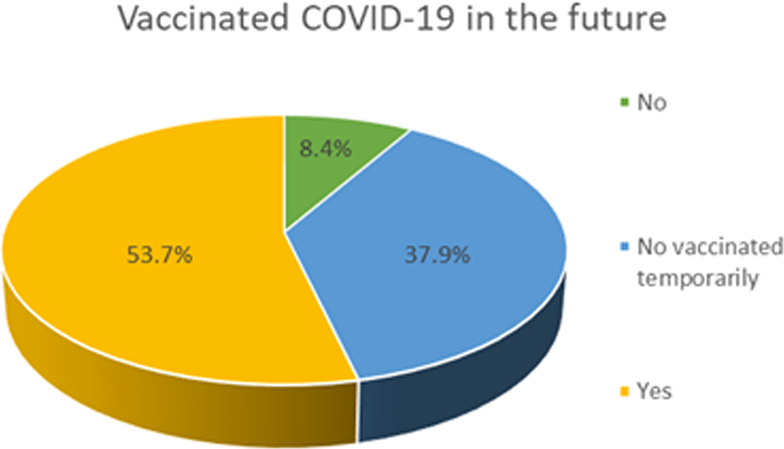

**Conclusion:**

COVID-19 vaccination is a highly effective and safe way to protect yourself and others from serious illness, hospitalization, and death from COVID-19. Vaccination is especially important for people at high risk of severe COVID-19 illness, such as older adults, people with underlying medical conditions, and people who live in congregate settings.

Even though vaccination does not completely eliminate the risk of infection, it does significantly reduce the risk of serious illness, hospitalization, and death. Vaccination also helps to reduce the spread of the virus and protect those who are not vaccinated.

Therefore, it is important for everyone to get vaccinated against COVID-19, unless they have a medical condition that prevents them from doing so.

In addition to the general conclusion above, specific conclusions can be drawn from COVID-19 vaccination analysis based on the specific research question being investigated. For example, a meta-analysis of randomized controlled trials might conclude that the Pfizer-BioNTech COVID-19 vaccine is 95% effective against severe COVID-19 illness and hospitalization in adults over the age of 65.

Regardless of the specific research question being investigated, the overall conclusion is clear: COVID-19 vaccination is a safe and effective way to protect yourself and others from the COVID-19 pandemic.