**COVID VACCINATION ANALYSIS :**

**SUMMARY OF COVID VACCINATION ANALYSIS :**

## **MECHANISM :**

The design of the COVID-19 vaccines must take into account both humoral and cellular immunity. In addition, COVID-19 is mainly spread through the respiratory tract and contact, so the role of mucosal immunity in preventing viral infections should be paid more attention. The virus contains four structural proteins. They are Spike S protein, Envelope E protein, Membrane/matrix protein, and Nucleocapsid N protein. The S protein has two subsections, S1 and S2. The S protein binds to specific receptors, causing the virus to infect cells. The neutralizing antibody against the S protein can block this process and prevent the virus from invading. S protein can also effectively stimulate T-cell immune response, so it is the most important target antigen for vaccine design. N and M proteins have also been shown to induce the body to produce an efficient cellular immune response.

**TYPES OF VACCINATION** :

### 1. DNA vaccines :

DNA vaccines can enter cells like viral infections and use the host protein translation system to generate target antigens. As an endogenous immunogen, it can induce humoral and cellular immune responses at the same time. Given the advantages of nucleic acid vaccines, DNA vaccines do not require live viruses, so safety is improved. DNA vaccines insert genes encoding foreign antigens into plasmids containing eukaryotic expression elements and then directly introduce the plasmids into humans or animals, allowing them to express antigen proteins in host cells and induce immune responses to prevent diseases.

The manufacturing process of plasmid DNA is relatively straightforward, and the double-strand DNA molecules are more stable than the virus and can be freeze-dried for long-term storage. DNA vaccine vaccination method limits its application. Since the vaccine is mainly distributed in the intercellular space after vaccination, only a very small amount can enter the cell to produce protein immunogen, so the immune effect is greatly reduced. The plasmid DNA vaccine's main prohibitory factor is the low transfection efficacy, which requires transfection modalities. For example, Inovio's COVID-19 vaccine candidate, INO-4800, uses a handheld electroporation device, CELLECTRA. The vaccine will be injected intradermally along with the electrodes. An electric pulse is then applied to open the cell membrane so that the plasmid can enter the cells. Using an established device may allow fast launch in clinical trials, but it also brings other obstacles to large-scale vaccination. Although nucleic acid vaccines can effectively induce systemic immune responses, their immunogenicity is weak, and mucosal immune responses are not easy to produce. Although a few animal DNA vaccines have been on the market, no human DNA vaccine has been approved for marketing so far. Combination with other vaccines will achieve better immune effects.

### 2. mRNA vaccines :

Compared with DNA vaccines that need to enter the nucleus, mRNA vaccines only need to enter the cytoplasm to achieve target antigens’ expression, so they are theoretically safer. In recent years, mRNA vaccines have been developed rapidly. Although the mRNA vaccines for rabies virus and influenza virus have completed phase I clinical evaluation, the immune effect is not satisfactory, such as a relatively high proportion of headaches, fatigue, and side effects such as muscle pain. The immune protection generated by the vaccine declined rapidly within one year, and no cellular immune response was detected. Therefore, it is necessary to improve further the immune efficacy and long-term protection of mRNA vaccines. So far, there is no mRNA vaccine on the market. However, the research of mRNA vaccines has been in the process of exploration and advancement. Many institutions at home and abroad have quickly initiated the research and development of COVID-19 mRNA vaccines. The mRNA vaccine developed by the National Institute of Allergy and Infectious Diseases (NIAID) and Moderna has taken the lead to initiate a phase I clinical trial. Moderna's vaccine, mRNA-1273, specifically encodes the S antigen's prefusion form, including a transmembrane anchor and an entire S1−S2 cleavage site.

### 3. Non-replicating viral vector vaccines :

One of the most explored viral vector options is the Adenovirus (Ad), currently being used by both CanSino and Oxford/ AstraZeneca. Adenovirus is common cold viruses with a double-stranded DNA genome. CanSino is using Ad type 5 (Ad5) and named the vaccine Ad5-nCoV. Ad5-nCoV can encode for the full-length S protein of SARS-CoV-2. This gene is derived from the Wuhan-Hu-1 sequence of SARS-CoV-2 and is cloned into the E1- and E3-deleted Ad5 vector together with the tissue plasminogen activator signal peptide. The effectiveness of this vaccine is relatively high, but the disadvantage is that it may not effective for people with recessive infectious viruses.

### 4. Inactivated vaccines :

Inactivated vaccines are the most classic form of vaccines. They are easy to prepare and can efficiently cause humoral immune responses. They are often the first choice for new infectious diseases. Inactivated vaccines are mainly obtained through three inactivation methods, such as formaldehyde, β-propiolactone, and ultraviolet. SARS and MERS inactivated vaccines can cause mice, hamsters, ferrets, and monkeys to produce high-titer neutralizing antibodies. The SARS-inactivated vaccine has completed phase I clinical trials, proving that it is safe in humans and can induce neutralizing antibodies’ production. However, the T-cell immune response caused by inactivated vaccines is generally weak. Previous studies have shown that SARS- and MERS-inactivated vaccines cannot effectively stimulate the body to produce cellular immune responses. Although high titers of serum neutralizing antibodies are produced, the protective effect is also not satisfied. Some studies have found that the MERS-inactivated vaccine can cause pathological allergic reactions in mice's lungs. Currently, the inactivated SARS-CoV-2 vaccine (Vero cells) is being used. In addition, vaccine production requires the operation of high concentrations of live viruses, which poses a certain biological safety risk.

### 5. Live attenuated vaccines :

Live attenuated vaccine reduces virus virulence through point mutation or deletion of crucial virus protein but does not affect its immunogenicity and replication ability. This vaccine program has very good immunogenicity and can induce systemic immunity and mucosal immune response, and the immunity is lasting. Several live attenuated vaccines have been on the market, including yellow fever, smallpox, measles, polio, mumps, rubella, and chickenpox. The SARS live attenuated vaccine will recover its virulence after continuous passage in cells or mice, suggesting that the vaccine scheme has a greater biological safety risk. Without sufficient evidence to ensure that live attenuated vaccines will not regain strength, this strategy is not currently recommended for COVID-19 vaccine development.

**Vaccine Efficacy:**

Assessing the effectiveness of COVID-19 vaccines in preventing infection, reducing the severity of illness, and preventing hospitalization and death.

**Vaccine Distribution:**

Analyzing the distribution and allocation of vaccines to different regions, populations, and countries, ensuring equitable access.

**Vaccine Hesitancy:**

Studying factors influencing vaccine hesitancy, addressing misinformation, and promoting vaccine acceptance.

**Herd Immunity:**

Evaluating progress toward achieving herd immunity through vaccination and estimating the percentage of the population that needs to be vaccinated.

**Variants:**

Monitoring the impact of new COVID-19 variants on vaccine efficacy and adjusting vaccination strategies accordingly.

**Booster Shots:**

Assessing the need for and effectiveness of booster doses to maintain immunity, especially in the context of waning immunity.

**Adverse Events:**

Analyzing and reporting adverse events following vaccination to ensure vaccine safety and build public trust.

**Global Impact:**

Examining the global efforts to ensure vaccination in lower-income countries and the effect of vaccination on global health and economy.

**Vaccine Passports:**

Assessing the implementation and impact of vaccine passports for travel, events, and other activities.

**Public Health Outcomes:**

Measuring the impact of vaccination on reducing COVID-19 cases, hospitalizations, and deaths, and the overall control of the pandemic.

**Piechart :**

(1).

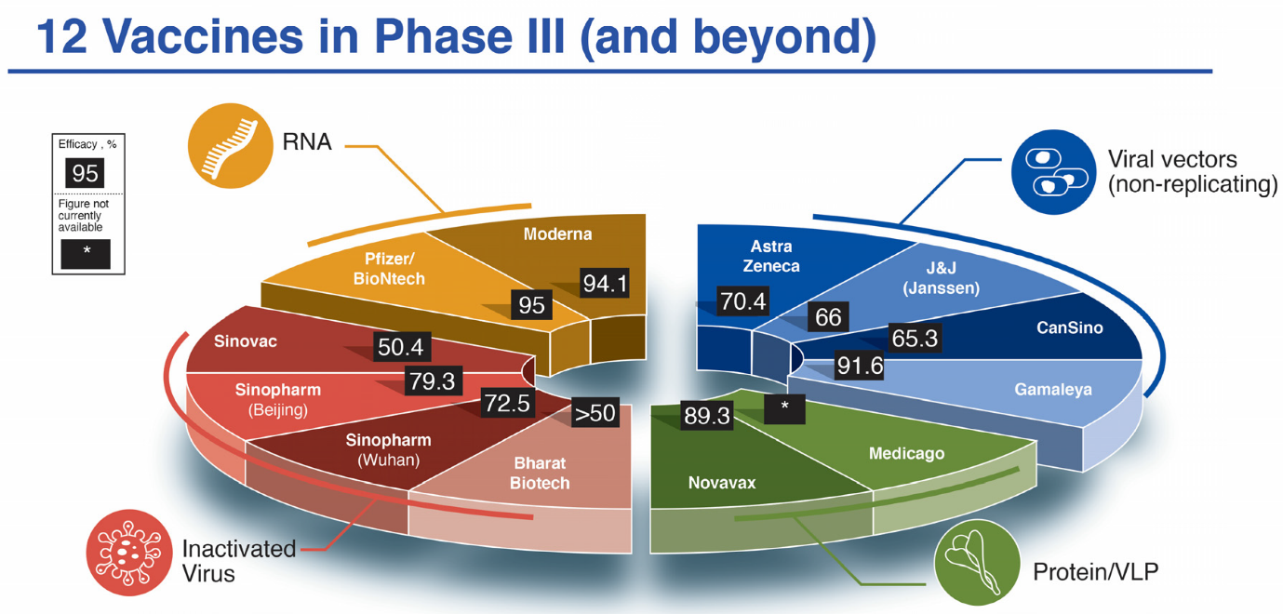

(2).

