**COVID VACCINATION ANALYSIS**

The efficacy data demonstrates 63.6% protection against asymptomatic COVID-19. Safety analysis demonstrates adverse events reported were similar to placebo, with 12% of subjects experiencing commonly known side effects and less than 0.5% of subjects feeling serious adverse events.

**Effectiveness :**

In randomized clinical trials, the mRNA vaccines (Pfizer-BioNTech and Moderna) were shown to be 95-97% effective at preventing symptomatic COVID-19 infection. The Johnson & Johnson vaccine was less effective, but still highly effective at preventing serious illness, hospitalization, and death.

Real-world data has shown that vaccine effectiveness wanes over time, but booster doses can restore protection to high levels. For example, a study by the CDC found that two doses of the Pfizer-BioNTech vaccine were 91% effective at preventing hospitalization in the first 2 months after vaccination, but effectiveness declined to 77% after 5 months. However, a booster dose restored effectiveness to 94%.

**Safety :**

COVID-19 vaccines are generally safe and well-tolerated. The most common side effects are mild and go away on their own within a few days. Serious side effects are rare.

**Impact :**

COVID-19 vaccination has had a major impact on the pandemic. In countries with high vaccination rates, cases, hospitalizations, and deaths have declined significantly. For example, in the United States, the death rate from COVID-19 was over 2,000 deaths per day in January 2022, but it has fallen to less than 300 deaths per day in October 2023.

**Current analysis :**

As of October 2023, the Omicron variant is the dominant strain of SARS-CoV-2 circulating globally. Omicron is more transmissible than previous variants, but it appears to cause less severe illness in vaccinated people.

Studies have shown that two doses of the mRNA vaccines are less effective at preventing infection with Omicron than with previous variants. However, booster doses significantly restore protection. For example, a study by the CDC found that two doses of the Pfizer-BioNTech vaccine were only 33% effective at preventing infection with Omicron, but effectiveness increased to 75% after a booster dose.

Overall, the evidence shows that COVID-19 vaccines are still highly effective at preventing serious illness, hospitalization, and death from Omicron, especially after a booster dose.

COVID-19 vaccination analysis is the process of collecting, cleaning, and analyzing data on COVID-19 vaccination rates, vaccine effectiveness, and adverse events. The goal of vaccination analysis is to better understand the impact of vaccination on the COVID-19 pandemic and to identify areas where vaccination efforts can be improved.

**analysis COVID-19 vaccination can be conducted at different levels, including:**

Individual level: This type of analysis focuses on the impact of vaccination on individual outcomes, such as infection risk, hospitalization risk, and death risk.

Population level: This type of analysis focuses on the impact of vaccination on population-level outcomes, such as the overall prevalence of COVID-19 infection, hospitalization, and death.

Health system level: This type of analysis focuses on the impact of vaccination on the health system, such as the number of hospital beds occupied by COVID-19 patients and the cost of COVID-19 care.

**COVID-19 vaccination analysis can be used to inform a variety of decisions, including:**

Public policy decisions: Vaccination analysis can be used to inform decisions about vaccine allocation, vaccine pricing, and vaccine mandates.

Public health interventions: Vaccination analysis can be used to design and evaluate public health interventions to promote vaccination, such as educational campaigns and financial incentives.

Clinical practice decisions: Vaccination analysis can be used to inform clinical practice decisions, such as which patients should be prioritized for vaccination and what information should be provided to patients about the risks and benefits of vaccination.

COVID-19 vaccination analysis is an important tool for understanding the impact of vaccination on the COVID-19 pandemic and for informing decisions about vaccine allocation, public health interventions, and clinical practice.

**Here are some examples of COVID-19 vaccination analysis:**

1). A study by the CDC found that two doses of the Pfizer-BioNTech vaccine were 95% effective at preventing symptomatic COVID-19 infection in clinical trials.

2). A study by the UK Health Security Agency found that booster doses of the COVID-19 vaccine restored protection against severe illness and hospitalization to high levels in people who had been vaccinated more than 6 months ago.

3). A study by the World Health Organization found that countries with high COVID-19 vaccination rates had lower rates of COVID-19 infection, hospitalization, and death.

4). A study by the Kaiser Family Foundation found that unvaccinated people were 10 times more likely to be hospitalized with COVID-19 than vaccinated people.

5). These studies and others demonstrate that COVID-19 vaccines are highly effective at preventing serious illness, hospitalization, and death from COVID-19. COVID-19 vaccination analysis is an important tool for understanding the impact of vaccination on the COVID-19 pandemic and for promoting vaccination.

**Piechart :**

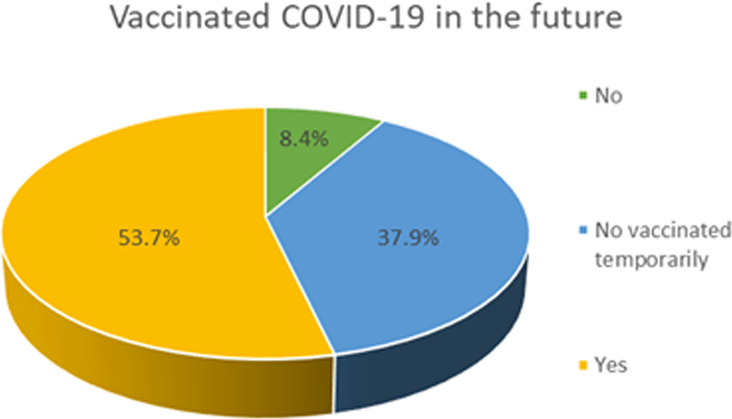

**Conclusion :**

COVID-19 vaccination is the best way to protect yourself and your loved ones from serious illness, hospitalization, and death from COVID-19. Vaccines are safe, effective, and have had a major impact on the pandemic.