OLIST E-COMMERCE DATA ANALYSIS CASE STUDY

Summary
Project Objective
The objective of this project was to analyze the Olist E-commerce dataset to understand customer purchasing behavior, revenue performance, delivery efficiency, and customer satisfaction.
The analysis focused on identifying operational issues affecting customer experience and generating actionable business recommendations.

Business Problem Statement
E-commerce businesses depend heavily on customer satisfaction and operational efficiency.
Delivery delays, customer feedback, and regional demand patterns directly impact customer retention and business growth.
This project aimed to identify:
- Delivery performance impact on customer reviews
- Revenue trends and customer behavior
- Regional order distribution
- Customer satisfaction drivers
- Operational improvement opportunities

Business Questions
- How do delivery delays affect customer reviews?
- Which states contribute the highest customer orders?
- What are the major revenue trends?
- Which product categories perform best? s
- How can operational efficiency be improved?

Tools & Technologies Used
Tools | Purpose
Python | Data Cleaning & Eda
Panda & Numpy | Data Processing
Matplotlib | Visualization
Power BI | Dashboard Development

Exploratory Data Analysis (EDA)
Dataset Overview:
The Olist E-commerce dataset contains multiple related tables used to analyze customer behavior, delivery performance, and customer satisfaction.
Tables used:
- Customers
- Orders
- OrderItems
- OrderPayments
- OrderReview
- Products
- Sellers
- ProductCategory
- Geolocation
Power BI relationships were created to build the data model.

Data Cleaning & Preparation
The following preprocessing steps were performed:
Missing Value Handling
- Checked null values across datasets
- Missing review comments were replaced with: No Review
- Dataset consistency was maintained before analysis.
Feature Engineering
Two new features were created:

Late Delivery
Used to identify delayed orders.
1 = Late Delivery
0 = On-time Delivery

Delivery Days
Calculated total delivery duration.
Formula:
Delivery Days = Delivered Customer Date − Purchase Date
KPI Metrics Developed
Business KPIs created:
KPI | PURPOSE
Total Orders | Customer order volume
Revenue | Business performance
Avg Review Score | Customer satisfaction
Late Delivery % | Operational performance
Avg Delivery Days | Delivery efficiency

Hypothesis Testing & Dashboard Insights
Hypothesis Statement
- Null Hypothesis (H0)
Delivery delays do not affect customer review scores.
- Alternative Hypothesis (H1)
Delivery delays negatively affect customer satisfaction.
Analysis Results
Average Review Scores:
- On-time Deliveries≈ 4.13
- Late Deliveries≈ 2.54
Result:
Customers receiving delayed deliveries provided significantly lower ratings.
Conclusion
- The analysis rejected the null hypothesis.
- Delivery performance strongly affected customer reviews.
- Business Impact: Poor delivery experience may reduce customer retention and repeat purchases.

Dashboard Insights

Dashboard 1 — Business Overview
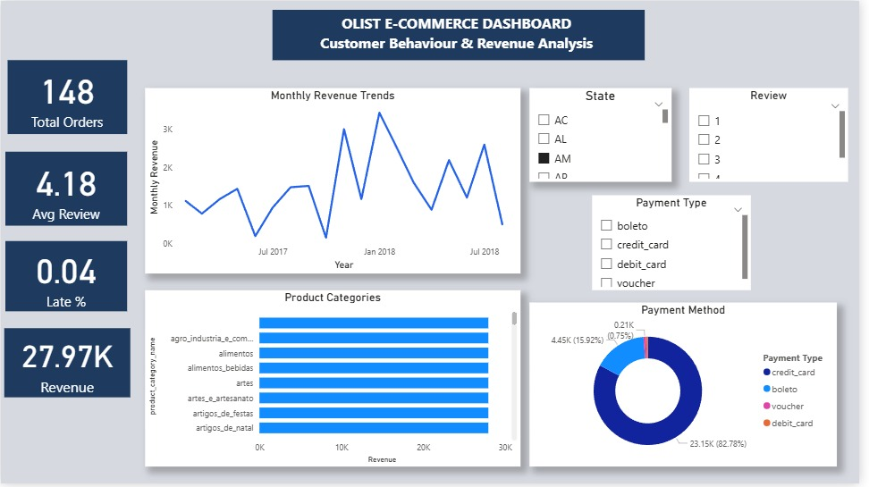

Key Findings
Revenue showed growth trend over time.
Top product categories contributed major business performance.
Dashboard 2 — Delivery & Customer Insights
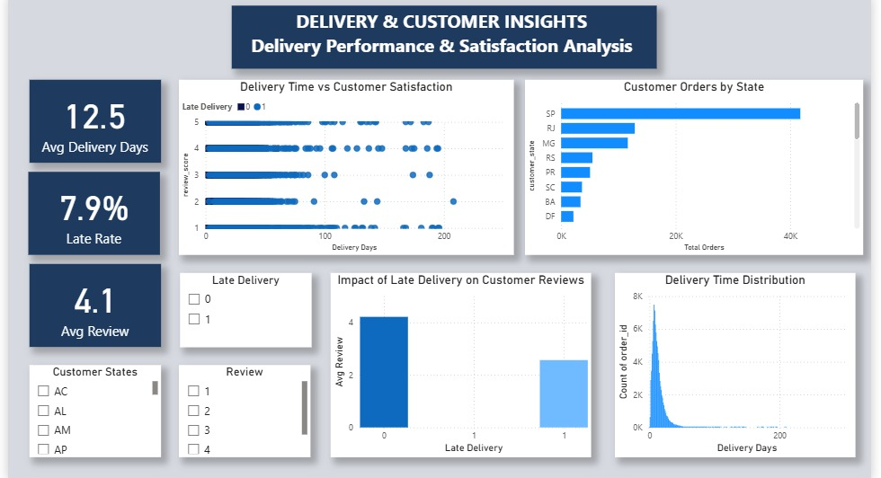

Key Insight
Late deliveries reduced review score from:
4.13 → 2.54
Recommendation:
Improve logistics efficiency and delivery monitoring.

Business Recommendations
Based on the analysis, the following recommendations were identified:
Recommendation 1 — Improve Delivery Performance
Observation:
Late deliveries reduced customer review scores from:
4.13 → 2.54
Recommendation:
Improve logistics tracking and delivery monitoring systems to reduce delivery delays.

Recommendation 2 — Focus High Demand States
Observation:
SP showed highest customer order concentration.
Recommendation:
Prioritize inventory planning and customer acquisition strategies in high-demand regions.

Recommendation 3 — Customer Experience Monitoring
Recommendation:
Track customer reviews continuously to identify operational issues affecting satisfaction.

Recommendation 4 — Product Category Optimization
Recommendation:
Increase focus on top-performing product categories to improve business performance.

Further Exploration
Future analysis opportunities:
- Customer Segmentation
- Cohort Analysis
- Churn Prediction
- Demand Forecasting
- Customer Lifetime Value Analysis
- Seller Performance Evaluation
LLM Usage Disclosure
LLM Used:
ChatGPT (GPT-5)
Usage Areas:
- Documentation structuring support
- Report formatting guidance
- Dashboard layout planning assistance

