**PROJECT ON**

**ONLINE NEWS PORTAL SYSTEM**

**Team members**

**Chityala Udhay(18311A05R4)**

**Nakka Satish Kumar(18311A05V2)**

**ABSTRACT**

News Portal Project using PHP and MySQL is a web based application. It is a dynamic system. It can be maintain n and changed easily because it is based on database. It’s contain web pages that are generated in real-time. These pages include Web scripting code, such as PHP. It is fully secured from unauthorized access. In a word in a word it can say that our Online News Portal website is a completely dynamic website.

Now-a-days we live in age of Information Communication and Technology. We can’t think a single moment without technology. From morning to night, we need help of the technology. This is the revolutionary time of computer technology. Most of the works depends on web application. For this reason, anytime, anywhere, anyone can access a website by internet at low cost and we can find our expectable and most update information from website. At present information is one the most valuable resource of the current world. We have developed our project so that we can aware the people.

**Table of contents**

Introduction

Existing method

Proposed method with Architecture

Methodology

Uml diagrams

Implementation

Conclusion and future scope

**Introduction**

Now-a-days we live in age of Information Communication and Technology . We can’t think a single moment without technology. From morning to night, we need help of the technology. This is the revolutionary time of computer technology. Most of the works depends on web application. For this reason, anytime, anywhere, anyone can access a website by internet at low cost and we can find our expectable and most update information from website. At present information is one the most valuable resource of the current world. We have developed our project so that we can aware the people.

**Objective of the Present Work**

* The objective of this project is to develop a web application for Online News Paper website that can aware the people
* The objective of this project is to provide the daily news.
* The objective of this project is to provide the breaking news.
* It makes use of various technologies to get required crime oriented information more quickly, easily, colorfully and attractively.
* Anytime, anywhere, anyone can know about the news or information by internet at low cost.
* Dynamically provides facility.
* To add any new information without any complexity.

**EXISTING SYSTEM:**

* In the present system a customer has to approach various book stall to find news paper
* It is a very long process. First to buy the newspaper and then to go through every page of the paper.
* If someone is looking for some specific sector news, then it got tough for them to get the news directly.

**PROPOSED SYSTEM:**

* The proposed system is a web based application and maintains a centralized repository of all related information.
* The system allows one to easily access the relevant information about news
* Users can decide what content to be read or to see.

**Architecture Design :**

**START**

**SEARCH**

**HOME**

**CONTACT US**

**CATEGORIES**

**search.php**

**ABOUT**

**categories.php?catid=2**

**contact-us.php**

**news-details.php**

**about-us.php**

**news-details.php**

**index.php**

**Leave Comment**

**Leave Comment**

**END**

**Fig. 4.1: The user panel flowchart part**

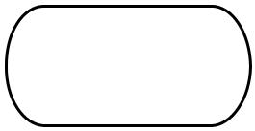**Admin Login Flow Chart:**

**Start**

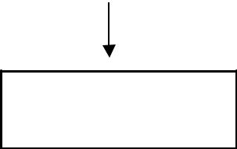

**admin Login**

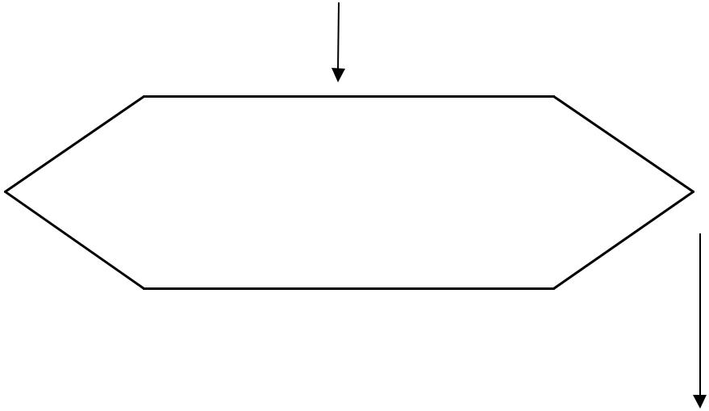

**if($_POST['username]==$arr[username]**

**&&**

**Manage Comments**

**Approve/ Unapprove / Delete**

**password_verify($password, $hashpassword)**

**No**

 **Yes**

**Dashboard**

**Dashboard.php**

**Wrong username OR password**

**Change Password**

**logout**

**Category**

**ADD/ UPDATE / DELETE**

**SubCategory**

**ADD/ UPDATE /DELETE**

**Pages**

**About & Contact us**

**UDATE Details**

**Posts /News**

**ADD/UPDATE/TRASHED/ RECOVERY/DELETE**

**RESULT**

**UML DIAGRAMS**

**Use Case Diagram**

**User Case Diagram**

**USER**

**Admin Case Diagram**

**ADMIN**

**Relationship between tables (Class Diagram)**

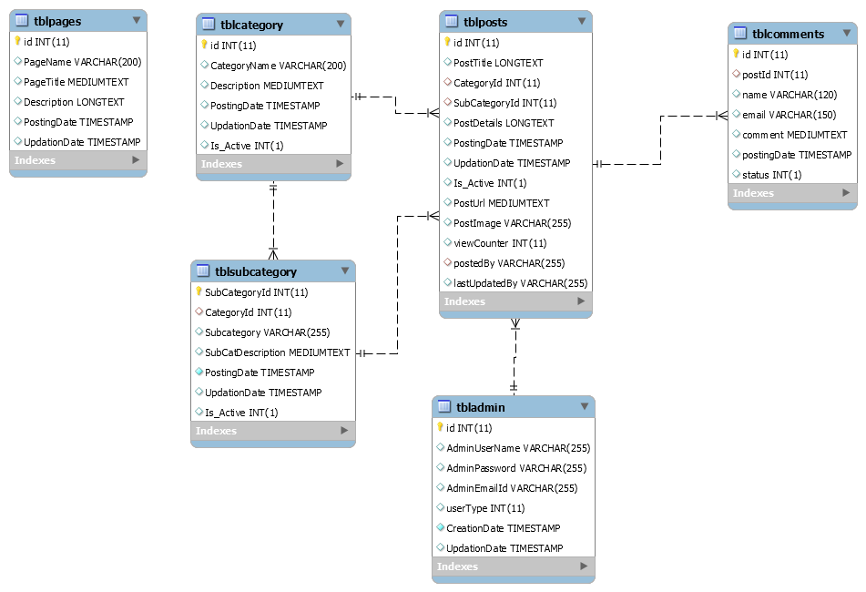

**METHODOLOGY**

We divided system development phase’s activities into three categories. These provide components of the development phase that can construct the program and including a list of the programs needed to meet the systems objectives and complete documentation

To complete our system development we three type of specification. These are……………..

**1.** User specification.

**2.** Admin specification.

**3.** Files and database.

The proposed systems are physically developed in this stage. User specification or output specification provides the proposed system goals. User specification stage fulfilled the user need by preparing building blocks of the system .User specification are developed by based on output design. It provides total outlook of the system and offer various features for user.

**News having three modules i.e. user , admin, sub-admins**

**User module**

Anyone can read the news and also search for particular news. The reader can leave comments on the particular news.

**Admin Module**

Secure admin login system

**Admin Dashboard:** In this section admin can view, listed categories & sub categories, total published news & trashed news.

**Sub-admin:** In this section, admin can add/edit/delete sub-admin.

**Category –** In this section admin can add/update/delete the category. Admin can also restore deleted category.

**Sub- Category –** In this section admin can add/update/delete the Subcategory. Admin can also restore deleted Subcategory.

**Post –** Admin can add /update / delete news posts. admin can also view deleted news post in trash post section and restore deleted posts.

**Pages –** Admin can manage the contact of about us and contact us page.

Comments – Admin can approve/ unapproved / delete reader comments.

**Su-bAdmin Module**

Sub-Admin and Admin features are the same except Sub-Admin creation. Sub-Admin can’t create the Sub-Admins.

**IMPLEMENTATION :**

The data in the system has to be stored and retrieved from database. Designing the database is part of system design. Data elements and data structures to be stored have been identified at analysis stage. They are structured and put together to design the data storage and retrieval system.

A database is a collection of interrelated data stored with minimum redundancy to serve many users quickly and efficiently. The general objective is to make database access easy, quick, inexpensive and flexible for the user. Relationships are established between the data items and unnecessary data items are removed. Normalization is done to get an internal consistency of data and to have minimum redundancy and maximum stability. This ensures minimizing data storage required, minimizing chances of data inconsistencies and optimizing for updates. The MySQL database has been chosen for developing the relevant databases.

**Database tables and Structure**

We have organized one database **news portal** for system design. It can be accessed directly or sequentially by registered. The database determines files, record, fields, and characters. It can be easily controlled and updated. This database and its table and component are described by using flow diagram that is given in the below……….

**Newsportal Database has 6 tables**

* tbladmin
* tblcategory
* tblcomments
* tblpages
* tblposts
* tblsubcategory
* **tbladmin**

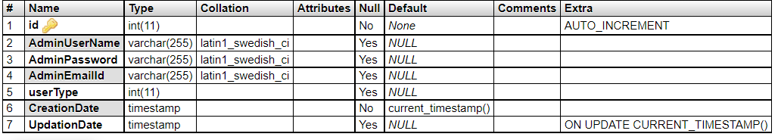

* **tblcategory**

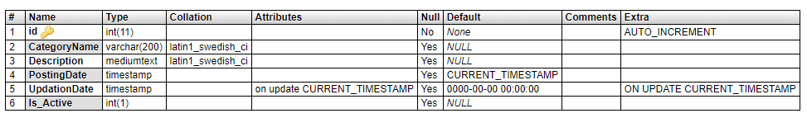

* **tblcomments**

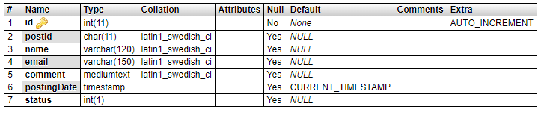

**tblpages**

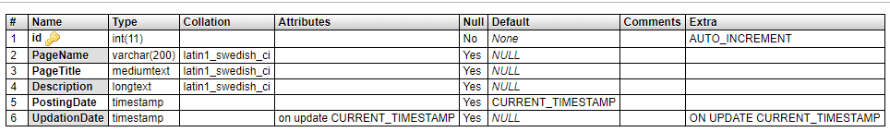

* **tblposts**

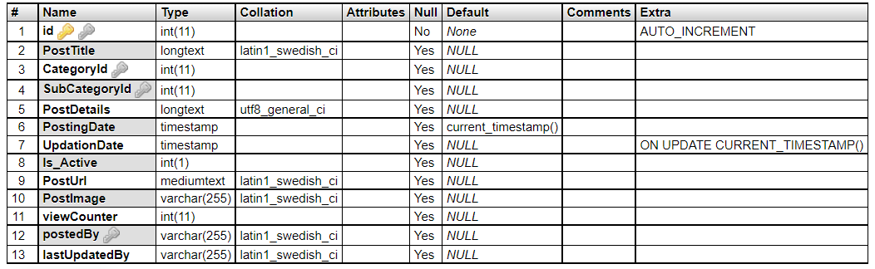

* **Tblsubcategory**

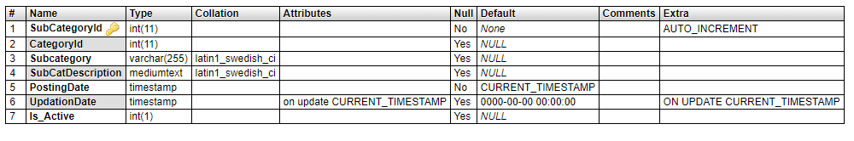

**OUTPUTS SCREENSHOTS**

**About us**

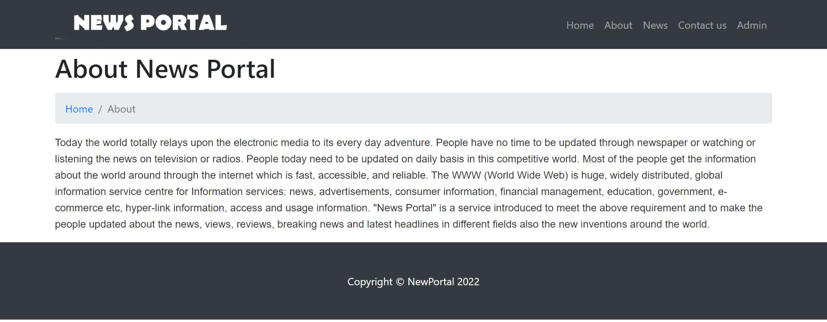

**Contact Us**

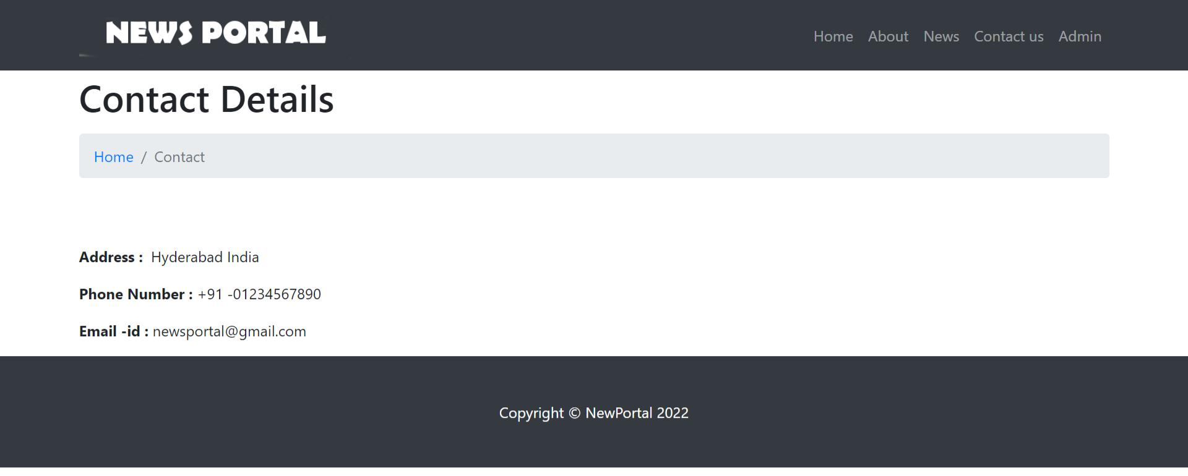

**News**

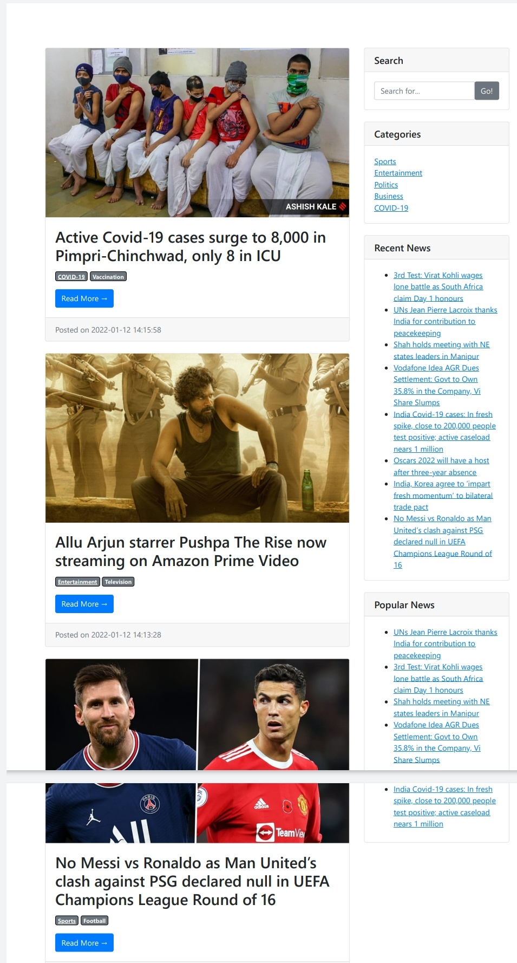

**Admin Login**

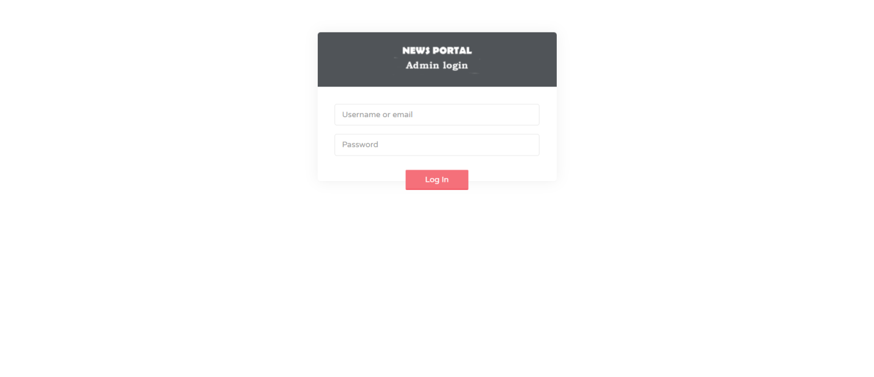

**Dashboard**

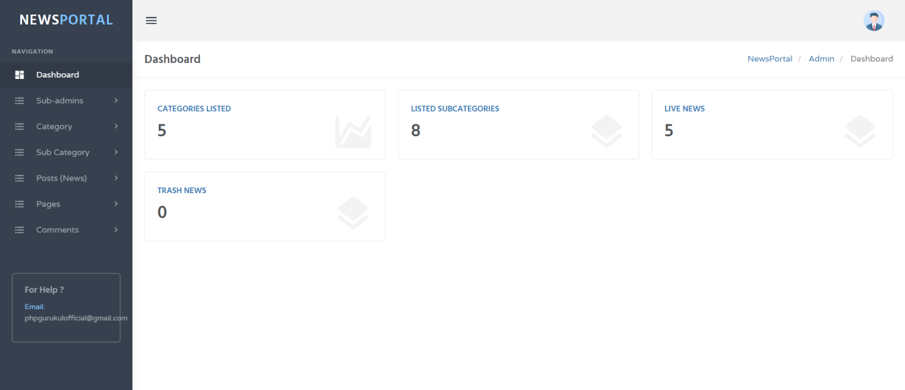

**Change Password**

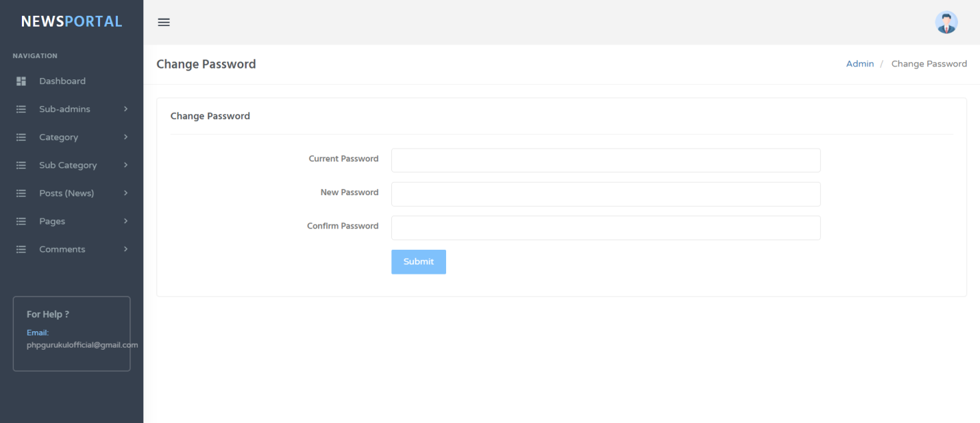

**Add Sub Admin**

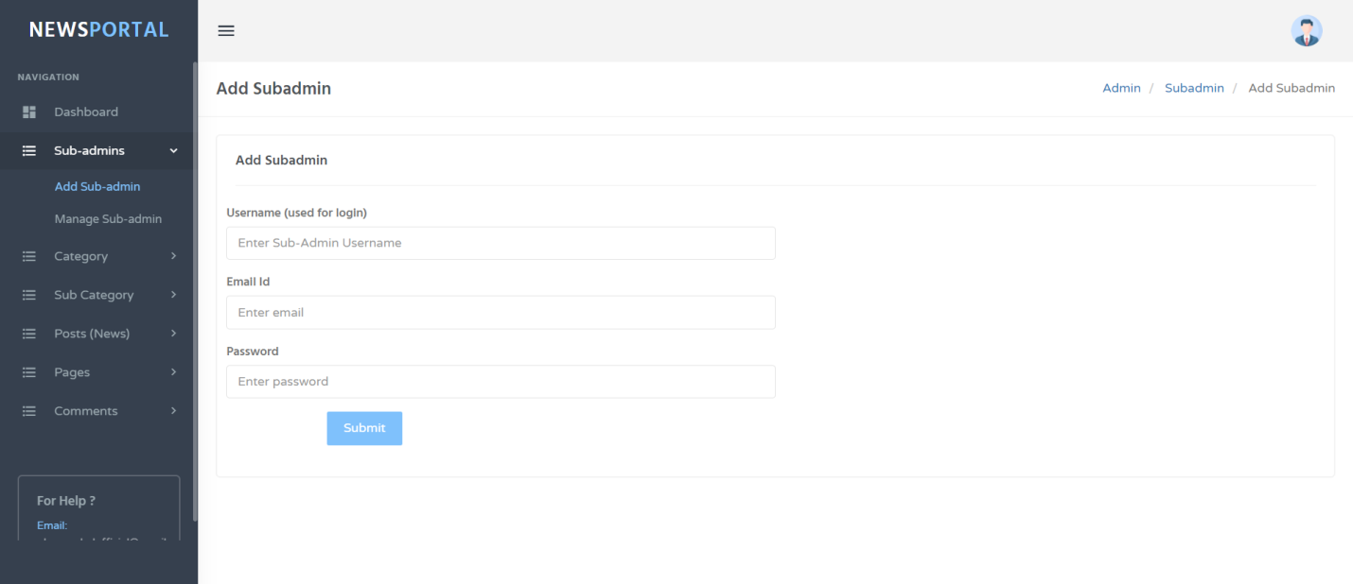

**Manage Subadmin**

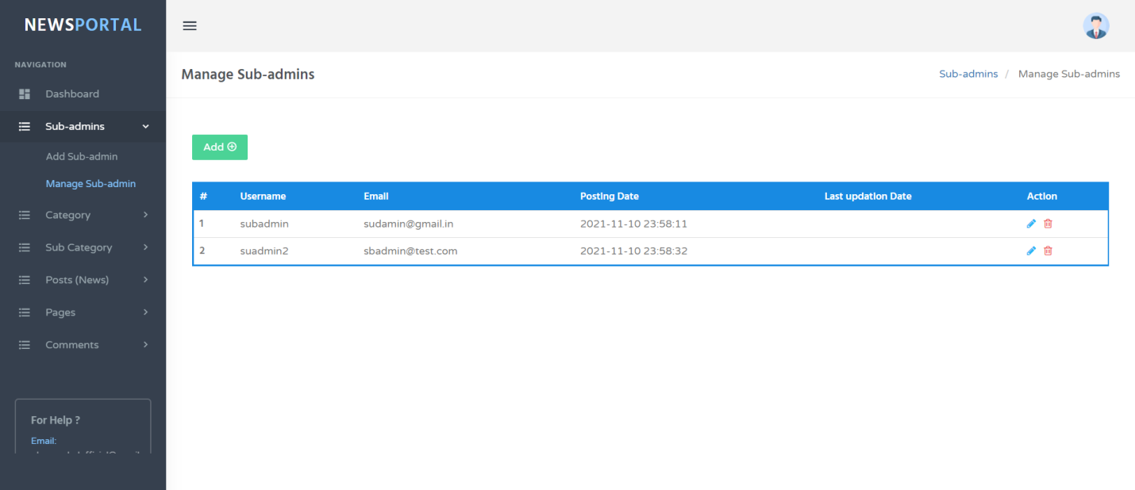

**Update Subadmin**

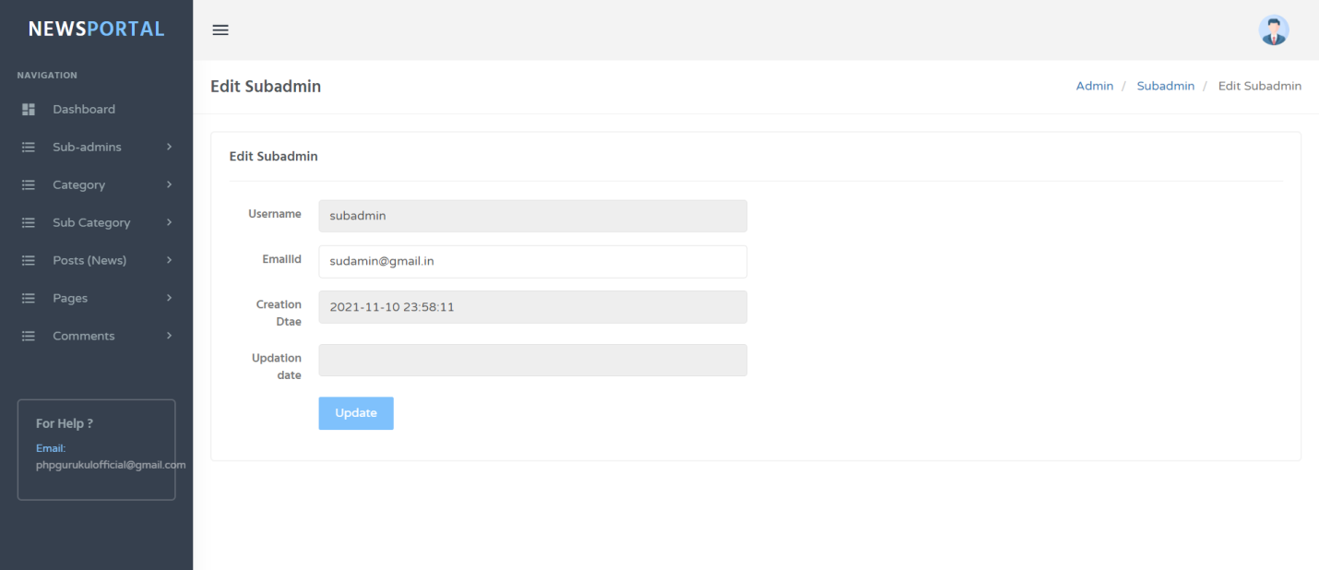

**Add Category**

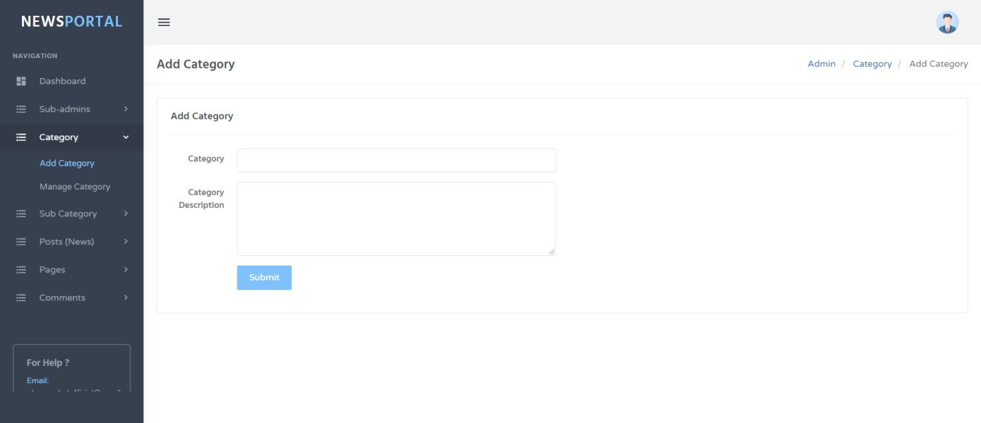

**Manage Category**

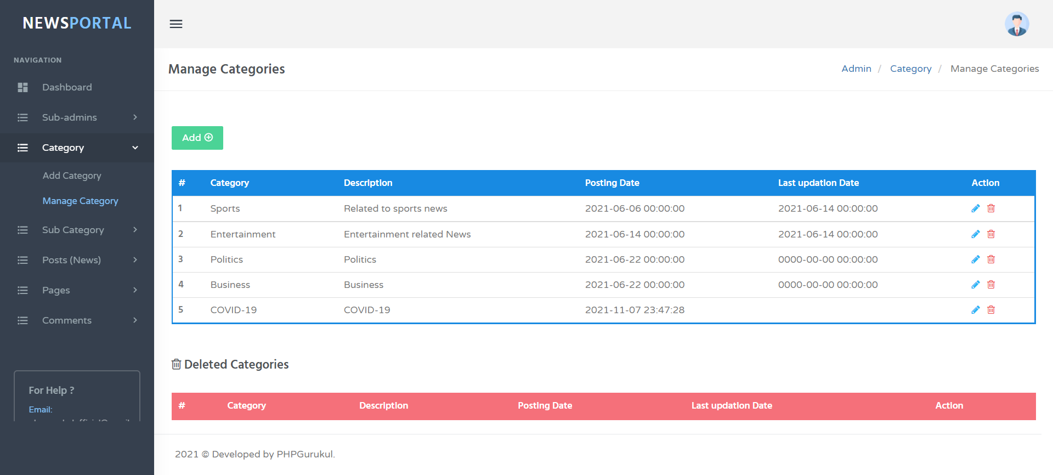

**Update Category**

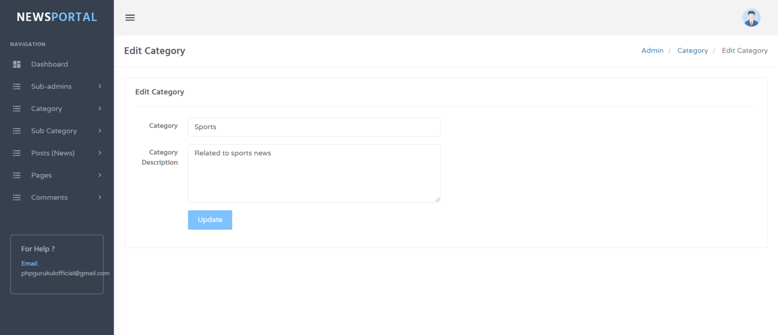

**Add Sub-Category**

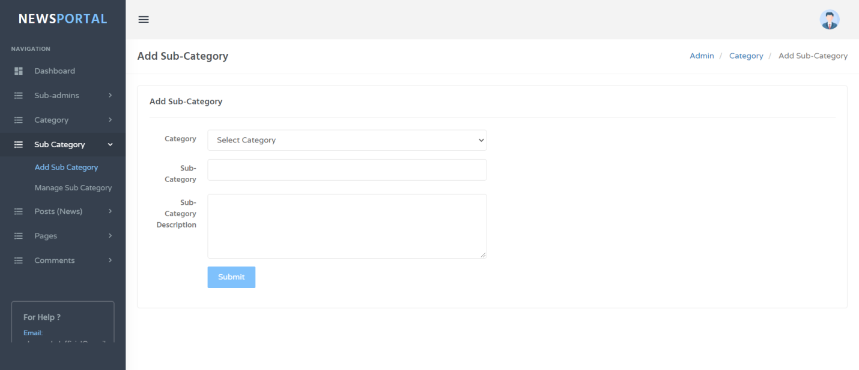

**Manage Sub-Category**

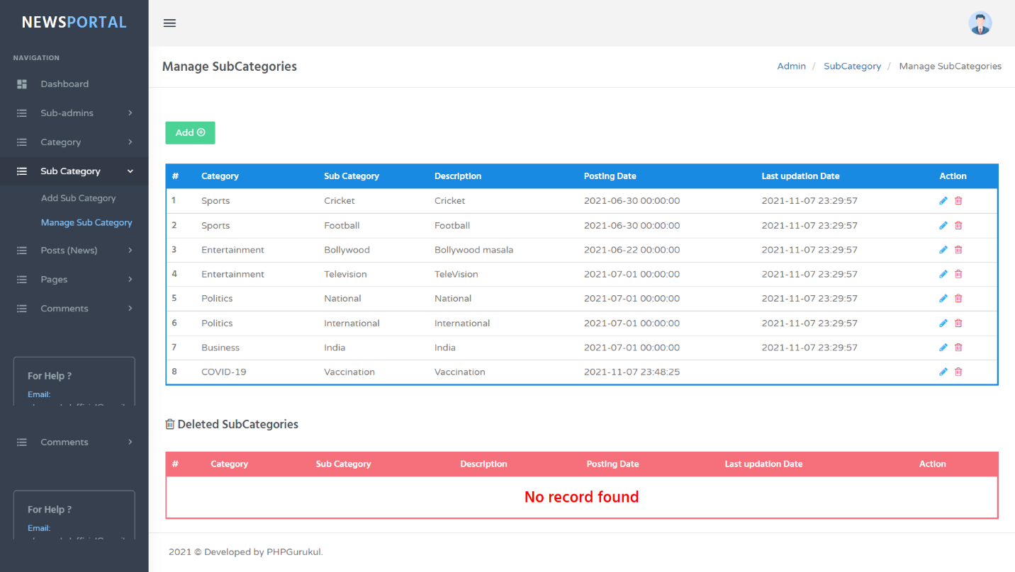

**Update Sub-Category**

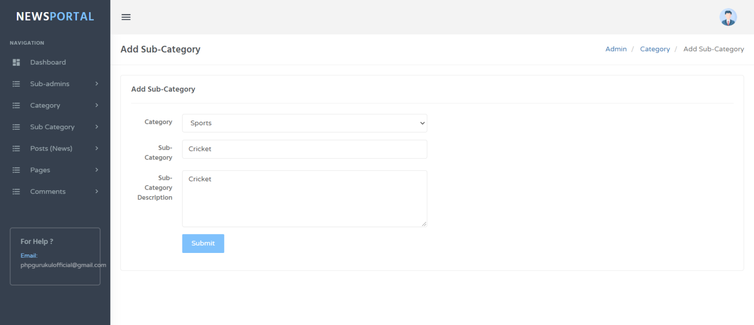

**Add Post**

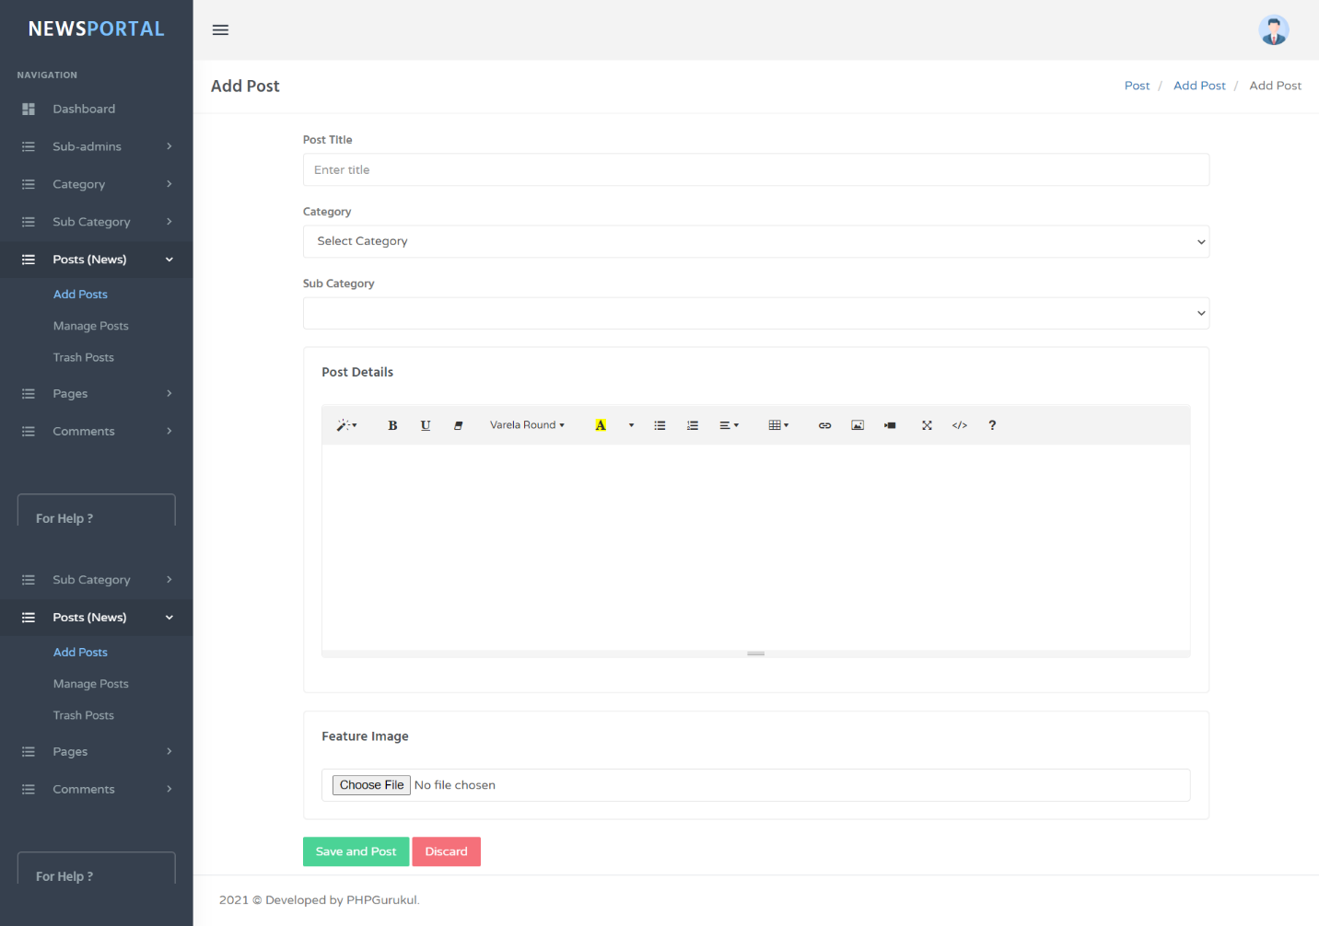

**Manage Post**

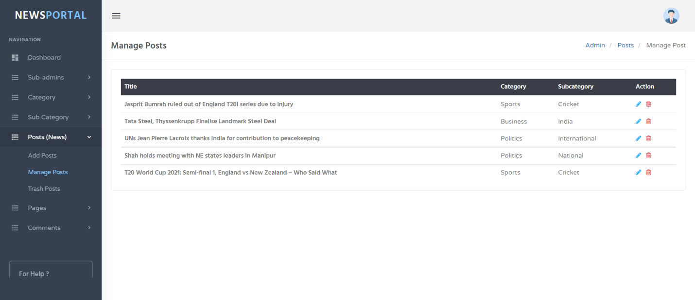

**Update Post**

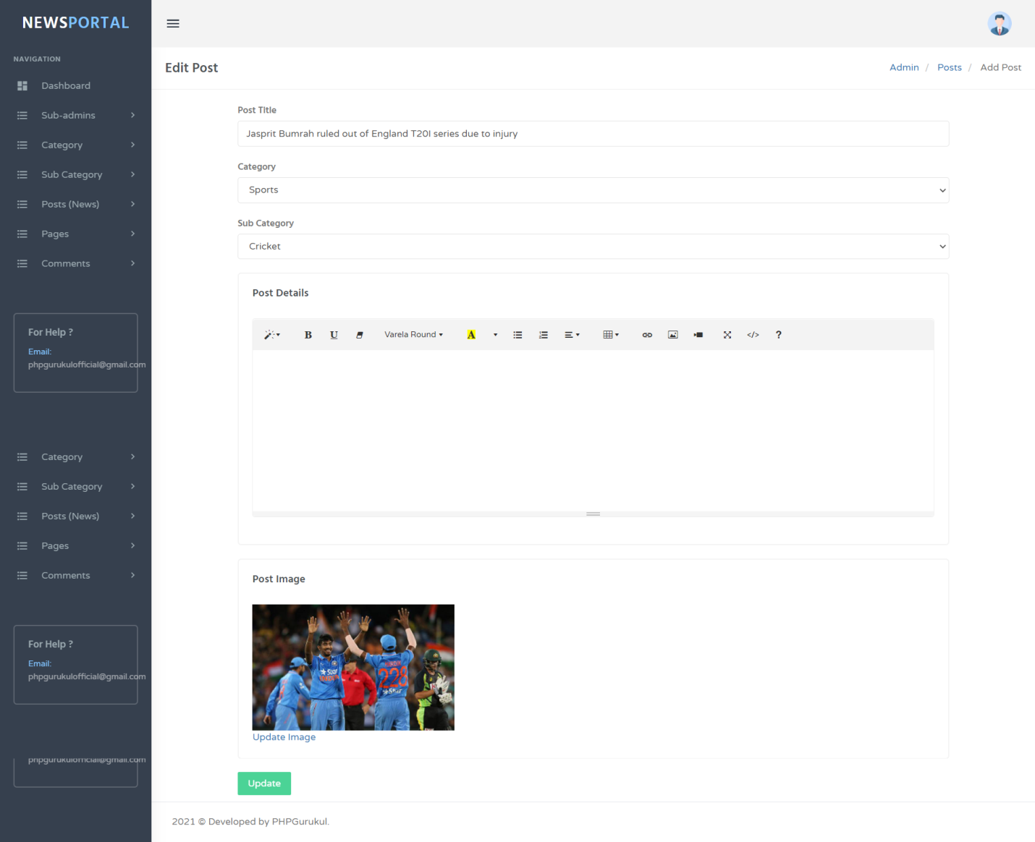

**Future scope**

The future scope of our project is valuable. Our project time duration was only one years .In this time interval we developed our project. It was very difficult to complete project within this time duration. In future if we get chance we will develop this website for large volume.

**As for other future developments, the following can be done:**

* We will manage news reporting system.
* We can make video conferencing system.
* We update our database.
* Sensibility level could add be added.

**Conclusion**

In our project work, an attempt has been made to develop News or information based web site. We develop this project that helps the people and make them aware so that they can know any news. To establish this website we use various methodologies. To develop this project we have faced many problem but we hardly tried to develop this project. Our supervisor helps us by giving his valuable opinion, decision .