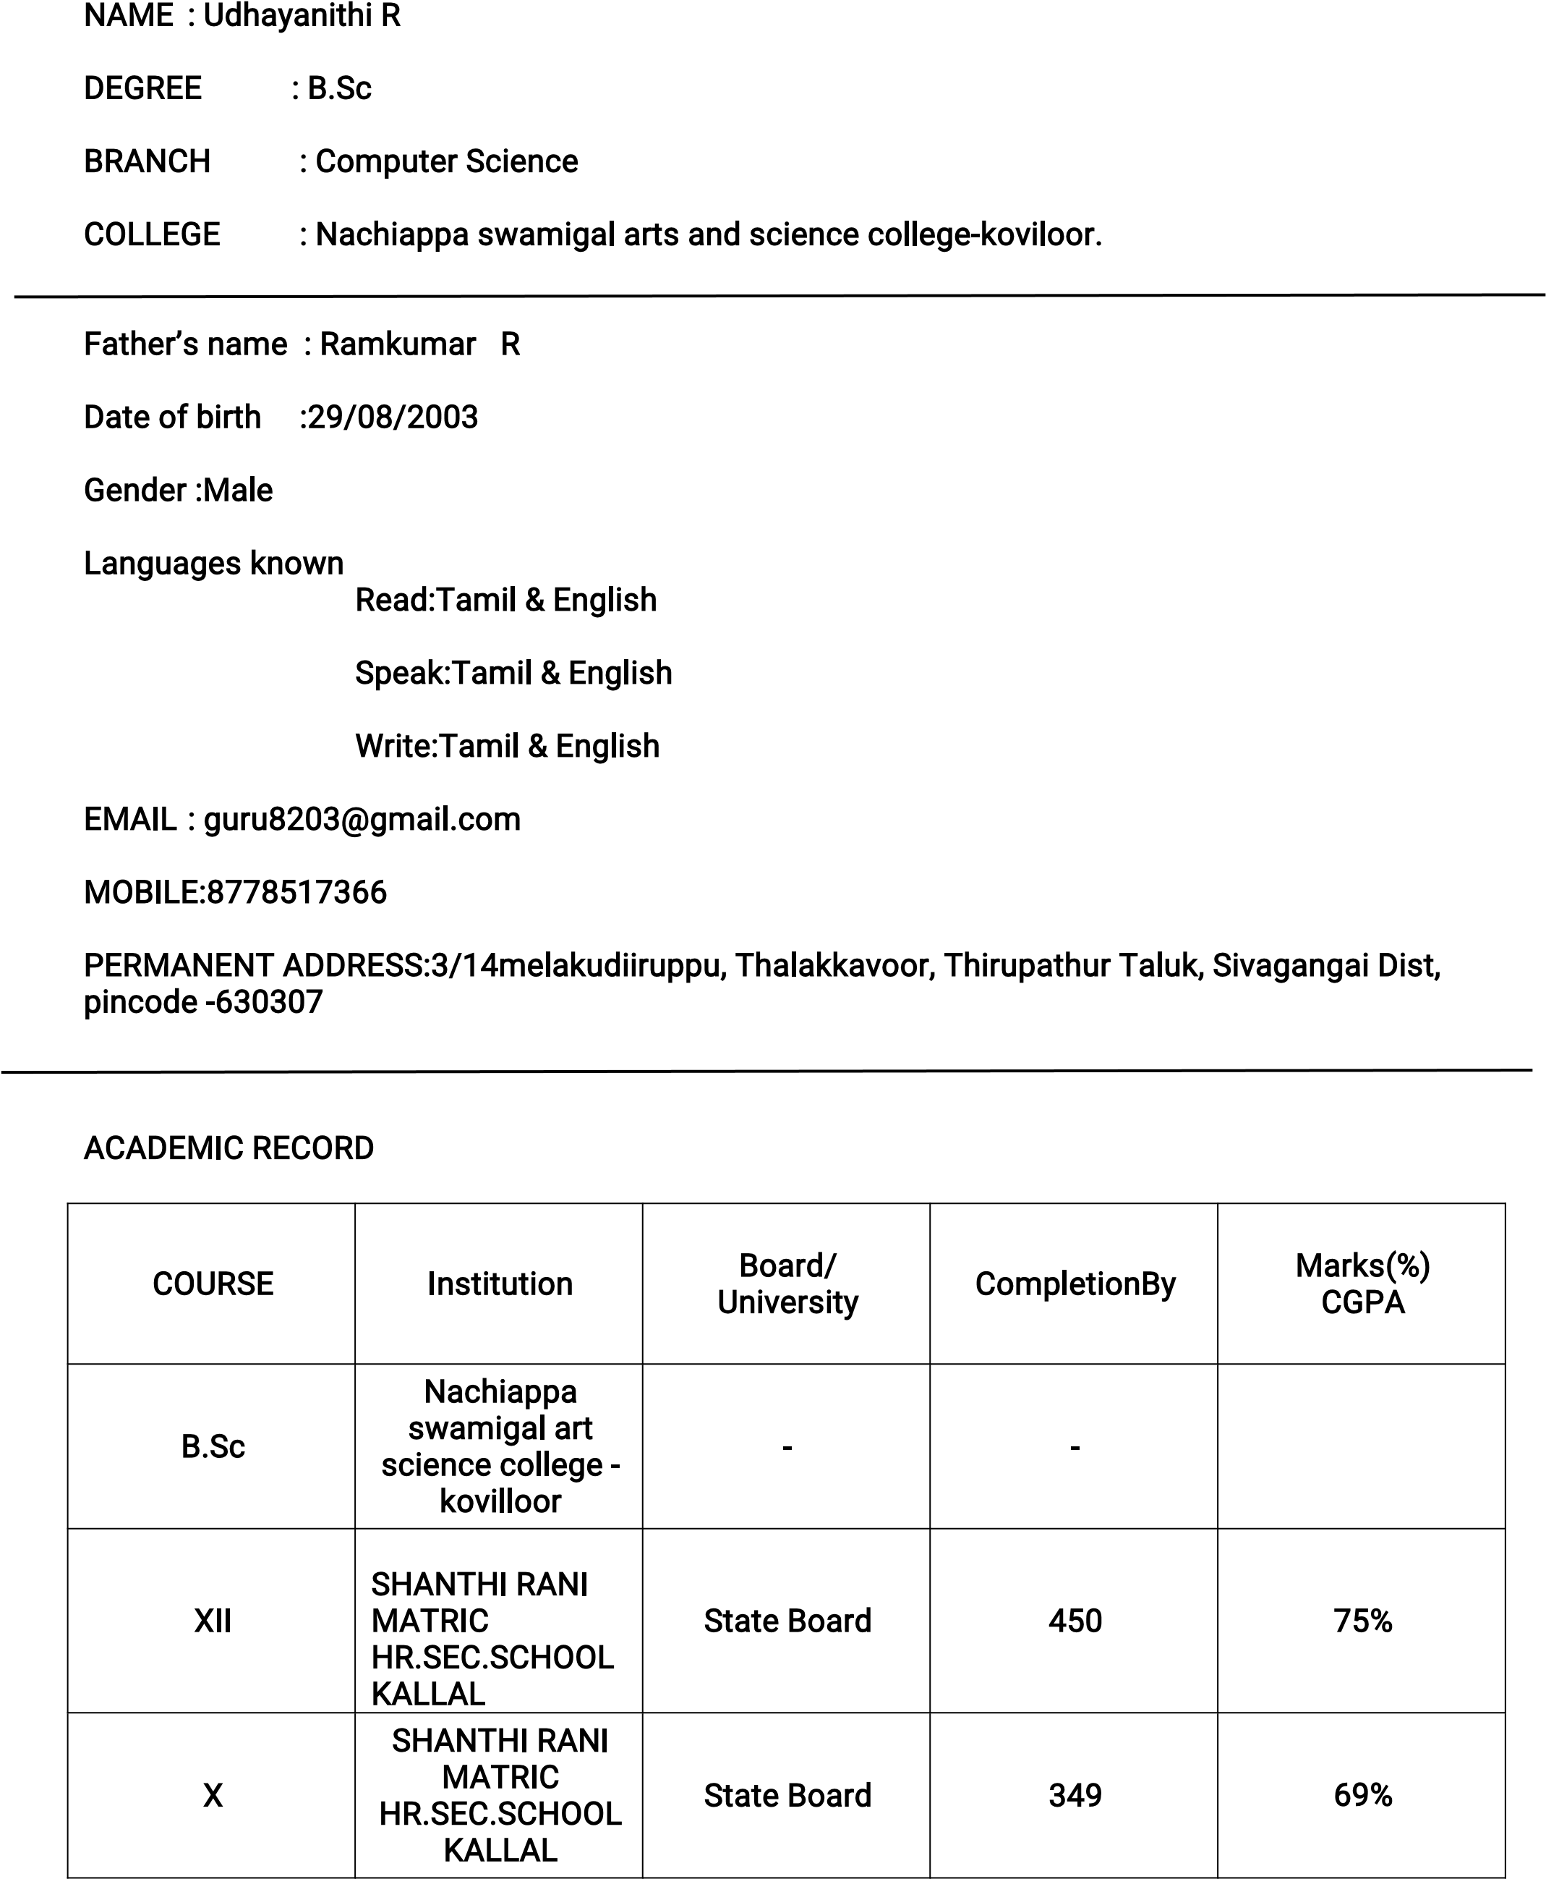

SKILL SET

* Proficient in Python Programming
* Expertise in Ambiance and Design Strategies
* Strong Event Management Capabilities - Demonstrated Leadership Skills

HOBBIES

* Art and Painting Enthusiast
* Avid Reader
* Freelance Interior Designer

EXTRACURRICULAR ACTIVITIES

* Fine Arts Club: Served as a dedicated member
* CAP and Nature: Active participation in environmental initiatives
* Hostel Floor Representative: Provided exceptional service and support
* Engaged in various Drawing and Painting Competitions showcasing talent

DECLARATION

I Udhayanithi R,do here by confirm that the information given above is true to the best of my knowledge.

P

l

a

c

e

~~:~~

K

o

v

i

l

o

o

r

D

a

t

e

~~:~~

2

6

/

1

0

/

2

0

2

3

.

U

D

H

A

Y

A

N

I

T

H

I

R

