**Phase 4**

|  |  |
| --- | --- |
| **Date** | 31-10-2023 |
| **Team Id** | **Proj_223982_team** |
| **Project Name** | Public Transport Optimization |
| **Students with**  **Id** | Saiprasanna P  Rajasuriya L K  Naveen Kumar K  Udhayakumar P  Vignesh V |

**Introduction:**

Public transport optimization is a crucial field aimed at improving efficiency, accessibility, and sustainability of urban transportation systems. It involves route planning, scheduling, technology integration, environmental sustainability, accessibility, and data analysis. Collaboration between planners, authorities, and technology companies ensures livable, sustainable, and well-connected urban environments.

**Objective:**

The public transport optimization program aims to create a user-friendly web application for optimizing public transport routes. It includes route planning, user interface design, real-time data integration, accessibility, customization, error handling, scalability, testing, documentation, feedback, privacy, and security measures.

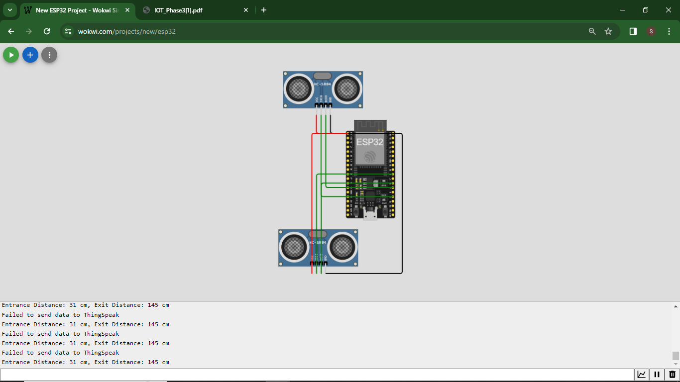

**Data Analysis Tool:** Implement a basic data analysis tool to compare environmental data over a specified time range.

**Technologies Used:**

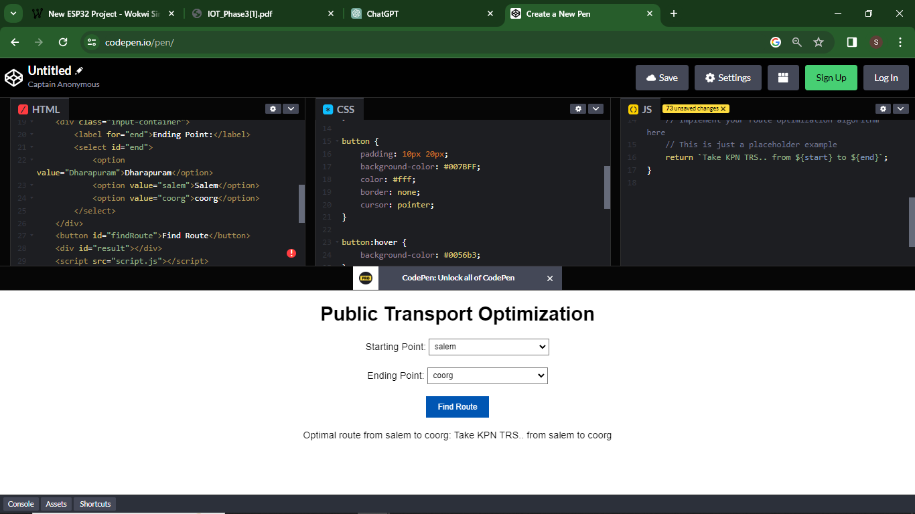

**HTML: For structuring the webpage.**

<!DOCTYPE html>

<html lang="en">

<head>

<meta charset="UTF-8">

<meta name="viewport" content="width=device-width, initial-scale=1.0">

<title>Public Transport Optimization</title>

<link rel="stylesheet" href="styles.css">

</head>

<body>

<h1>Public Transport Optimization</h1>

<div class="input-container">

<label for="start">Starting Point:</label>

<select id="start">

<option value="Dharapuram">Dharapuram</option>

<option value="salem">salem</option>

<option value="coorg">coorg</option>

</select>

</div>

<div class="input-container">

<label for="end">Ending Point:</label>

<select id="end">

<option value="Dharapuram">Dharapuram</option>

<option value="salem">Salem</option>

<option value="coorg">coorg</option>

</select>

</div>

<button id="findRoute">Find Route</button>

<div id="result"></div>

<script src="script.js"></script>

</body>

</html>

**Css code : For styling and layout.**

body {

font-family: Arial, sans-serif;

text-align: center;

}

.input-container {

margin: 20px;

}

select {

padding: 5px;

width: 200px;

}

button {

padding: 10px 20px;

background-color: #007BFF;

color: #fff;

border: none;

cursor: pointer;

}

button:hover {

background-color: #0056b3;

}

#result {

margin: 20px;

}

**Javascript: For dynamic content, real-time updates, and data analysis.**

**Chart.js: A JavaScript library for creating interactive charts.**

document.getElementById("findRoute").addEventListener("click", function() {

const start = document.getElementById("start").value;

const end = document.getElementById("end").value;

// You can implement your public transport optimization logic here

// This is a placeholder example

const route = findOptimalRoute(start, end);

const resultElement = document.getElementById("result");

resultElement.innerHTML = `Optimal route from ${start} to ${end}: ${route}`;

});

function findOptimalRoute(start, end) {

// Implement your route optimization algorithm here

// This is just a placeholder example

return `Take KPN TRS.. from ${start} to ${end}`;

}

**Data Analysis Tool using codepen:**

A simple data analysis tool is integrated into the website, allowing users to compare environmental data over a specified time range. Users can input start and end dates, and the website fetches and displays the corresponding data in a separate chart for detailed analysis.

**User Experience**

The website is designed to be visually appealing and user-friendly. Responsive design ensures compatibility with various devices. The colour scheme and layout are chosen to enhance readability and engagement. The inclusion of charts aids in the intuitive understanding of data trends.



**Conclusion:**

The public transport optimization system aims to create a user-friendly web application that helps users find efficient and convenient public transport routes. It should consider factors like distance, travel time, number of transfers, and cost, be accessible to all users, and handle errors. The system should be scalable, test thoroughly, collect user feedback, and be deployed to a web server for internet accessibility.