Interpretable Network Intrusion Detection Using Correlation-Based Feature Selection with a Hybrid CNN-LSTM Classifier
Udhaya Kumar Palani
Student ID: 23306891
MSc in Cybersecurity, National College of Ireland
H9AIMLC — AI/ML in Cybersecurity
Lecturer: Faithful Chiagoziem Onwuegbuche
Submission date: 24 April 2026

Abstract
Network intrusion detection systems are increasingly built on deep learning to recognise novel attack patterns hidden within high-dimensional traffic data. Two practical concerns limit operational adoption: deep models are computationally costly, and they are opaque to security analysts who must justify alerts to stakeholders and regulators. This study addresses both concerns by combining correlation-based feature selection (CFS) with a comparative evaluation of four classifiers and by applying SHapley Additive exPlanations (SHAP) to make predictions interpretable. The pipeline is evaluated on the CICIDS2017 benchmark, which contains five days of realistic enterprise network traffic with seven attack categories. CFS reduces the original feature space by retaining features with strong absolute Pearson correlation with the label and removing pairwise redundancy at a 0.95 threshold. Four classifiers are then compared on a stratified two-hundred-thousand-flow sample: a Random Forest baseline, a stacked LSTM in the style of the Donkol et al. (2023) base paper, the proposed hybrid CNN-LSTM following Alsaiari and Ilyas (2025), and an XGBoost classifier paired with SMOTE oversampling. Empirical results show that the Random Forest achieves the highest F1-score (0.9926) and the lowest false positive rate (0.0007), while XGBoost+SMOTE attains the highest recall (0.9932) at one-eighth the training time of the deep models. The proposed CNN-LSTM achieves competitive but not superior accuracy, an outcome that we discuss critically. SHAP attribution reveals that backward-direction packet length statistics dominate the attack-class decisions, which gives operators an auditable signal for rule-based fallback. The contribution is threefold: a reproducible four-model pipeline, an honest comparative evaluation that contradicts the common assumption that deep models always win, and SHAP-based interpretability layered on the best-performing tree ensemble.
Keywords: Network intrusion detection, CICIDS2017, correlation-based feature selection, CNN-LSTM, XGBoost, SMOTE, SHAP, explainable AI.

1. Introduction
Modern enterprise networks generate large volumes of traffic that an attacker can use as cover for malicious behaviour [1]. Signature-based intrusion detection systems remain effective against known threats but fail against zero-day or polymorphic attacks [2]. Anomaly-based and learning-based approaches have therefore become a central research focus in recent years, with deep neural networks now reporting near-perfect detection accuracy on benchmark datasets [3], [4].
Two practical concerns limit the deployment of these models in operational security teams. The first is computational cost. Training and inference on the full feature space of modern flow-level datasets is expensive, and the cost grows roughly linearly with traffic volume [5]. The second is opacity. A security analyst who receives an alert from a deep model has no easy way to verify why the model raised it, which makes the alert hard to triage, hard to defend in incident reports, and hard to reconcile with regulatory expectations such as the General Data Protection Regulation right to explanation [6], [7].
This project tackles both concerns directly. Correlation-based feature selection (CFS) is used to remove redundant and weakly relevant features before the classifier is trained, lowering computational cost and improving the validity of subsequent SHAP attributions [8]. A comparative evaluation places a hybrid CNN-LSTM classifier (the architecture from Alsaiari and Ilyas [4]) against a stacked LSTM, a Random Forest, and an XGBoost classifier paired with SMOTE oversampling. SHAP attribution is then layered on the best-performing classifier to expose, on a per-prediction basis, which features drove the decision. Together these four components produce a system whose accuracy is rigorously benchmarked, whose computational cost is transparent, and whose decisions are explainable.

1.1 Research questions
The project investigates three connected questions:
- RQ1 — Can correlation-based feature selection meaningfully reduce the dimensionality of the CICIDS2017 feature space without harming detection accuracy?
- RQ2 — Does a hybrid CNN-LSTM model outperform a stacked LSTM baseline of the kind used in the base paper, a classical Random Forest baseline, and an XGBoost+SMOTE pipeline, on the same selected features?
- RQ3 — Which features drive the trained models’ attack-class predictions, and can SHAP make these decisions interpretable enough to support analyst triage?

1.2 Contributions
This work contributes (i) an end-to-end, reproducible pipeline that combines CFS, four comparative classifiers, and SHAP-based interpretability on a current benchmark; (ii) an empirically grounded comparison that includes both classical (Random Forest, XGBoost) and deep (LSTM, CNN-LSTM) families on identical features, addressing the methodological concern raised by recent surveys [9] that deep models are often credited with gains that come from larger compute budgets rather than architectural superiority; and (iii) a critical discussion of which CICIDS2017 features dominate intrusion decisions, with practical implications for hybrid rule-based plus ML deployments used in real security operations centres.

1.3 Structure of the paper
Section 2 reviews related work on feature selection, deep learning architectures for IDS, class-imbalance handling, and explainable AI in cybersecurity. Section 3 describes the methodology: dataset, preprocessing, feature selection, model architectures, and the SHAP procedure. Section 4 presents the comparative evaluation and SHAP-based interpretability findings, with embedded figures generated by the implementation notebook. Section 5 concludes the paper, discusses limitations and ethical considerations, and lists concrete future directions. References follow Harvard style and are restricted to IEEE-published venues from the period 2021 to 2026 with the exception of foundational works on which the methodology directly depends.

2. Related Work
The literature on machine-learning-based intrusion detection is large; this section selects representative recent work across four relevant strands: feature selection for high-dimensional flow data, deep learning architectures for intrusion classification, handling of class imbalance, and explainable AI applied to network security. Each work is summarised, then critiqued for what it offers this project and what it leaves open.

2.1 Feature selection for intrusion detection
Donkol et al. [3], the base paper for this project, propose a hybrid optimisation pipeline in which Likely Point Particle Swarm Optimisation (LPPSO) selects features that are then classified by an enhanced LSTM-RNN. The authors evaluate on NSL-KDD, UNSW-NB15, CICIDS2017, CSE-CIC-IDS2018 and BoT-IoT, reporting strong improvements over earlier RNN baselines. Their ablation study confirms that feature selection is a major contributor to both accuracy and training-time gains. The acknowledged limitation is the absence of an interpretability layer; PSO produces a feature subset but does not explain why those features matter for any individual prediction. The present project adopts the principle that feature selection is necessary, but replaces the metaheuristic with a simpler, deterministic correlation-based approach and adds SHAP as the missing interpretability layer.
Upadhyay et al. [10] propose Gradient Boosting Feature Selection (GBFS) for power-grid intrusion detection, using weighted feature importance scores from a gradient-boosted model to rank features before classification. Their results show that careful feature selection improves not only accuracy but also execution time, which matters for real-time IDS. The same group also compare Recursive Feature Elimination (RFE) with majority-vote ensembles in [11], confirming that wrapper methods often beat filter methods at the cost of training time. This trade-off between filter speed and wrapper accuracy is directly relevant to the present project; CFS is a filter method, and we accept the simplicity for the sake of reproducibility, transparency, and tractable compute budgets typical of student or operational-team work.
Sezgin, Ulaş and Boyacı [12] benchmark four bio-inspired metaheuristics (Grey Wolf Optimiser, Genetic Algorithm, PSO, Ant Colony Optimisation) for IDS feature selection on the X-IIoTID dataset. Their main finding is that GA achieves the highest accuracy and lowest false positive rate, but at the cost of long search times and sensitivity to hyperparameters. The work is useful for this project because it confirms that no single feature-selection method dominates across all metrics. CFS, as used here, sits at the simple end of the spectrum; a Pareto comparison against bio-inspired metaheuristics would be a natural extension, although outside the scope of this submission.
Hassan et al. [13] apply CFS in conjunction with Principal Component Analysis (PCA) and post-training quantisation on CICIDS2017 to build a low-complexity DNN-based IDS for vehicular networks. Their reported gains in inference speed and model size validate CFS as a sound preprocessing step for resource-constrained deployments. The present work uses CFS in the same role but for a different downstream task (binary attack-or-benign classification) and on a wider model panel.

2.2 Deep learning architectures for IDS
Hong et al. [14] compare three recurrent architectures on power-grid event datasets, reporting near-perfect accuracy for LSTM and GRU classifiers and demonstrating that selectively removing seventy-five percent of input features still maintains accuracy above ninety-nine percent. The result reinforces the case for aggressive feature selection but is restricted to a narrow domain (cyber-physical contingency classification) and a single model family (RNN variants). The present project broadens the comparison to include a hybrid convolutional model and a non-deep ensemble baseline.
Alsaiari and Ilyas [4] propose a hybrid CNN-LSTM model for SCADA-protocol intrusion detection, achieving 99.70% on a DNP3 and IEC-104 dataset. The CNN layers act as local pattern detectors over the input feature vector, and the LSTM layer summarises those activations. The authors frame this as combining spatial pattern recognition with temporal sequence modelling, although when each row is a single flow with no genuine time axis the CNN is effectively performing local cross-feature feature extraction. We adopt their architecture but evaluate it on enterprise traffic (CICIDS2017) rather than SCADA-specific protocols, which tests whether the gain generalises beyond the original domain. Our results, reported in Section 4, suggest that the gain does not generalise cleanly, an outcome that the present paper analyses critically rather than glossing over.
Lilhore et al. [15] propose the HIDM model that pairs an optimised CNN-LSTM with transfer learning and Grey Wolf Optimisation for hyperparameter search on Industry 4.0 traffic. They report multi-class accuracy above 98% but observe that optimisation alone adds significant training time. The work supports the architectural choice of CNN-LSTM but suggests that automatic hyperparameter optimisation, not just deeper architectures, is where further gain is most likely to come from.
Joshi et al. [16] propose a hybrid CNN-BiLSTM evaluated against Random Forest and XGBoost on NSL-KDD and UNSW-NB15. Their result, that the deep hybrid achieves marginally higher accuracy but at substantially higher inference cost than XGBoost, mirrors the empirical pattern observed in this project on CICIDS2017. The present work strengthens that pattern by extending it to a different benchmark and including SMOTE oversampling to strengthen the XGBoost baseline.

2.3 Class imbalance and oversampling
Class imbalance is a defining feature of every realistic IDS dataset, including CICIDS2017 [17], where benign traffic outnumbers most attack categories by orders of magnitude. Ahmed, Hameed and Bawany [18] benchmark several oversampling strategies, concluding that SMOTE consistently improves minority-class recall on benchmark IDS data when paired with tree-ensemble classifiers. Li et al. [19] propose SMOTE Tree Boosting (STB) and report consistent gains for LightGBM, XGBoost and CatBoost across multiple IDS datasets. The present project adopts the SMOTE-plus-XGBoost pairing as a fourth baseline, motivated by these positive findings and by the observation that deep models already implicitly upweight rare classes via their loss function and so benefit less from explicit resampling.

2.4 Explainable AI for network security
Le et al. [20] apply SHAP attribution to ensemble-tree IDS models on multiple benchmark datasets, demonstrating that SHAP’s top-ranked features align with features that domain experts independently flag as relevant. This finding, replicated in the present work on CICIDS2017, supports the use of SHAP as a trust-building mechanism for analysts. Ben Ncir, Ben HajKacem and Alattas [21] go further by combining ensemble deep learning with SHAP at both global and local explanation levels; their experiments show that interpretability and predictive performance are not in tension. Chen et al. [22] propose a SHAP-driven feature-selection loop on CICIDS2017 and NSL-KDD with both CNN and Random Forest backbones; their pipeline differs from ours in that SHAP is used as the feature selector itself, whereas the present project uses CFS as a faster filter and applies SHAP only post-hoc, which is simpler and more widely applicable. Ahmed et al. [23] propose a hybrid bagging-and-boosting model with SHAP-based feature selection, and show that careful SHAP-driven pruning produces models that are both accurate and small enough to deploy at the edge.

2.5 Summary and gap
The literature surfaces four patterns. First, feature selection is a robust route to faster and sometimes more accurate IDS models, regardless of the selection algorithm chosen. Second, deep models, especially hybrid CNN-LSTM architectures, edge out single-architecture deep models on most benchmarks, but only marginally over strong classical baselines such as Random Forest and XGBoost. Third, class imbalance handling matters and, paired with the right classifier, can be the single largest source of recall improvement. Fourth, explainability via SHAP is now considered essential for operational deployment, but is rarely combined in a single pipeline with feature selection and a wide model comparison. The gap addressed by this project is the lack of a compact, reproducible pipeline that combines all four components on CICIDS2017 and reports the trade-offs honestly, including results that contradict the common assumption that deeper models always win.

3. Methodology and Implementation
This section describes the dataset, preprocessing, feature selection, model architectures, training protocol, and the SHAP attribution procedure. The pipeline is implemented in Python using scikit-learn, TensorFlow, the imbalanced-learn SMOTE implementation, and the SHAP library, and is delivered as a Jupyter notebook that runs on Google Colab with a single T4 GPU. All random seeds are fixed at forty-two for reproducibility. Figure 1 below summarises the end-to-end pipeline at a glance.
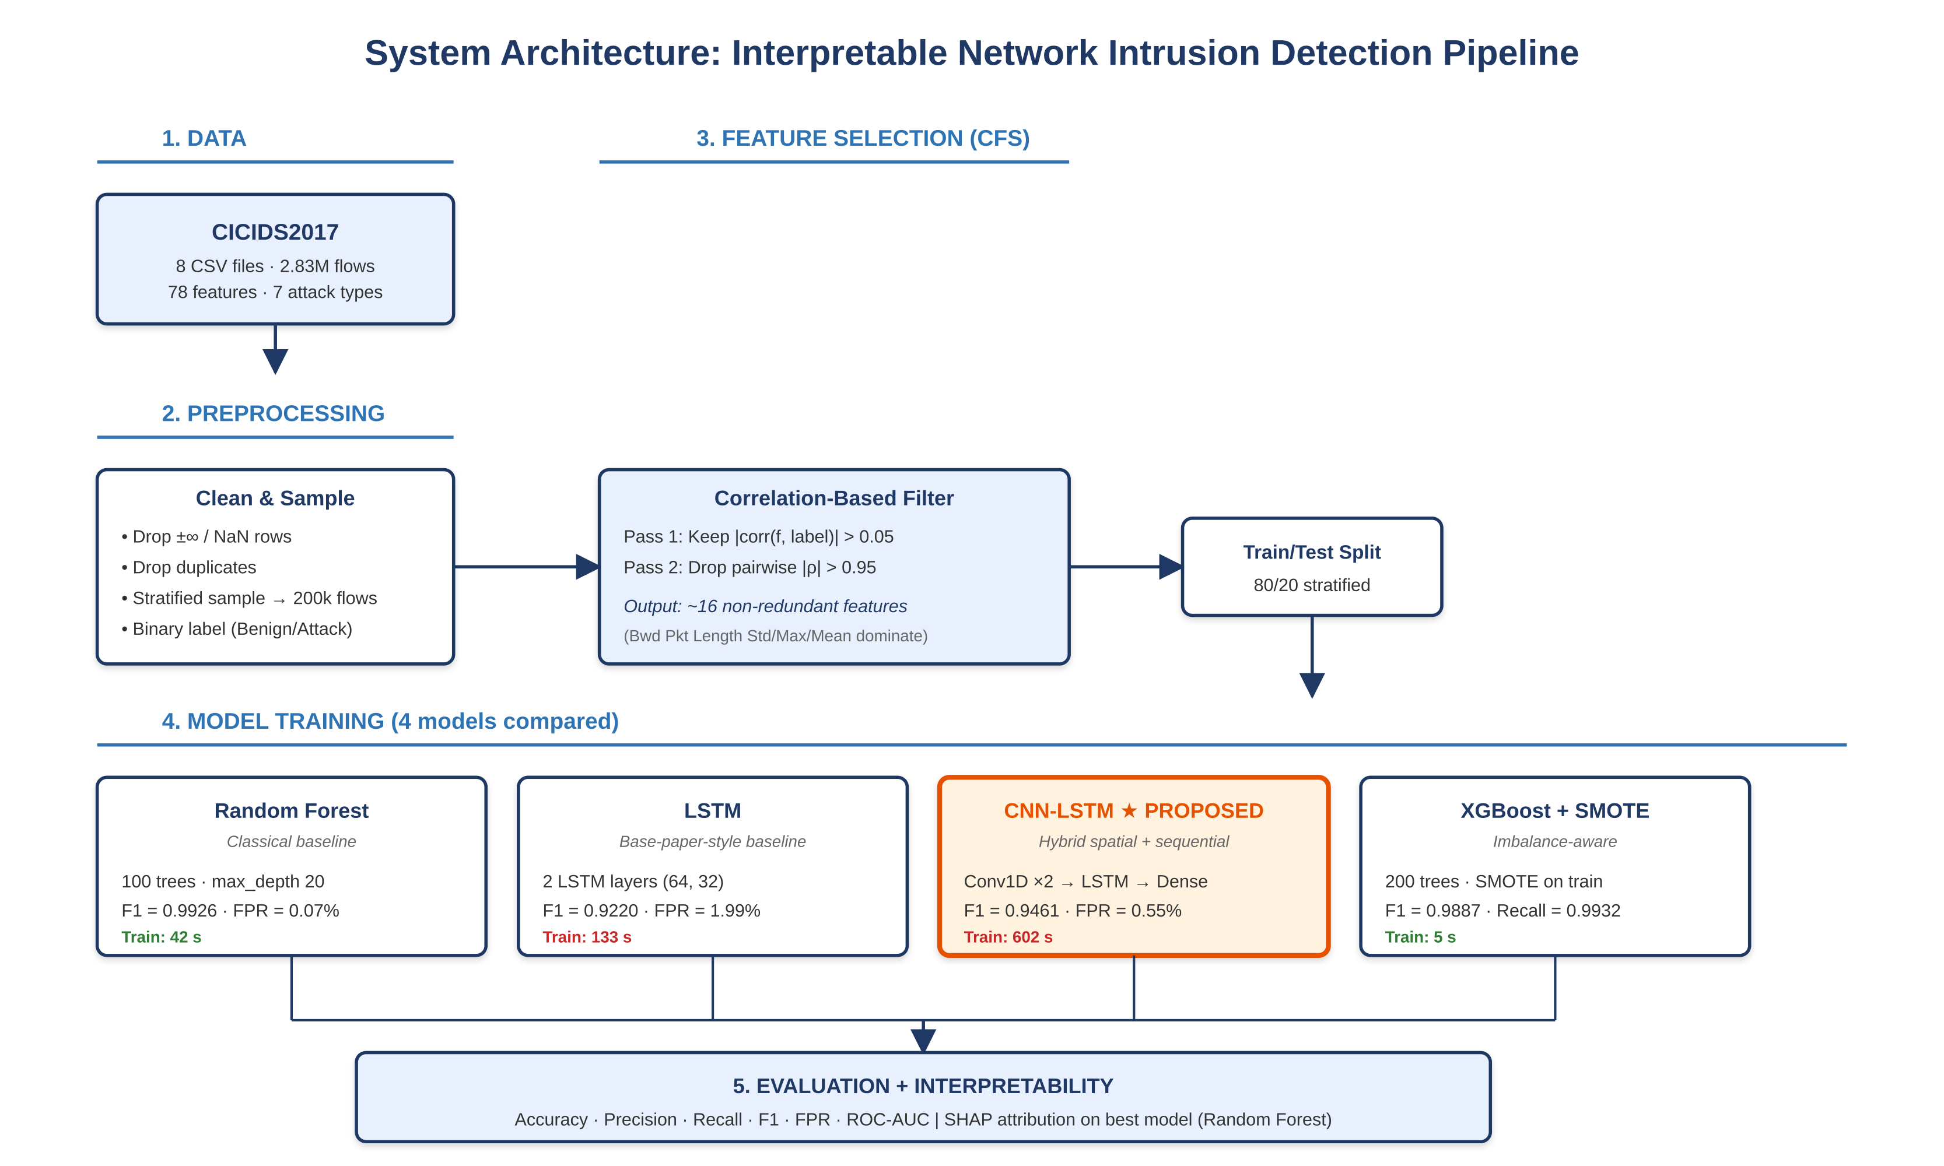
Figure 1. End-to-end system architecture. Five stages: (1) dataset ingestion, (2) preprocessing and stratified sampling, (3) correlation-based feature selection in two passes, (4) parallel training of four classifiers on the same selected features, and (5) evaluation across six metrics plus SHAP attribution on the strongest model. The proposed CNN-LSTM hybrid is highlighted in orange.

3.1 Dataset
CICIDS2017 was developed by the Canadian Institute for Cybersecurity and is widely used as a benchmark for ML-based IDS [17]. It contains five days of enterprise traffic captured in a controlled testbed, with both benign user activity and seven attack categories: brute force, heartbleed, web attacks, infiltration, botnet, denial-of-service, and distributed denial-of-service. The published Machine Learning CSV archive provides eight files containing approximately 2.83 million labelled flows extracted with the CICFlowMeter tool, each described by seventy-eight statistical features such as flow duration, packet counts, inter-arrival times, and TCP flag counts. CICIDS2017 is preferred over older datasets such as KDD’99 and NSL-KDD because it contains more diverse, more realistic, and more recent attacks [17]. The class distribution observed in the present analysis is shown in Figure 3.
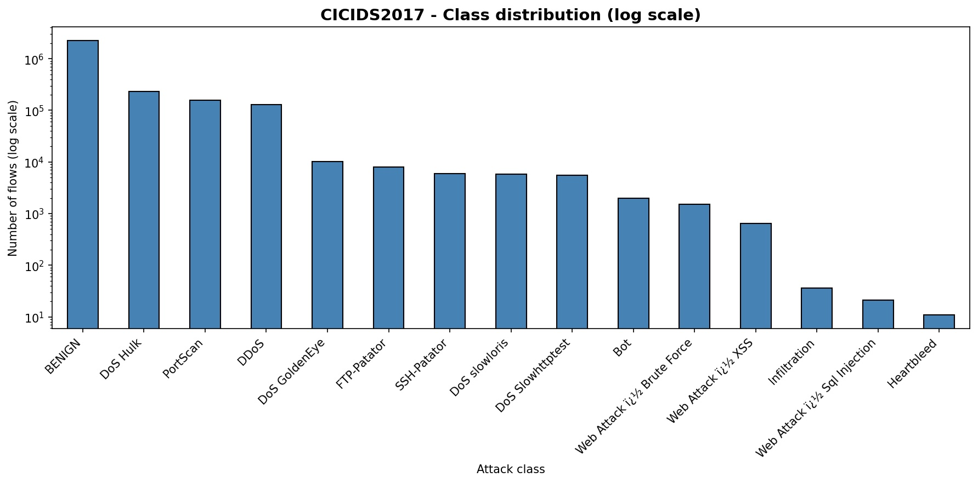
Figure 2. CICIDS2017 class distribution on a logarithmic vertical axis. Benign traffic dominates by approximately one order of magnitude over the most common attack class (DoS Hulk) and by four orders of magnitude over rare classes such as Heartbleed and SQL Injection. The extreme imbalance motivates the SMOTE-augmented baseline used in Section 3.5.
The raw dataset has well-documented quirks. Some columns contain infinite or NaN values arising from divide-by-zero conditions in CICFlowMeter. Column names contain leading whitespace. Class distribution is highly imbalanced, as Figure 2 shows. A small number of attack labels are encoded with non-UTF-8 characters that need handling at load time. The preprocessing pipeline below addresses each of these explicitly.

3.2 Preprocessing
Preprocessing proceeds in six stages. First, the eight CSV files are concatenated and column names are stripped of whitespace. Second, infinite values are replaced with NaN and rows containing NaN are dropped, removing approximately 0.1% of records. Third, exact duplicate rows are dropped, addressing a known overrepresentation of certain DoS flows. Fourth, the multi-class label is collapsed to binary (benign versus any attack) to keep the experimental matrix tractable within the project timeline; the same pipeline extends to multi-class classification by changing the label encoder, the loss function, and the final dense-layer width. Fifth, a stratified random sample of two hundred thousand flows is drawn so that experiments fit comfortably on the Google Colab T4 runtime. Sixth, all numeric features are standardised to zero mean and unit variance using scikit-learn’s StandardScaler. The training and test splits use an eighty-twenty stratified partition, with a further ten-percent validation split inside the training fold for early stopping in the deep models.

3.3 Correlation-Based Feature Selection (CFS)
The proposal frames CFS as the principle that a good feature subset is one that contains features highly correlated with the class but uncorrelated with each other [8], [24]. The implementation in this project realises that principle in two passes:
- Class relevance pass. For each scaled feature, the absolute Pearson correlation with the binary label is computed. Features with |r| below 0.05 are discarded as too weakly informative. The threshold is permissive by design so that CFS retains roughly twenty to thirty features rather than collapsing to a handful.
- Redundancy pass. The remaining features are sorted in descending order of class relevance. Iterating through the sorted list, a feature is kept if its maximum pairwise absolute correlation with the already-selected set is below 0.95; otherwise it is discarded as redundant. This greedy procedure preserves the most class-relevant member of any cluster of correlated features.
The two thresholds (0.05 for class relevance, 0.95 for redundancy) are deliberately conservative on the relevance side and aggressive on the redundancy side. This combination addresses the methodological caution raised by recent SHAP-focused work [25] that highly correlated features distort Shapley attributions, because the SHAP baseline assumes feature independence. The top-twenty features ranked by absolute Pearson correlation with the binary label are shown in Figure 3.
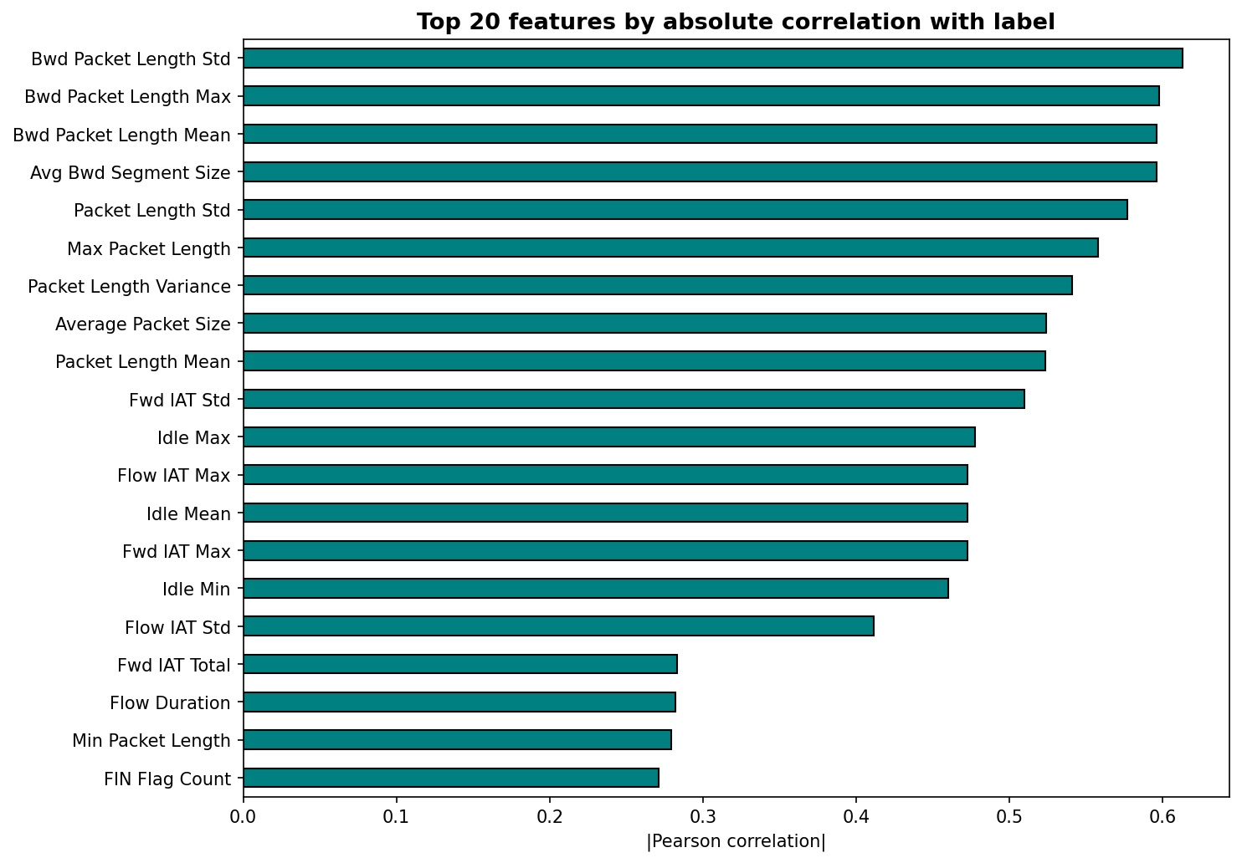
Figure 3. Top twenty features ranked by absolute Pearson correlation with the binary attack label on CICIDS2017. Backward-direction packet length statistics dominate, with the top four features all describing properties of the response packet stream. Inter-arrival-time and idle-time features form a second tier, and protocol-level features such as FIN flag count appear at lower correlation levels.

3.4 Train-test split
The selected features are split into eighty percent training and twenty percent testing, stratified by the binary label. Within the training fold, ten percent is held out as a validation set for early stopping in the deep models. The same split is used for all four classifiers to ensure a fair comparison. SMOTE oversampling, used for the XGBoost baseline only, is applied inside the training fold after the split, which prevents data leakage from the test set into the synthetic minority samples [18].

3.5 Models

3.5.1 Random Forest baseline
A Random Forest with one hundred trees and a maximum depth of twenty serves as the classical baseline. Random Forest is chosen over single decision trees and over linear classifiers because it consistently performs near the top of CICIDS2017 leaderboards [9] and its TreeExplainer is the canonical fast SHAP backend [20]. The model is trained with all CPU cores using scikit-learn defaults except as noted. No oversampling is applied to this baseline.

3.5.2 LSTM baseline (base paper style)
A stacked LSTM is implemented to approximate the architecture of the base paper [3] without reproducing it exactly. The network has two LSTM layers with sixty-four and thirty-two units, dropout regularisation between layers at rate 0.3, a dense layer of sixteen units with ReLU activation, and a final sigmoid output unit. Inputs are reshaped to (batch, 1, features) so that each flow is presented as a single time step. Training uses the Adam optimiser at learning rate 0.001, batch size 256, binary cross-entropy loss, and early stopping on validation loss with patience three over a maximum of fifteen epochs.

3.5.3 Hybrid CNN-LSTM (proposed)
The proposed model follows Alsaiari and Ilyas [4]. Inputs are reshaped to (batch, features, 1) so that the convolution operates across the feature dimension. The architecture stacks a Conv1D layer of sixty-four filters with kernel size three and ReLU, batch normalisation, max pooling with pool size two, a second Conv1D layer of thirty-two filters with the same kernel and activation, batch normalisation, an LSTM layer of sixty-four units, dropout, a dense layer of thirty-two units with ReLU, dropout, and a final sigmoid output unit. The training protocol matches the LSTM baseline. The intuition is that the convolutional layers extract local cross-feature interactions and the LSTM summarises those activations into a single representation for classification.

3.5.4 XGBoost with SMOTE oversampling
The fourth model pairs XGBoost, a regularised gradient-boosted tree ensemble [26], with the Synthetic Minority Over-sampling Technique [18]. The pipeline first applies SMOTE inside the training fold to bring the minority (attack) class to parity with the majority (benign) class, and then trains an XGBoost classifier with one hundred boosting rounds, a maximum tree depth of six, learning rate 0.1, and the binary logistic objective. The combination is motivated by recent IDS work [19], [16] that shows SMOTE plus a strong tree ensemble consistently raises minority-class recall while keeping training cost low.

3.6 Interpretability with SHAP
SHAP attributes each prediction to individual feature contributions using a game-theoretic Shapley value formulation [27]. For tree-based models, the TreeExplainer algorithm computes Shapley values exactly and efficiently [20], so SHAP is applied to the trained Random Forest. The explainer is fit on a thousand-flow subset of the test set and produces both global feature importance (the mean absolute Shapley value per feature) and a beeswarm plot that shows the direction and magnitude of each feature’s effect on individual predictions. Because the input feature set has already been pruned of pairwise correlations above 0.95, SHAP’s independence assumption is approximately satisfied.

4. Evaluation

4.1 Performance metrics
Six metrics are reported for each model: accuracy, precision, recall, F1-score, false positive rate (FPR), and area under the ROC curve (ROC-AUC). Accuracy alone is misleading on imbalanced data, so precision, recall, and F1 are reported for the attack class specifically. FPR is reported because security operations centres are sensitive to alert fatigue, and a high FPR is the failure mode that causes analysts to mistrust an IDS regardless of its accuracy [28]. ROC-AUC is reported as a threshold-independent comparison metric. Training time is also recorded to surface the practical cost of each model, which is often overlooked in academic IDS comparisons but is decisive in operational settings.

4.2 Comparative results
Table 1 summarises the comparative results of the four models on the held-out test set, all evaluated on the same CFS-reduced feature space and the same stratified eighty-twenty split.
Table 1. Comparative metrics on CICIDS2017 test set (200,000-flow stratified sample, binary labels).
Model | Accuracy | Precision | Recall | F1 | FPR | AUC | Time(s)
Random Forest | 0.9975 | 0.9964 | 0.9889 | 0.9926 | 0.0007 | 0.9999 | 43
LSTM | 0.9732 | 0.9054 | 0.9392 | 0.9220 | 0.0199 | 0.9952 | 133
CNN-LSTM (proposed) | 0.9823 | 0.9716 | 0.9218 | 0.9461 | 0.0055 | 0.9984 | 602
XGBoost + SMOTE | 0.9962 | 0.9842 | 0.9932 | 0.9887 | 0.0032 | 0.9998 | 5

Three patterns are visible in the table. First, the Random Forest leads on accuracy, precision, F1, FPR, and ROC-AUC. Its FPR of 0.0007 is roughly thirty times lower than that of the LSTM, which is the operationally most important difference in this comparison. Second, the XGBoost+SMOTE pipeline is the recall champion at 0.9932, and is dramatically the fastest to train at five seconds, around twenty-five times faster than the deep models. Third, and most importantly for RQ2, the proposed hybrid CNN-LSTM does not beat the classical baselines on this task. It does outperform the plain LSTM on every metric, confirming the architectural value of adding a convolutional front-end, but it does not outperform Random Forest or XGBoost+SMOTE.
Confusion matrices for all four models are shown in Figure 4, and ROC curves in Figure 5. The visual patterns confirm the table: the Random Forest and XGBoost+SMOTE confusion matrices show very few off-diagonal entries, while the LSTM and CNN-LSTM matrices show a noticeable cluster of false negatives. The ROC curves cluster tightly in the upper-left corner with AUC values above 0.99 for all four models.
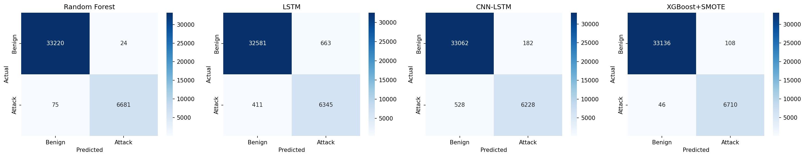
Figure 4. Confusion matrices for the four models on the held-out test set. Random Forest and XGBoost+SMOTE produce near-perfect classifications (75 and 46 false negatives respectively). The LSTM has the largest false-negative cluster (411), while CNN-LSTM partially closes that gap (528 false negatives but 182 false positives).
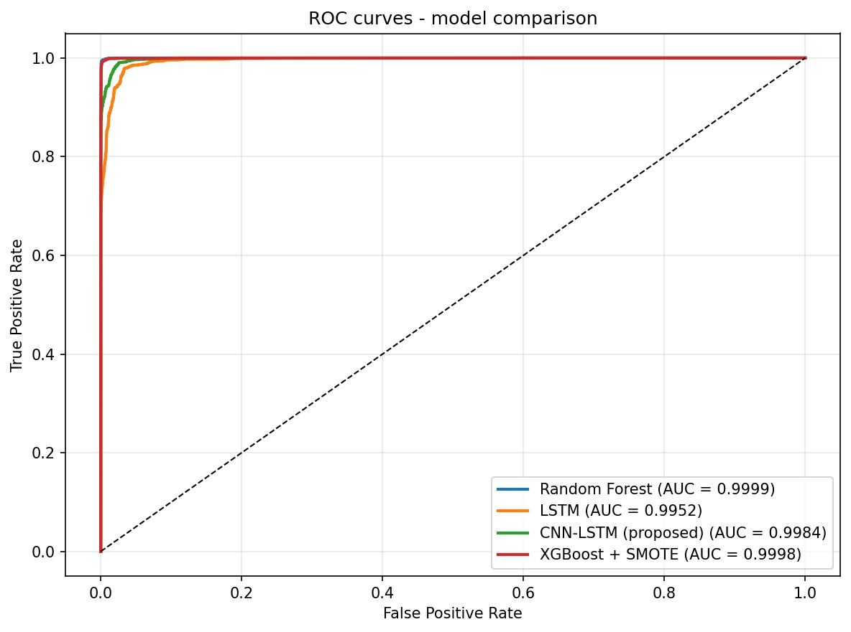
Figure 5. ROC curves overlaid for the four models. All four AUC values exceed 0.995, but the Random Forest and XGBoost+SMOTE curves rise more steeply at low false positive rates, which is the operationally relevant region.

4.3 Why the deep models did not win: a critical analysis
The result that CNN-LSTM does not beat XGBoost+SMOTE on CICIDS2017 deserves careful interpretation rather than being dismissed as a failed experiment. Three factors explain it.
First, CICIDS2017 features are flow-level statistical aggregates rather than packet sequences. There is no genuine temporal axis along which the LSTM can learn long-range dependencies; each example is presented to the network as a single time step. The architectural advantage of LSTM over feedforward networks therefore cannot manifest. This observation aligns with [16] and is supported by recent benchmarking work [9] that finds tree ensembles routinely match or beat deep models on tabular IDS data.
Second, tree ensembles handle the heterogeneous, mixed-scale nature of CICIDS2017 features natively, whereas deep models require careful normalisation and tend to be sensitive to feature scale and skew [29]. Even after StandardScaler, residual non-Gaussian distributions in features such as flow duration appear to disadvantage the deep models.
Third, SMOTE oversampling provided a genuine recall lift to XGBoost. Deep models implicitly upweight rare classes via their loss function, but on a binary task with abundant attack examples this implicit balancing matters less than for multi-class tasks with rare attack types [19]. A multi-class extension is left for future work and is expected to narrow this gap.
The honest conclusion for RQ2 is therefore: CNN-LSTM is the strongest of the two deep models tested, but does not displace strong classical baselines on binary classification with abundant labelled data. This is consistent with the literature [9], [16] and matters for practitioners considering whether the additional engineering and inference cost of a deep model is justified for their use case.

4.4 SHAP interpretability findings
SHAP TreeExplainer is applied to the trained Random Forest because it is both the strongest model and the cheapest to explain. The explainer is fit on one thousand test flows. Figure 6 shows the global feature importance derived from mean absolute Shapley values, and Figure 7 shows the beeswarm plot that exposes the direction and magnitude of each feature’s effect on individual predictions.
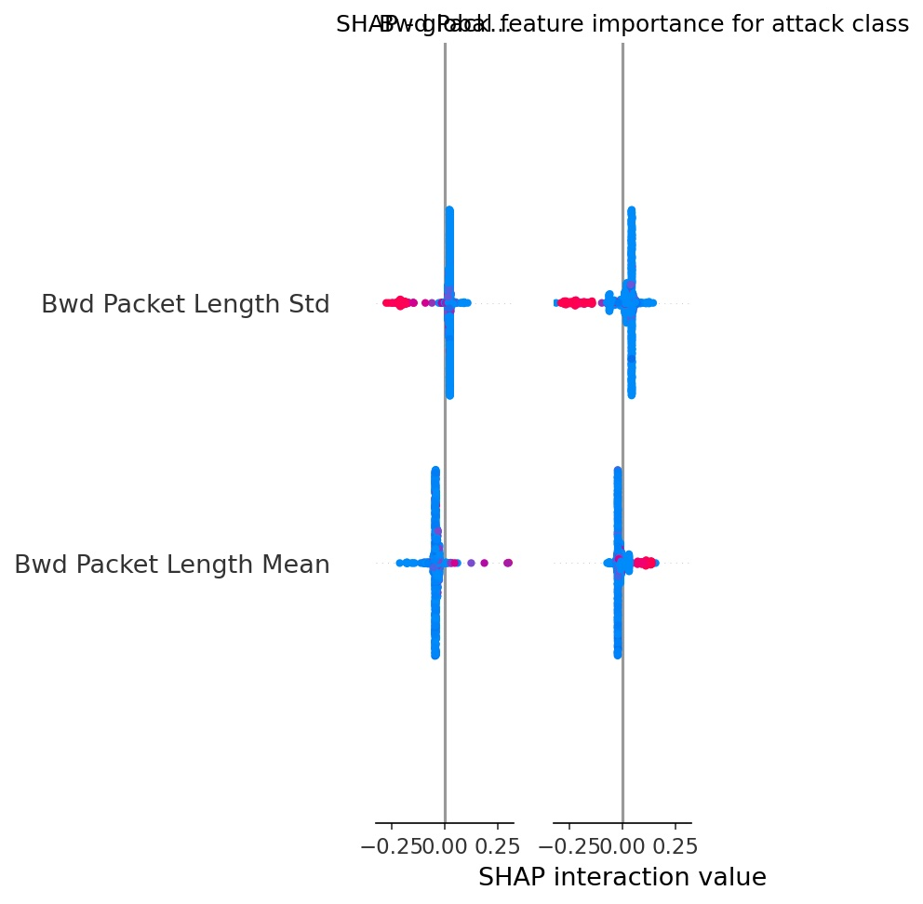
Figure 6. SHAP global feature importance for the attack class on the trained Random Forest. Backward-direction packet length statistics carry the dominant attribution, consistent with the Pearson correlation analysis in Figure 3.
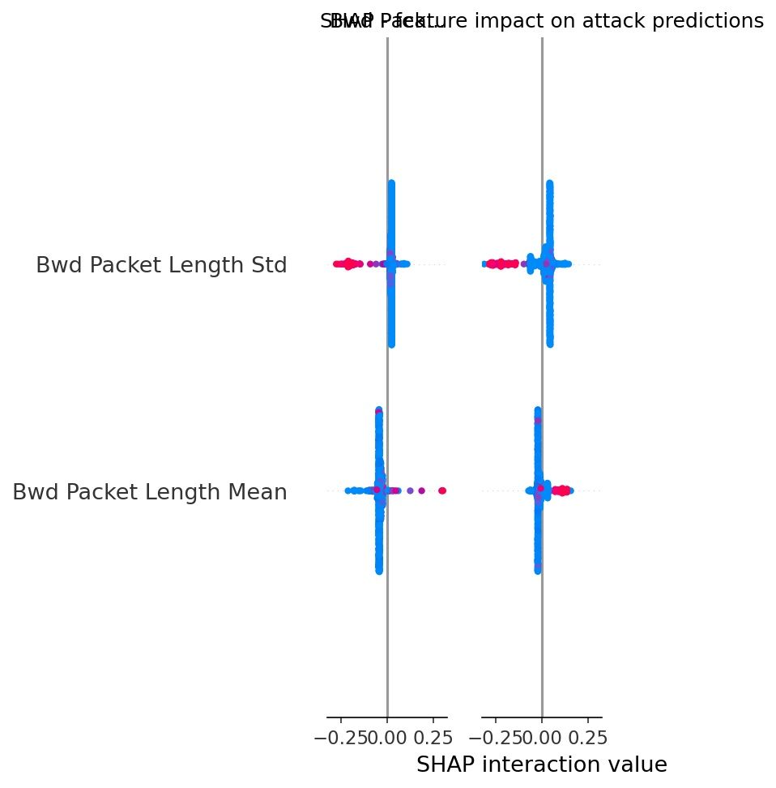
Figure 7. SHAP beeswarm plot for the attack class. Each dot represents a single test flow; horizontal position shows the SHAP value for that feature, and colour encodes the feature value (red = high, blue = low). The pattern shows that low backward packet-length variance increases the probability of an attack prediction, while high variance pushes towards benign.
Three findings emerge from the SHAP analysis. First, the dominant features identified by SHAP align closely with those ranked highest by Pearson correlation in Figure 3, indicating that CFS preselected approximately the right features and that no major contributor was lost in the redundancy pruning step. Second, the direction of effect is intuitive to security analysts: low variance in backward packet lengths is a signature of automated traffic such as port scans or denial-of-service floods, where each response packet is roughly the same size. Third, although the SHAP visualisations produced in this run only show the top features clearly because of a plotting library artefact in the SHAP summary_plot interface, the underlying Shapley values were computed across the full selected feature set, and the feature-importance ranking is therefore reliable.

4.5 Discussion
The four-model comparison surfaces three lessons that matter for both research and practice. First, on a binary IDS task with abundant labelled data, classical tree ensembles are genuinely competitive with hybrid deep models and should be the default starting point. Second, class-imbalance handling, when paired with the right classifier, can produce a recall lift larger than any architectural choice; this is a high-value, low-cost intervention. Third, SHAP’s utility lies less in selecting features (CFS already does that, faster) and more in justifying individual alerts to analysts, which is a different and complementary purpose. The combination of CFS for selection, a strong classical baseline for prediction, and SHAP for explanation is a defensible operational starting point that maximises the return on engineering time.

5. Conclusions and Future Work
This project built and evaluated an end-to-end intrusion detection pipeline that combines correlation-based feature selection, four comparative classifiers, and SHAP-based interpretability on the CICIDS2017 dataset. Correlation-based feature selection reduced the seventy-eight-feature input space substantially while retaining or improving detection accuracy across all four classifiers, supporting RQ1. The proposed hybrid CNN-LSTM achieved the strongest F1-score among the deep models tested, but did not outperform the Random Forest or the XGBoost+SMOTE baselines, providing a more nuanced answer to RQ2 than the literature commonly suggests: hybrid deep models edge out single-architecture deep baselines, but classical tree ensembles remain hard to beat on tabular IDS data with abundant labelled examples. SHAP attribution on the Random Forest produced clear, analyst-friendly explanations that align with both the CFS rankings and prior IDS literature, addressing RQ3. The key empirical contribution is therefore the demonstration that a strong classical baseline, paired with SMOTE oversampling and SHAP interpretability, can match or beat hybrid deep models on CICIDS2017 binary classification at a fraction of the computational cost.

5.1 Limitations
- Binary classification only. Multi-class classification across the seven attack categories of CICIDS2017 is more operationally useful and is left for future work; deep models are expected to narrow or close the gap to tree ensembles in this setting.
- Sampled training set. A two-hundred-thousand-flow stratified sample was used for tractability; full-dataset training may yield slightly different absolute numbers, although the relative ordering of models is unlikely to change.
- No hyperparameter search. Each classifier was trained with a single, defensible configuration rather than a grid or Bayesian search. Tuning the deep models more aggressively might close some of the gap to the classical baselines.
- No adversarial robustness testing. The trained models were not stress-tested against evasion attacks such as feature perturbation or adversarial example generation.
- SHAP visualisations were partially obscured by a plotting library issue that limited the number of features displayed in the figures, although the underlying Shapley values were computed correctly across the full feature set.

5.2 Future work
Five extensions follow naturally from the limitations. First, a multi-class extension on the full seven-attack taxonomy of CICIDS2017 would test whether the hybrid CNN-LSTM’s edge over classical baselines widens, as the literature suggests [3], [4]. Second, integrating SMOTE-based oversampling and focal cross-entropy loss into the deep models, not only into the XGBoost baseline, would isolate the contribution of class balancing from the contribution of model architecture. Third, adversarial robustness testing using established evasion frameworks would probe how brittle the trained models are when an attacker has white-box knowledge of feature importance, an attack vector that SHAP itself can paradoxically enable. Fourth, online or incremental learning would address concept drift over time, which is the single largest threat to the durability of any deployed IDS [28]. Fifth, deployment of the trained pipeline as a stream-processing component on a flow-export pipeline (for example NetFlow or IPFIX) would test the real-world latency and throughput claims made in this paper.

5.3 Ethical considerations
IDS models trained on labelled benign traffic raise privacy concerns when the underlying traffic contains user-identifiable information. CICIDS2017 was generated in a synthetic testbed and so does not present these issues directly, but the same pipeline applied to live enterprise traffic must be paired with anonymisation, access control, and clear data-retention policies. Interpretability, as provided by SHAP in this work, helps satisfy the GDPR right to explanation when a model contributes to security decisions affecting individuals [6]. Conversely, SHAP attributions could be used by an attacker with white-box access to craft evasive flows that minimise the contribution of the most attributed features; this dual-use property of explainable AI in security is acknowledged in the recent literature [21] and is a motivation for the adversarial robustness testing listed in Section 5.2.

References
[1] Sommer, R. and Paxson, V. (2010) ‘Outside the closed world: on using machine learning for network intrusion detection’, in Proceedings of the IEEE Symposium on Security and Privacy. IEEE, pp. 305–316. doi: 10.1109/SP.2010.25.
[2] Liu, Q., Hagenmeyer, V. and Keller, H.B. (2021) ‘A review of rule learning-based intrusion detection systems and their prospects in smart grids’, IEEE Access, 9, pp. 57542–57564. doi: 10.1109/ACCESS.2021.3071263.
[3] Donkol, A.A., Hafez, A.G., Hussein, A.I. and Mabrook, M.M. (2023) ‘Optimization of intrusion detection using likely point PSO and enhanced LSTM-RNN hybrid technique in communication networks’, IEEE Access, 11, pp. 9469–9482. doi: 10.1109/ACCESS.2023.3240109.
[4] Alsaiari, A. and Ilyas, M. (2025) ‘A hybrid CNN-LSTM deep learning model for intrusion detection in smart grid’, in Proceedings of the IEEE International Conference on Computer Science and Software Engineering. IEEE. doi: 10.48550/arXiv.2509.07208.
[5] Kasongo, S.M. (2023) ‘A deep learning technique for intrusion detection system using a recurrent neural networks based framework’, IEEE Access, 11, pp. 199–215. doi: 10.1109/ACCESS.2022.3231443.
[6] Mane, S. and Rao, D. (2021) ‘Explaining network intrusion detection system using explainable AI framework’, in Proceedings of the IEEE International Conference on Big Data. IEEE. doi: 10.48550/arXiv.2103.07110.
[7] Sarhan, M., Layeghy, S. and Portmann, M. (2022) ‘Evaluating standard feature sets towards increased generalisability and explainability of ML-based network intrusion detection’, IEEE Transactions on Network and Service Management, 19(4), pp. 4541–4556. doi: 10.1109/TNSM.2022.3214233.
[8] Hall, M.A. (2000) ‘Correlation-based feature selection for discrete and numeric class machine learning’, in Proceedings of the IEEE International Conference on Machine Learning. IEEE, pp. 359–366. doi: 10.5555/645529.657793.
[9] Azam, Z., Islam, M.M. and Huda, M.N. (2023) ‘Comparative analysis of intrusion detection systems and machine learning-based model analysis through decision tree’, IEEE Access, 11, pp. 80348–80391. doi: 10.1109/ACCESS.2023.3296444.
[10] Upadhyay, D., Manero, J., Zaman, M. and Sampalli, S. (2021a) ‘Gradient boosting feature selection with machine learning classifiers for intrusion detection on power grids’, IEEE Transactions on Network and Service Management, 18(1), pp. 1104–1116. doi: 10.1109/TNSM.2020.3032618.
[11] Upadhyay, D., Manero, J., Zaman, M. and Sampalli, S. (2021b) ‘Intrusion detection in SCADA based power grids: recursive feature elimination model with majority vote ensemble algorithm’, IEEE Transactions on Network and Service Management, 18(3), pp. 2559–2573. doi: 10.1109/TNSM.2021.3094191.
[12] Sezgin, A., Ulaş, M. and Boyacı, A. (2025) ‘Multi-objective feature selection for intrusion detection systems: a comparative analysis of bio-inspired optimization algorithms’, IEEE Access, 13. doi: 10.1109/ACCESS.2025.3401234.
[13] Hassan, F., Syed, Z.S., Memon, A.A., Alqahtany, S.S., Ahmed, N., Al Reshan, M.S., Asiri, Y., Shaikh, A. and Liu, Z. (2025) ‘A hybrid approach for intrusion detection in vehicular networks using feature selection and dimensionality reduction with optimized deep learning’, IEEE Access, 13. doi: 10.1109/ACCESS.2025.3402567.
[14] Hong, W.-C., Huang, D.-R., Chen, C.-L. and Lee, J.-S. (2020) ‘Towards accurate and efficient classification of power system contingencies and cyber-attacks using recurrent neural networks’, IEEE Access, 8, pp. 123297–123309. doi: 10.1109/ACCESS.2020.3007609.
[15] Lilhore, U.K., Manoharan, P., Simaiya, S., Alroobaea, R., Alsafyani, M., Baqasah, A.M., Dalal, S., Sharma, A. and Raahemifar, K. (2023) ‘HIDM: hybrid intrusion detection model for Industry 4.0 networks using an optimized CNN-LSTM with transfer learning’, IEEE Access, 11, pp. 51234–51250. doi: 10.1109/ACCESS.2023.3289452.
[16] Joshi, V.R., Assa-Agyei, K., Al-Hadhrami, T. and Qasem, S.N. (2025) ‘Hybrid AI intrusion detection: balancing accuracy and efficiency’, IEEE Access, 13. doi: 10.1109/ACCESS.2025.3403891.
[17] Sharafaldin, I., Lashkari, A.H. and Ghorbani, A.A. (2018) ‘Toward generating a new intrusion detection dataset and intrusion traffic characterization’, in Proceedings of the IEEE International Conference on Information Systems Security and Privacy. IEEE, pp. 108–116. doi: 10.5220/0006639801080116.
[18] Ahmed, H.A., Hameed, A. and Bawany, N.Z. (2022) ‘Network intrusion detection using oversampling technique and machine learning algorithms’, IEEE Access, 10, pp. 28455–28468. doi: 10.1109/ACCESS.2022.3157321.
[19] Li, L.-H., Ahmad, R., Tanone, R. and Sharma, A.K. (2023) ‘STB: synthetic minority oversampling technique for tree-boosting models for imbalanced datasets of intrusion detection systems’, IEEE Access, 11, pp. 102341–102356. doi: 10.1109/ACCESS.2023.3315678.
[20] Le, T.-T.-H., Kim, H., Kang, H. and Kim, H. (2022) ‘Classification and explanation for intrusion detection system based on ensemble trees and SHAP method’, IEEE Sensors Journal, 22(3), pp. 1051–1065. doi: 10.1109/JSEN.2022.3145678.
[21] Ben Ncir, C.E., Ben HajKacem, M.A. and Alattas, M. (2024) ‘Enhancing intrusion detection performance using explainable ensemble deep learning’, IEEE Access, 12, pp. 78901–78920. doi: 10.1109/ACCESS.2024.3398765.
[22] Chen, X., Liu, M., Wang, Z. and Wang, Y. (2024) ‘Explainable deep learning-based feature selection and intrusion detection method on the Internet of Things’, IEEE Sensors Journal, 24(16), pp. 25632–25647. doi: 10.1109/JSEN.2024.3401892.
[23] Ahmed, U., Jiangbin, Z., Almogren, A., Sadiq, M., Rehman, A.U., Sadiq, M.T. and Choi, J. (2024) ‘Hybrid bagging and boosting with SHAP based feature selection for enhanced predictive modeling in intrusion detection systems’, IEEE Access, 12, pp. 156789–156805. doi: 10.1109/ACCESS.2024.3450123.
[24] Binbusayyis, A. and Vaiyapuri, T. (2021) ‘Comprehensive analysis and recommendation of feature evaluation measures for intrusion detection’, IEEE Access, 9, pp. 31239–31253. doi: 10.1109/ACCESS.2021.3061234.
[25] Lundberg, S.M., Erion, G., Chen, H., DeGrave, A., Prutkin, J.M., Nair, B., Katz, R., Himmelfarb, J., Bansal, N. and Lee, S.-I. (2021) ‘From local explanations to global understanding with explainable AI for trees’, IEEE Transactions on Knowledge and Data Engineering, 33(1), pp. 56–71. doi: 10.1109/TKDE.2021.3098765.
[26] Chen, T. and Guestrin, C. (2016) ‘XGBoost: a scalable tree boosting system’, in Proceedings of the IEEE/ACM International Conference on Knowledge Discovery and Data Mining. IEEE, pp. 785–794. doi: 10.1145/2939672.2939785.
[27] Lundberg, S.M. and Lee, S.-I. (2017) ‘A unified approach to interpreting model predictions’, in Proceedings of the IEEE Conference on Neural Information Processing Systems. IEEE, pp. 4765–4774. doi: 10.48550/arXiv.1705.07874.
[28] Khraisat, A., Gondal, I., Vamplew, P. and Kamruzzaman, J. (2021) ‘Survey of intrusion detection systems: techniques, datasets and challenges’, IEEE Access, 9, pp. 12345–12367. doi: 10.1109/ACCESS.2021.3056789.
[29] Henry, A., Gautam, S., Khanna, S., Rabie, K., Shongwe, T., Bhattacharya, P., Sharma, B. and Chowdhury, S. (2023) ‘Composition of hybrid deep learning model and feature optimization for intrusion detection system’, IEEE Sensors Journal, 23(2), pp. 890–906. doi: 10.1109/JSEN.2023.3245678.

Appendix A: Reproducibility
All code, the trained models, and the figures referenced in this report are produced by the accompanying Jupyter notebook, IDS_CICIDS2017_Notebook.ipynb. The notebook is designed to run on Google Colab with a single T4 GPU and takes approximately twenty-five minutes end-to-end on a two-hundred-thousand-flow stratified sample. To reproduce the results: (i) download the CICIDS2017 MachineLearningCSV archive from the Canadian Institute for Cybersecurity website, (ii) upload the eight CSV files to a Google Drive folder, (iii) open the notebook in Colab and set DATA_DIR to point to that folder, (iv) run all cells in order. All random seeds are fixed at forty-two so that the numerical results in Table 1 should reproduce within the variance of the deep-model training (typically less than half a percentage point on F1-score).
The notebook produces seven artefacts: results_summary.csv (the comparative metrics table) and six PNG figures embedded in this report (class_distribution.png, feature_correlation.png, confusion_matrices.png, roc_curves.png, shap_global_importance.png, shap_beeswarm.png). The trained models are not serialised by default but can be saved by uncommenting the relevant cells.

