1. Create a windows Vm machine in AWS and connect with RDP open CMD in windows share the about system info.

Type 1: Windows OS Launched in AWS web console VM Named Windows_Task_1

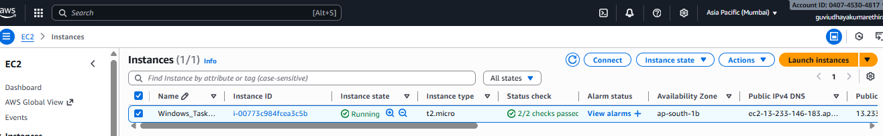

Type 2: Windows OS launched using AWS Cloud Shell, VM Named Windows_Task_2

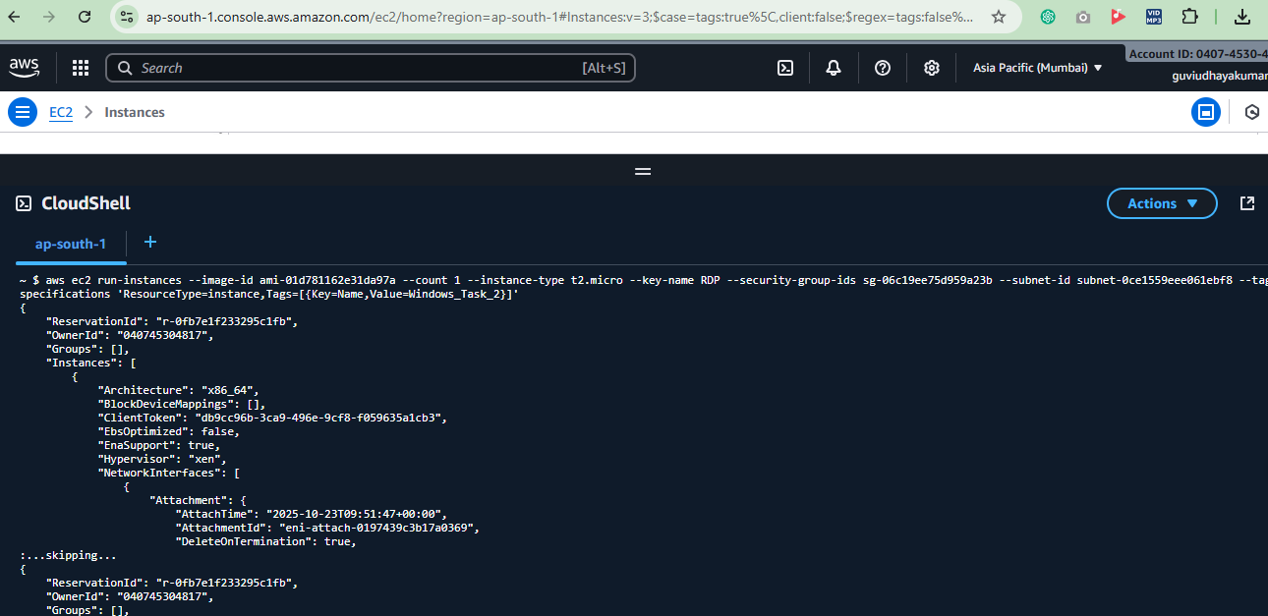

Getting password for Administrator:

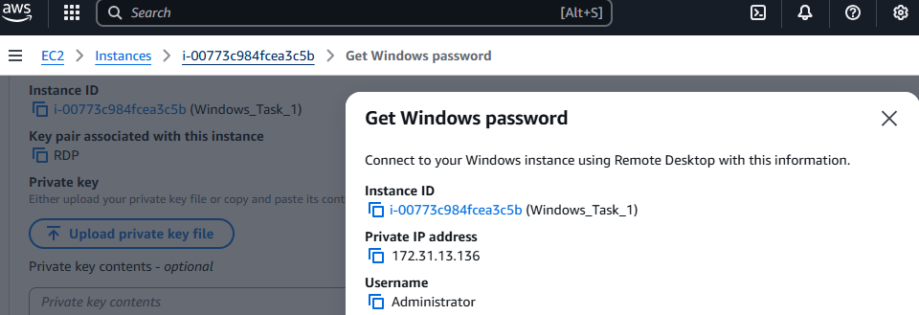

Connecting Remote Session:

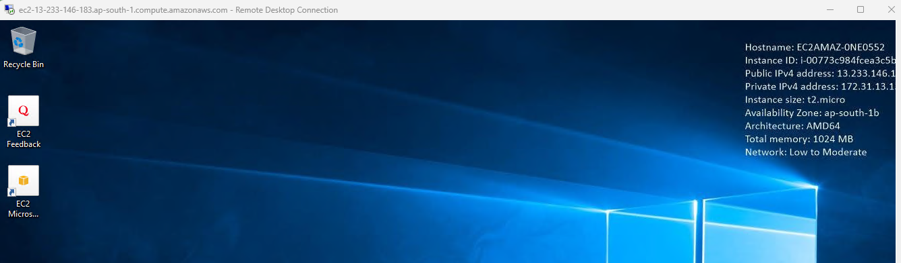

Systeminfo details

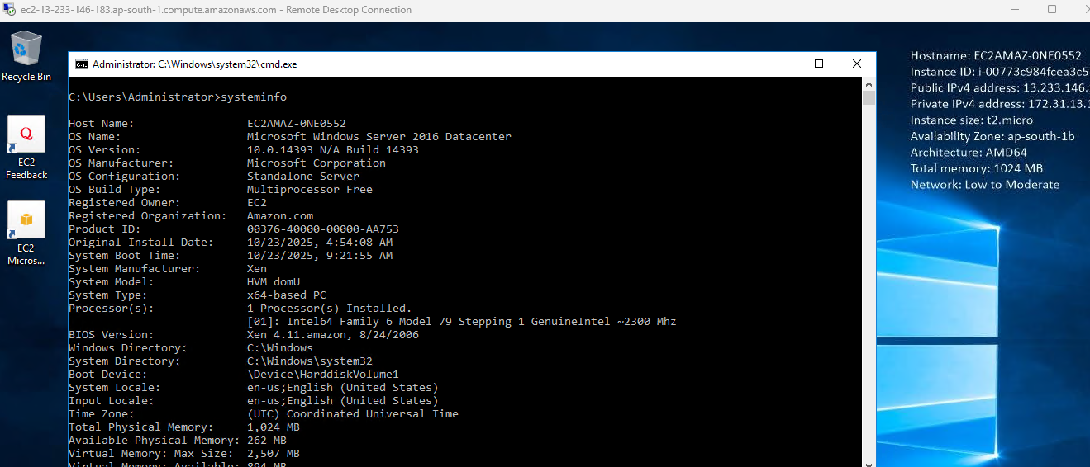

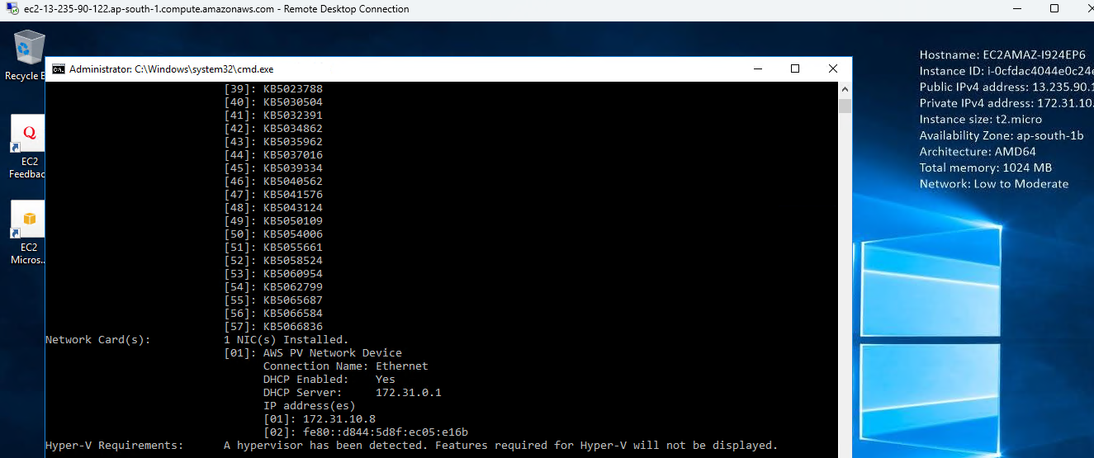

Systeminfo details for VM Name : Windows_Task_1

C:\Users\Administrator>systeminfo

Host Name: EC2AMAZ-0NE0552

OS Name: Microsoft Windows Server 2016 Datacenter

OS Version: 10.0.14393 N/A Build 14393

OS Manufacturer: Microsoft Corporation

OS Configuration: Standalone Server

OS Build Type: Multiprocessor Free

Registered Owner: EC2

Registered Organization: Amazon.com

Product ID: 00376-40000-00000-AA753

Original Install Date: 10/23/2025, 4:54:08 AM

System Boot Time: 10/23/2025, 9:21:55 AM

System Manufacturer: Xen

System Model: HVM domU

System Type: x64-based PC

Processor(s): 1 Processor(s) Installed.

[01]: Intel64 Family 6 Model 79 Stepping 1 GenuineIntel ~2300 Mhz

BIOS Version: Xen 4.11.amazon, 8/24/2006

Windows Directory: C:\Windows

System Directory: C:\Windows\system32

Boot Device: \Device\HarddiskVolume1

System Locale: en-us;English (United States)

Input Locale: en-us;English (United States)

Time Zone: (UTC) Coordinated Universal Time

Total Physical Memory: 1,024 MB

Available Physical Memory: 262 MB

Virtual Memory: Max Size: 2,507 MB

Virtual Memory: Available: 894 MB

Virtual Memory: In Use: 1,613 MB

Page File Location(s): C:\pagefile.sys

Domain: WORKGROUP

Logon Server: \\EC2AMAZ-0NE0552

Hotfix(s): 57 Hotfix(s) Installed.

[01]: KB5066136

[02]: KB3176936

[03]: KB3186568

[04]: KB3192137

[05]: KB3199209

[06]: KB3199986

[07]: KB4013418

[08]: KB4023834

[09]: KB4035631

[10]: KB4049065

[11]: KB4089510

[12]: KB4093137

[13]: KB4132216

[14]: KB4465659

[15]: KB4485447

[16]: KB4486129

[17]: KB4498947

[18]: KB4503537

[19]: KB4509091

[20]: KB4512574

[21]: KB4520724

[22]: KB4521858

[23]: KB4535680

[24]: KB4540723

[25]: KB4550994

[26]: KB4562561

[27]: KB4565912

[28]: KB4576750

[29]: KB4589210

[30]: KB5001078

[31]: KB5001402

[32]: KB5005698

[33]: KB5011264

[34]: KB5011570

[35]: KB5014026

[36]: KB5016058

[37]: KB5017095

[38]: KB5017396

[39]: KB5023788

[40]: KB5030504

[41]: KB5032391

[42]: KB5034862

[43]: KB5035962

[44]: KB5037016

[45]: KB5039334

[46]: KB5040562

[47]: KB5041576

[48]: KB5043124

[49]: KB5050109

[50]: KB5054006

[51]: KB5055661

[52]: KB5058524

[53]: KB5060954

[54]: KB5062799

[55]: KB5065687

[56]: KB5066584

[57]: KB5066836

Network Card(s): 1 NIC(s) Installed.

[01]: AWS PV Network Device

Connection Name: Ethernet

DHCP Enabled: Yes

DHCP Server: 172.31.0.1

IP address(es)

[01]: 172.31.13.136

[02]: fe80::d829:1967:9f84:a26a

Hyper-V Requirements: A hypervisor has been detected. Features required for Hyper-V will not be displayed.

C:\Users\Administrator>

Systeminfo details for VM Name : Windows_Task_2  
  
Microsoft Windows [Version 10.0.14393]

(c) 2016 Microsoft Corporation. All rights reserved.

C:\Users\Administrator>systeminfo

Host Name: EC2AMAZ-I924EP6

OS Name: Microsoft Windows Server 2016 Datacenter

OS Version: 10.0.14393 N/A Build 14393

OS Manufacturer: Microsoft Corporation

OS Configuration: Standalone Server

OS Build Type: Multiprocessor Free

Registered Owner: EC2

Registered Organization: Amazon.com

Product ID: 00376-40000-00000-AA753

Original Install Date: 10/23/2025, 3:48:29 AM

System Boot Time: 10/23/2025, 9:52:08 AM

System Manufacturer: Xen

System Model: HVM domU

System Type: x64-based PC

Processor(s): 1 Processor(s) Installed.

[01]: Intel64 Family 6 Model 79 Stepping 1 GenuineIntel ~2300 Mhz

BIOS Version: Xen 4.11.amazon, 8/24/2006

Windows Directory: C:\Windows

System Directory: C:\Windows\system32

Boot Device: \Device\HarddiskVolume1

System Locale: en-us;English (United States)

Input Locale: en-us;English (United States)

Time Zone: (UTC) Coordinated Universal Time

Total Physical Memory: 1,024 MB

Available Physical Memory: 75 MB

Virtual Memory: Max Size: 2,048 MB

Virtual Memory: Available: 819 MB

Virtual Memory: In Use: 1,229 MB

Page File Location(s): C:\pagefile.sys

Domain: WORKGROUP

Logon Server: \\EC2AMAZ-I924EP6

Hotfix(s): 57 Hotfix(s) Installed.

[01]: KB5066136

[02]: KB3176936

[03]: KB3186568

[04]: KB3192137

[05]: KB3199209

[06]: KB3199986

[07]: KB4013418

[08]: KB4023834

[09]: KB4035631

[10]: KB4049065

[11]: KB4089510

[12]: KB4093137

[13]: KB4132216

[14]: KB4465659

[15]: KB4485447

[16]: KB4486129

[17]: KB4498947

[18]: KB4503537

[19]: KB4509091

[20]: KB4512574

[21]: KB4520724

[22]: KB4521858

[23]: KB4535680

[24]: KB4540723

[25]: KB4550994

[26]: KB4562561

[27]: KB4565912

[28]: KB4576750

[29]: KB4589210

[30]: KB5001078

[31]: KB5001402

[32]: KB5005698

[33]: KB5011264

[34]: KB5011570

[35]: KB5014026

[36]: KB5016058

[37]: KB5017095

[38]: KB5017396

[39]: KB5023788

[40]: KB5030504

[41]: KB5032391

[42]: KB5034862

[43]: KB5035962

[44]: KB5037016

[45]: KB5039334

[46]: KB5040562

[47]: KB5041576

[48]: KB5043124

[49]: KB5050109

[50]: KB5054006

[51]: KB5055661

[52]: KB5058524

[53]: KB5060954

[54]: KB5062799

[55]: KB5065687

[56]: KB5066584

[57]: KB5066836

Network Card(s): 1 NIC(s) Installed.

[01]: AWS PV Network Device

Connection Name: Ethernet

DHCP Enabled: Yes

DHCP Server: 172.31.0.1

IP address(es)

[01]: 172.31.10.8

[02]: fe80::d844:5d8f:ec05:e16b

Hyper-V Requirements: A hypervisor has been detected. Features required for Hyper-V will not be displayed.

C:\Users\Administrator>