**Set up a VPC with an Internet gateway, create a public subnet with 256 IP addresses, a private subnet with 256 IP addresses, make a route table connecting the Internet gateway and the subnets, and launch a Linux EC2 instance by using the above VPC and public subnet.**

Set up a VPC

VPC created with 10.0.0.0/16 CIDR

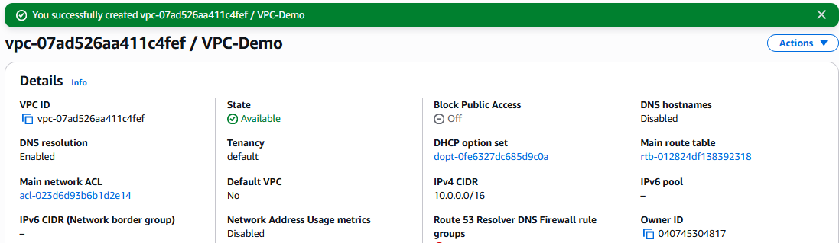

Creating Internet Gateway and attached with VPC-Demo

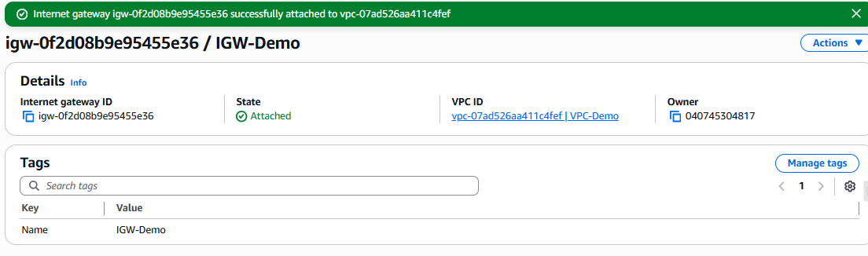

Created Public Subnet with 256 IP’s : 10.0.90.0/24

Usable IP’s : 251

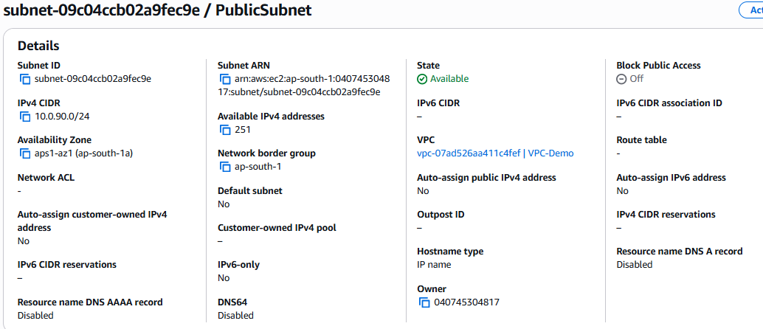

Created Private Subnet with 256 IP’s : 10.0.20.0/24

Usable IP’s : 251

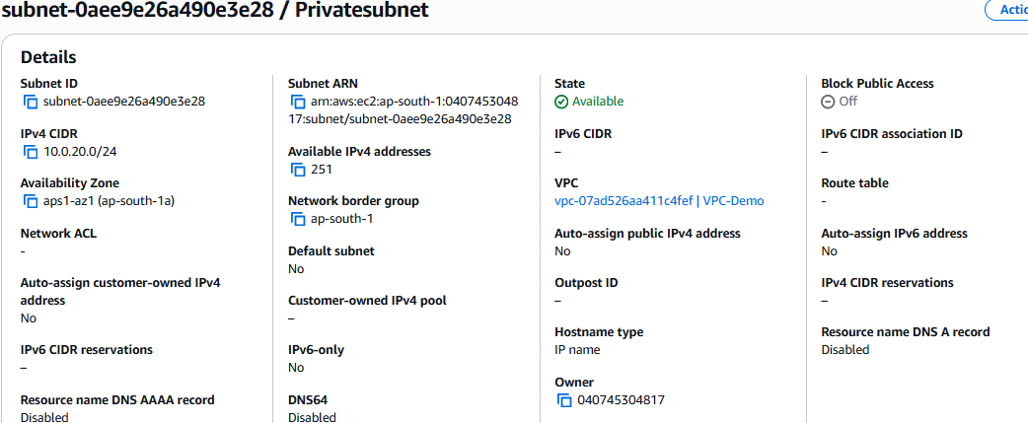

Created Route for Subnet’s

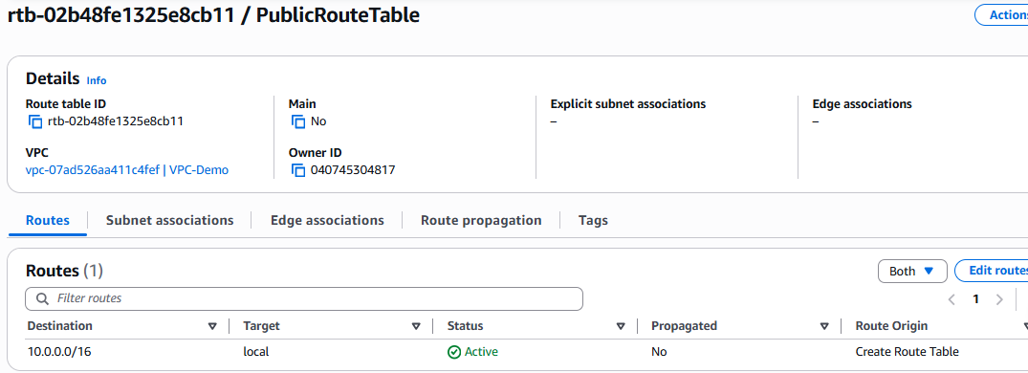

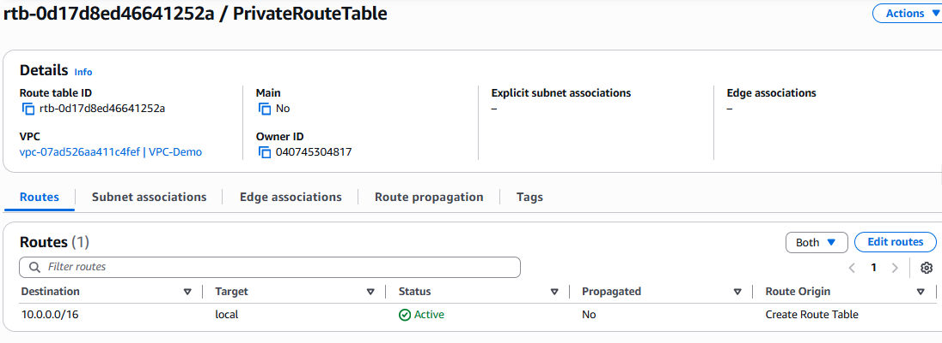

Route Table update with Internet Gateway

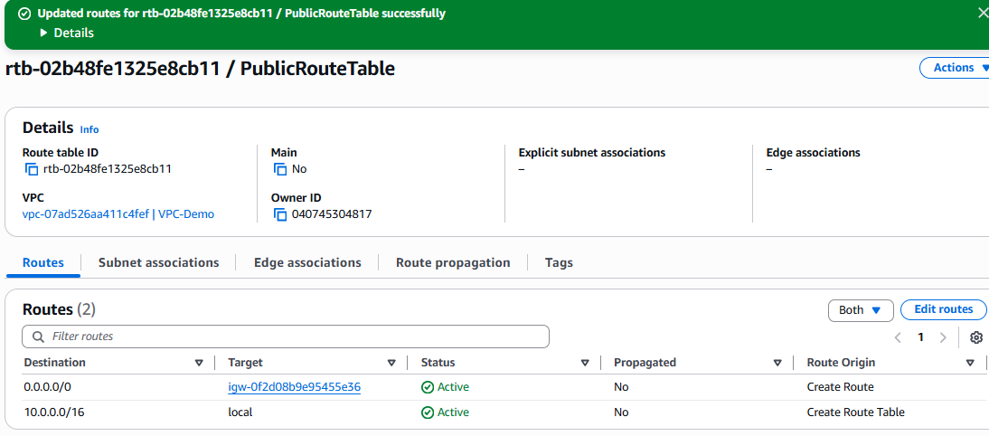

Route Table with IG and subnet

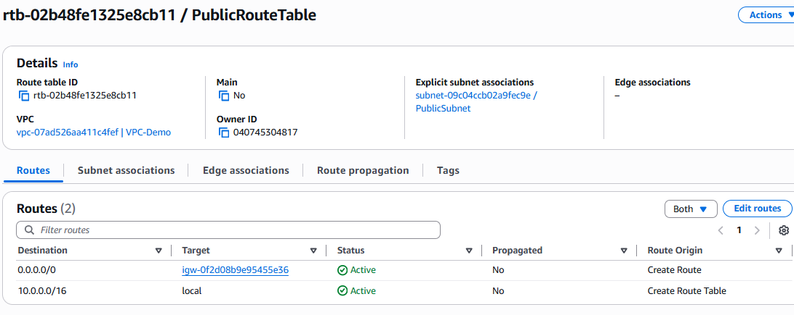

EC2 instance launched with VPC-Demo and Public Subnet

