1. **Create a S3 bucket, with no public access and upload files to the bucket & view the logs using cloudwatch for the uploaded files.**

Created a S3 bucket with no public access

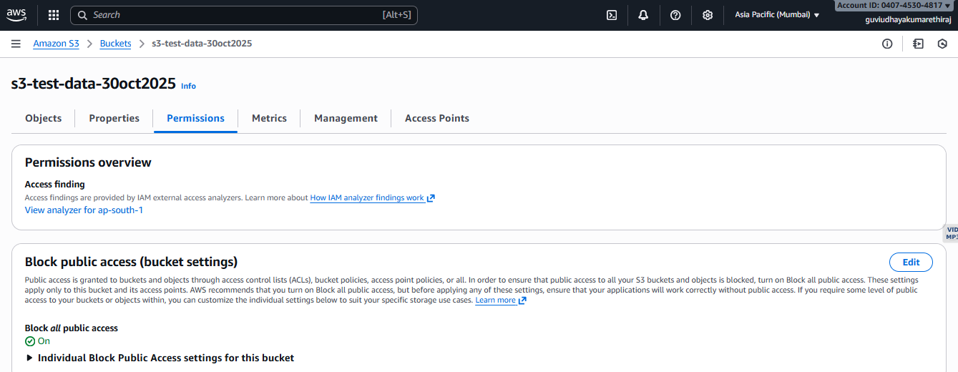

Logs enabled for the bucket

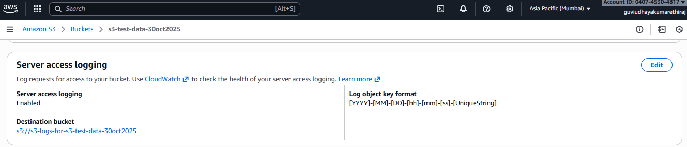

Files uploaded to the bucket folder

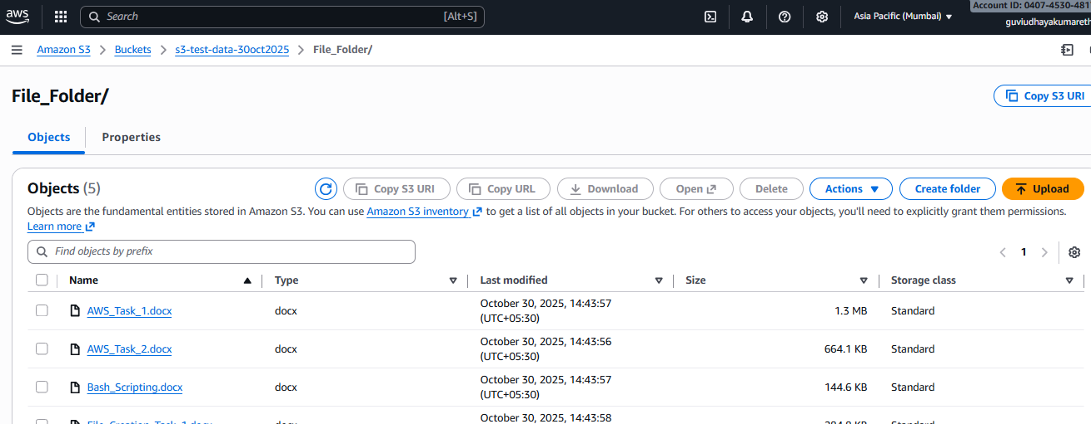

Uploaded logs using cloudwatch.

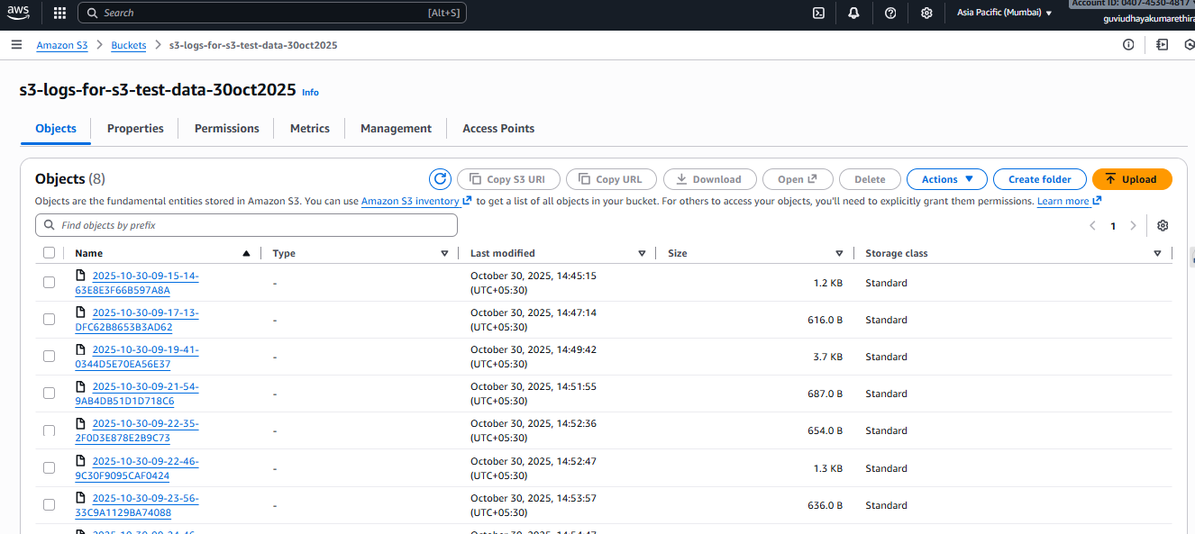

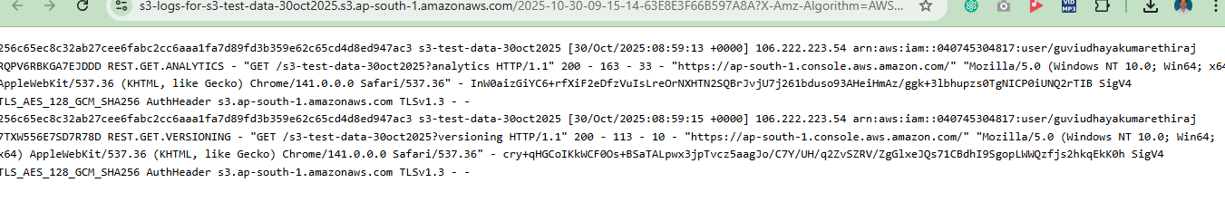

1. **Launch two ec2-instances and connect it to a application load balancer, where the output traffic from the server must be an load balancer IP address.**

2 Ec2 instances launched

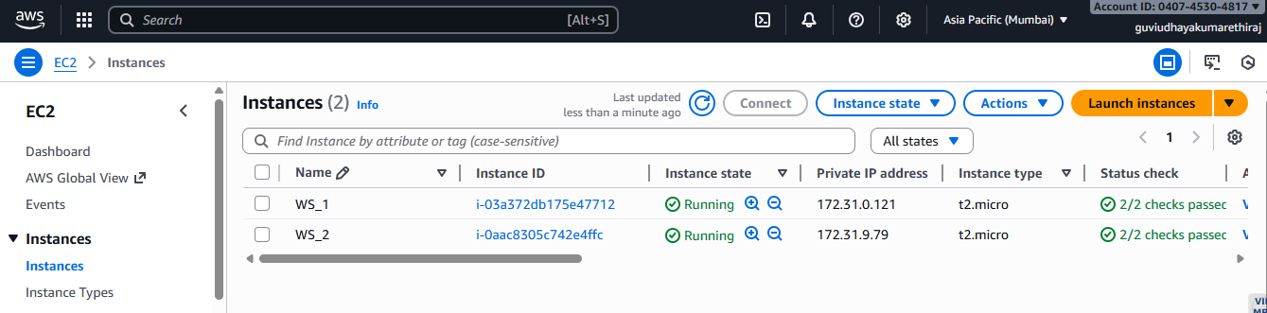

Application Load Balancer created

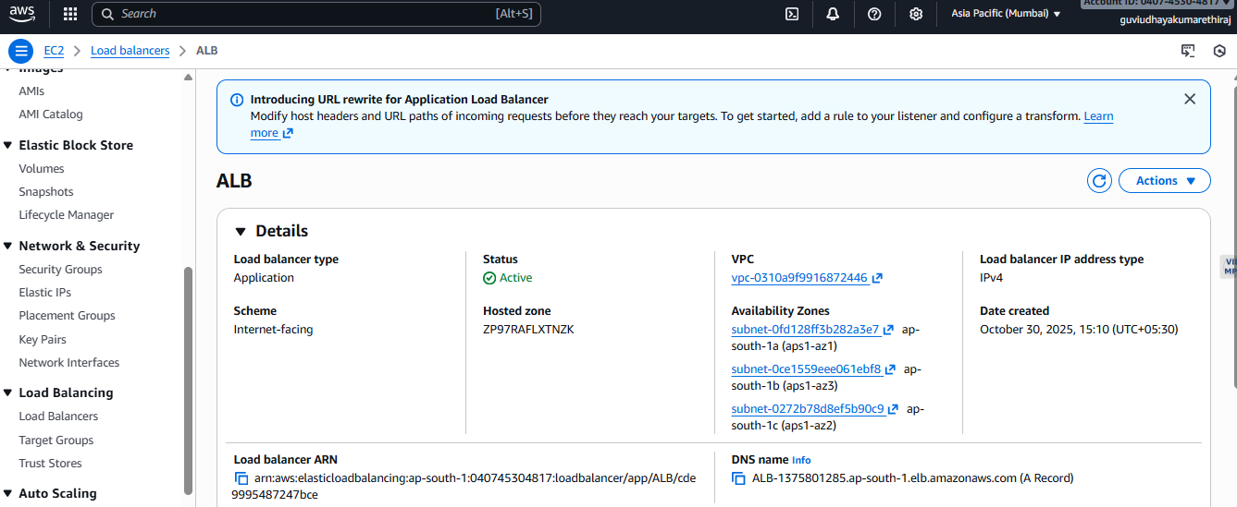

website status from ALB

