1. **Launch an EC2 instance (Linux and Windows) along with a web server. Then, create an EBS volume of 5 GB, attach it to an EC2 machine (Linux and Windows), and take a snapshot. Finally, create an EBS volume using the taken snapshot..**

Launched EC2 instances in Windows & Linux with web server

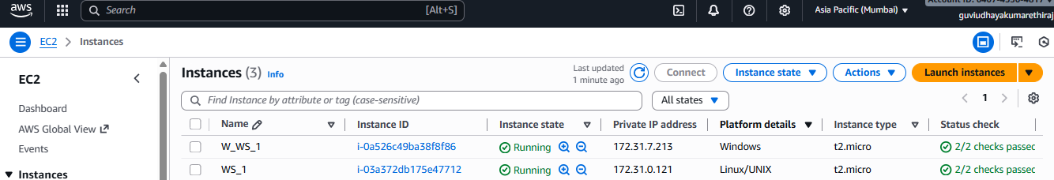

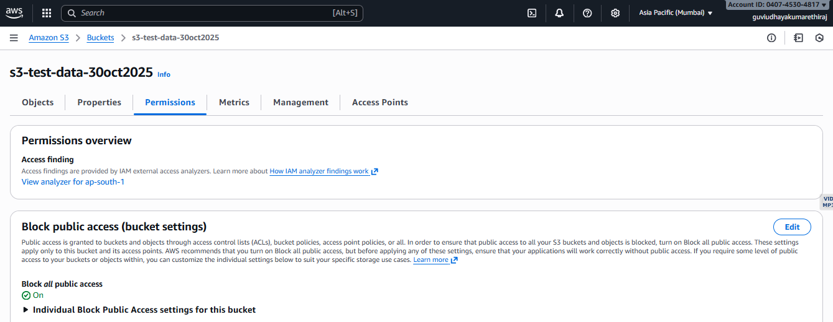

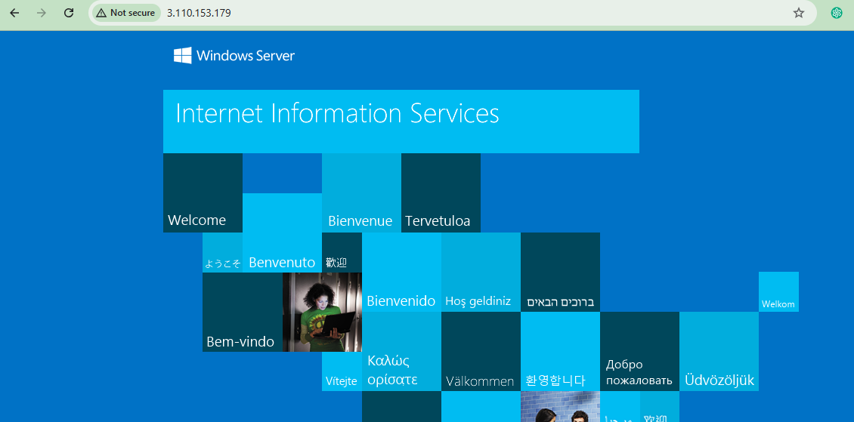

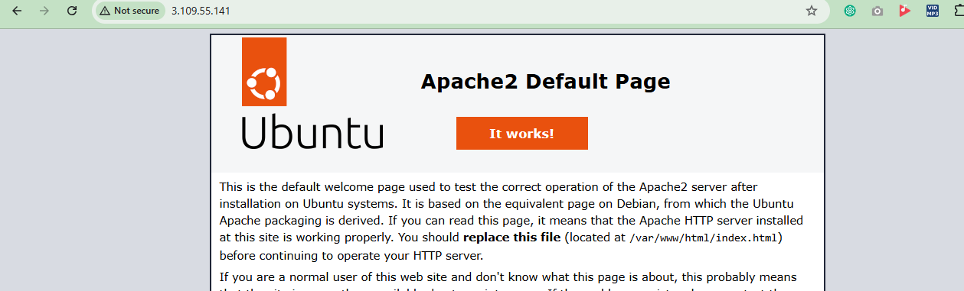

Created 2 volume in 5 GB and attached 1 with Windows and 1 with Linux

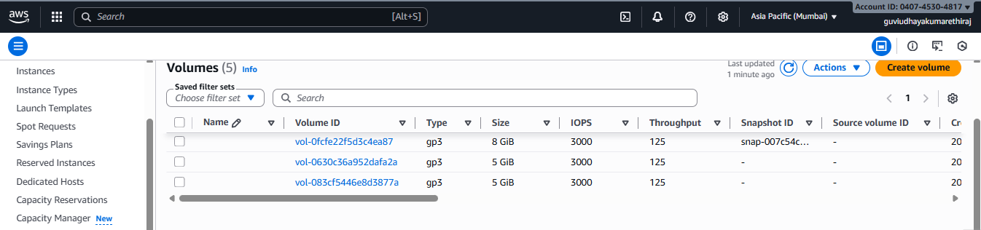

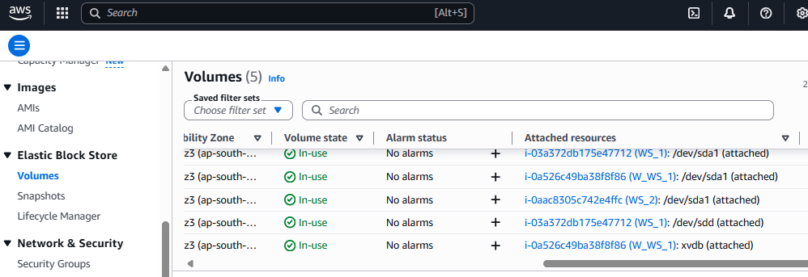

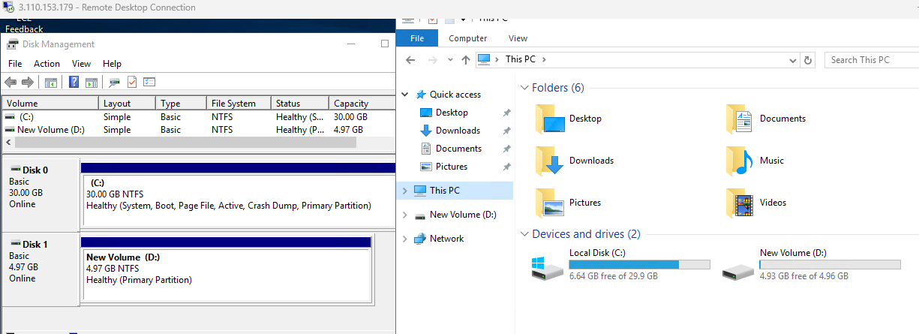

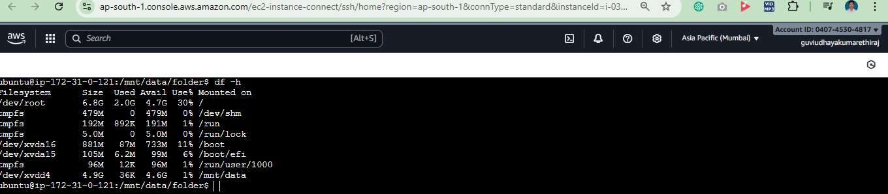

Snapshot of the created EBS volume  
  
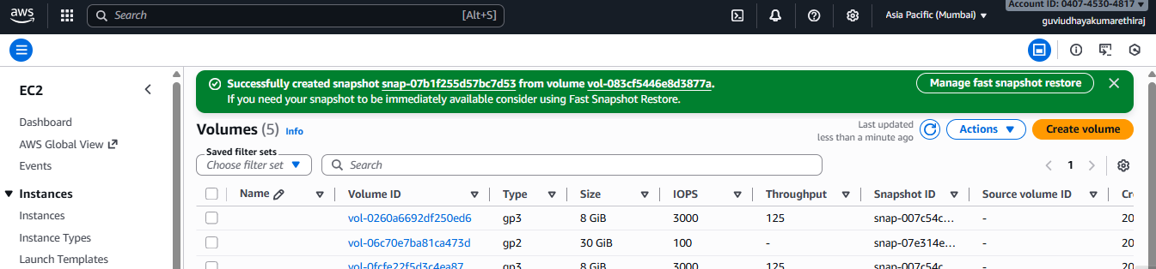

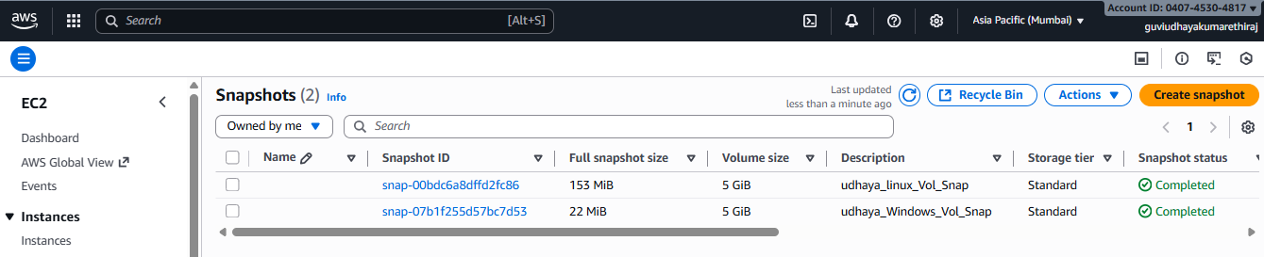

Attached Volume created from snap

