1. Create a shell script to print the HTTP error code of guvi.in & print, the success/failure message based on the error code response

Creating bash script file using nano command  


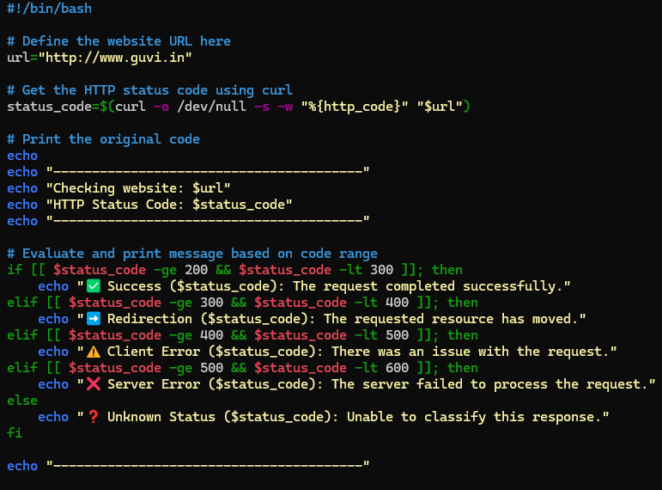

Providing execute permission to file.

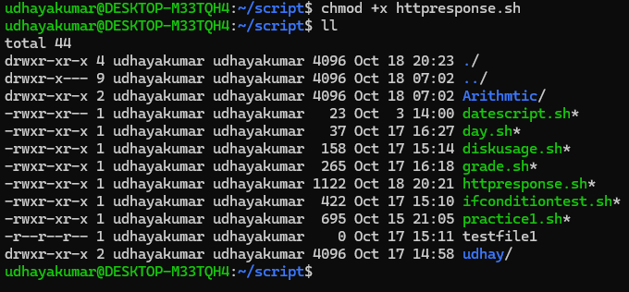

Error code for <http://www.guvi.in> website

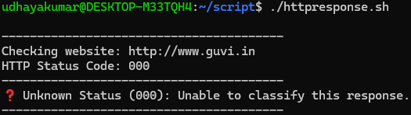

1. Given a file, replace all occurrence of the word "give" with "learning" from 5th line till the end in only those lines that contain the word "welcome"

We can use this command to achieve the above request

sed '5,$ {/welcome/s/give/learning/g}' filename.txt

File is missing.