1.Get me the IP address of a particular domain (guvi.in). How do I find my CPU/memory usage of my server?. Test the connectivity between 2 nodes?  
  
IP address of guvi.in.  
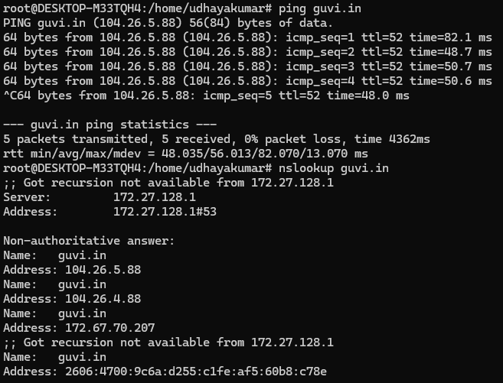

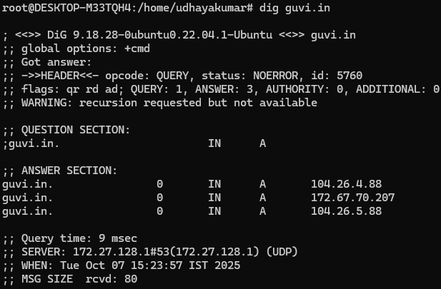

CPU/memory usage of my server  
  
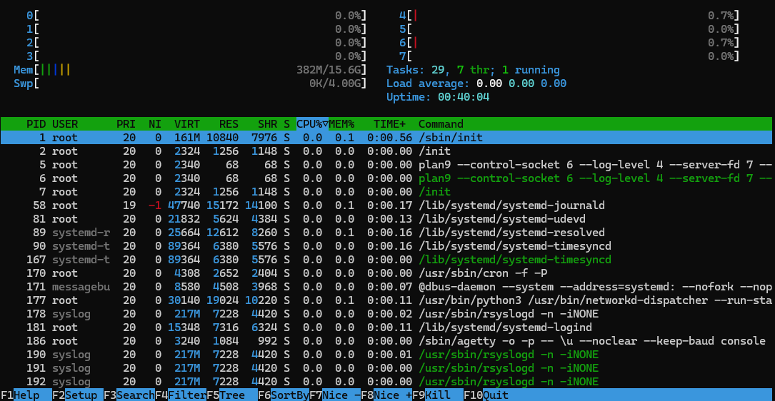  
  
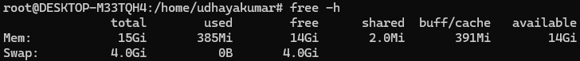  
  
Test the connectivity between 2 nodes  
  
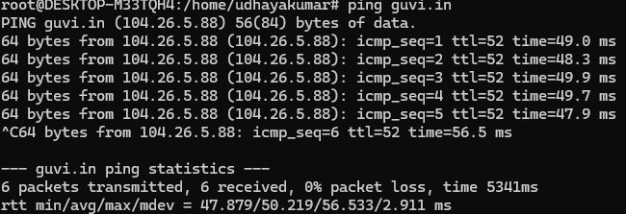

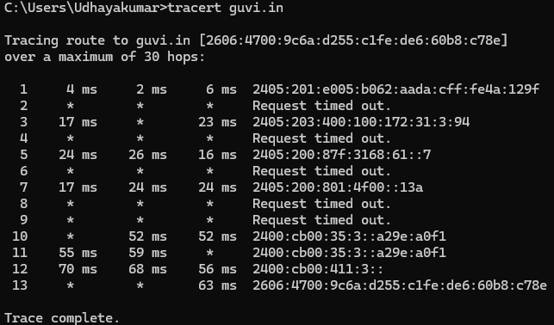

2. I have deployed an application in guvi.com:9000, and logs show my app is running, but I’m unable to view the page. Check whether my port is open or not?  
  
guvi.com:9000 – Port is not open

