**1. Create a file with .txt extension** **(/home/demo.txt). Change the permission set of that file, so that any user can read it, group can read/write & owner can read/write/execute it.**

Step 1: File created /home/demo.txt

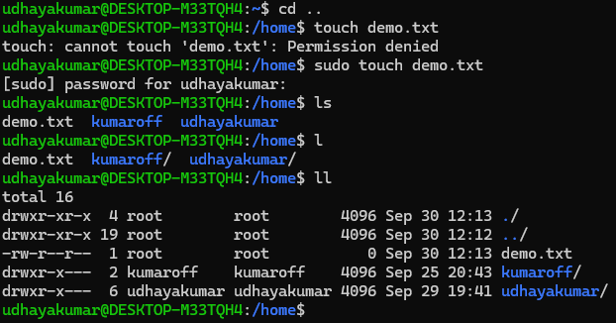

Step 2 : Permission change from -rw-r--r-- to -rwxrw-r-- for Owner - read/write/execute

group - read/write & any user – read

