Jenkins Task
Launch Jenkins and explore creating projects and users.
EC2 Instance launched for Jenkins install
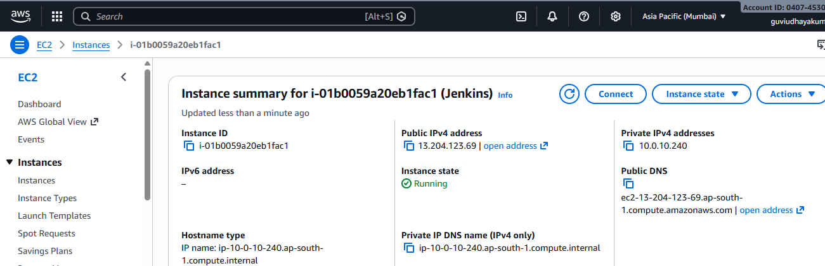

Connected EC2 instance using putty
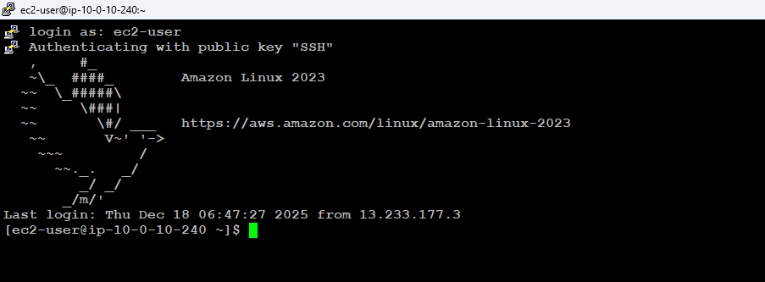
Installing Jenkins in Amazon Linux
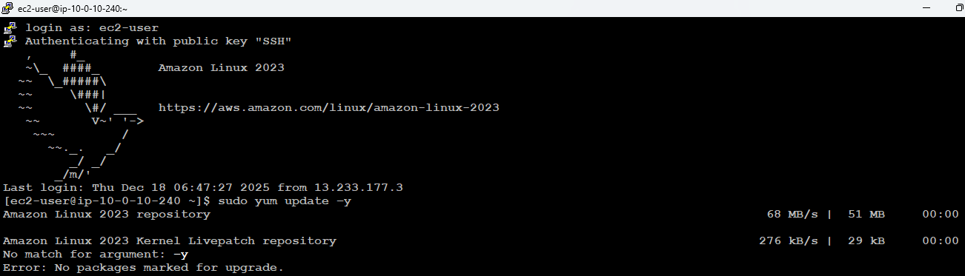
Followed the steps from official Jenkins website to install Jenkins
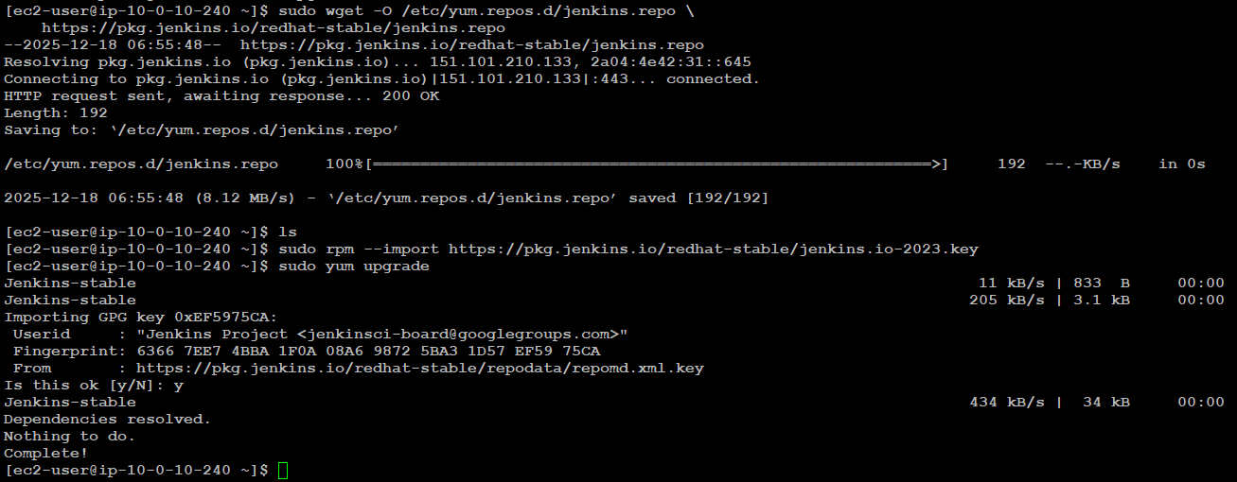
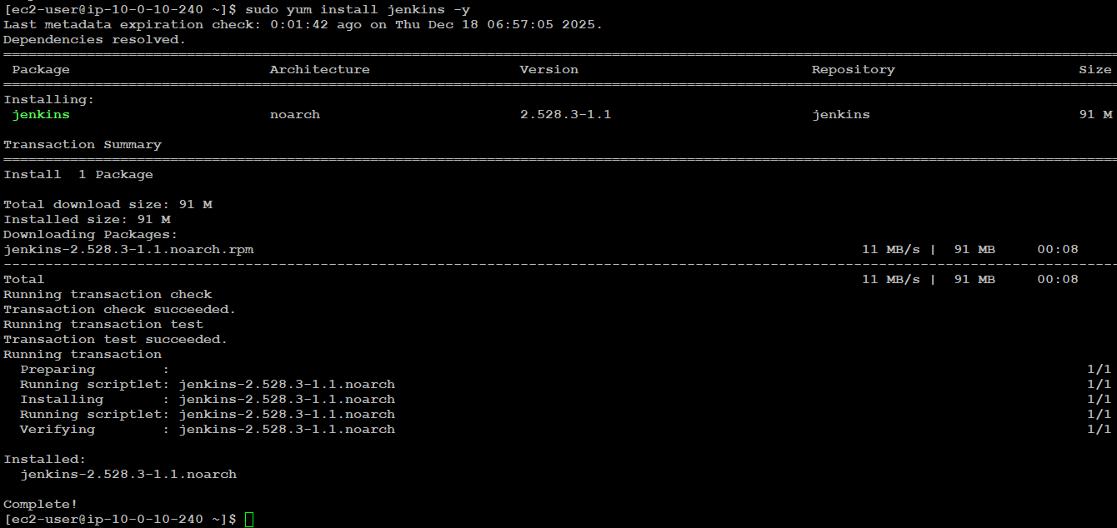
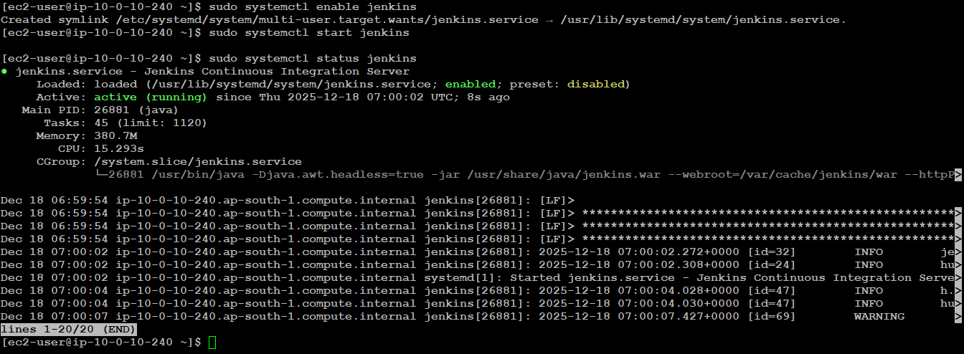
Configuring Jenkins
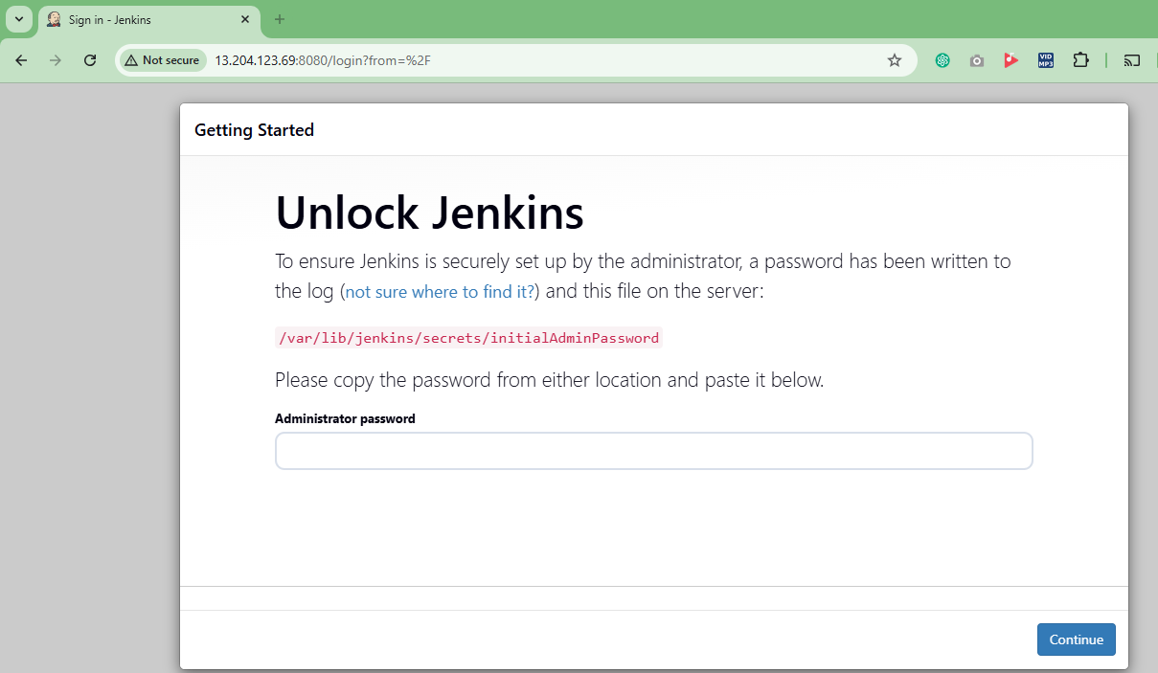
Password retrived from location /var/lib/jenkins/secrets/initialAdminPassword
Jenkins installed
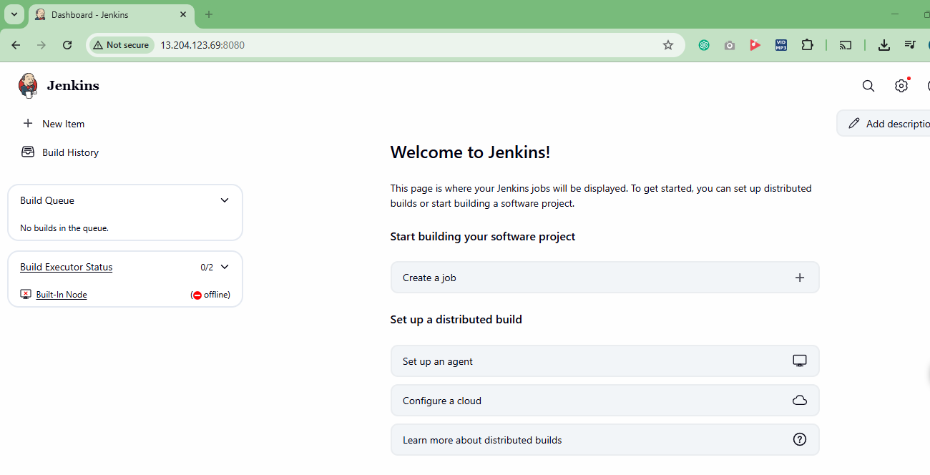

Freestyle Project creation
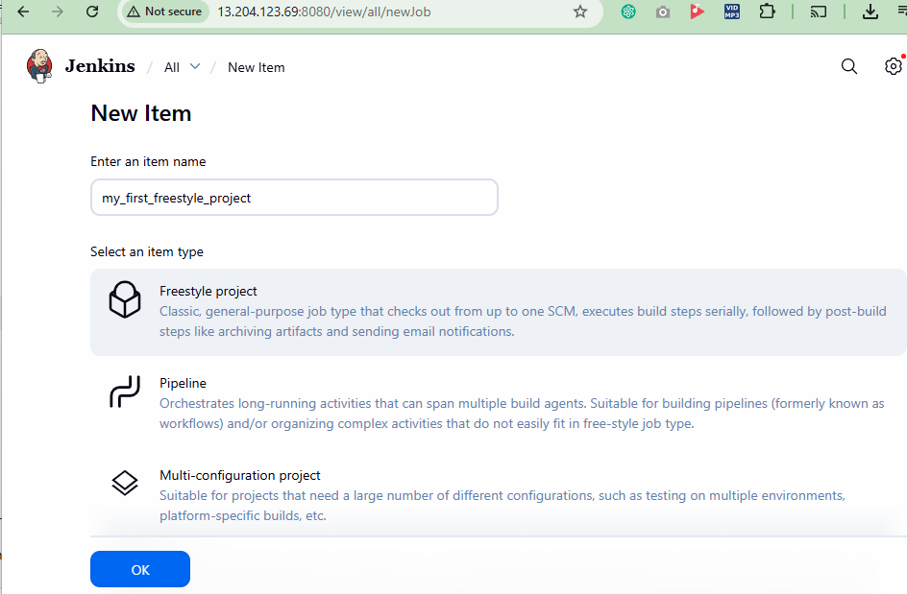
created
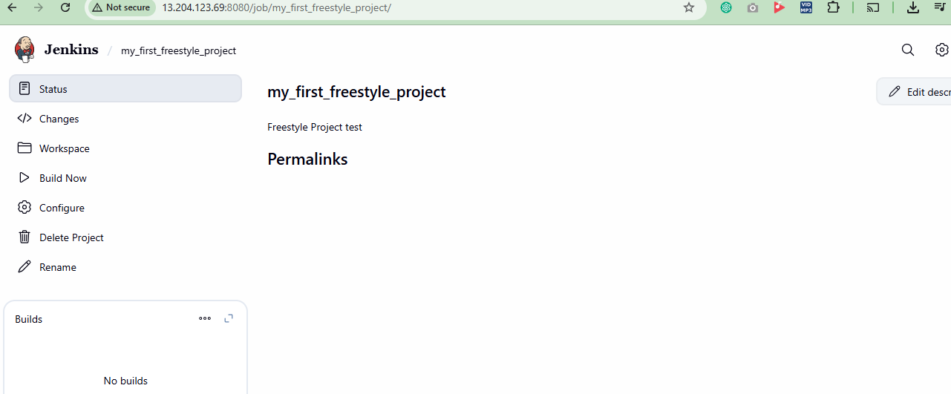

Build console output
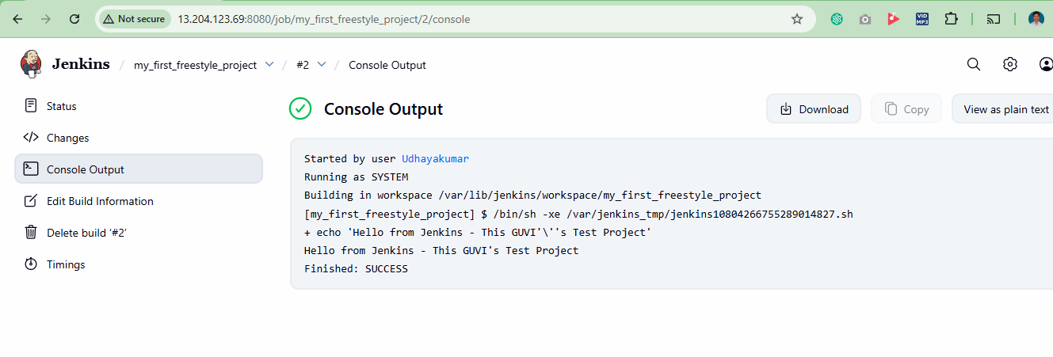

jenkinsfile created for pipeline and stored in Git repo

New item Pipeline-test created
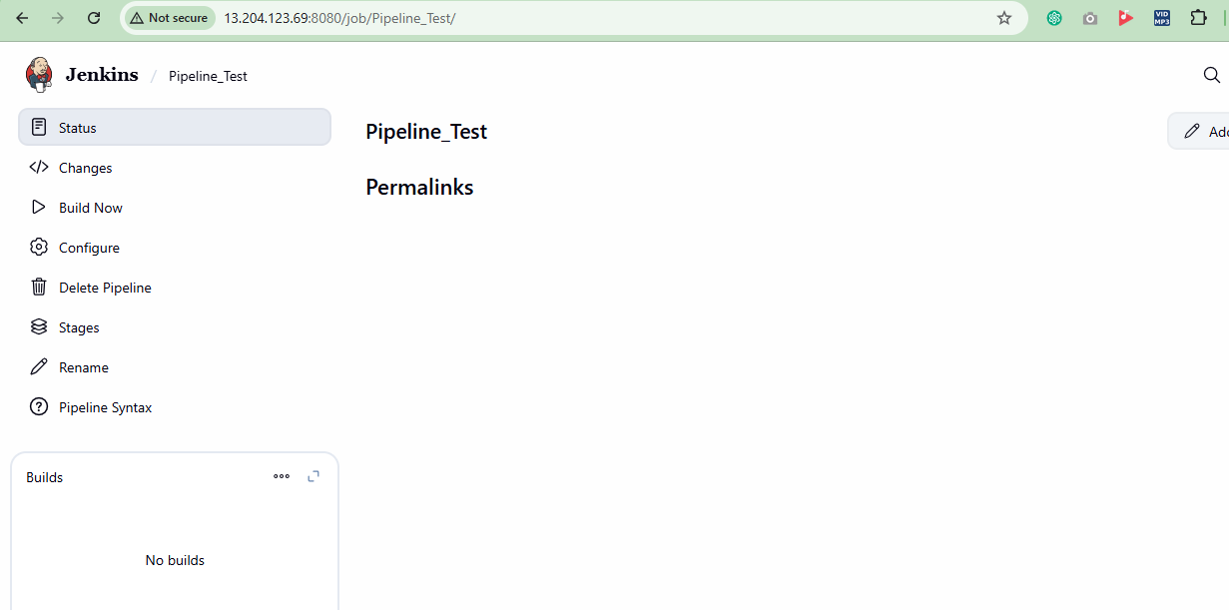

console output for pipeline_test
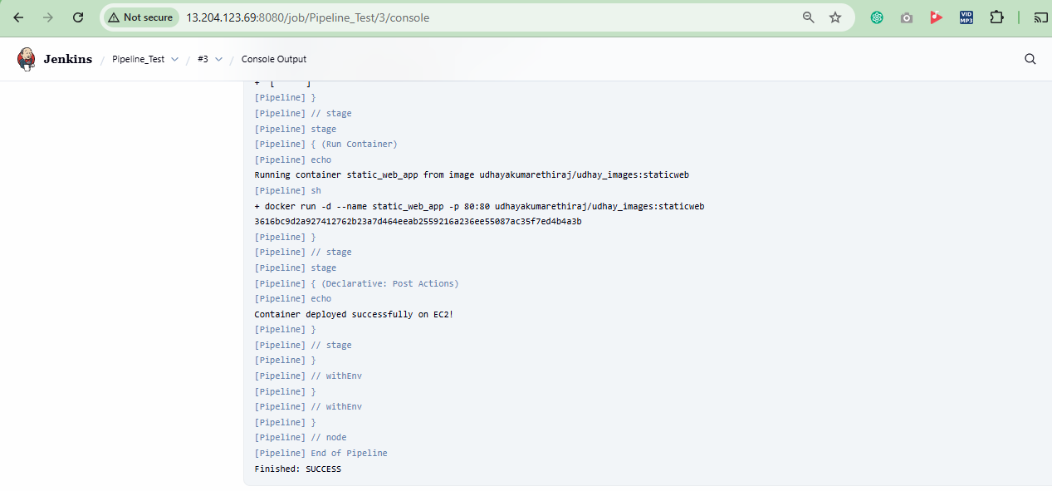
Application output launched in EC2
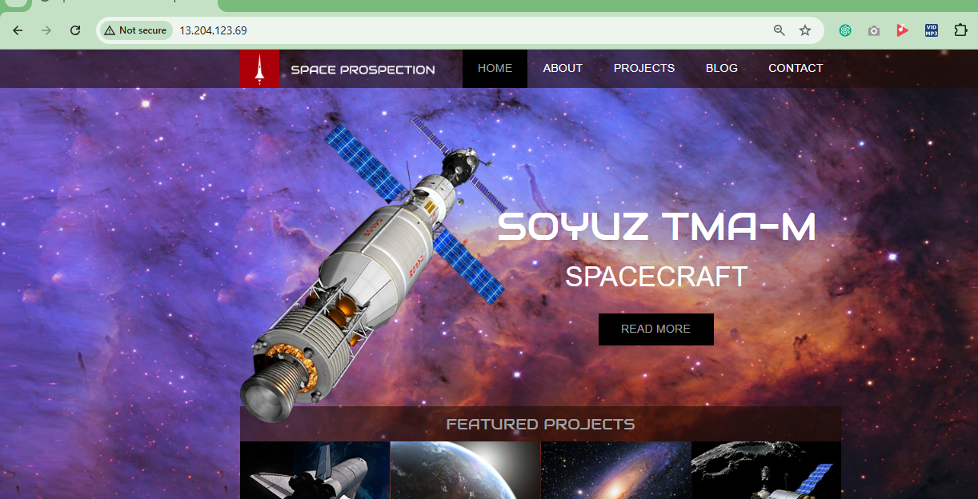

User created in Jenkins
