VCS Task
Establish a new directory, populate it with script files, initiate an empty repository on GitHub, convert the local directory into a Git repository, and link it to GitHub for pushing the code into the repository.Perform merge, rebase, stash commands in following github repo.

Established a new directory named my_git_task_repo
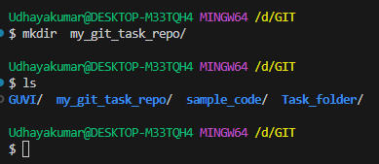
populate it with script files
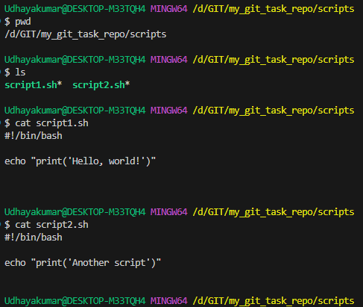
Created an empty repository on GitHub
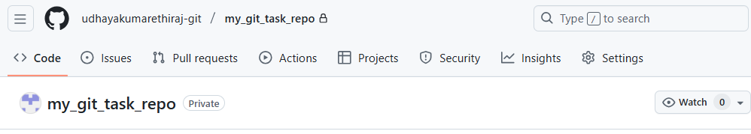

Convert the local directory into a Git repository, and link it to GitHub for pushing the code into the repository
Local directory into GIT Repository
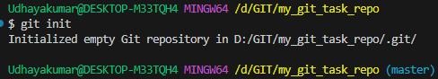
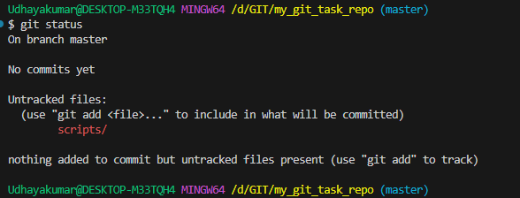

link it to GitHub

Renaming branch Master to Main
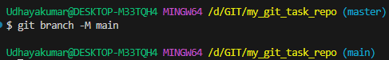
First commit
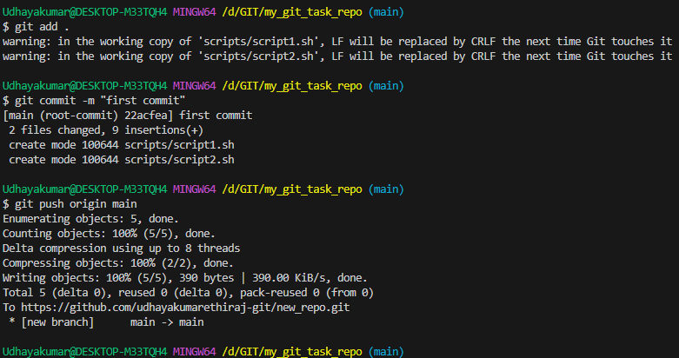
Creating branch named branch_1
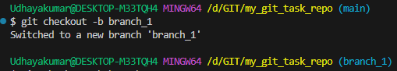

appspec & buildspec uploaded to use command rebase
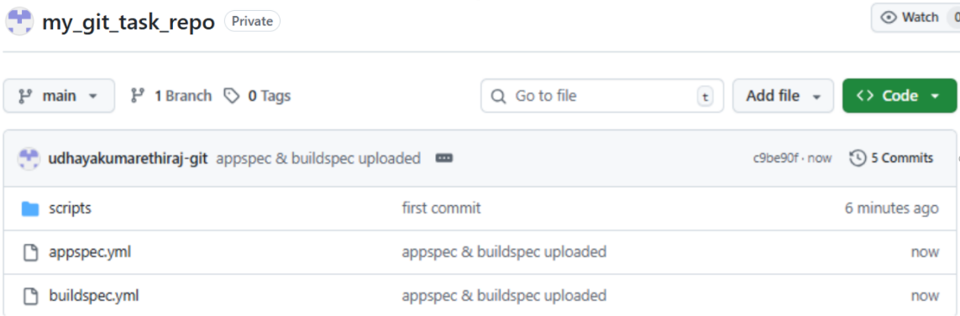
rebase_test_1.txt file created in branch_1
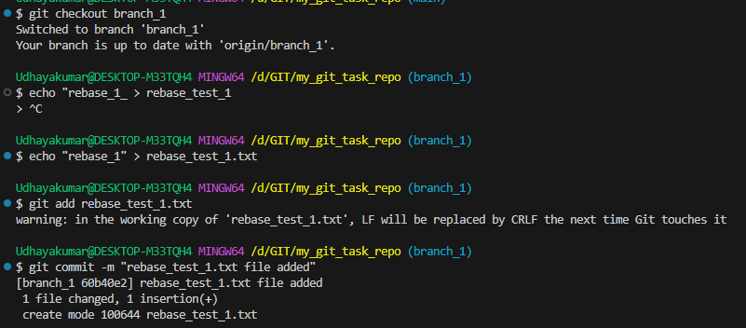
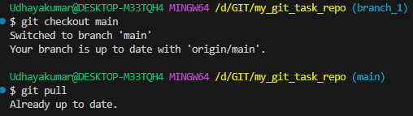
Testfile added in remote directory “rebase”
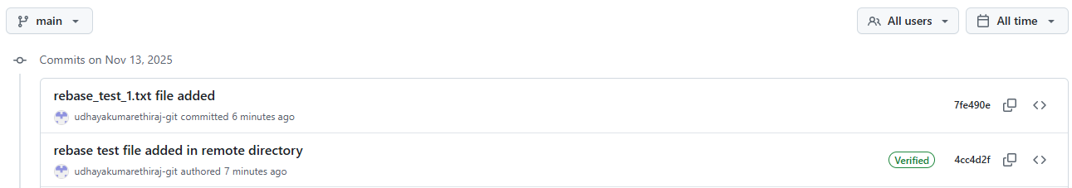
Added latest remote directory files to main branch
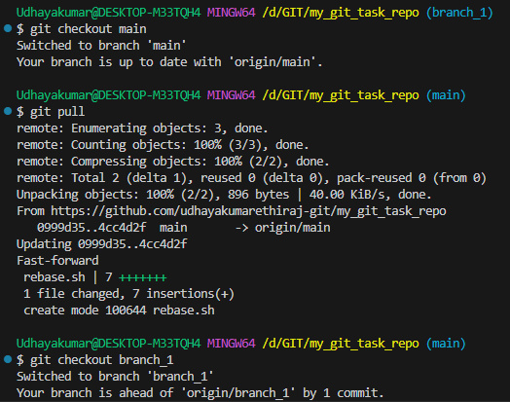
Rebase command used for the checkout
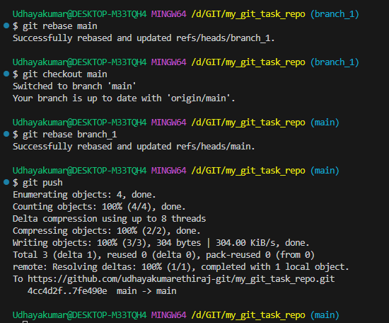
Graph view for commit used by rebase
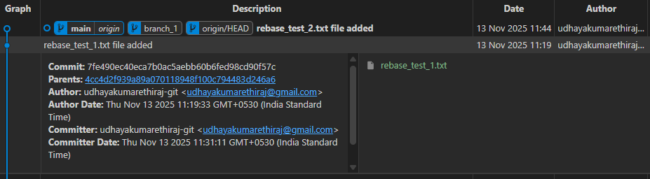
Merge command - branch_1 merge_2 file created and commited
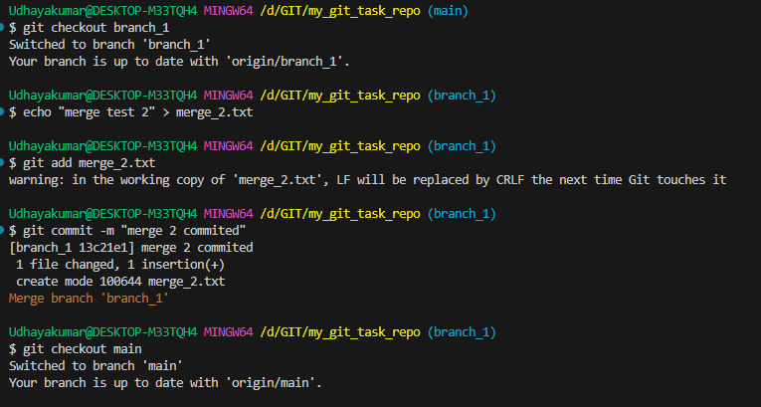
Main branch merge_3 file created and commited.
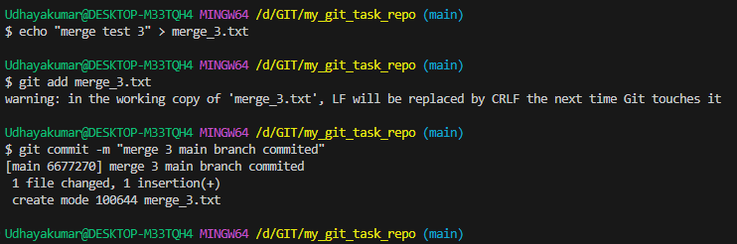
Main branch merged with branch_1 and merge_2 file synced.
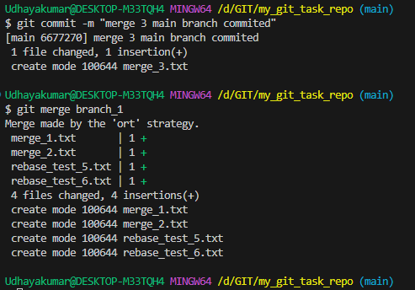
Graph view
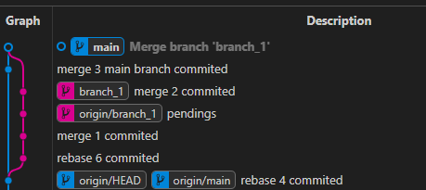
Before using stash command not allowing to switch branches
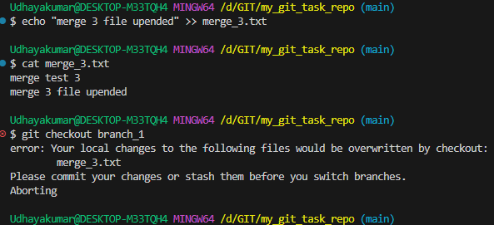
stash command used to switch the branches and staged the work.
