Monitoring Task
Install Prometheus and Grafana on a Linux EC2 machine, connect Prometheus to Grafana, and create a dashboard to view metrics.

EC2 instance launched
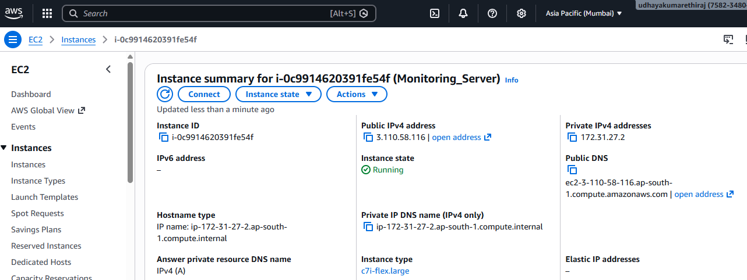

Prometheus and Grafana Port enabled in Security Group.

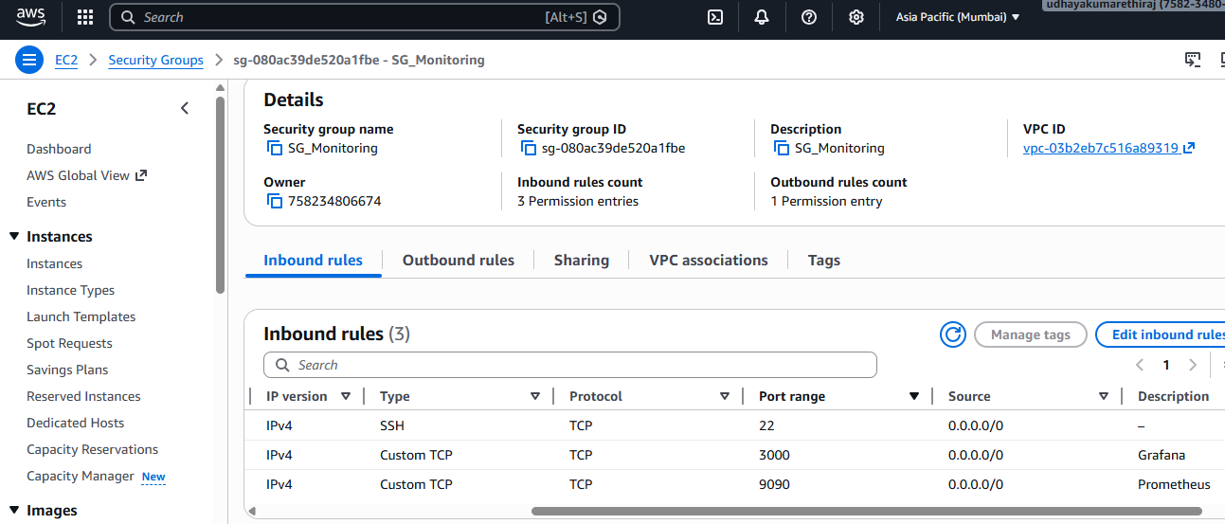

Prometheus installed on ubuntu
comments used to install Prometheus
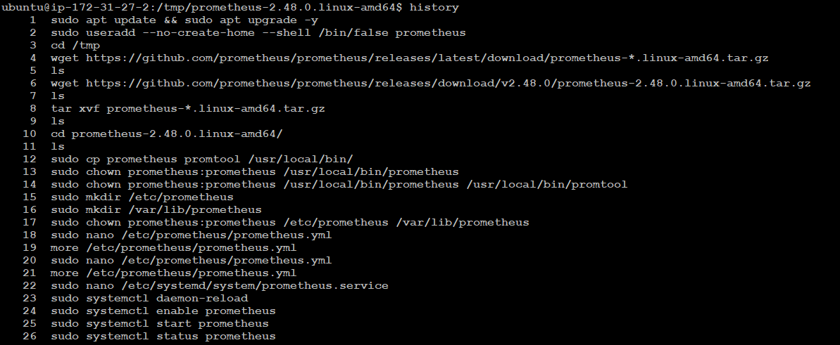
prometheus user created
Prometheus Package downloaded from github
https://github.com/prometheus/prometheus/releases/download/v2.48.0/prometheus-2.48.0.linux-amd64.tar.gz
Downloaded binaries & files copied to /usr/local/bin/
Folder owner changed to Prometheus
/usr/local/bin/prometheus /usr/local/bin/promtool
/etc/prometheus/prometheus.yml file created for Prometheus configuration

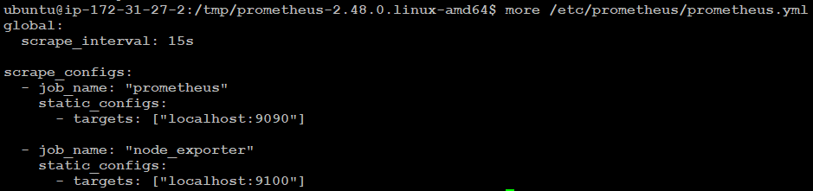

prometheus created as a services
/etc/systemd/system/prometheus.service
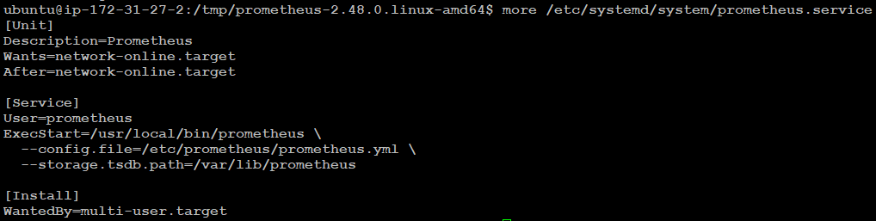
services started
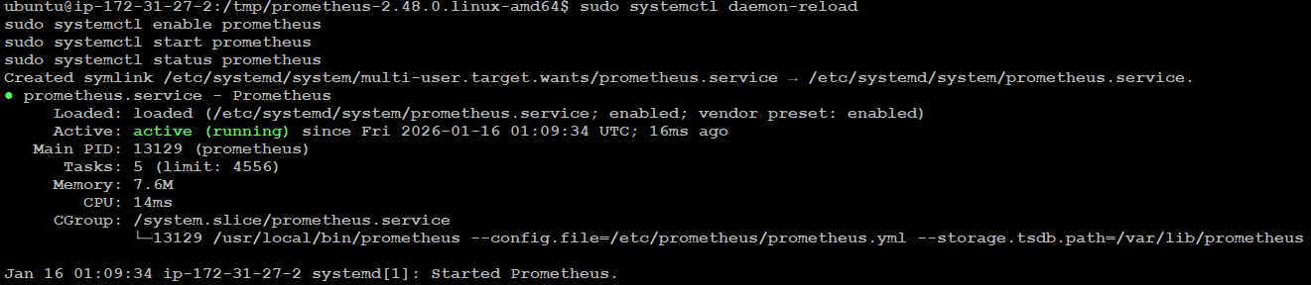

prometheus output

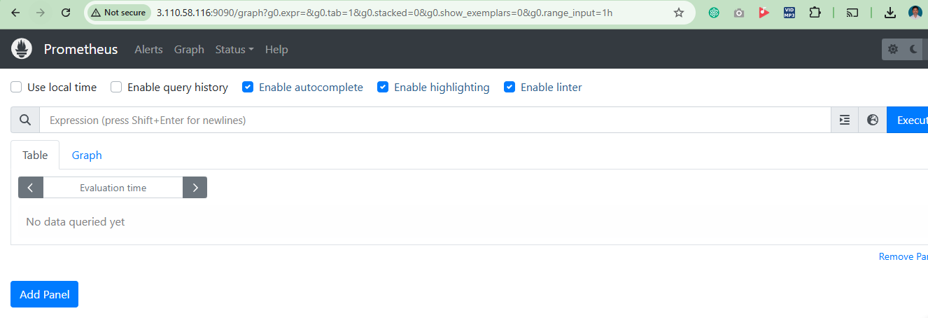

Node Exporter Installtion
Node Exporter files downloaded from
https://github.com/prometheus/node_exporter/releases/download/v1.7.0/node_exporter-1.7.0.linux-amd64.tar.gz
Files copied to /usr/local/bin/

node_exporter.service Service created

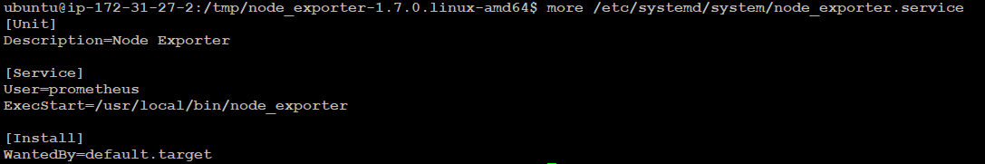

Service started

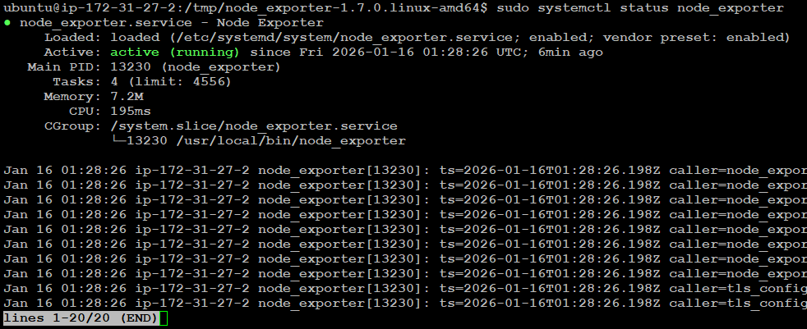

Node exporter metrics verified

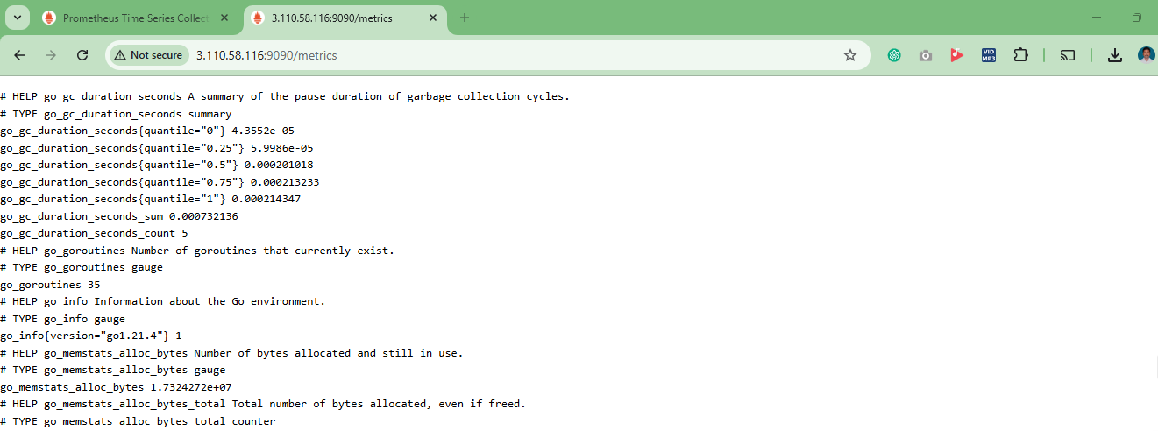

Grafana installed and service started

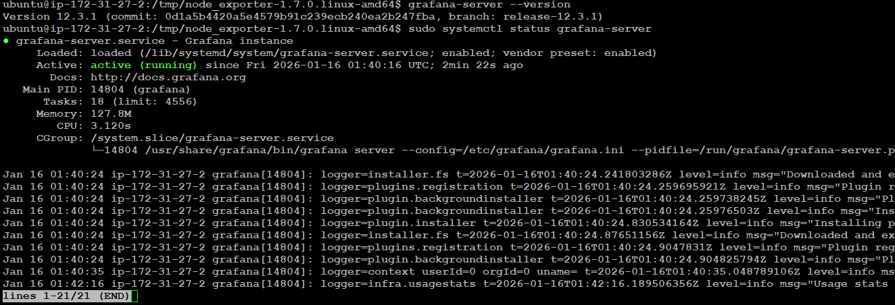

Grafana page
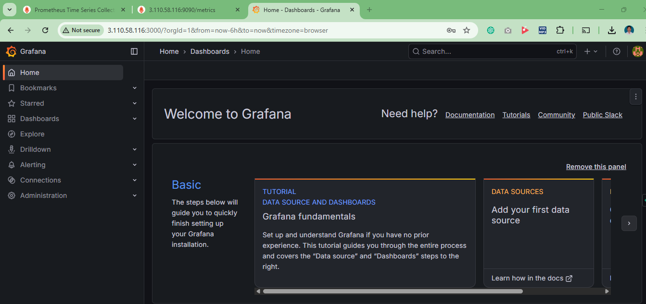

Added Prometheus Data source to Grafana and tested.

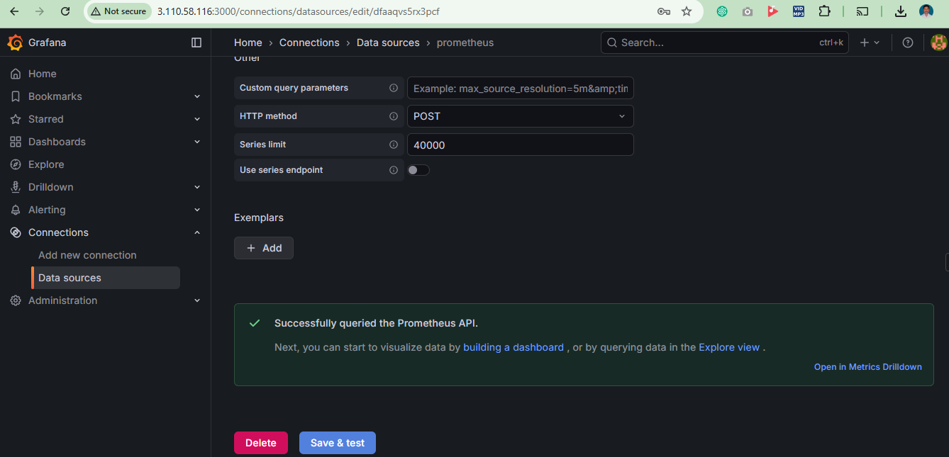

Dashboard created

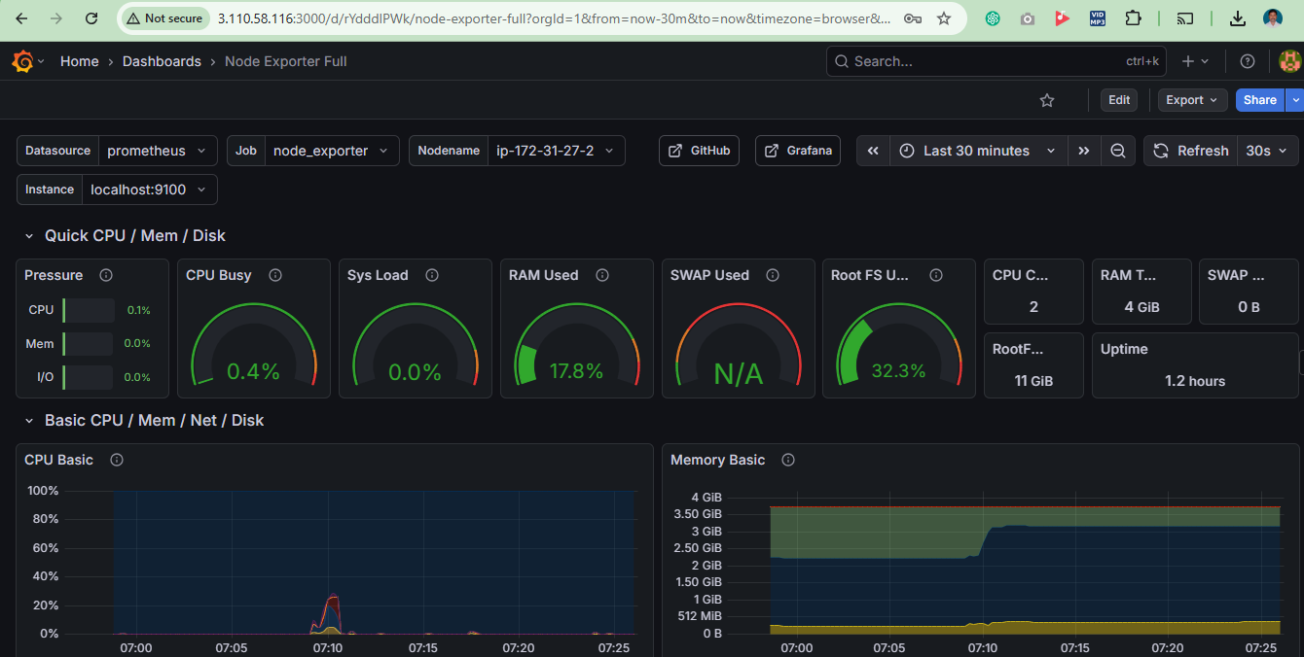

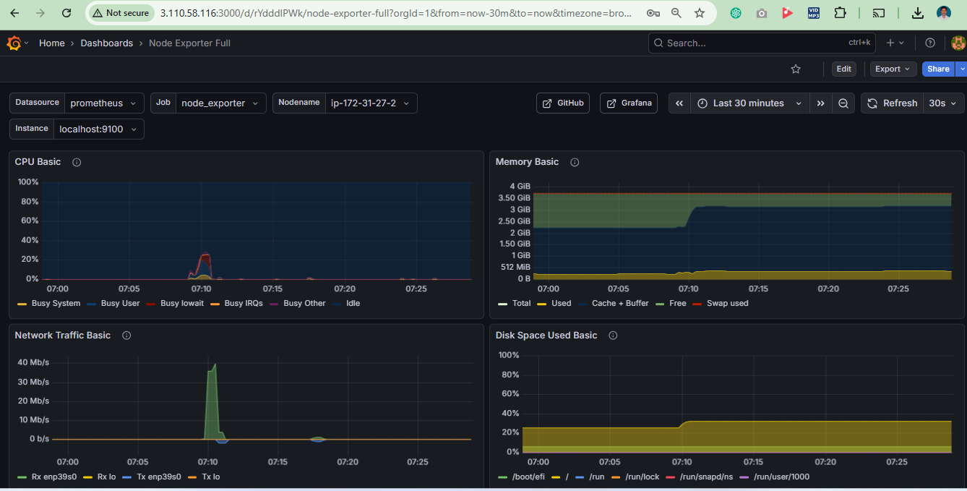

Metrics query result on Grafana

