Kubernetes Task
Create the K8s EKS,further you have to do the deployment of the Nginx application and access the application outside the cluster.

Kubernets EKS Cluster created

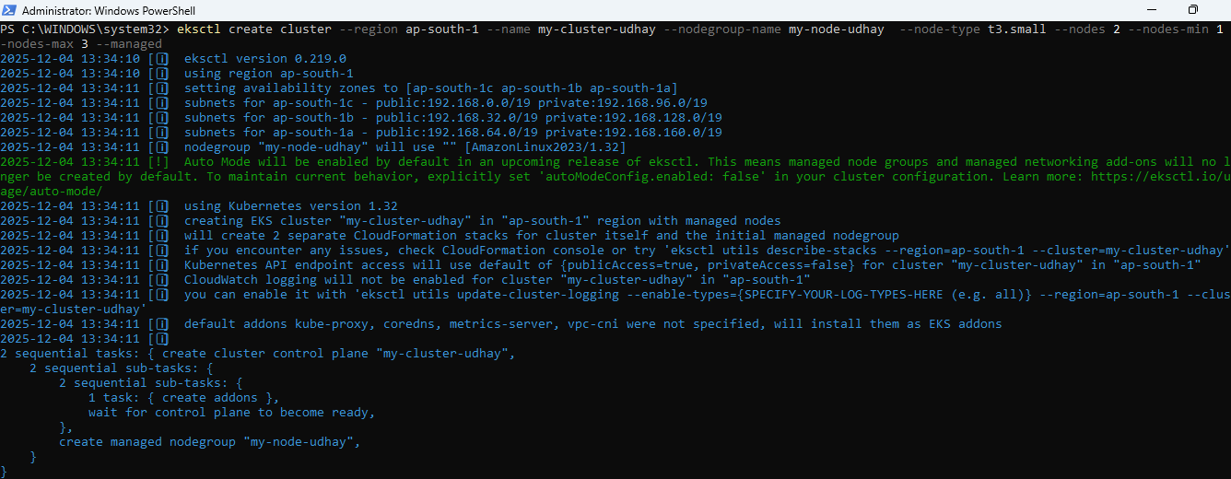

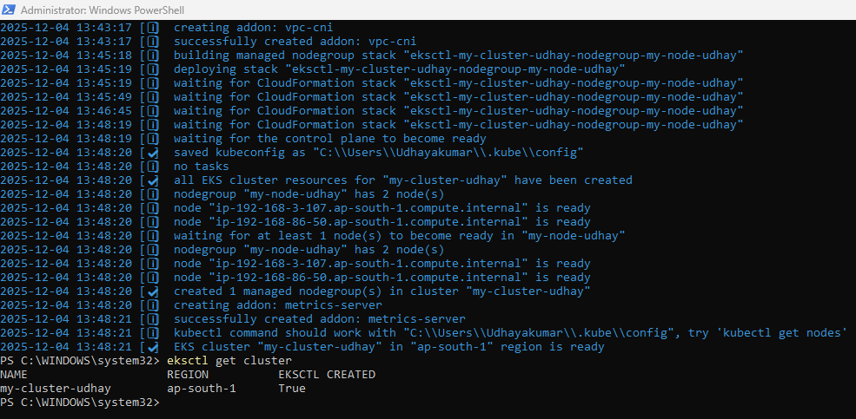

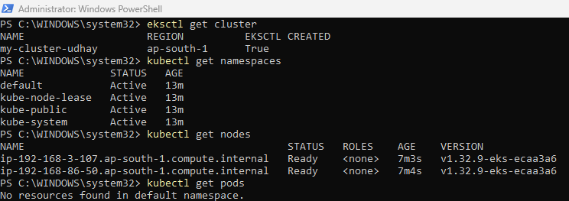
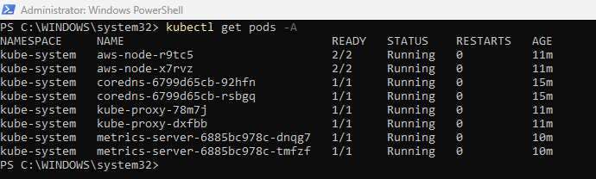

Deployment.yml file created for nginx deployment
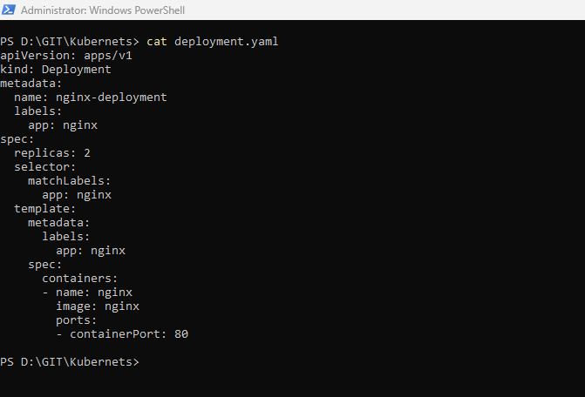
Apply deployment
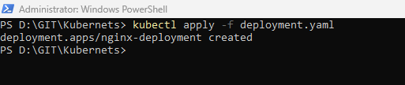
Pods created named nginx-deployment
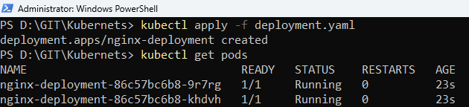

Service.yml file created
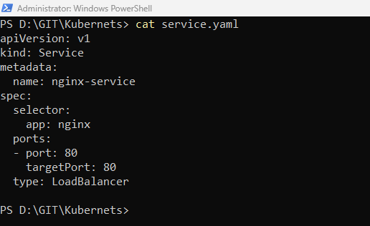

Apply Service
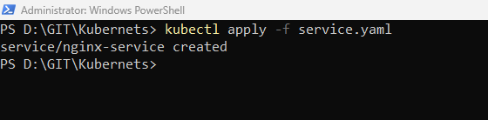
Result on service
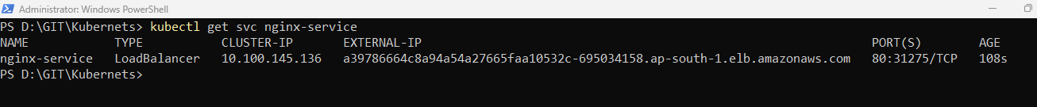

Nginx deployment result outside of cluster

