Docker Task - 3
Create a custom docker image for nginx and deploy it using docker compose, where the volume bind mount should be at /var/opt/nginx location. Push the created custom docker image to your docker-hub.
Docker file to create docker image
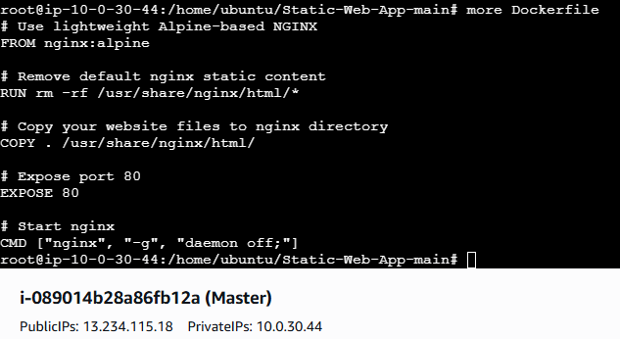
Docker image created
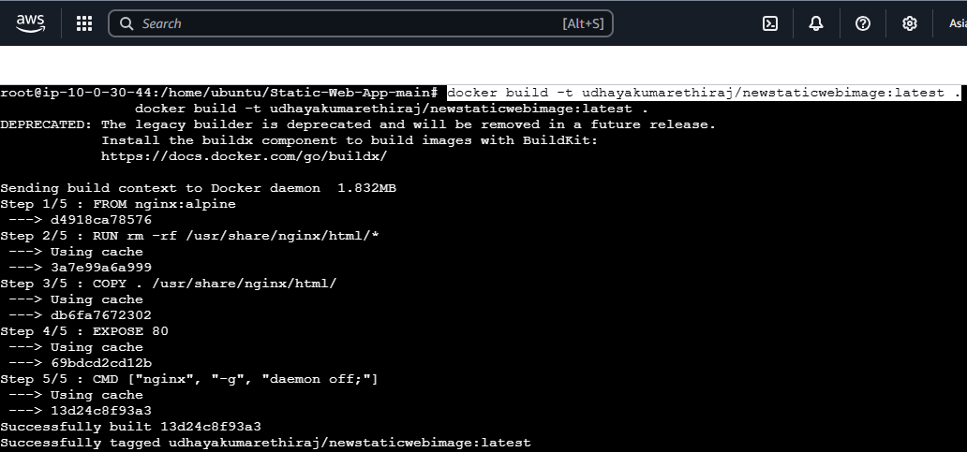
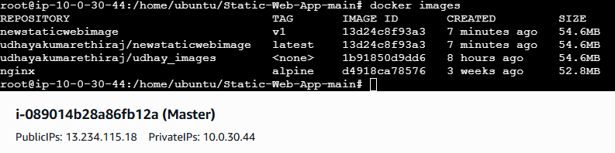
Docker volume
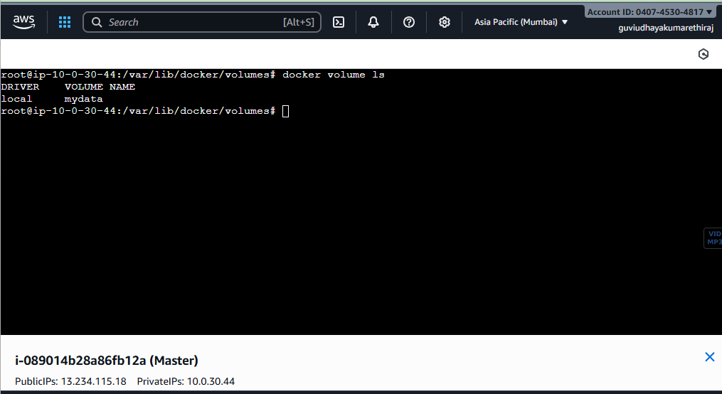

Docker compose yml file to use docker compose
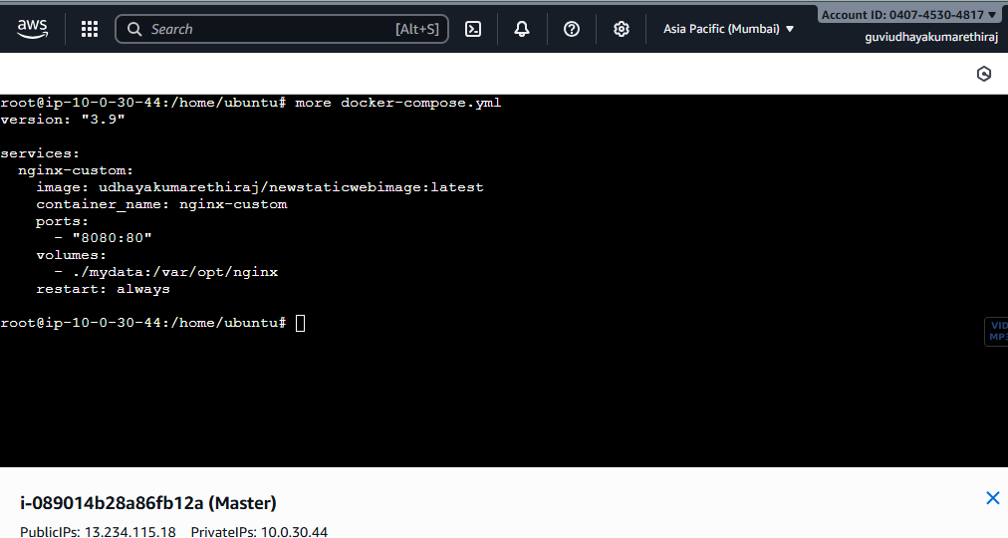
Deployed using docker compose
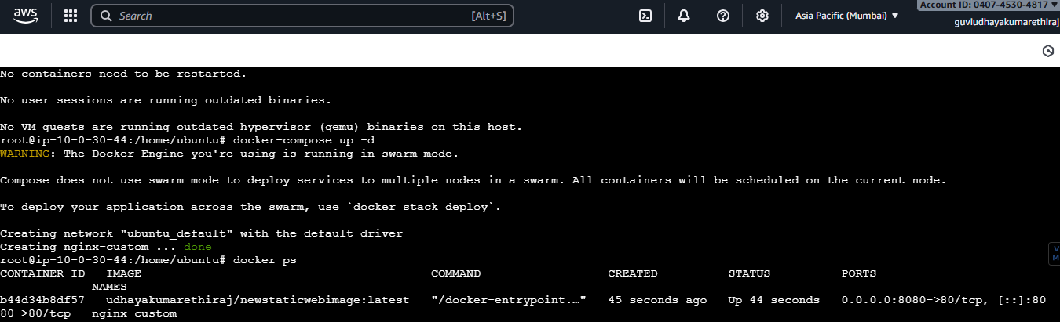
Output
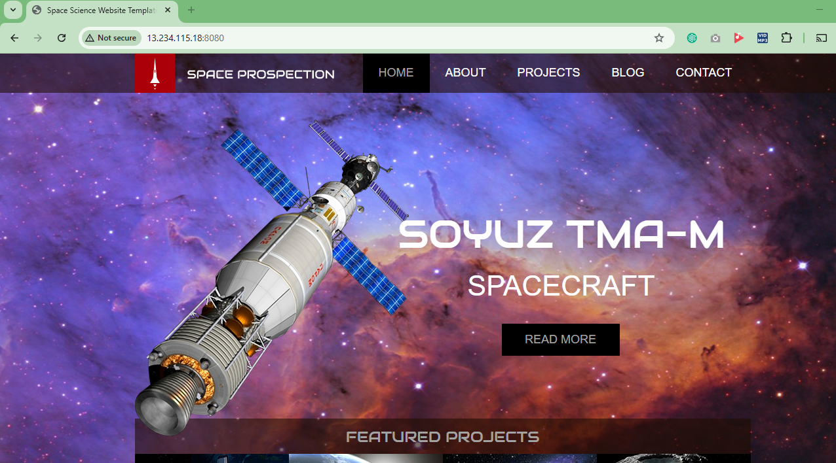

Pushing Docker image to Docker hub

