Docker Task
Install docker on EC2 and explore the docker commands (docker images, containers, volumes, network)
Docker installed on EC2 instance
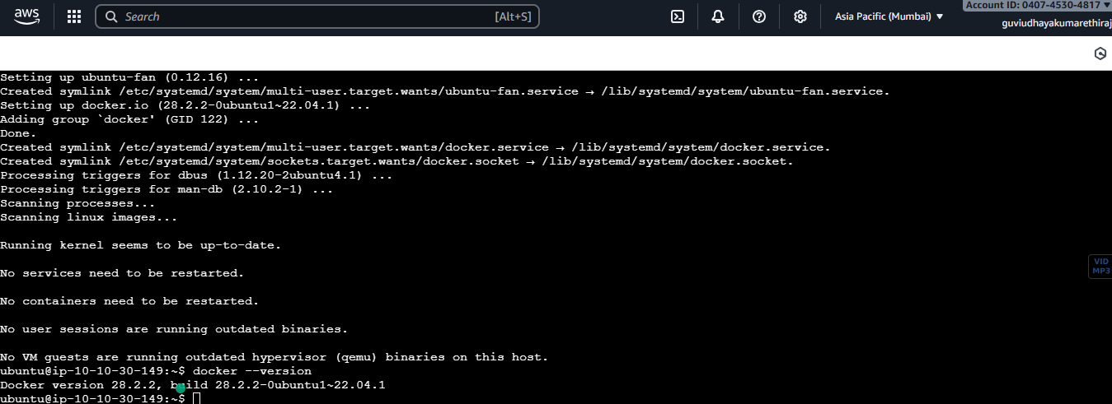
Docker Images commands
Docker pull
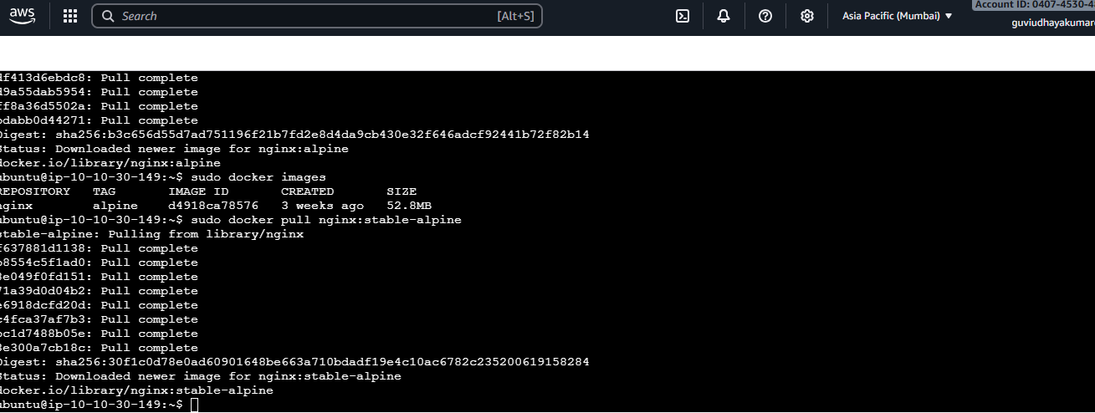

Docker images
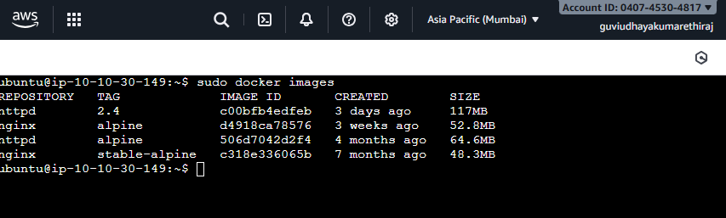
Running a new container
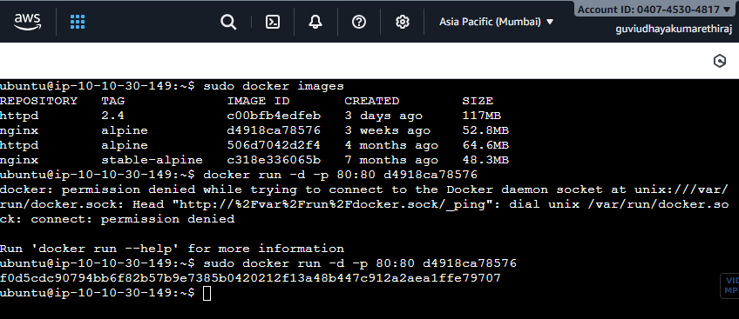
View running container
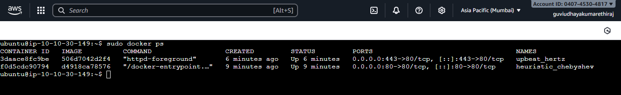

View all container
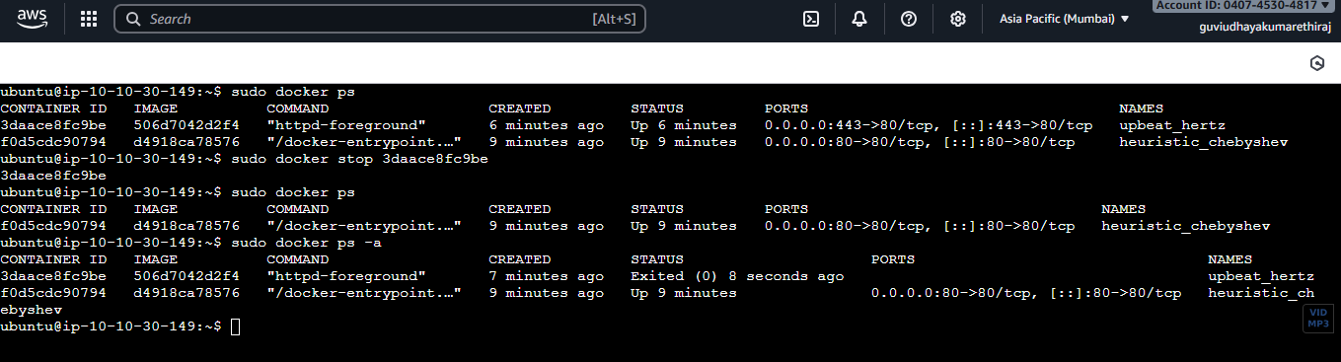

Start and stop a container
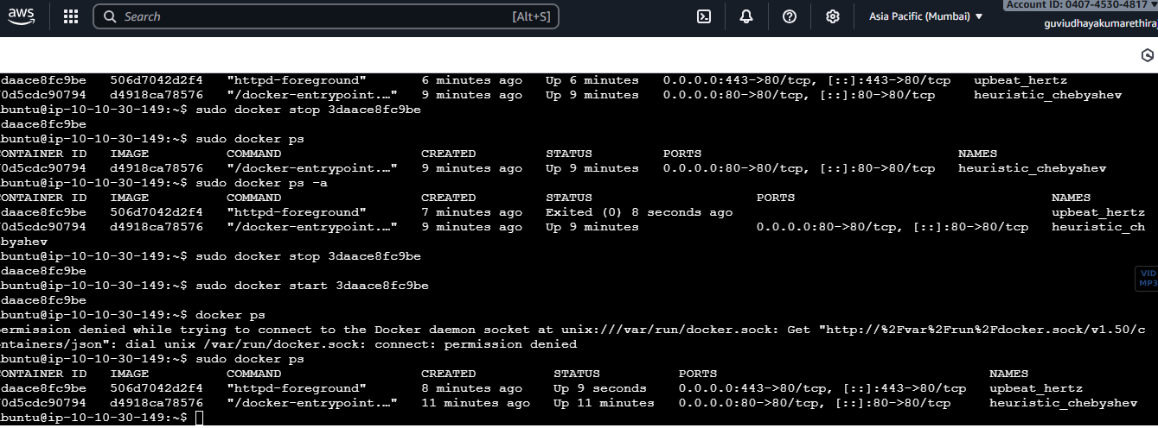

Network commands

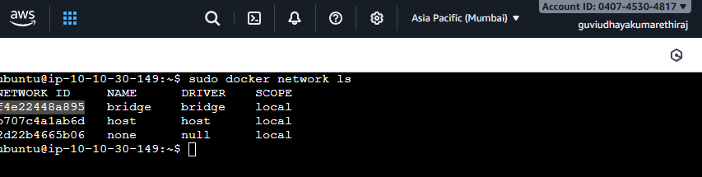
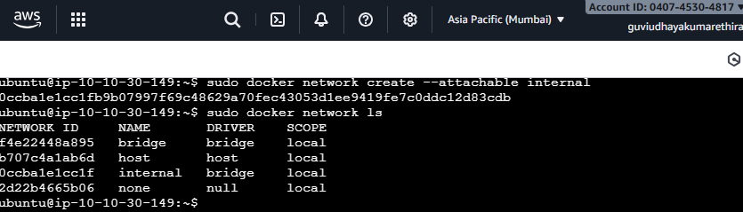
Host network used to run a container
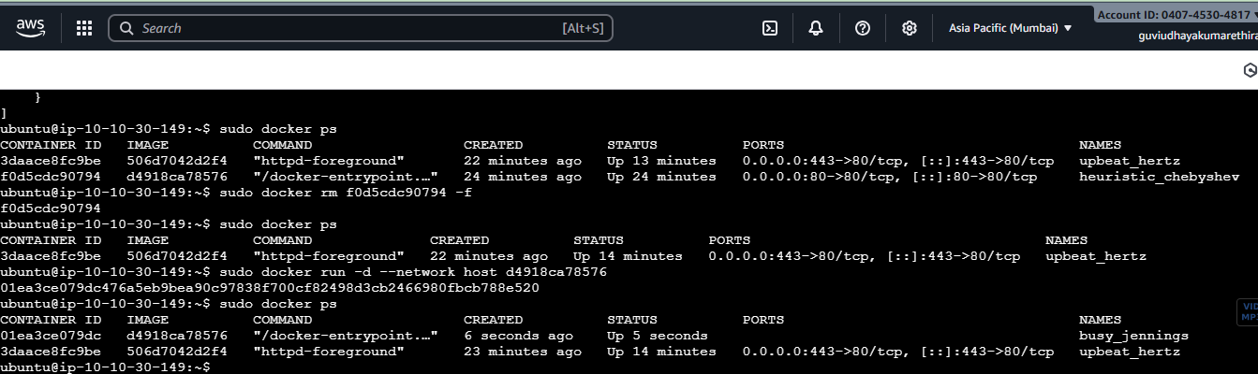
Removing a running container
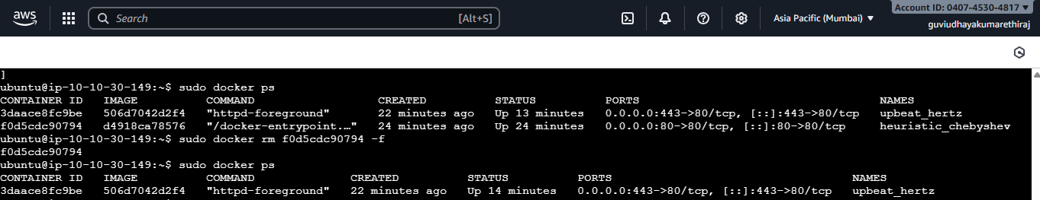
Docker Volumes
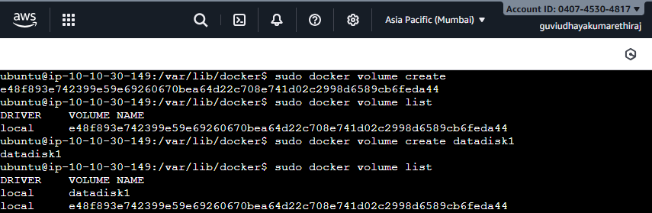
Container created with docker Volume
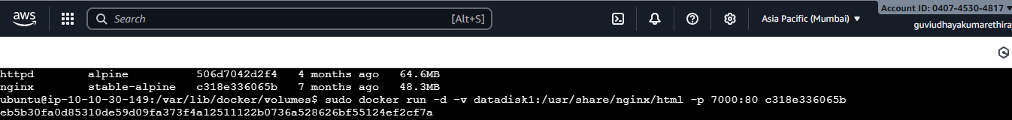

Deleting Docker Volume
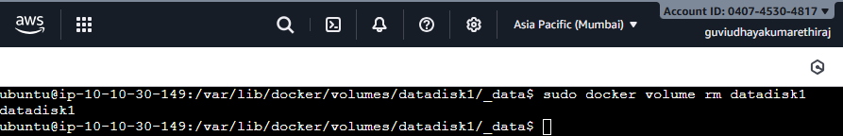

Deleting docker container
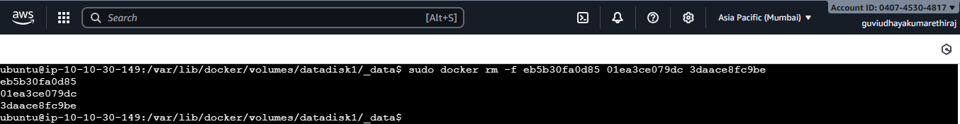

Deleting docker images
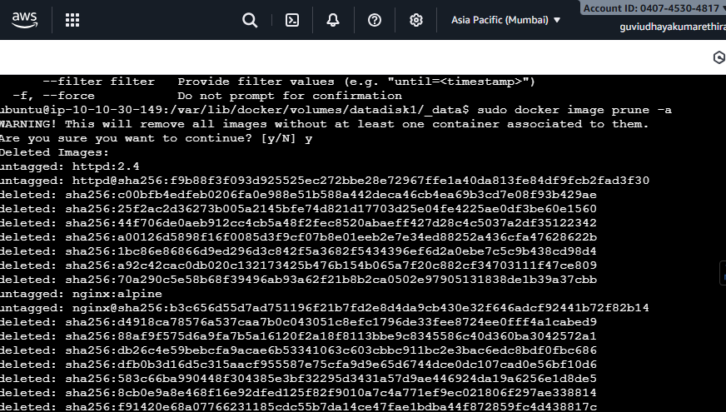

Deleting docker network
