**1 . Home Page**

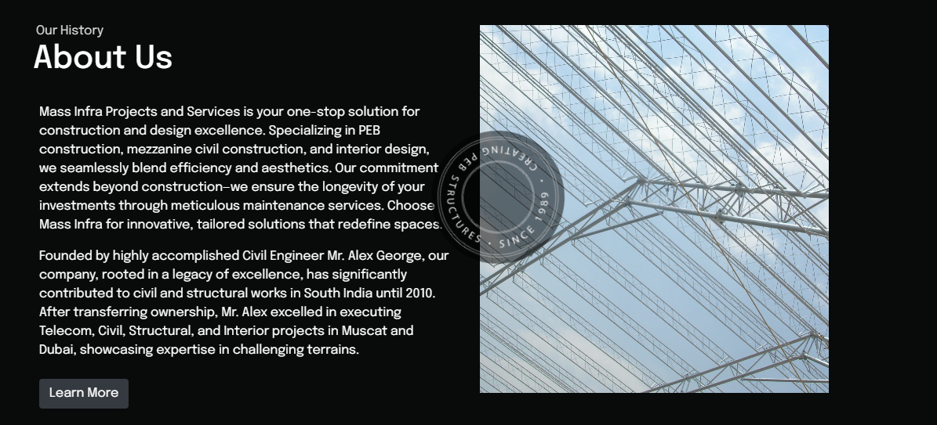

Mass Infra Projects and Services is your one-stop solution for construction and design excellence. Specializing in PEB construction, mezzanine civil construction, and interior design, we seamlessly blend efficiency and aesthetics. Our commitment extends beyond construction—we ensure the longevity of your investments through meticulous maintenance services. Choose Mass Infra for innovative, tailored solutions that redefine spaces.

Founded by highly accomplished Civil Engineer Mr. Alex George, our company, rooted in a legacy of excellence, has significantly contributed to civil and structural works in South India until 2010. After transferring ownership, Mr. Alex excelled in executing Telecom, Civil, Structural, and Interior projects in Muscat and Dubai, showcasing expertise in challenging terrains.

**2 . About page**

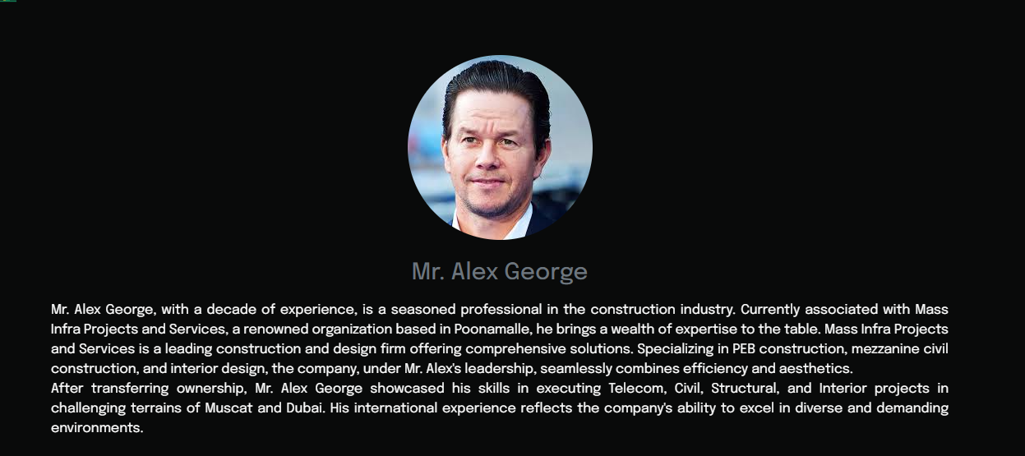

Mr. Alex George, with a decade of experience, is a seasoned professional in the construction industry. Currently associated with Mass Infra Projects and Services, a renowned organization based in Poonamalle, he brings a wealth of expertise to the table. Mass Infra Projects and Services is a leading construction and design firm offering comprehensive solutions. Specializing in PEB construction, mezzanine civil construction, and interior design, the company, under Mr. Alex's leadership, seamlessly combines efficiency and aesthetics.

After transferring ownership, Mr. Alex George showcased his skills in executing Telecom, Civil, Structural, and Interior projects in challenging terrains of Muscat and Dubai. His international experience reflects the company's ability to excel in diverse and demanding environments.

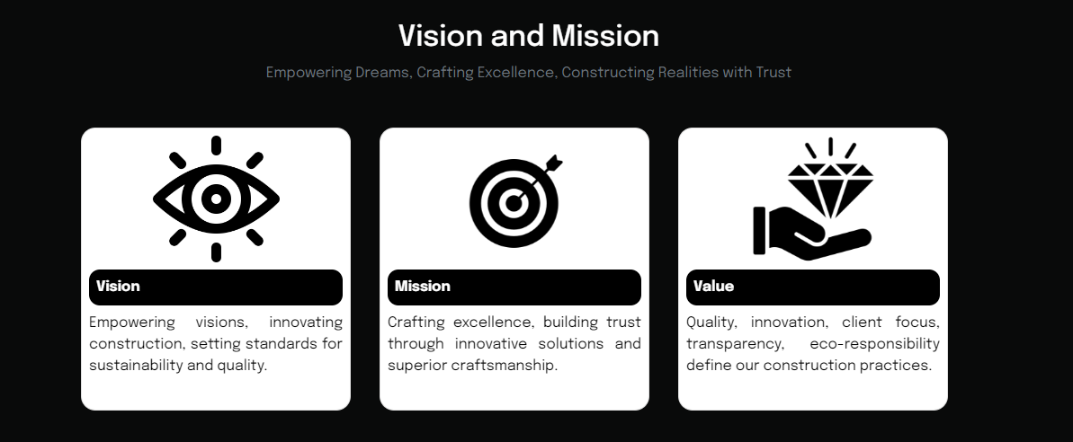

**Vision:**

Empowering visions, innovating construction, setting standards for sustainability and quality.

**Mission :**

Crafting excellence, building trust through innovative solutions and superior craftsmanship.

**Value :**

Quality, innovation, client focus, transparency, eco-responsibility define our construction practices.

**Our Journey**



**Navigating uncharted paths, weaving memories, discovering beauty in shared experiences**

**1985**

**College Graduation and Early Career**

Mr. Alex George graduated with High Distinction from the College of Engineering, Trivandrum. Shortly after, he delved into the professional realm, gaining valuable experience in the Design wing of a prominent Structural Engineering Company in Chennai for 3.5 years.

**1989**

**Entrepreneurial Venture**

Mr. Alex George took a significant step by establishing a Proprietorship company. This venture later evolved into a private limited company, successfully operating until 2010. During this period, the company undertook various civil and structural works, making a significant impact on South India's infrastructure landscape.

**2010**

**Transition and New Beginnings**

Mr. Alex George strategically transitioned the company by relinquishing shares to a new set of directors, opening avenues for broader prospects. This pivotal move marked the end of one chapter and the beginning of a new phase in Mr. Alex's professional journey.

**2010-2018**

**Gulf Experience and Diversification**

Following the shift, Mr. Alex George ventured into international markets, specifically Muscat and later Dubai. Over the course of eight years, he successfully executed Telecom installation projects across Oman, encompassing Civil, Structural, and Interior projects. Notably, Mr. Alex handled complex HDD (Trenchless Ducting) and Micro Tunneling Projects, overcoming challenges posed by Oman's demanding terrains.

**2018 Onward Revamping and**

**Infrastructural Focus**

After accumulating eight years of Gulf experience and diverse project executions, Mr. Alex George decided to revamp his business. In 2018, he established "Prefabricated Shed Manufacturers and Services," with a renewed commitment to providing top-notch services in the field of infrastructure development in India. This move reflects his dedication to contributing to India's infrastructural growth with the expertise gained over the years.

**Service Page**

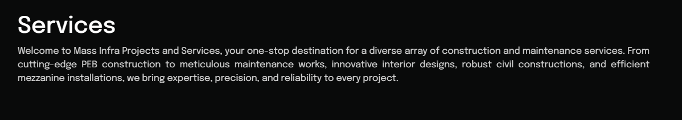

Welcome to Mass Infra Projects and Services, your one-stop destination for a diverse array of construction and maintenance services. From cutting-edge PEB construction to meticulous maintenance works, innovative interior designs, robust civil constructions, and efficient mezzanine installations, we bring expertise, precision, and reliability to every project.

**PEB Constructions**

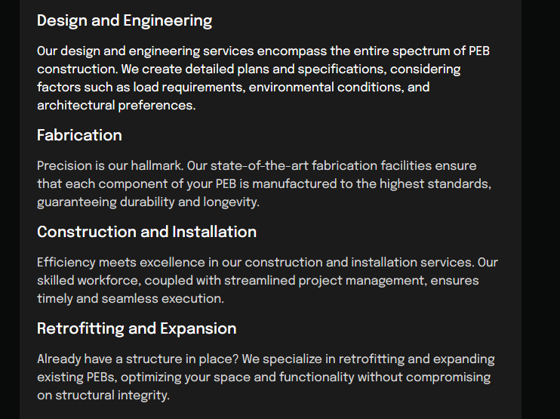

**Design and Engineering**

Our design and engineering services encompass the entire spectrum of PEB construction. We create detailed plans and specifications, considering factors such as load requirements, environmental conditions, and architectural preferences.

**Fabrication**

Precision is our hallmark. Our state-of-the-art fabrication facilities ensure that each component of your PEB is manufactured to the highest standards, guaranteeing durability and longevity.

**Construction and Installation**

Efficiency meets excellence in our construction and installation services. Our skilled workforce, coupled with streamlined project management, ensures timely and seamless execution.

**Retrofitting and Expansion**

Already have a structure in place? We specialize in retrofitting and expanding existing PEBs, optimizing your space and functionality without compromising on structural integrity.

**Mezzanine Constructions**

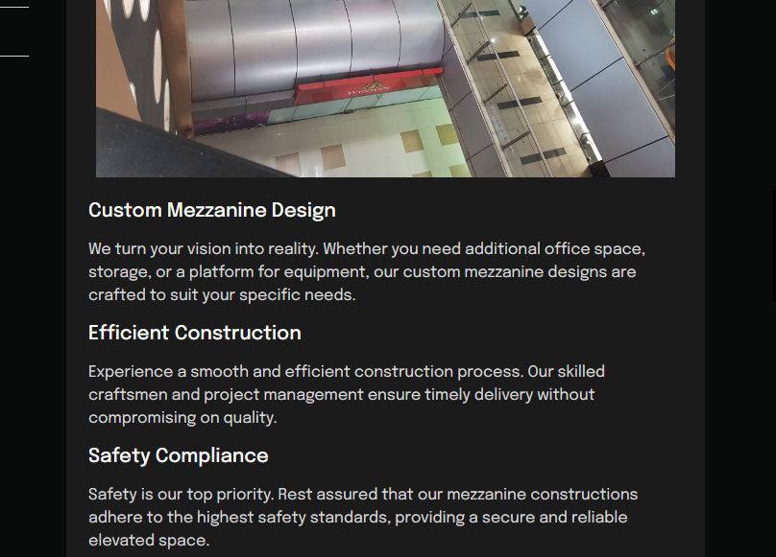**Custom Mezzanine Design**

We turn your vision into reality. Whether you need additional office space, storage, or a platform for equipment, our custom mezzanine designs are crafted to suit your specific needs.

**Efficient Construction**

Experience a smooth and efficient construction process. Our skilled craftsmen and project management ensure timely delivery without compromising on quality.

**Safety Compliance**

Safety is our top priority. Rest assured that our mezzanine constructions adhere to the highest safety standards, providing a secure and reliable elevated space.

**Civil Constructions**

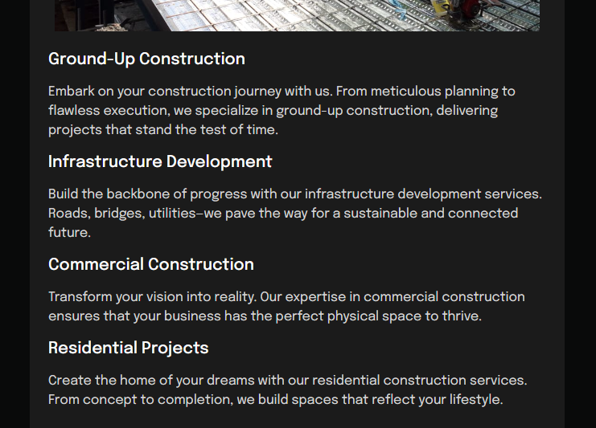

**Ground-Up Construction**

Embark on your construction journey with us. From meticulous planning to flawless execution, we specialize in ground-up construction, delivering projects that stand the test of time.

**Infrastructure Development**

Build the backbone of progress with our infrastructure development services. Roads, bridges, utilities—we pave the way for a sustainable and connected future.

**Commercial Construction**

Transform your vision into reality. Our expertise in commercial construction ensures that your business has the perfect physical space to thrive.

**Residential Projects**

Create the home of your dreams with our residential construction services. From concept to completion, we build spaces that reflect your lifestyle.

**Interior Work**

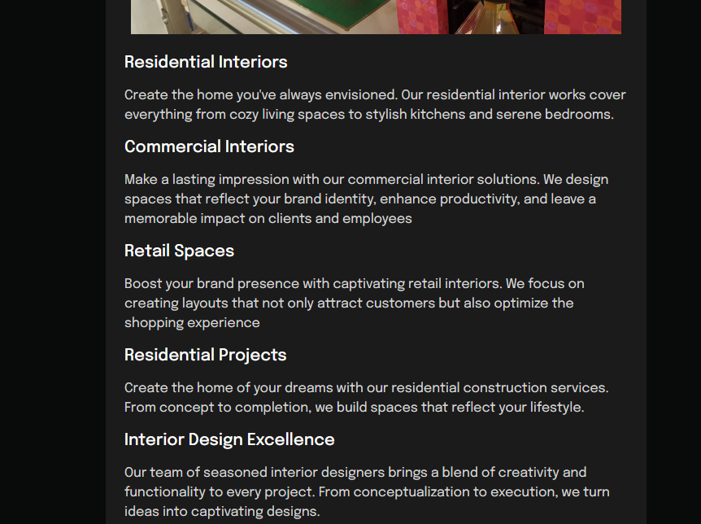

**Residential Interiors**

Create the home you've always envisioned. Our residential interior works cover everything from cozy living spaces to stylish kitchens and serene bedrooms.

**Commercial Interiors**

Make a lasting impression with our commercial interior solutions. We design spaces that reflect your brand identity, enhance productivity, and leave a memorable impact on clients and employees

**Retail Spaces**

Boost your brand presence with captivating retail interiors. We focus on creating layouts that not only attract customers but also optimize the shopping experience

**Residential Projects**

Create the home of your dreams with our residential construction services. From concept to completion, we build spaces that reflect your lifestyle.

**Interior Design Excellence**

Our team of seasoned interior designers brings a blend of creativity and functionality to every project. From conceptualization to execution, we turn ideas into captivating designs.

**Custom Solutions**

We understand that each space is unique. Our approach involves crafting bespoke solutions that align with your preferences, needs, and the distinctive character of your space.

**Maintenance works**

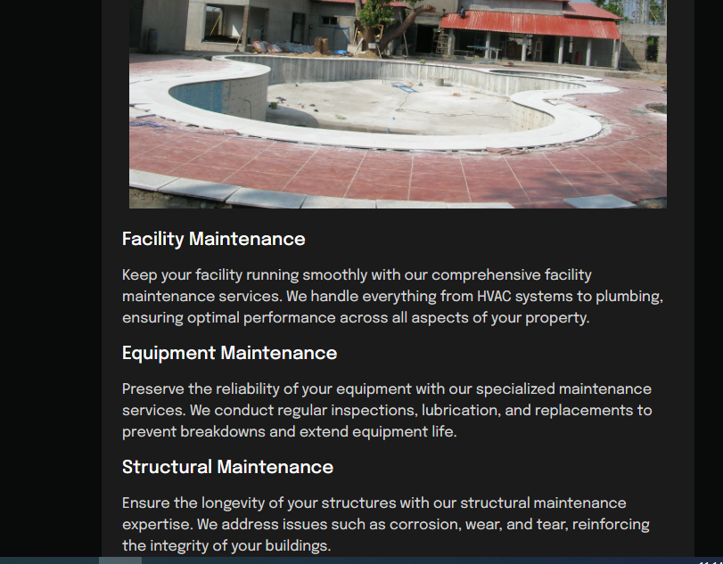

**Facility Maintenance**

Keep your facility running smoothly with our comprehensive facility maintenance services. We handle everything from HVAC systems to plumbing, ensuring optimal performance across all aspects of your property.

**Equipment Maintenance**

Preserve the reliability of your equipment with our specialized maintenance services. We conduct regular inspections, lubrication, and replacements to prevent breakdowns and extend equipment life.

**Structural Maintenance**

Ensure the longevity of your structures with our structural maintenance expertise. We address issues such as corrosion, wear, and tear, reinforcing the integrity of your buildings.

**Project Page**

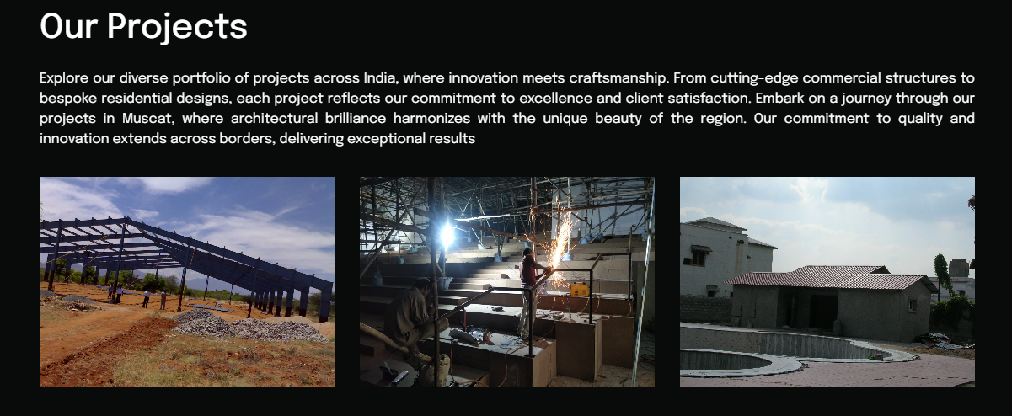

Explore our diverse portfolio of projects across India, where innovation meets craftsmanship. From cutting-edge commercial structures to bespoke residential designs, each project reflects our commitment to excellence and client satisfaction. Embark on a journey through our projects in Muscat, where architectural brilliance harmonizes with the unique beauty of the region. Our commitment to quality and innovation extends across borders, delivering exceptional results