Day8 –Java and DSA

class Node {
int data;
Node next;

Node(int data) {
this.data = data;
this.next = null;
}
}

public class LinkedList {
static Node head = null;

// Insert at Beginning
static void insertFirst(int data) {
Node newNode = new Node(data);
newNode.next = head;
head = newNode;
}

// Insert at End
static void insertLast(int data) {
Node newNode = new Node(data);
if (head == null) {
head = newNode;
return;
}
Node temp = head;
while (temp.next != null) {
temp = temp.next;
}
temp.next = newNode;
}

// Insert at Position (1-based)
static void insertPosition(int pos, int data) {
if (pos <= 0) {
System.out.println("Invalid Position");
return;
}
if (pos == 1) {
insertFirst(data);
return;
}
Node newNode = new Node(data);
Node temp = head;
for (int i = 1; i < pos - 1; i++) {
if (temp == null) {
System.out.println("Invalid Position");
return;
}
temp = temp.next;
}
if (temp == null) {
System.out.println("Invalid Position");
return;
}
newNode.next = temp.next;
temp.next = newNode;
}

// Delete First
static void deleteFirst() {
if (head == null) {
System.out.println("List is Empty");
return;
}
head = head.next;
}

// Delete Last
static void deleteLast() {
if (head == null) {
System.out.println("List is Empty");
return;
}
if (head.next == null) {
head = null;
return;
}
Node temp = head;
while (temp.next.next != null) {
temp = temp.next;
}
temp.next = null;
}

// Delete at Position (1-based)
static void deletePosition(int pos) {
if (head == null) {
System.out.println("List is Empty");
return;
}
if (pos <= 0) {
System.out.println("Invalid Position");
return;
}
if (pos == 1) {
head = head.next;
return;
}
Node temp = head;
for (int i = 1; i < pos - 1; i++) {
if (temp == null) {
System.out.println("Invalid Position");
return;
}
temp = temp.next;
}
if (temp == null || temp.next == null) {
System.out.println("Invalid Position");
return;
}
temp.next = temp.next.next;
}

// Display
static void display() {
if (head == null) {
System.out.println("List is Empty");
return;
}
Node temp = head;
while (temp != null) {
System.out.print(temp.data + " -> ");
temp = temp.next;
}
System.out.println("null");
}

public static void main(String[] args) {
System.out.println("Insert Operations");
insertFirst(20);
insertFirst(10);
insertLast(30);
insertPosition(3, 25);

display();

System.out.println("\nDelete First");
deleteFirst();
display();

System.out.println("\nDelete Last");
deleteLast();
display();

System.out.println("\nDelete Position");
deletePosition(2);
display();
}
}

Output:
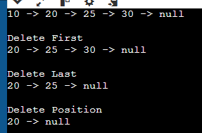

Stack Operation:
Code:
import java.util.*;
class Main{
public static void main(String[] args){
Stack<Integer> s = new Stack<Integer>();
s.push(20);
s.push(30);
s.push(40);
s.push(50);
System.out.println("After Insertion: "+s);
System.out.println("Search 40: "+s.search(40));
s.pop();
s.pop();
System.out.println("Search 40: "+s.search(40));
System.out.println("Size Of the Stack:"+s.size());
System.out.println("Top Element: "+s.peek());
System.out.println("Is Empty? : "+s.isEmpty());
s.pop();
s.pop();
System.out.println("Is Empty? : "+s.isEmpty());
}
}
Output:
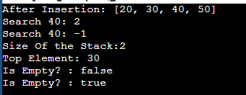

Valid Parantheses:
import java.util.*;
class para{
public static void main(String[] args){
Stack<Character> s=new Stack<Character>();
String str="[(]){}";
for(int i=0;i<str.length();i++){
char ch=str.charAt(i);
if(ch=='(' || ch=='[' || ch=='{'){
s.push(ch);
}
else{
if(s.peek()=='(' && ch==')'){
s.pop();
}
else if(s.peek()=='[' && ch==']'){
s.pop();
}
else if(s.peek()=='{' && ch=='}'){
s.pop();
}
else if(s.isEmpty()){
System.out.print("False");
return;
}
}
}
if(!s.isEmpty()){
System.out.println("False");
}
else{
System.out.println("True");
}
}
}
Output:
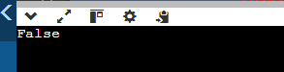

Remove digit from string:
import java.util.*;
class Main{
public static void main(String[] args){
Stack<Character> s=new Stack<Character>();
String str="He3l5l2o";
for(int i=0;i<str.length();i++){
if(Character.isLetter(str.charAt(i))){
s.push(str.charAt(i));
}
}
for(Character ch:s){
System.out.print(ch);
}
}
}
Output:
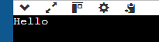

Remove Duplicates:
import java.util.*;
class seq{
public static void main(String[] args){
Stack<Character> s=new Stack<Character>();
String str="pqqprs";
for(int i=0;i<str.length();i++){
char ch=str.charAt(i);
if(!s.isEmpty() && s.peek()==ch){
s.pop();
}
else{
s.push(ch);
}
}
for(Character ch:s){
System.out.print(ch);
}
}
}
Output:
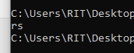
To Check Palindrome or not using Stack:
import java.util.*;
class pali{
public static void main(String[] args){
Scanner sc=new Scanner(System.in);
String s=sc.nextLine();
Stack<Character> stack=new Stack<Character>();
for(int i=0;i<s.length();i++){
char ch=s.charAt(i);
stack.push(ch);
}
boolean pali=true;
for(int i=0;i<s.length();i++){
if(stack.pop()!=s.charAt(i)){
pali=false;
break;
}
}
if(pali){
System.out.println("Palindrome");
}
else{
System.out.println("Not a palindrome");
}
}}
Output:
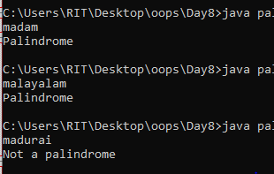

PostfixExpression:
import java.util.*;
class post{
public static void main(String[] args){
Scanner sc=new Scanner(System.in);
String s=sc.nextLine();
Stack<Integer> stack=new Stack<>();
for(int i=0;i<s.length();i++){
char ch=s.charAt(i);
if(Character.isDigit(ch)){
stack.push(ch-'0');
}
else{
int a=stack.pop();
int b=stack.pop();
if(ch=='+'){
int c=b+a;
stack.push(c);
}
else if(ch=='-'){
int c=b-a;
stack.push(c);
}
else if(ch=='*'){
int c=b*a;
stack.push(c);
}
else if(ch=='/'){
int c=b/a;
stack.push(c);
}
else if(ch=='^'){
int c=b^a;
stack.push(c);
}
else{
System.out.println("Invalid Character");
break;
}
}
}
System.out.println("Stack: "+stack);
}
}
Output:
