Data Quality and Exploratory Analysis
Customer Churn Dataset — Internship Project Report
Prepared by: [Kalaiarasans]
Course: Bachelor of Computer Applications (BCA)
Date: [23/10/2026]
Dataset: Synthetic practice data (not real company data)

1. Project Overview
This project audits and cleans a customer churn dataset, documents assumptions, validates the cleaned output, and explores summary statistics and distributions. The raw dataset deliberately includes data-quality issues to demonstrate a repeatable workflow.

2. Objectives
- Profile columns, data types, missing values, outliers, and duplicates.
- Clean the data with documented assumptions and validation checks.
- Calculate summary statistics and inspect meaningful distributions.
- Package the work with a short explanation for sharing as a public or view-only link.

3. Dataset Profile
Raw dataset: 243 rows × 14 columns. Exact duplicate rows: 3.
The profile CSV contains each column's data type, missing-value count and percentage, and number of unique values. Numeric fields include tenure and charges; categorical fields include contract, payment method, and churn status.
Column | Data type | Missing | Unique incl. NA
CustomerID | object | 0 (0.0%) | 240
Gender | object | 5 (2.06%) | 4
SeniorCitizen | int64 | 0 (0.0%) | 3
Partner | object | 0 (0.0%) | 2
Dependents | object | 0 (0.0%) | 2
TenureMonths | int64 | 0 (0.0%) | 71
PhoneService | object | 0 (0.0%) | 2
InternetService | object | 0 (0.0%) | 4
Contract | object | 0 (0.0%) | 4
PaperlessBilling | object | 0 (0.0%) | 2
PaymentMethod | object | 0 (0.0%) | 5
MonthlyCharges | float64 | 4 (1.65%) | 237
TotalCharges | object | 3 (1.23%) | 236
Churn | object | 0 (0.0%) | 2

4. Data Cleaning Decisions and Assumptions
Issue | Action | Assumption / reason
Whitespace / blank strings | Trimmed spaces; converted blanks to missing values. | Blank-only values are not valid observations.
Category inconsistencies | Standardized known spelling/case variants. | Labels with clear equivalent meanings represent the same category.
Numeric data types | Safely converted tenure and charge fields to numeric. | These fields must support arithmetic and range checks.
Duplicates | Removed exact duplicate rows. | Exact duplicate records should not count twice.
Invalid values | SeniorCitizen outside 0/1 and negative tenure/charges marked missing. | Assumes senior-citizen flag is binary and tenure/charges cannot be negative.
Missing values | Numeric fields filled with median; categorical fields filled with mode. | Simple baseline imputation for this educational task; real projects should validate with a domain owner.
Outliers | Screened numeric values using the IQR rule; reported flags, did not automatically delete. | An extreme charge may be valid, so statistical flags alone are not sufficient grounds for removal.

5. Validation Checks
After cleaning, the dataset has 240 rows and 14 columns. Validation assertions confirmed: no missing cells, no duplicate rows, SeniorCitizen values are 0/1, tenure and charges are non-negative, and churn labels are Yes/No.

6. Summary Statistics and Initial Patterns
Overall churn rate is 29.2% in this synthetic sample.
Churn rate by contract type: Month-to-month 34.3%; One year 23.4%; Two year 20.8%. Month-to-month customers have the highest observed churn rate in this generated dataset.
The script also calculates descriptive statistics for tenure, monthly charges, and total charges, plus tenure and monthly-charge summaries by churn status.
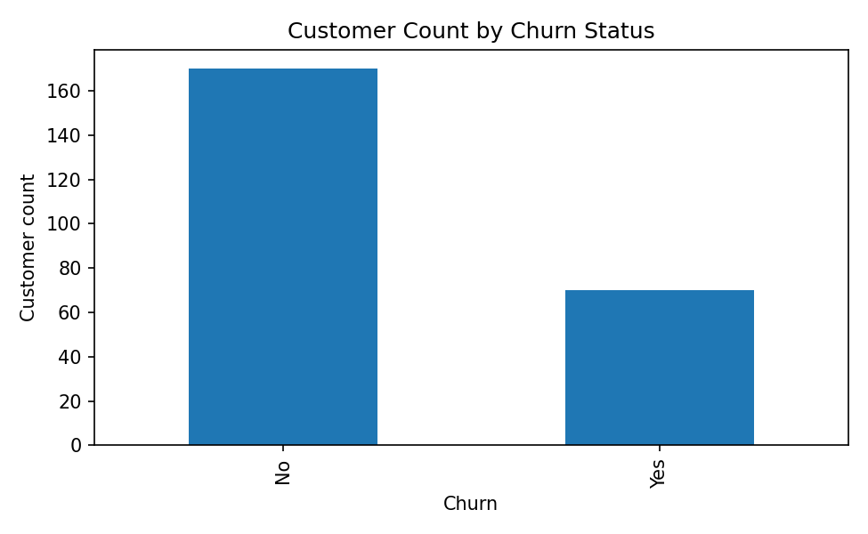
Figure 1. Customer counts by churn status.
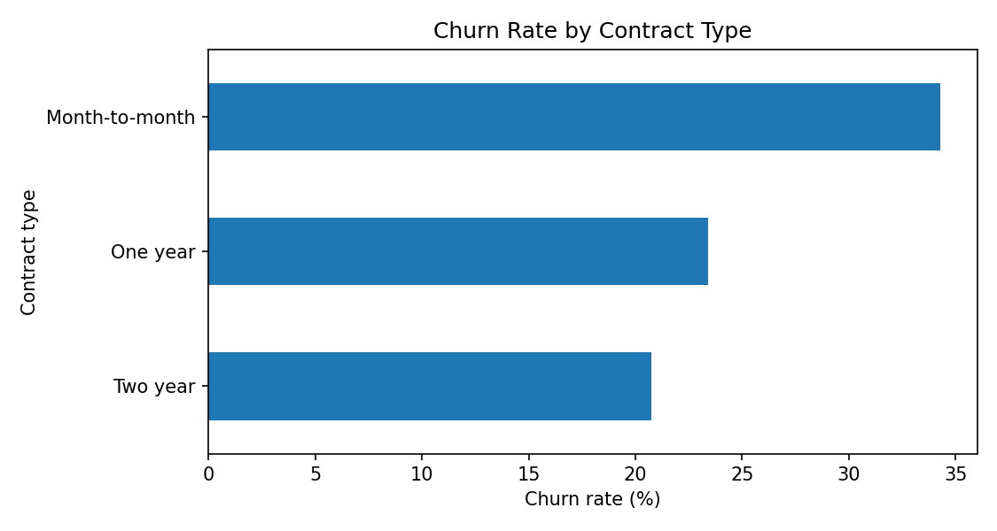
Figure 2. Churn rate by contract type.
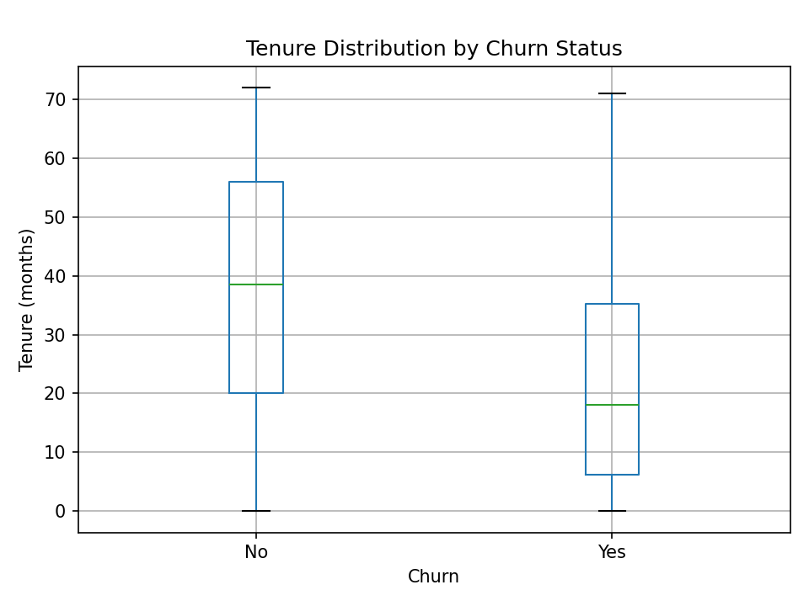
Figure 3. Tenure distribution by churn status.

7. Conclusion and Limitations
The project demonstrates data profiling, cleaning, documented assumptions, validation, and basic exploratory analysis. The dataset is synthetic and relatively small; results are illustrative only and must not be presented as evidence about a real company. The analysis is descriptive and does not establish causation.

8. Files Included
- customer_churn_raw.csv — raw data with deliberate quality issues
- customer_churn_cleaned.csv — cleaned dataset
- data_quality_profile.csv — column/type/missingness/unique-value profile
- churn_analysis.py — reproducible cleaning and EDA script
- analysis_summary.txt — decisions, outlier screening, summary statistics
- churn_counts.png, churn_by_contract.png, tenure_by_churn.png — charts
- Customer_Churn_Project_Report.docx and project_report.hSStml — reports

