Please find the screenshots below to assist you in executing the test suite.

**________________________________________________________________________**

**Package.json :**

**Cucumber.js**

I have created 2 profiles

* 1. Default profile – This is the profile you need for a normal execution
  2. Rerun profile - This is only for the failed scenario.

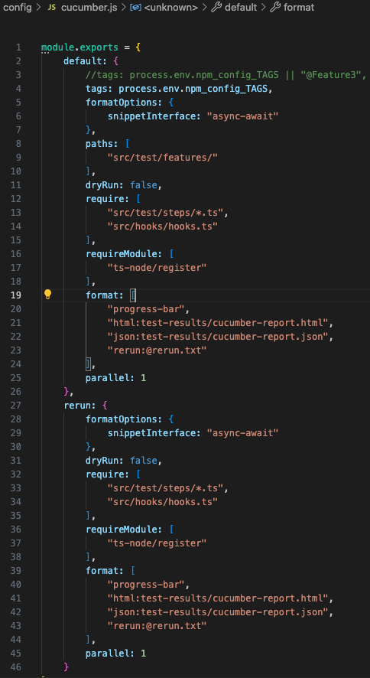

**___________________________________________________________________________**

**Folder Structures:**

**________________________________________________________________________**

**Results & Reports:**

Test-results folder generates folder by itself, using the below library.

**________________________________________________________________________**

**Scripting – Assumptions & Considerations:**

A few assumptions made according to the Automation standards which have been commented out with quick notes, as in above green texts.

The test data at the header (Webpage Launched) has a space as highlighted, which it shouldn’t be. Or not sure if that was for an assessment trick, due to which it fails by default. I have removed the space manually and updated the Featurefile accordingly.

1. Added multiple rows for testdata at the Feature files, for running with additional data as well. Feel free to use different data sets as required.

**________________________________________________________________________**

**********Thank you ************