1. 1.Find all the information about each products

   db.Task1.find({})

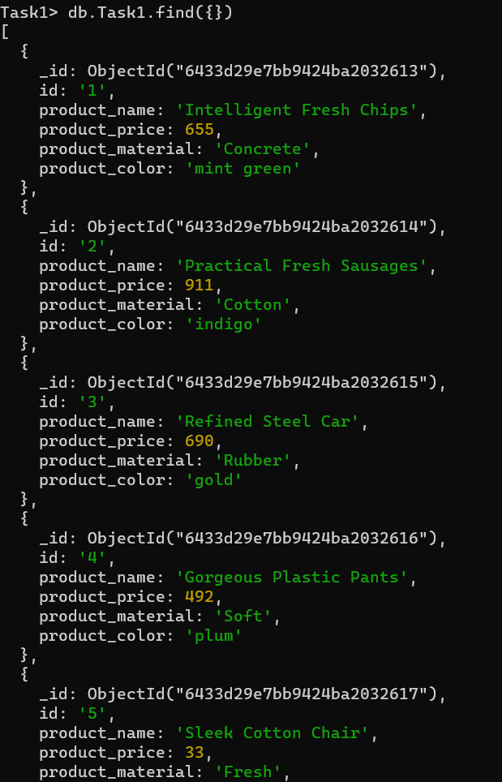

2.Find the product price which are between 400 to 800

   db.Task1.find({product_price:{$gt:400,$lt:800}})

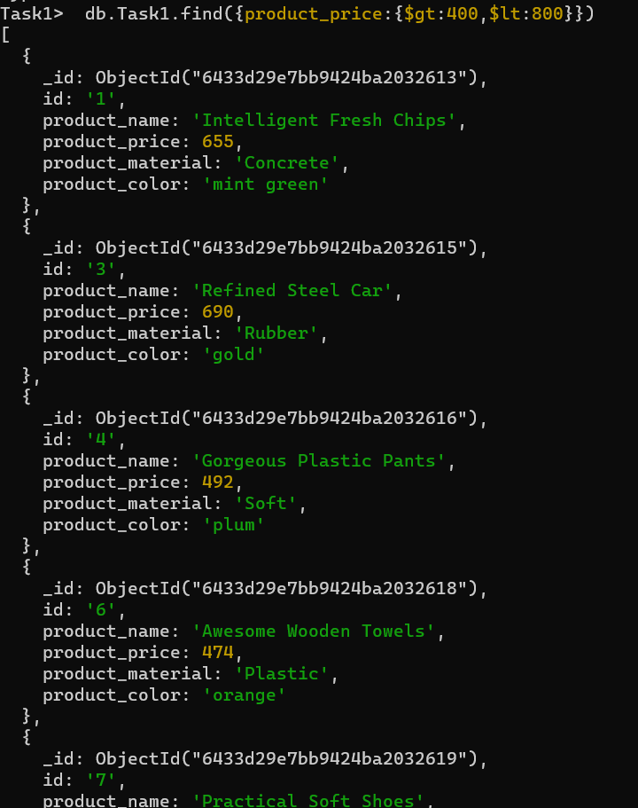

3. 3.Find the product price which are not between 400 to 600

     db.Task1.find({product_price:{$not:{$gt:400,$lt:600}}})

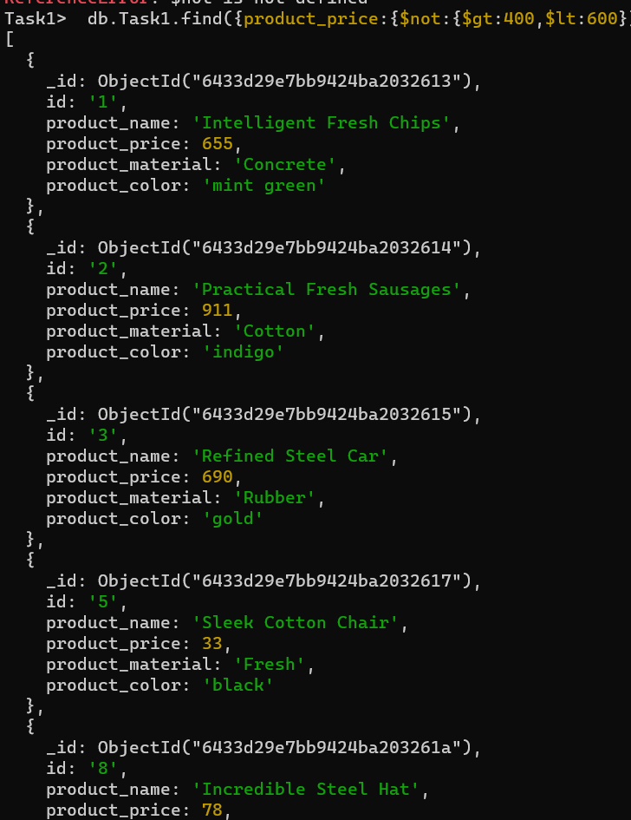

4.List the four product which are grater than 500 in price

     db.Task1.find({product_price:{$gt:500}}).limit(4)

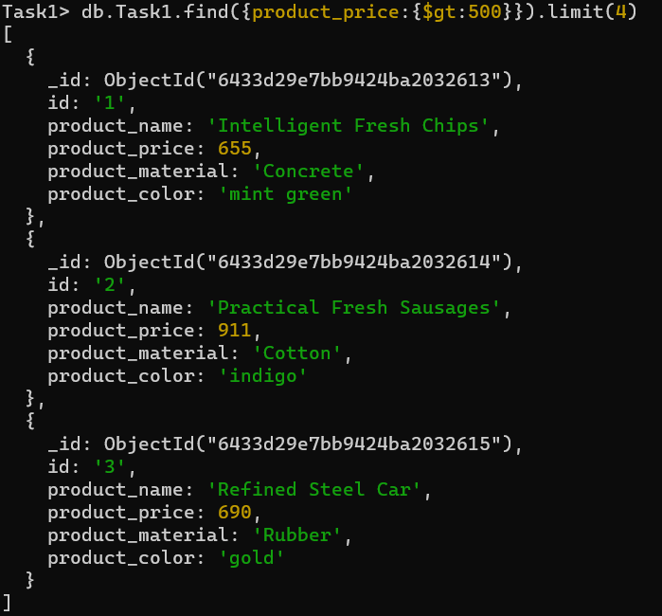

5. Find the product name and product material of each products

     db.Task1.find({},{_id:0,product_name:1,product_material:1})

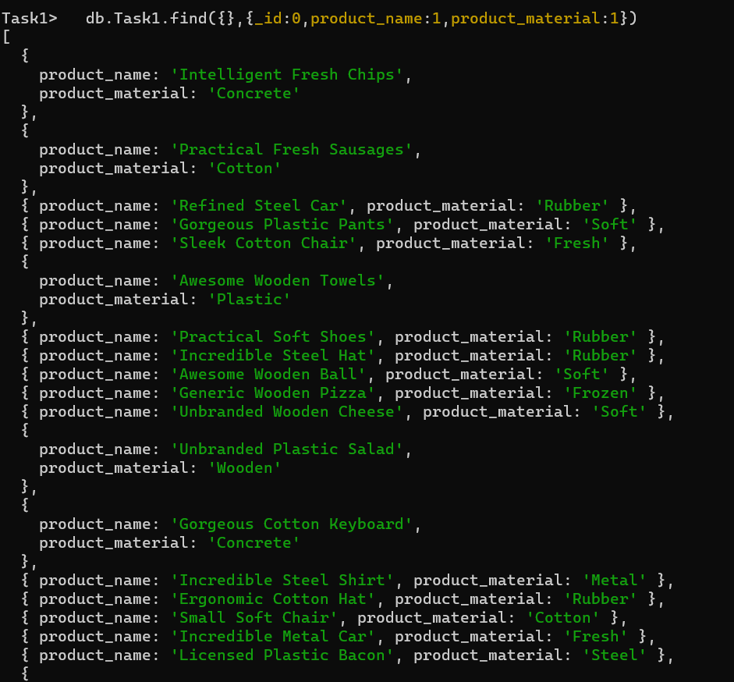

6. Find the product with a row id of 10

     db.Task1.find({'id':'10'})

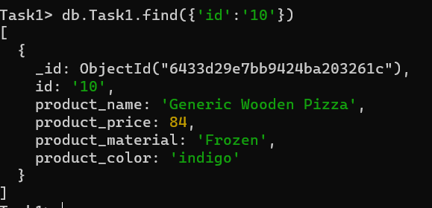

 7. Find only the product name and product material

     db.Task1.find({ id: '10' }, { _id: 0, product_name: 1, product_material: 1 })

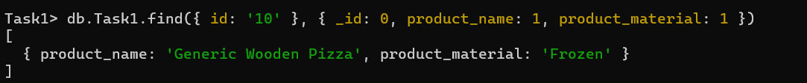

8. Find all products which contain the value of soft in product material

     db.Task1.find({product_material:'Soft'})

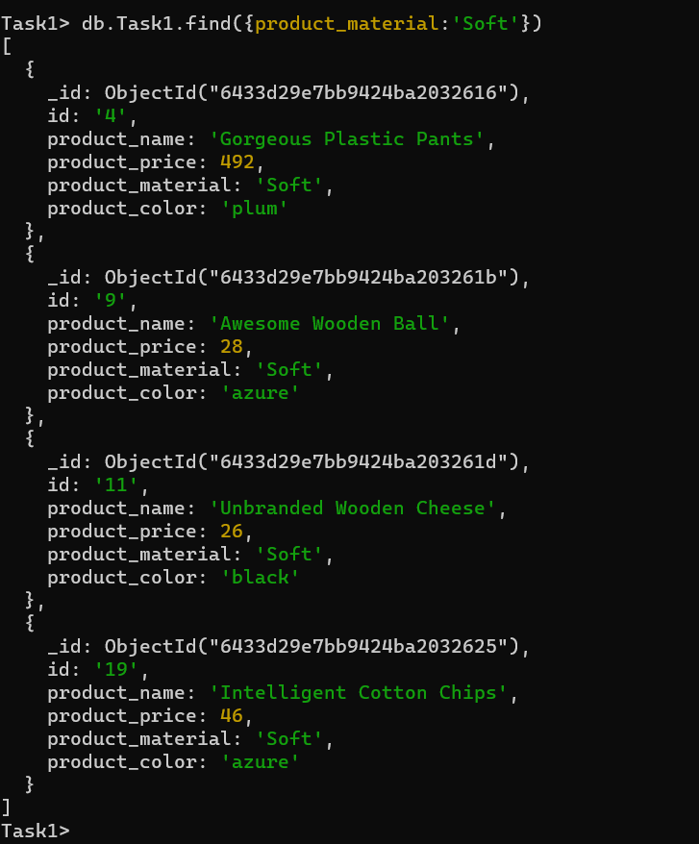

9. Find products which contain product color indigo  and product price 492.00

     db.Task1.find({ product_color: 'indigo', product_price: 492 })

10. Delete the products which product price value are same

     db.Task1.aggregate([

      {$group: {

        _id: "$product_price",

        duplicates: {$addToSet: "$_id"},

        count: {$sum: 1}

        }

      },

      {$match: {

        count: {"$gt": 1}

        }

      }

    ]).forEach(function(doc) {

      db.Task1.remove({id: {$in: doc.duplicates}})

     })