**LESSION-1:**

1. SELECT title FROM movies;
2. SELECT director FROM movies;
3. SELECT title,director FROM movies;
4. SELECT title,year FROM movies;
5. SELECT * FROM movies;

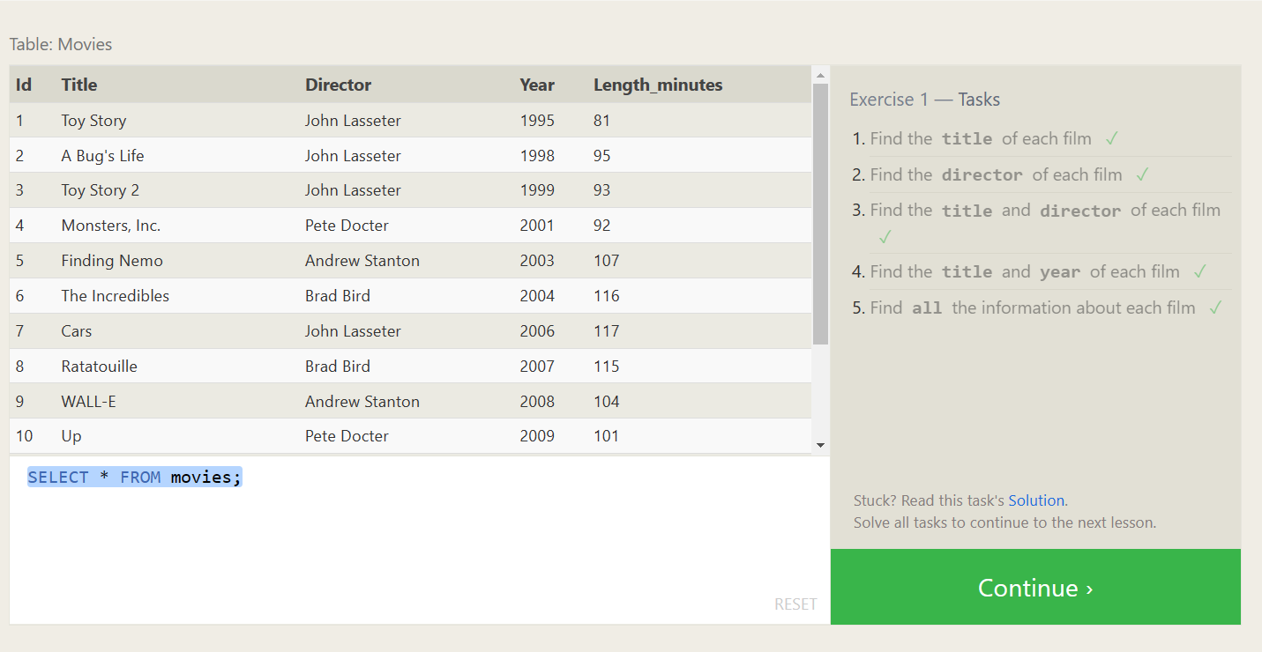

**LESSION-2**

1. SELECT * FROM movies where id=6;
2. SELECT * FROM movies where year between 2000 and 2010;
3. SELECT * FROM movies where year not between 2000 and 2010;
4. SELECT title FROM movies limit 5 offset 0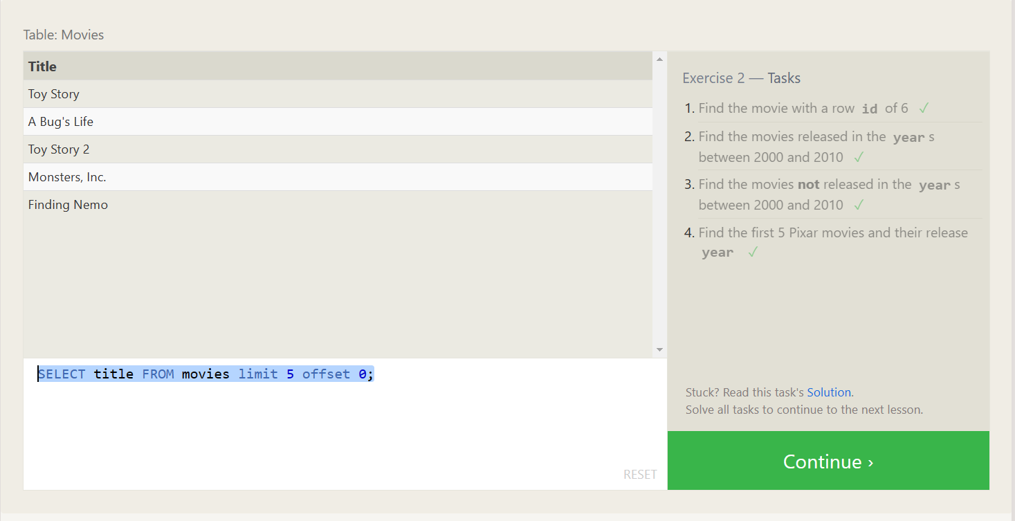

**LESSION-3:**

1. SELECT * FROM movies where title like '%Toy Story%';
2. SELECT * FROM movies where director like '%john lasseter%';
3. SELECT * FROM movies where director not like '%john lasseter%';
4. SELECT * FROM movies where title like '%wall%'

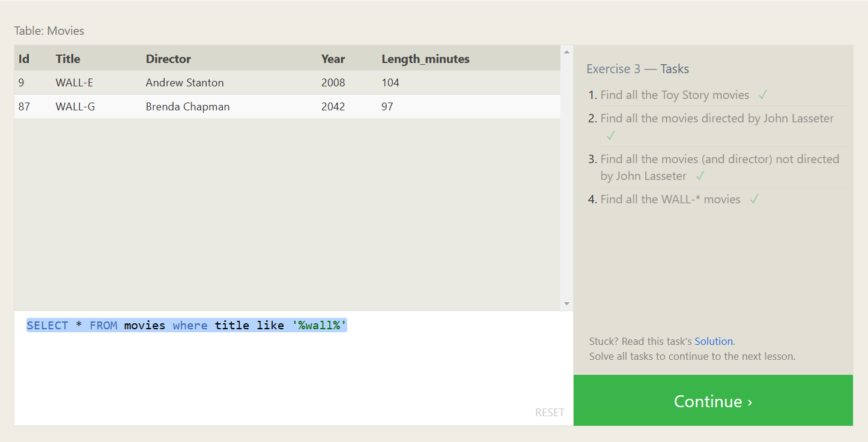

**LESSION-4**

1.SELECT DISTINCT director FROM Movies ORDER BY director;

2. SELECT * FROM movies ORDER BY year DESC LIMIT 4;

3. SELECT * FROM movies ORDER BY title asc LIMIT 5;

4. SELECT * FROM movies ORDER BY title asc LIMIT 5 offset 5;

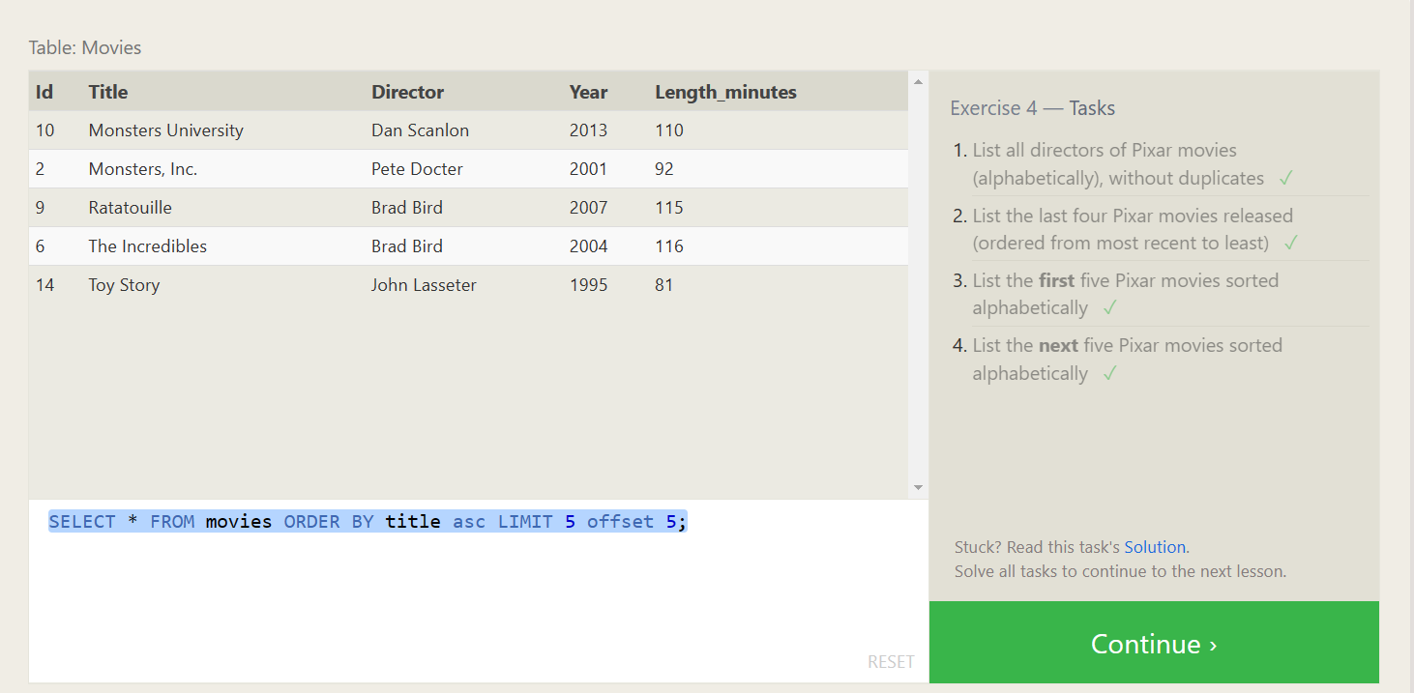

**LESSION-5:**

1. SELECT city, population FROM north_american_cities WHERE country = "Canada";
2. SELECT city,latitude,longitude FROM north_american_cities where country="United States";
3. SELECT * FROM north_american_cities WHERE longitude < -87.629798 ORDER BY longitude;
4. SELECT city FROM north_american_cities where country ="Mexico"order by population desc limit 2;
5. SELECT city FROM north_american_cities WHERE country = "United States" ORDER BY population DESC LIMIT 2 OFFSET 2;

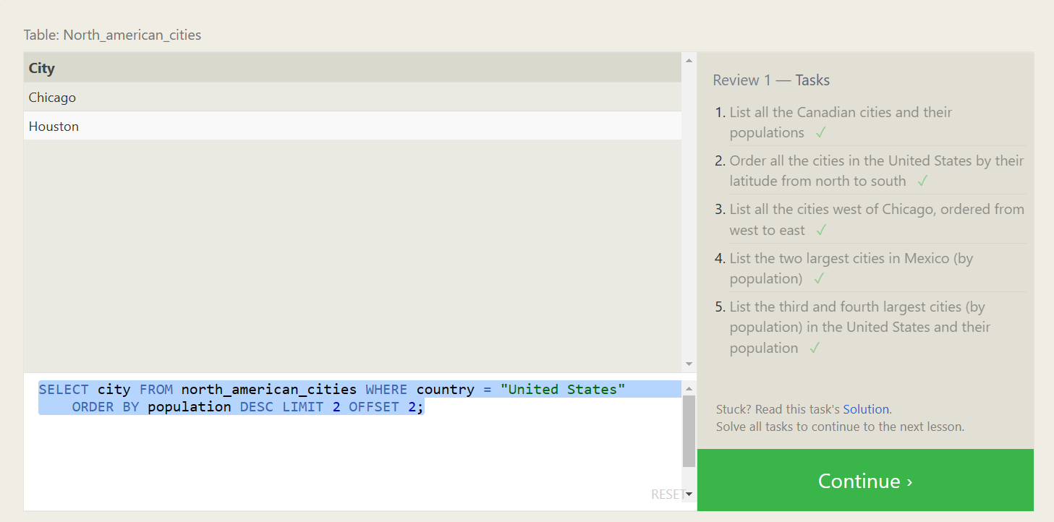

**LESSION-6:**

1. SELECT title, domestic_sales, international_sales FROM movies INNER JOIN boxoffice ON movies.id = boxoffice.movie_id;
2. SELECT title, domestic_sales, international_sales FROM movies INNER JOIN boxoffice ON movies.id = boxoffice.movie_id where domestic_sales<international_sales;
3. SELECT title,rating FROM movies INNER JOIN boxoffice ON movies.id = boxoffice.movie_id order by rating desc;

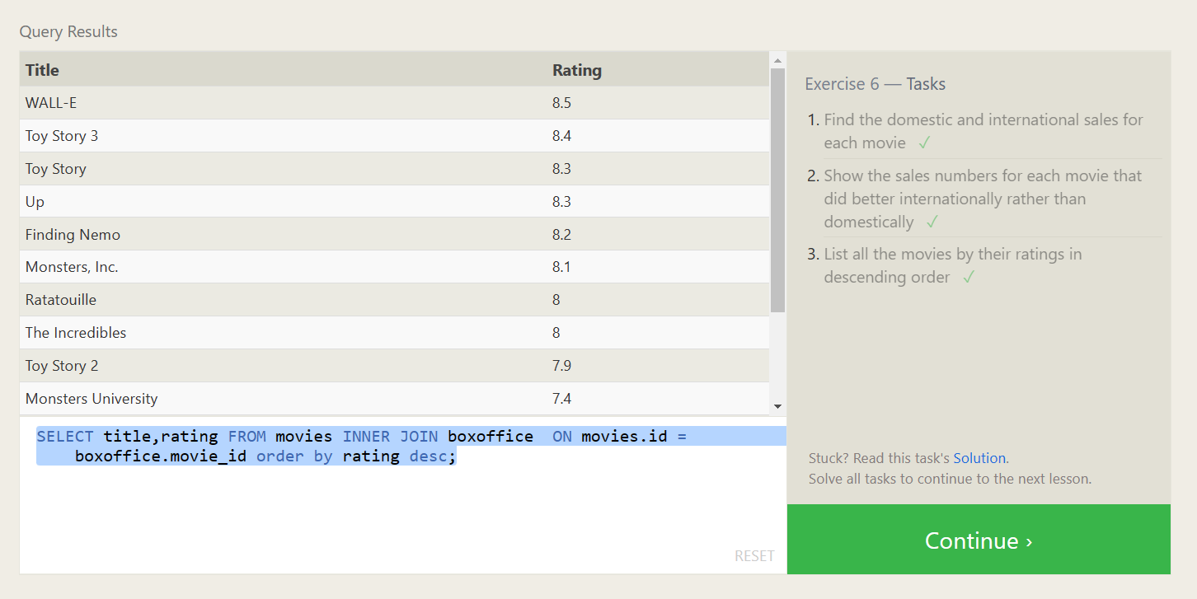

**LESSION-7:**

1. SELECT distinct building FROM employees;
2. SELECT * FROM buildings;
3. SELECT DISTINCT building_name, role FROM buildings LEFT JOIN employees ON building_name = employees.building;

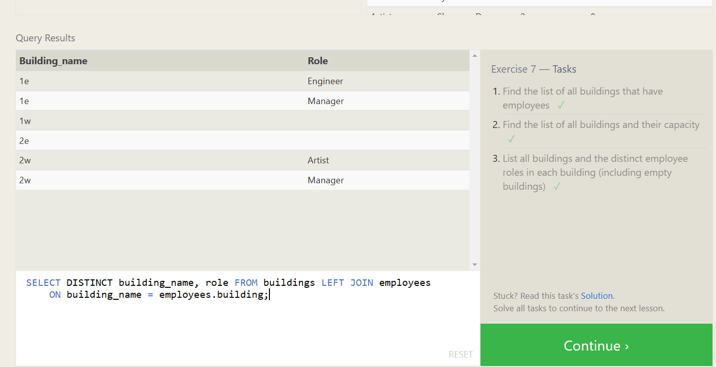

**LESSION-8:**

1. SELECT NAME,ROLE FROM employees WHERE BUILDING IS NULL;
2. SELECT DISTINCT BUILDING_NAME FROM BUILDINGS LEFT JOIN EMPLOYEES ON BUILDING_NAME = EMPLOYEES.BUILDING WHERE EMPLOYEES.BUILDING IS NULL;

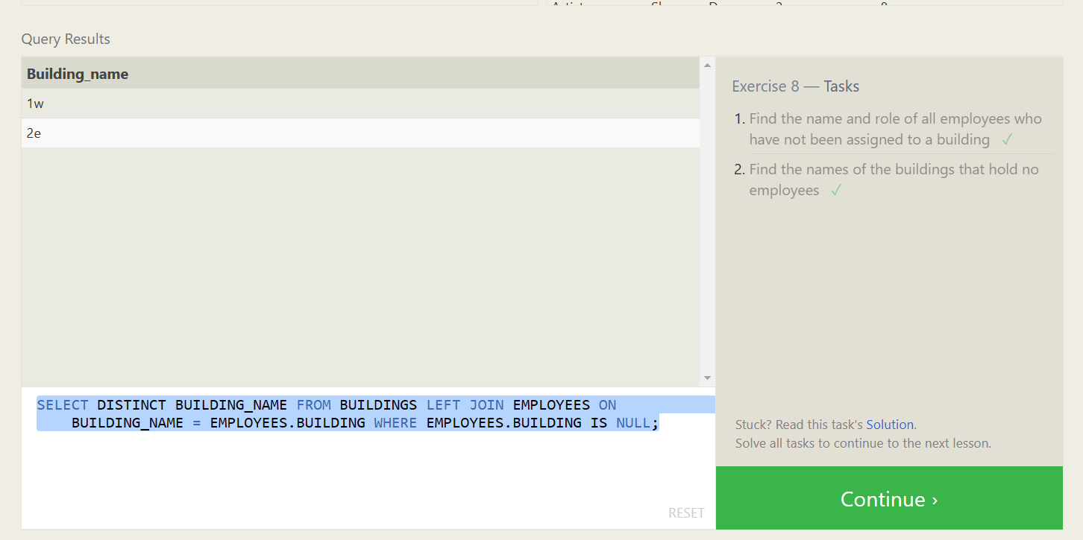

**LESSION-9:**

1. SELECT title,(domestic_sales+international_sales)/1000000 as combinedsales FROM movies left join Boxoffice on movies.id=boxoffice.movie_id;
2. SELECT title,rating * 10 as present FROM movies left join Boxoffice on movies.id=boxoffice.movie_id;
3. SELECT title,year as year FROM movies left join Boxoffice on movies.id=boxoffice.movie_id where year%2==0;

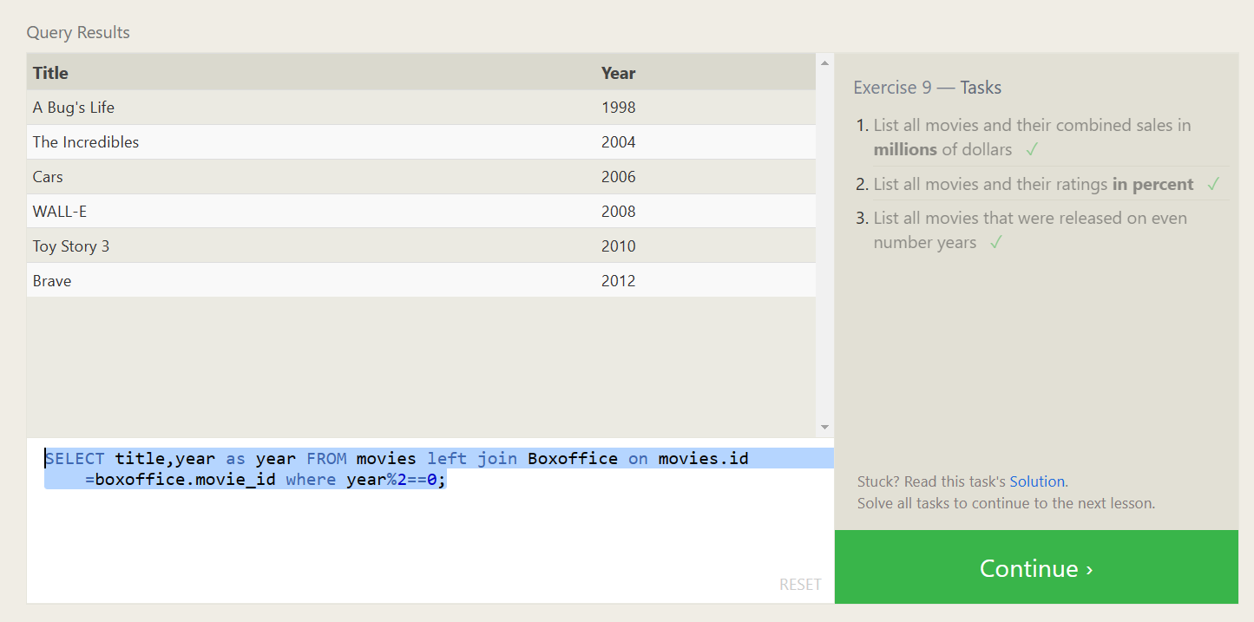

**LESSION-10:**

1. SELECT max(years_employed) FROM employees;
2. SELECT role,Avg(years_employed) FROM employees GROUP BY role;
3. SELECT building, sum(years_employed) FROM employees group by building;

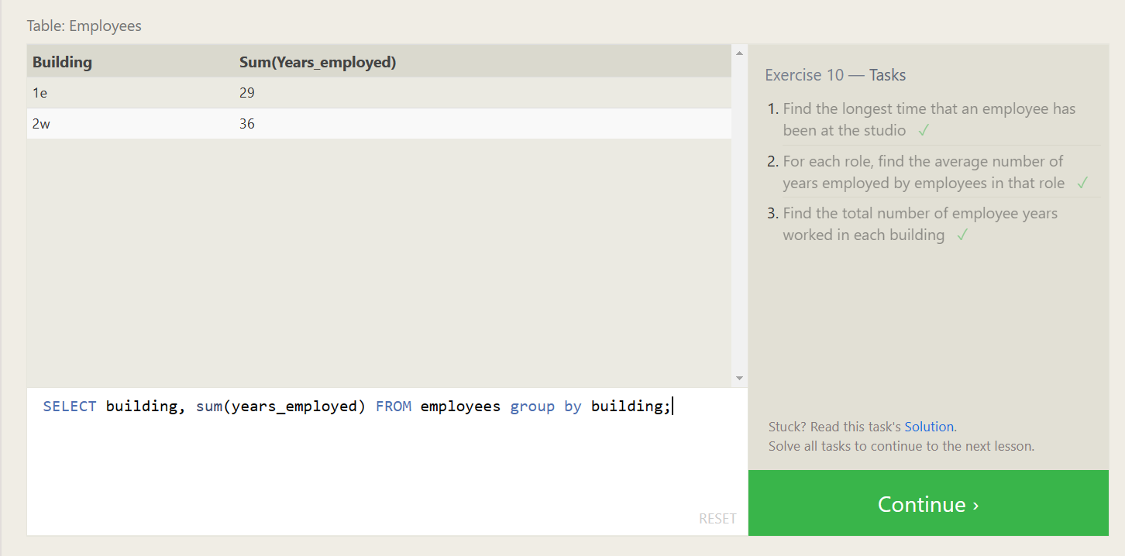

**LESSION-11:**

1. SELECT count(*) FROM employees where role = "Artist";
2. SELECT role,count(*) FROM employees group by role;
3. SELECT sum(years_employed) from employees where role ='Engineer';

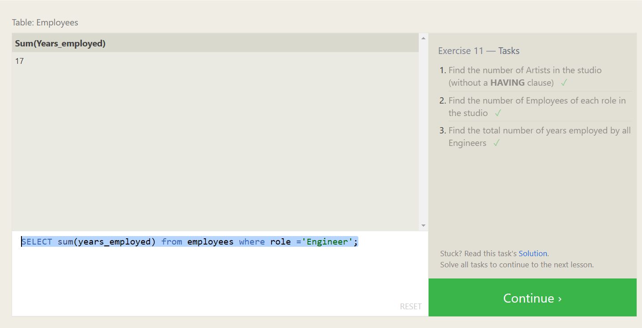

**LESSION-12:**

1. SELECT count(*)title,director FROM movies group by director;
2. SELECT director, sum(domestic_sales+international_sales) FROM movies inner join Boxoffice on movies.id = boxoffice.movie_id group by director;

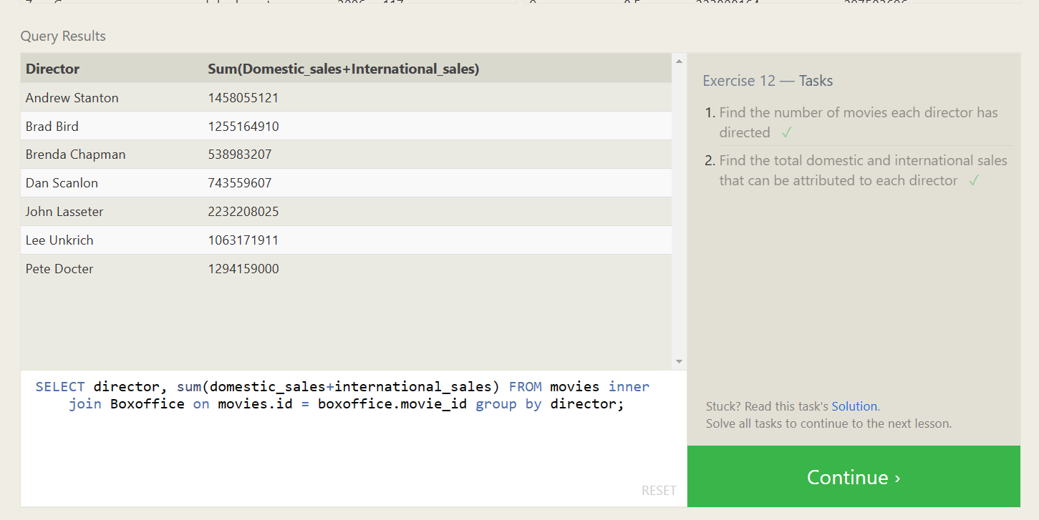

**LESSION-13:**

1. insert into Movies (title,director,year,length_minutes) values('Toy Story 4','John Lasseter',' 1999','81');

2. insert into Boxoffice (movie_id,rating,domestic_sales,international_sales) values('15','8.7','340000000','270000000')

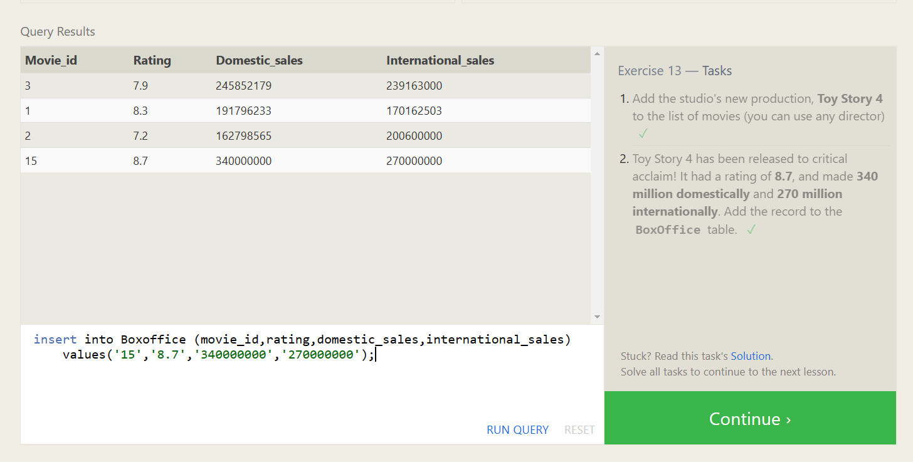

**LESSION-14:**

1. UPDATE movies SET director = "John Lasseter" WHERE title = "A Bug's Life";
2. UPDATE movies SET year = "1999" WHERE title = "Toy Story 2";
3. UPDATE movies SET title = 'Toy Story 3',director = 'Lee Unkrich' WHERE title = 'Toy Story 8';

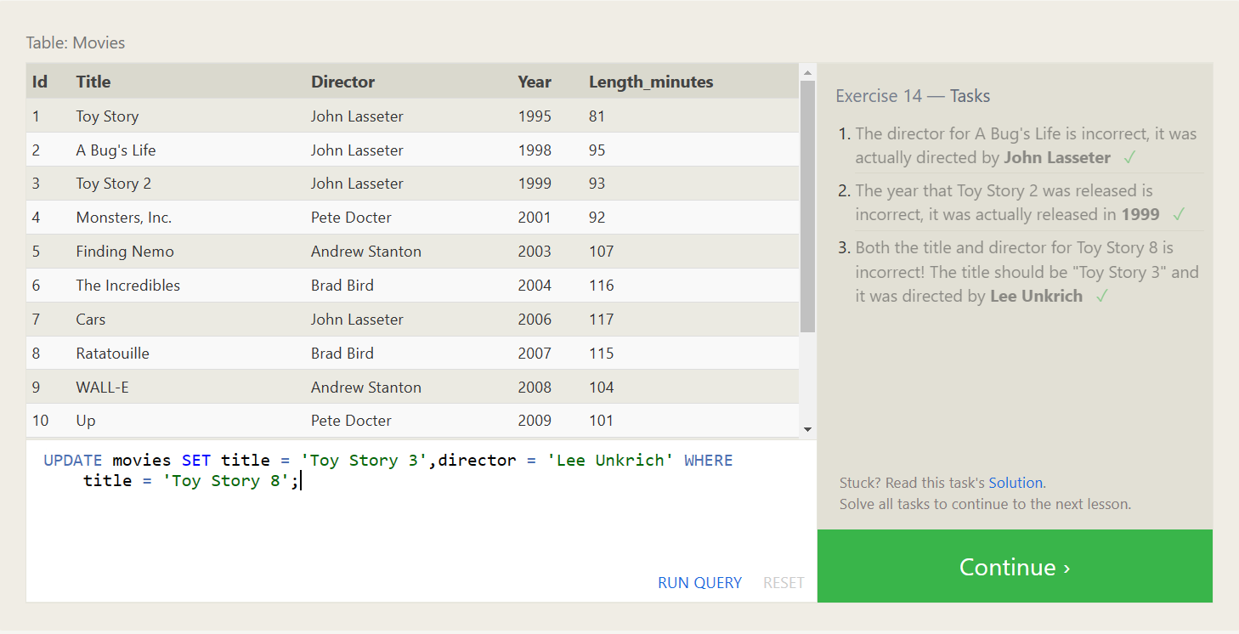

**LESSION-15:**

1. Delete FROM movies where year < 2005;
2. DELETE FROM movies WHERE director = 'Andrew Stanton';

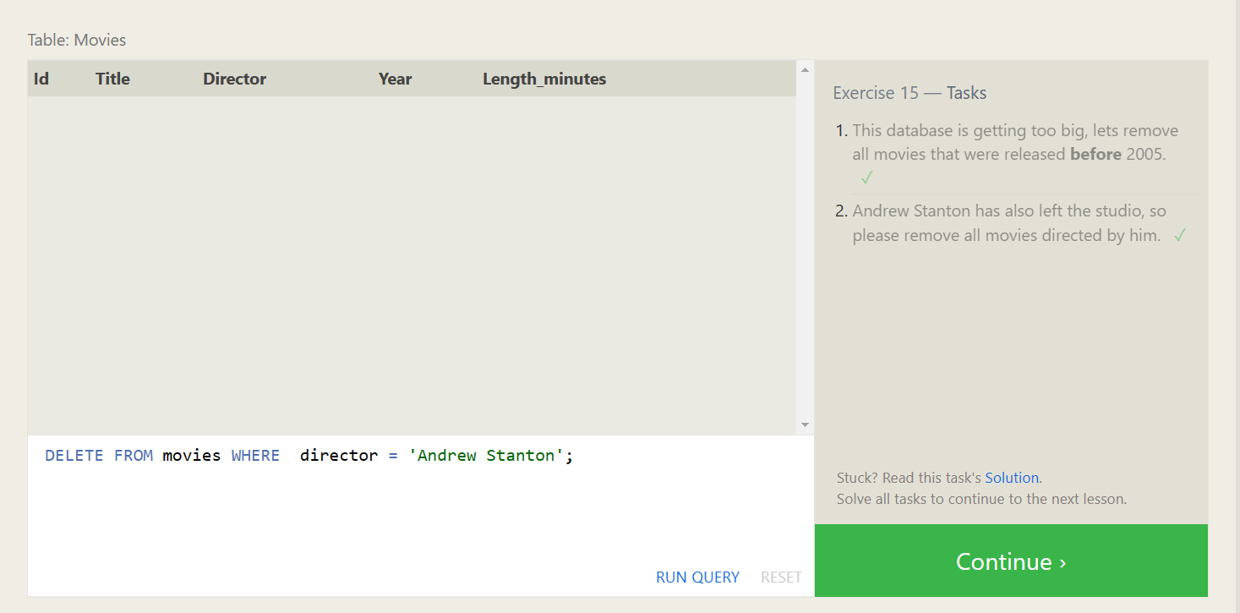

**LESSION-16:**

1. create table Database(

Name varchar(255),

Version int,

Download_count int

)

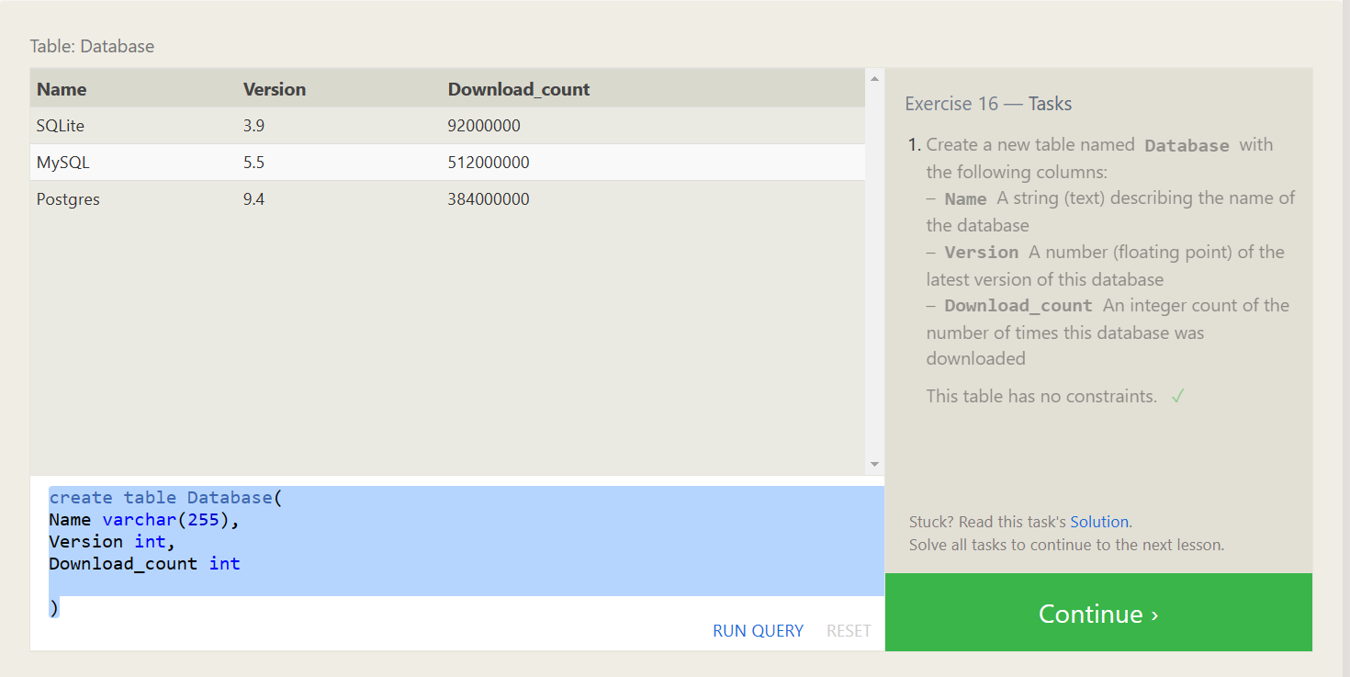

**LESSION-17:**

1. alter table movies

add aspect_ratio float;

2. alter table movies

add Language varchar(255) default 'English';

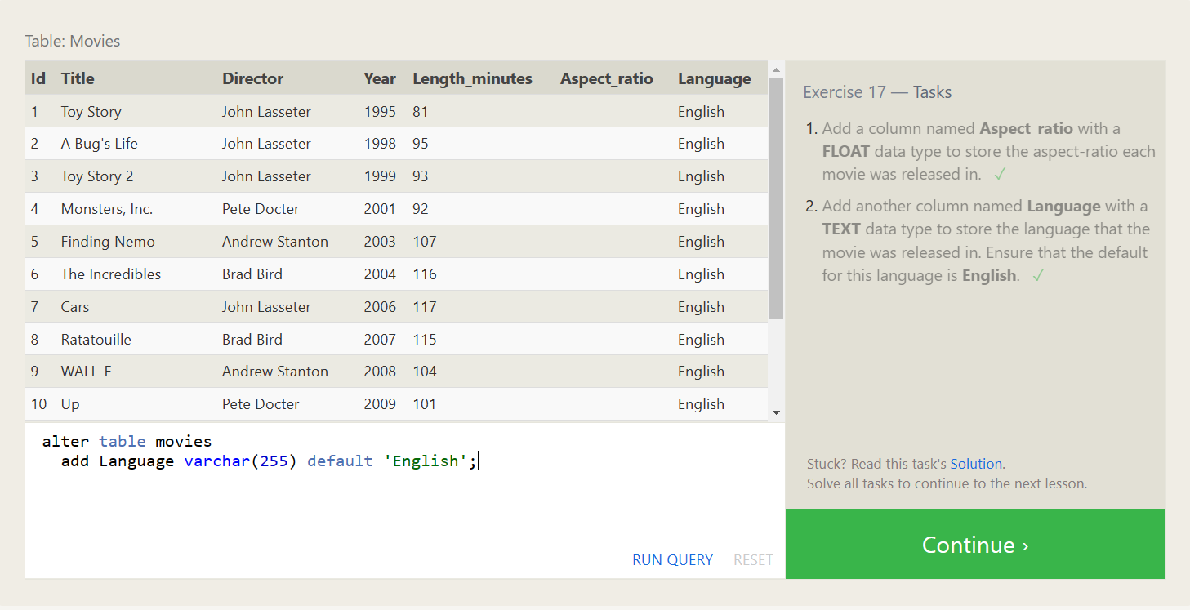

**LESSION-18:**

1. drop table movies;
2. drop table Boxoffice;

