1.Find all the topics and tasks which are thought in the month of October

db.topics.aggregate([

    {

        $lookup: {

               from: "tasks",

               localField: "topicid",

               foreignField: "topicid",

               as: "taskinfo"

             }

    },

    {

        $match:{$and:[{$or:[{topic_date:{$gt:new Date("30-sep-2020")}},{topic_date:{$lt:new Date("1-nov-2020")}}]},

          {$or:[{"taskinfo.due_date":{$gt:new Date("30-sep-2020")}},{"taskinfo.due_date":{$lt:new Date("1-nov-2020")}}]}

        ]}

    }

    ])

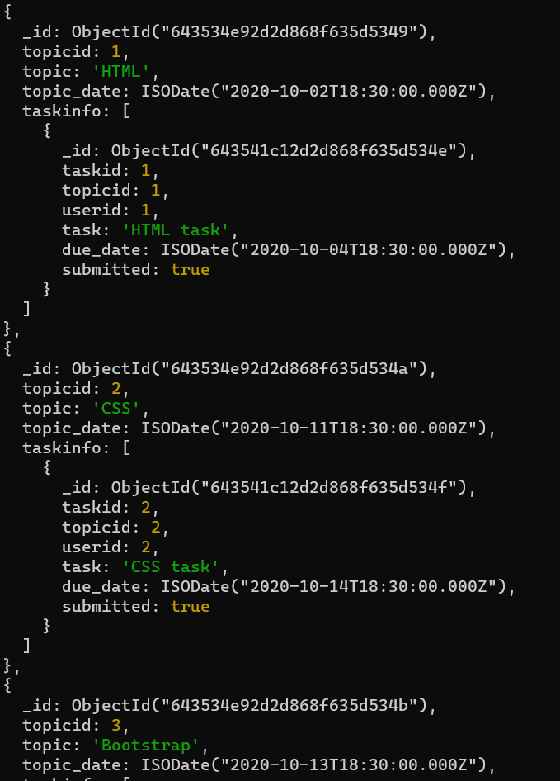

2.Find all the company drives which appeared between 15 oct-2020 and 31-oct-2020

    db.companydrives.find({$or:[{drive_date:{$gte:new Date("15-oct-2020")}},

    {drive_date:{$lte:new Date("31-0ct-2020")}}]})

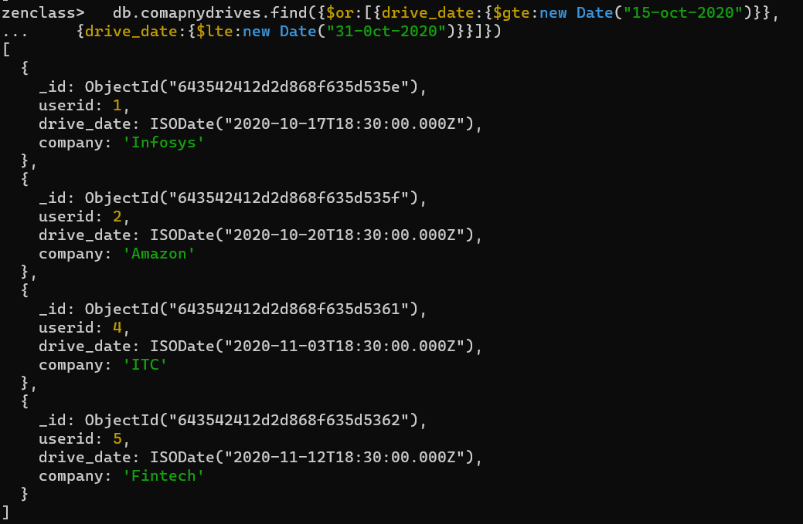

 3.Find all the company drives and students who are appeared for the placement.

db.companydrives.aggregate([

    {

        $lookup: {

              from:"users",

              localField:"userid",

              foreignField:"userid",

              as :"userinfo"

             }

    },

    {

        $project:{

            _id:0,

            "userinfo.name":1,

            company:1,

            drive_date:1,

            "userinfo.email":1,

            "userinfo.userid":1

        }

    }

    ])

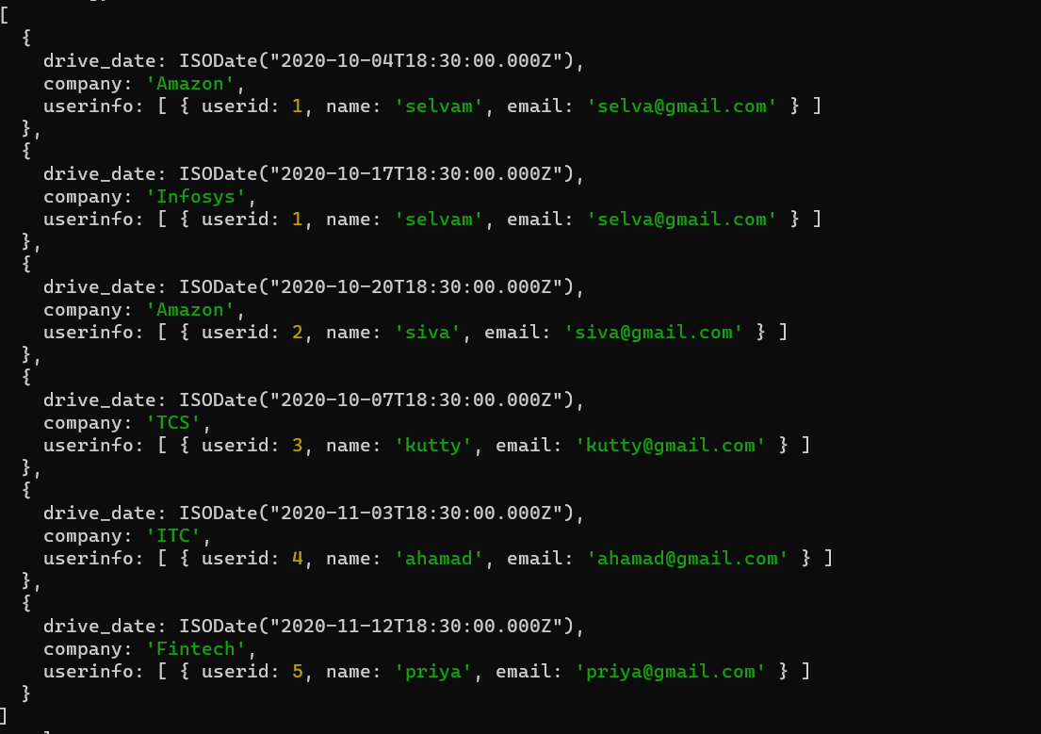

4.Find the number of problems solved by the user in codekata

   db.codekata.aggregate([

    {

        $lookup:{

            from:"users",

            localField:"userid",

            foreignField:"userid",

            as:"userinfo"

        }

    },

    {

        $project:{

            _id:0,

            "userinfo.name":1,

            userid:1,

            problems:1

        }

    }

])

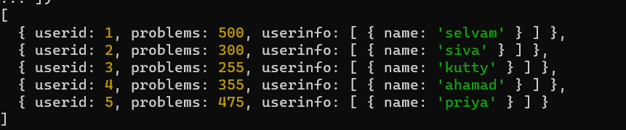

5.Find all the mentors with who has the mentee's count more than 15

  db.mentors.find({mentee_count:{$gt:15}});

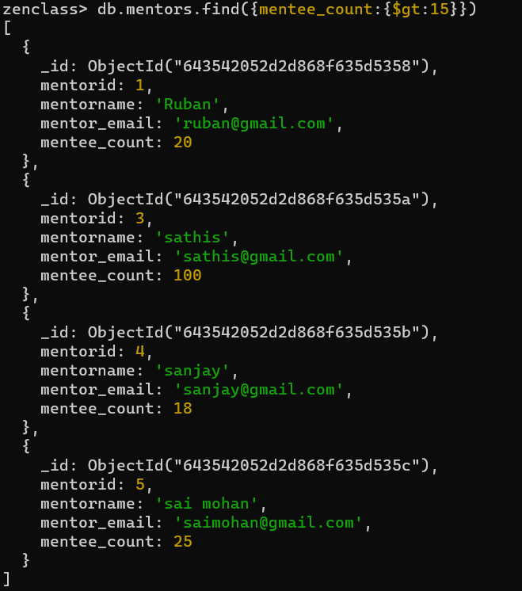

//6.Find the number of users who are absent and task is not submitted  between 15 oct-2020 and 31-oct-2020

db.attendance.aggregate([

    {$lookup: {

           from: "topics",

           localField: "topicid",

           foreignField: "topicid",

           as: "topics"

         }},

         {

             $lookup: {

                    from: "tasks",

                    localField: "topicid",

                    foreignField: "topicid",

                    as: "tasks"

                  }

         },

         {$match:{$and:[{attended:false},{"tasks.submitted":false}]}},

         {$match:{$and:[{$or:[{"topics.topic_date":{$gte:new Date("15-oct-2020")}},{"topics.topic_date":{$lte:new Date("31-oct-2020")}}]},

         {$or:[{"tasks.due_date":{$gte:new Date("15-oct-2020")}},{"tasks.due_date":{$lte:new Date("31-oct-2020")}}]}

         ]}},

         {

             $count: "No_of_students_absent"

         }

    ])

