Internal Marks Management System
UI Prototype & Project Documentation
Department: MCA (Master of Computer Applications)
Technology: Python Flask, HTML, CSS, JavaScript, SQLite

1. Introduction
The Internal Marks Management System is a web-based application for managing internal assessment marks for the MCA department. It supports Admin, Faculty, and Student roles with dedicated dashboards.

2. Technology Stack
Layer | Technology
Backend | Python 3, Flask
Frontend | HTML5, CSS3, JavaScript
Database | SQLite
Templates | Jinja2

3. User Roles & Credentials
Role | Login URL | Credentials
Admin | /login | admin / admin123
Faculty | /faculty/login | Admin-uploaded email / faculty123
Student | /student/login | Admin-uploaded USN / student123

4. User Interface Screens (Actual Screenshots)

Figure 4.1 - Admin Login Page
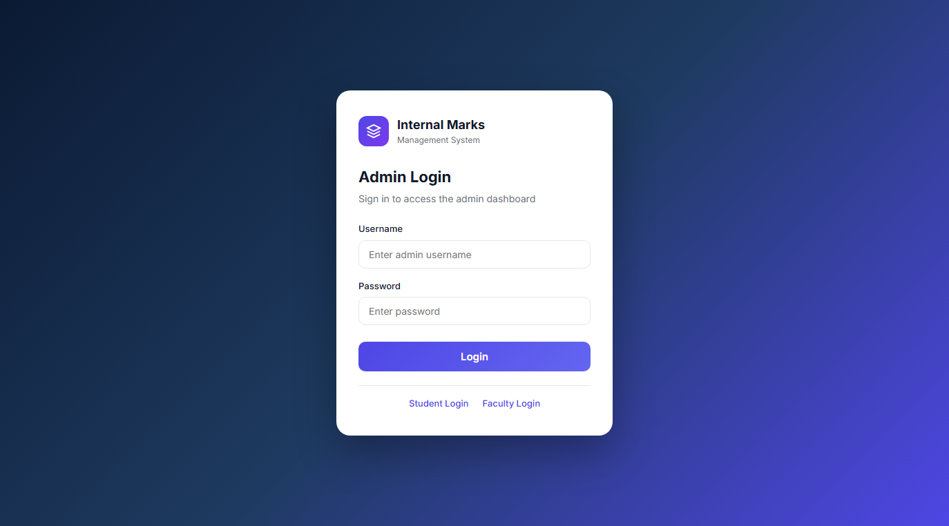
Figure 4.1 - Admin Login Page

Figure 4.2 - Student Login Page
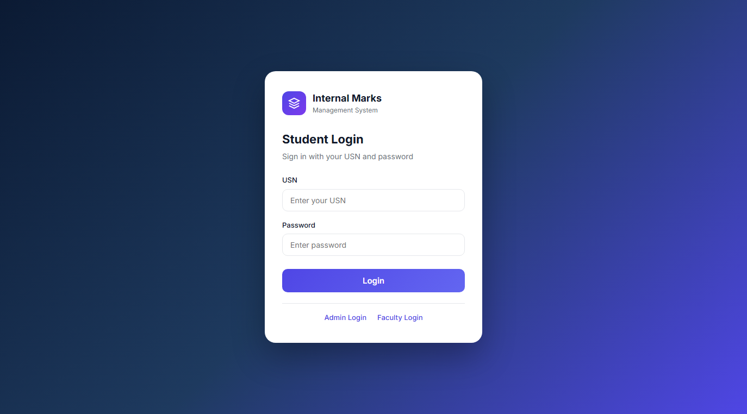
Figure 4.2 - Student Login Page

Figure 4.3 - Faculty Login Page
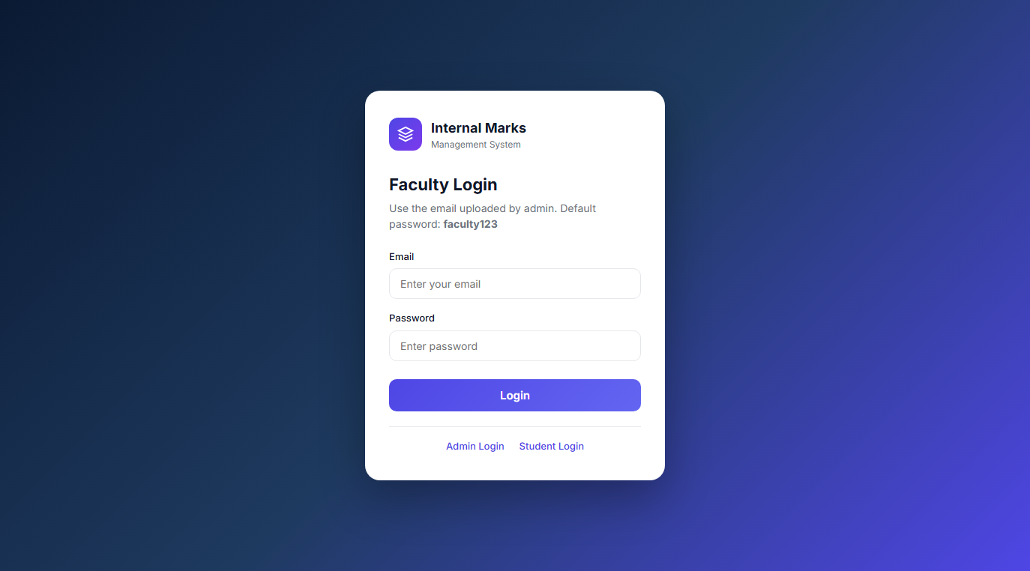
Figure 4.3 - Faculty Login Page

Figure 4.4 - Admin Dashboard
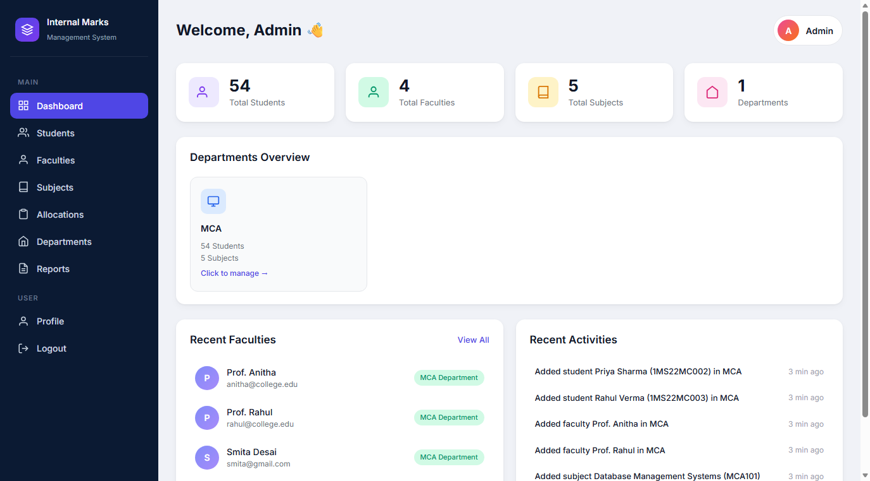
Figure 4.4 - Admin Dashboard

Figure 4.5 - Students Management
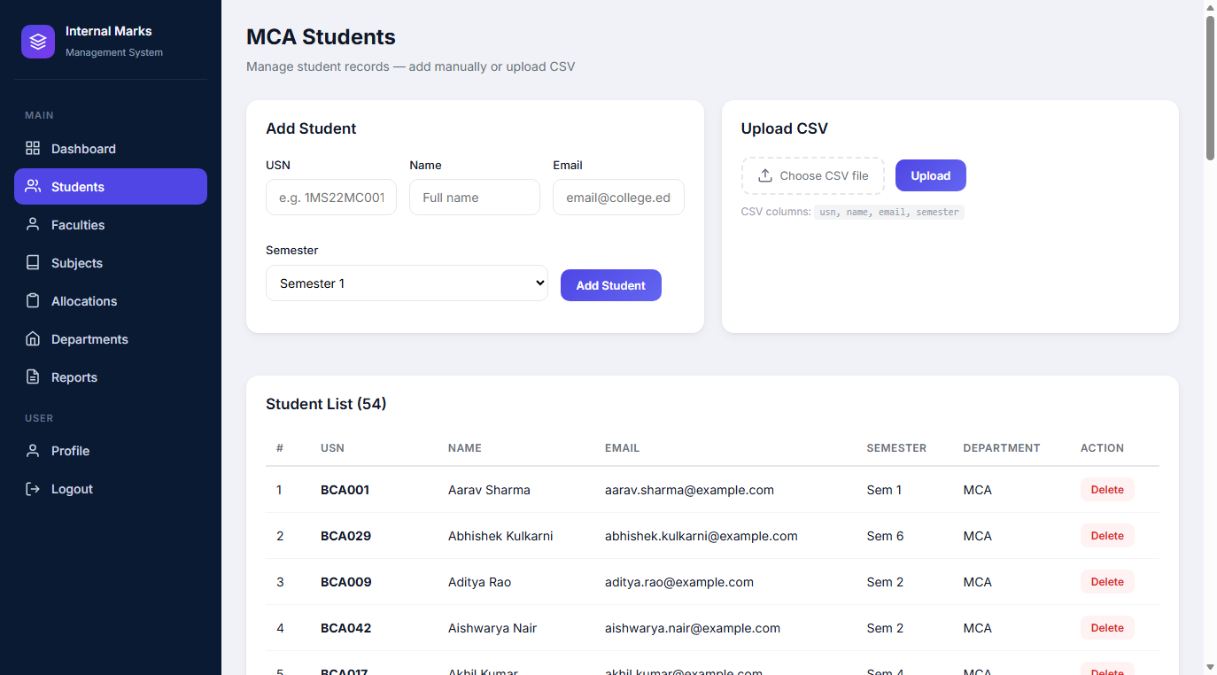
Figure 4.5 - Students Management

Figure 4.6 - Faculties Management
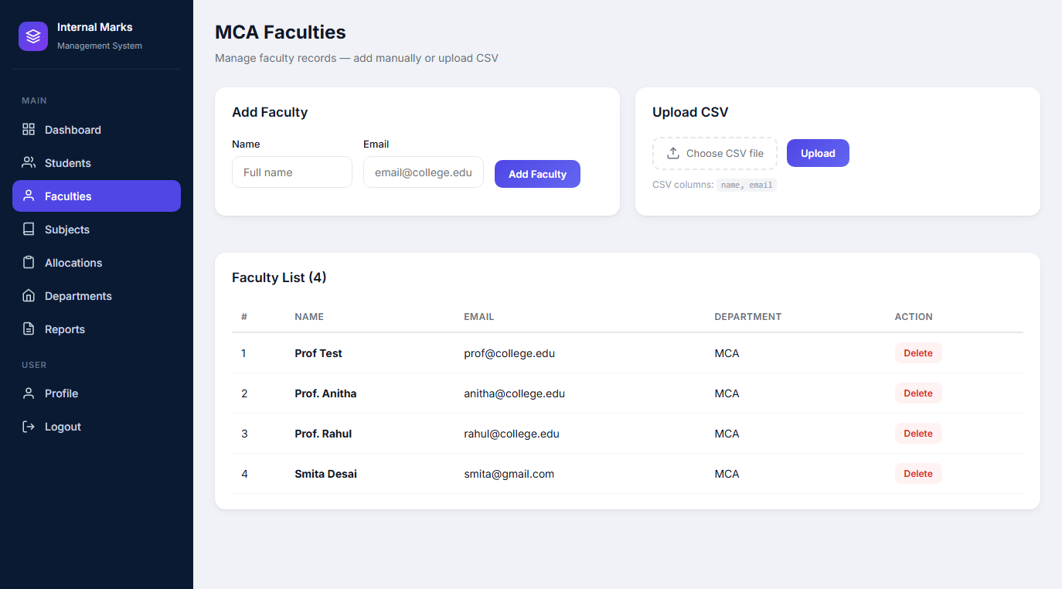
Figure 4.6 - Faculties Management

Figure 4.7 - Subjects Management
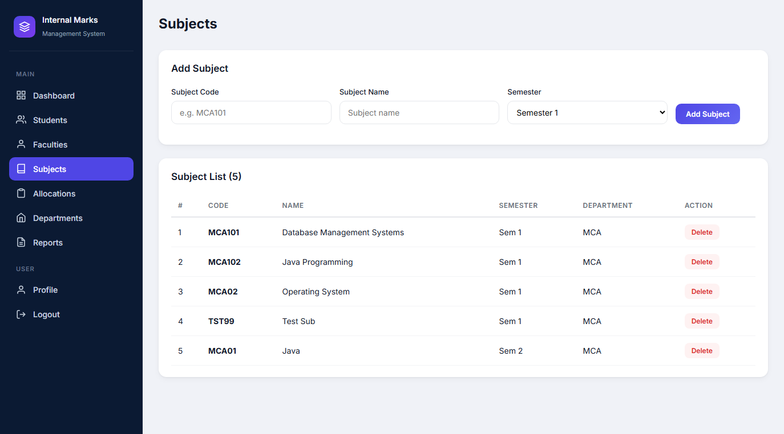
Figure 4.7 - Subjects Management

Figure 4.8 - Subject Allocations
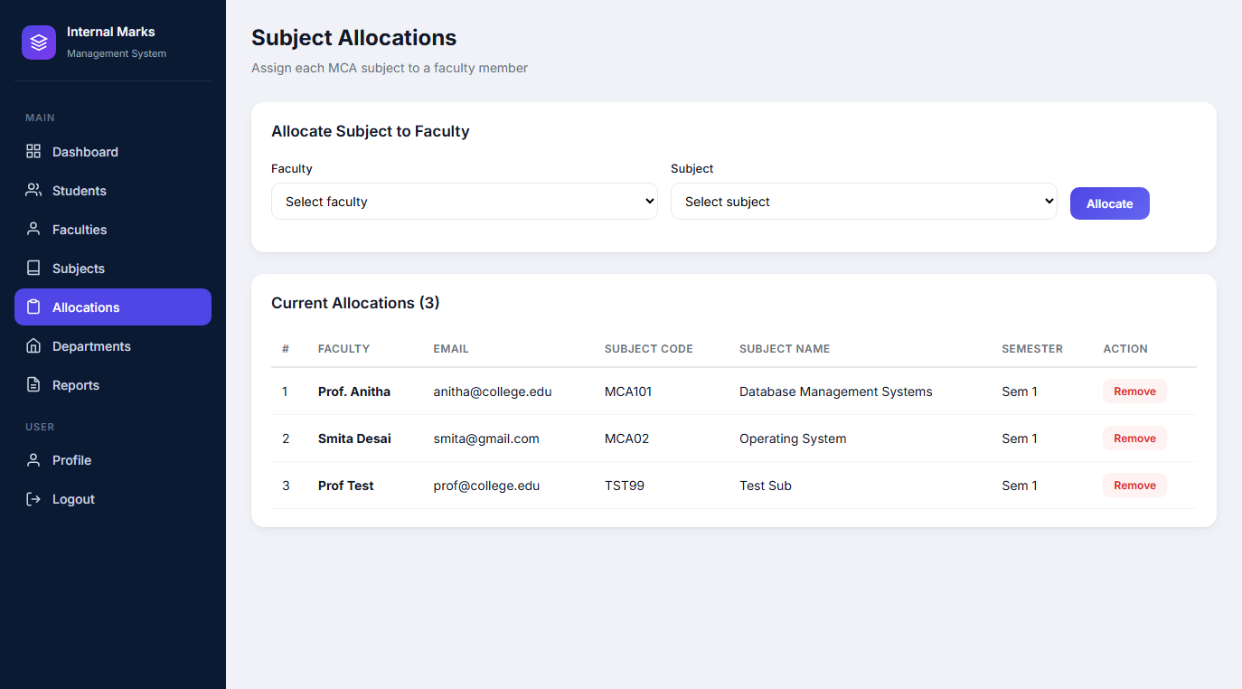
Figure 4.8 - Subject Allocations

Figure 4.9 - Departments Overview
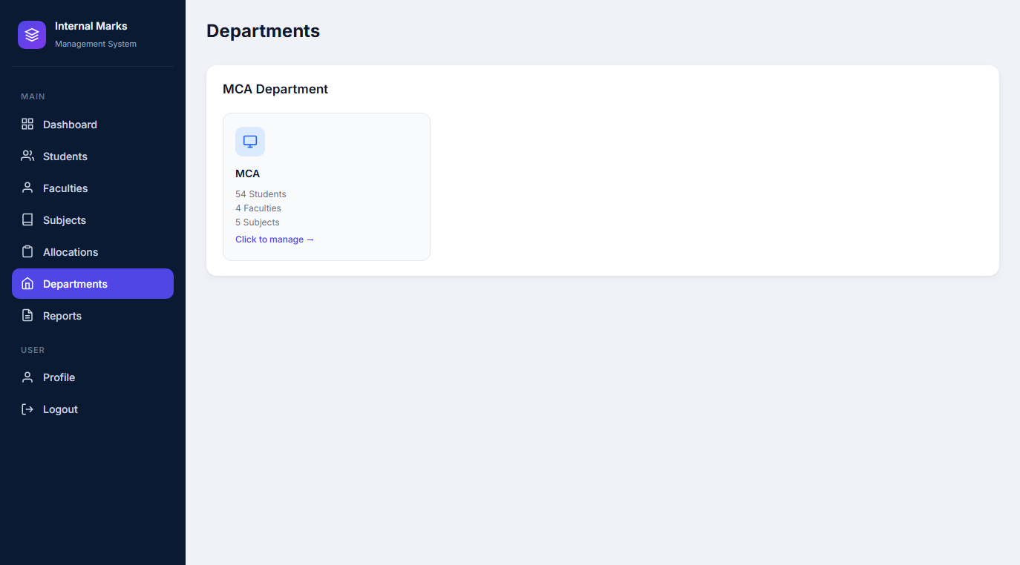
Figure 4.9 - Departments Overview

Figure 4.10 - Faculty Dashboard
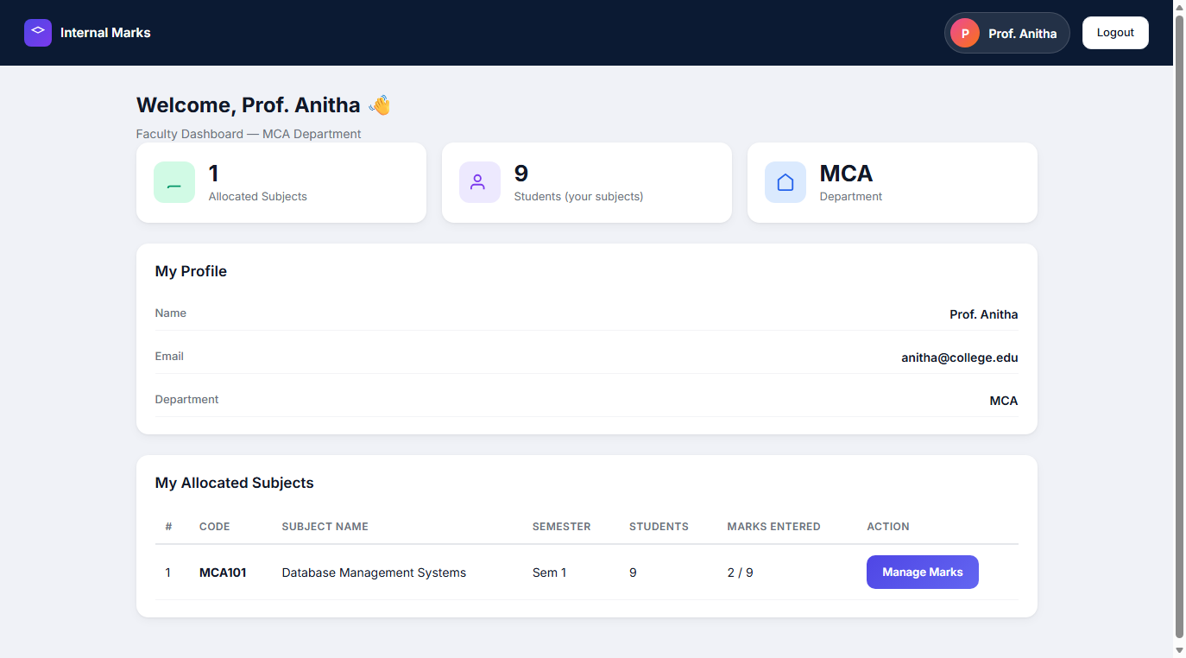
Figure 4.10 - Faculty Dashboard

Figure 4.11 - Faculty Marks Entry
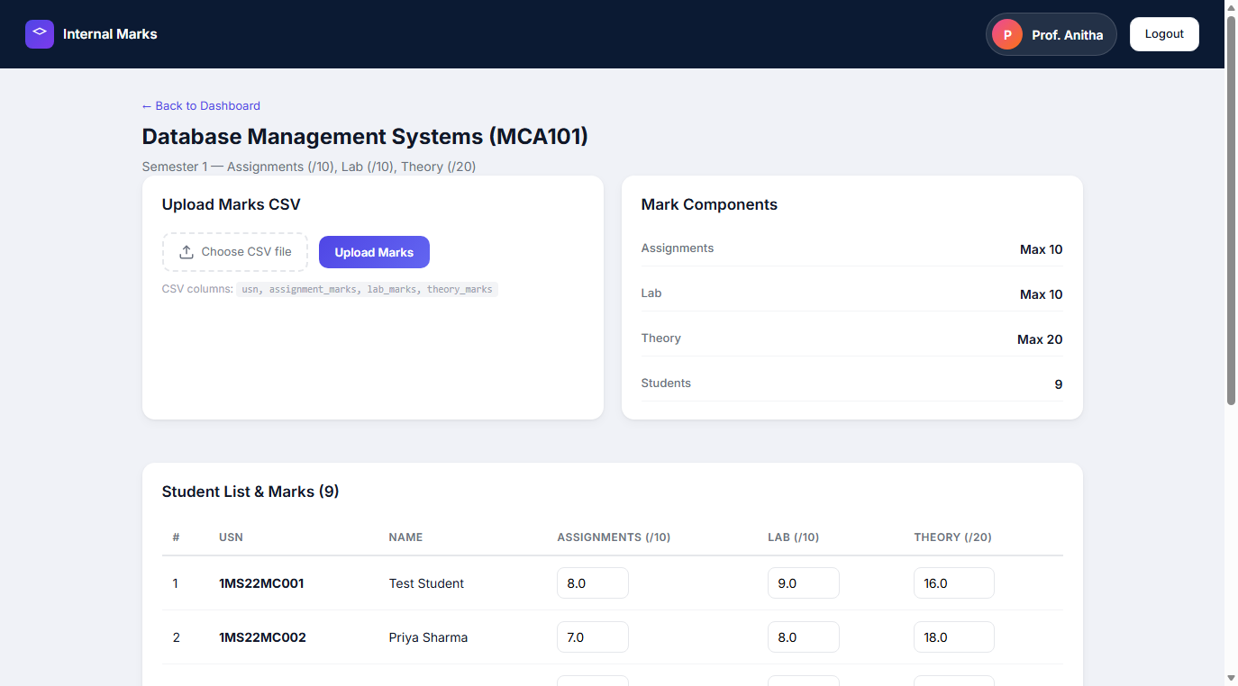
Figure 4.11 - Faculty Marks Entry

Figure 4.12 - Student Dashboard with Marks
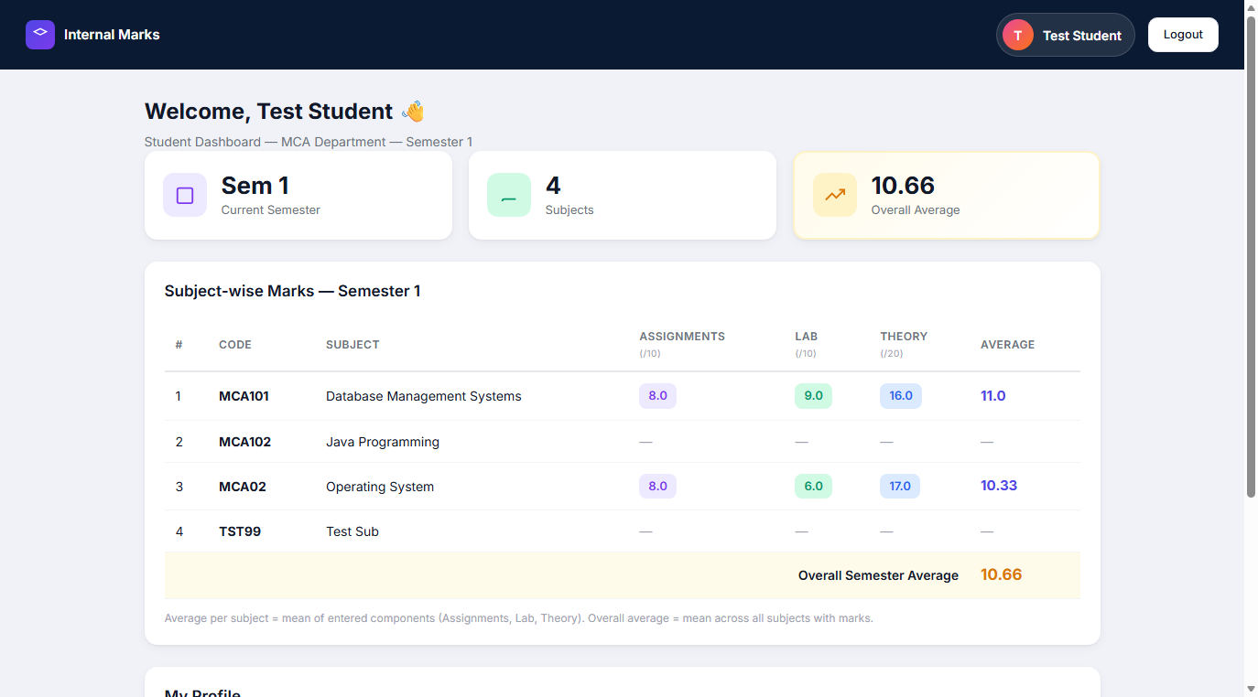
Figure 4.12 - Student Dashboard with Marks

5. Mark Components
Component | Max Marks | Entered By
Assignments | 10 | Faculty
Lab | 10 | Faculty
Theory / Internal | 20 | Faculty

Subject Average = mean of entered components. Overall Semester Average = mean of subject averages.

6. Database Schema
Table | Key Fields | Description
students | usn, name, email, semester | Student records
faculties | name, email, password | Faculty records
subjects | code, name, semester | Subject catalog
allocations | faculty_id, subject_id | Subject-faculty mapping
marks | assignment, lab, theory | Internal marks per student/subject
activities | action, created_at | Audit log

7. CSV Upload Formats

7.1 Students
usn | name | email | semester
1MS22MC001 | Amit Kumar | amit@college.edu | 1
1MS22MC002 | Priya Sharma | priya@college.edu | 1

7.2 Faculties
name | email
Prof. Anitha | anitha@college.edu
Prof. Rahul | rahul@college.edu

7.3 Marks (Faculty)
usn | assignment_marks | lab_marks | theory_marks
1MS22MC001 | 8 | 9 | 16
1MS22MC002 | 7 | 8 | 18

8. Navigation Access Matrix
Page | Admin | Faculty | Student
Dashboard | Yes | Yes | Yes
Manage Students/Faculties | Yes | No | No
Allocations | Yes | No | No
Enter Marks | No | Yes | No
View Marks | No | No | Yes

9. User Workflows
Admin: Login -> Add data -> Allocate subjects to faculty.
Faculty: Login with email -> Enter marks manually or CSV.
Student: Login with USN -> View subject-wise marks and average.

10. Conclusion
This document presents the complete UI prototype with actual application screenshots and structured tables for the Internal Marks Management System.

