Generate Manhattan plot from GAPIT output

In order to better understand the output of GAPIT an application was created to visualize and integrate the results.

The application can be found at: <http://icci-2:9100/manhattan/>

You need to be connected to the TAU network, so if you work from home or with Wi-Fi you need to connect with VPN.

It is not recommended to upload files from home because it could take a long time.

How to use the application?

1. Create a Manhattan plot



Execute (can take some time)

Select GAPIT results (wait for the ‘Upload complete’)

Select P-value cutoff (Will present only data above this value)

Add title (optional)

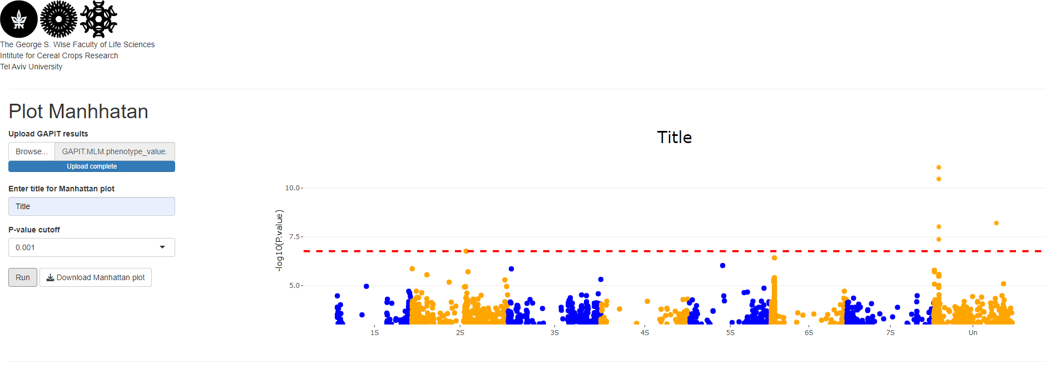Results:

An interactive plot, hover with mouse in a SNP to see attributes, click on a SNP to go to the genome browser.

Points in a star shape are significant

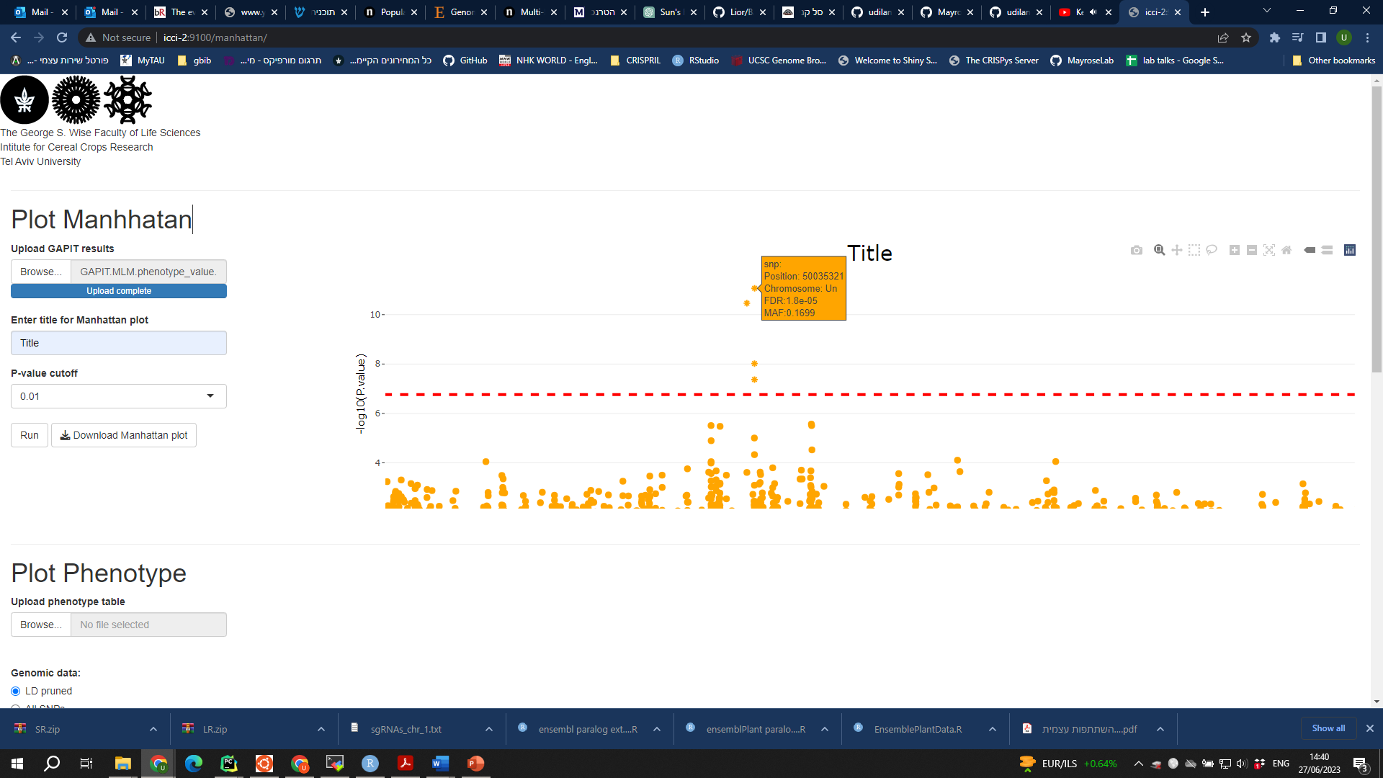

Save as HTML which will keep the interactive features

You can zoom in, move around and save the plot. Just be patient it can be slugy

1. Plot phenotype data

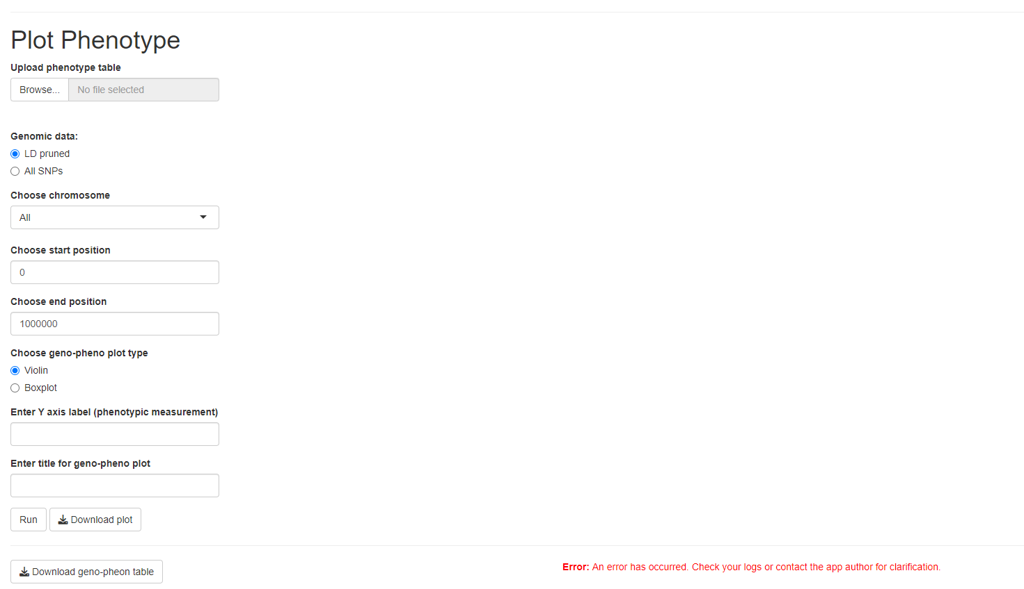In this section we will create a table of SNPs and plot the distribution of the phenotype data for each genotype. Use the same phenotypic table you used for the GWAS analisys.

Execute (can take some time)

Enter plot title and/or y-axis label (optional)

Type of plot (interactive, can be switched after the plot was created) change )

Upload phenotypes table

If you focused on one Chromosome

Choose the genomic data you used in the GWAS analysis

You can choose to focus on a specific range (use this when loading large number of SNPs, i.e., when working with full data)

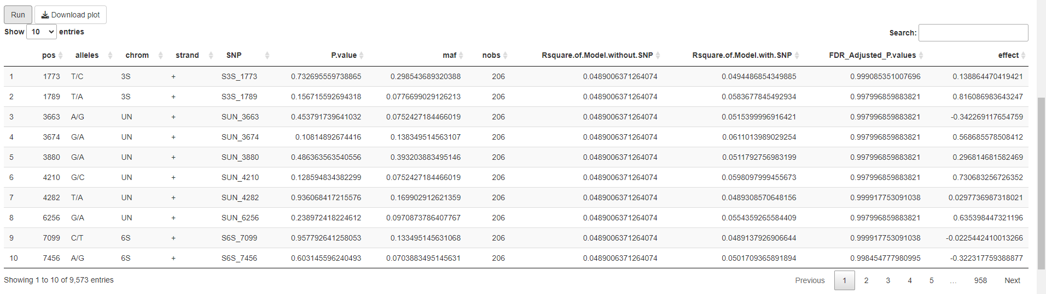The result is a table with each SNP in the range selected and its GWAS results, you can sort the table by a column by clicking on the column name.  
Usually you want to sort by the ‘FDR_Adjusted_P.values’ column to see the most significant SNPs

Sort by significant

Then select the row of the SNP you want and a plot will show on top, with the phenotype values for each genotype, you can select different row and the plot will change accordingly.

Also, you can change the type of plot between ‘violin’ and ‘boxplot’ and download the table and plot.  
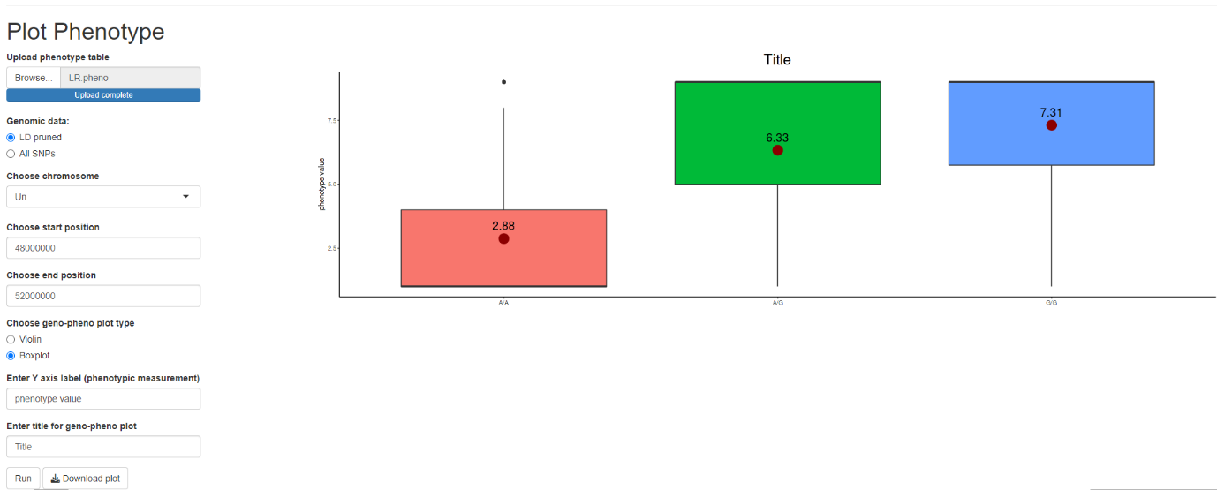

Notice the difference in phenotype between genotypes

Another SNP:

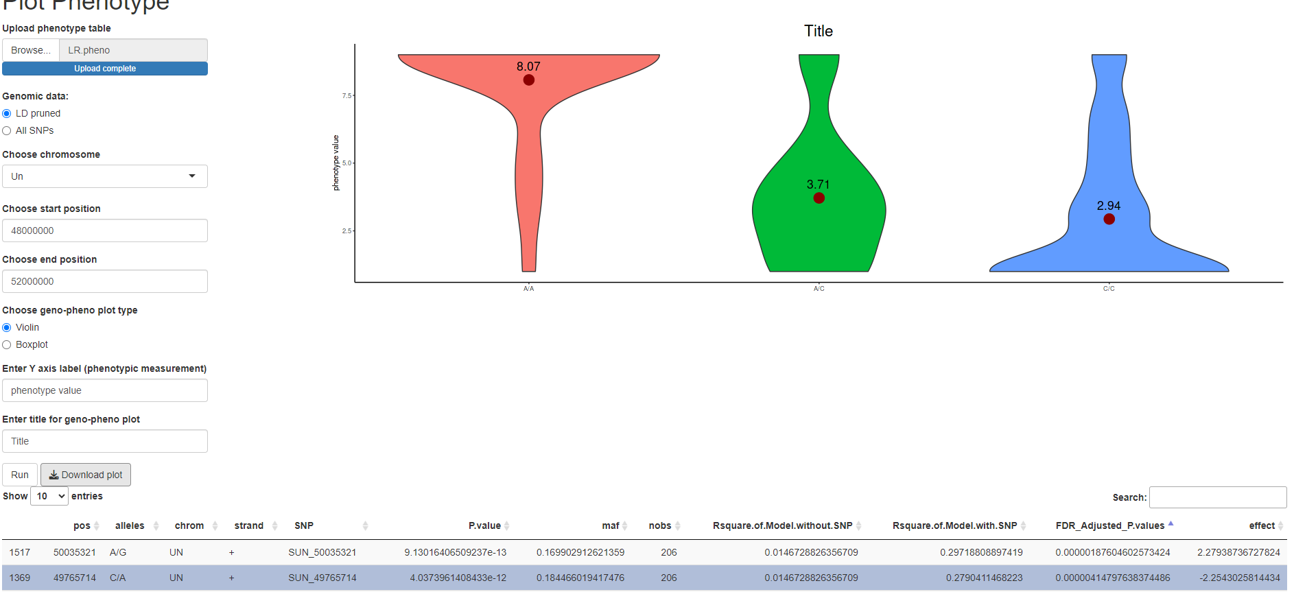

1. Plot geographical location  
   When selecting a SNP, another table is created that shows the SNP, accession, genotype, phenotype and location for each accession and for the chosen SNP:

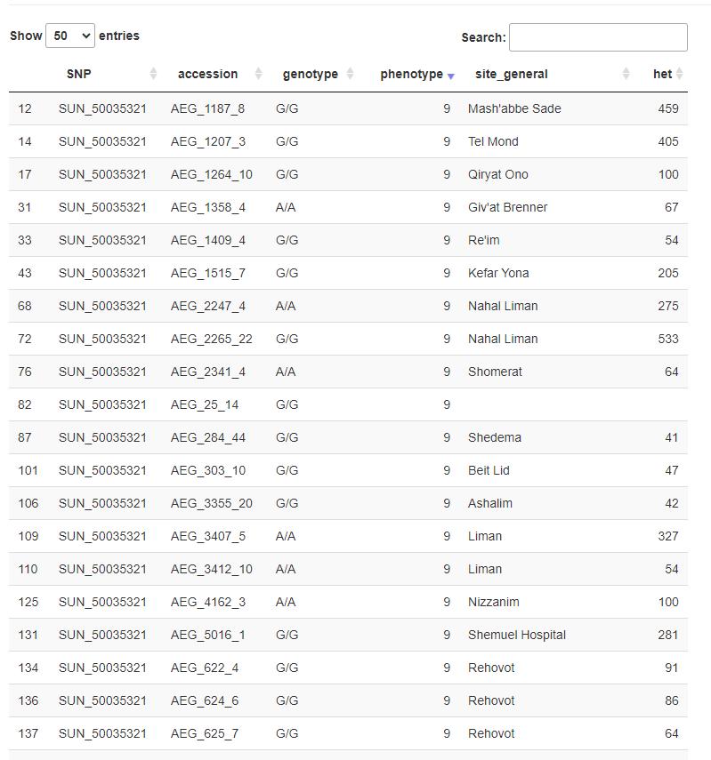

You can search, sort and choose how many rows to display and also download the table.

By selecting rows from the table, a map will be shown and the location of the selected accessions will be visible and will be colored by the value of the phenotype, you can hover or click on a point for more information.

You can also download the map to PDF.

In this example I have selected all accession collected from Akko and Ashalim:

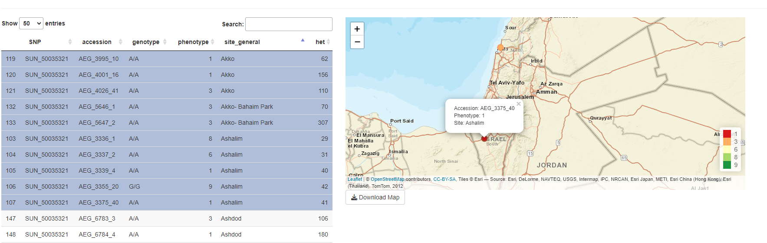

1. Compare SNPs

If you select 2 or more rows the plot will change to a comparison of genotypes and phenotypic value between the selected SNPs:

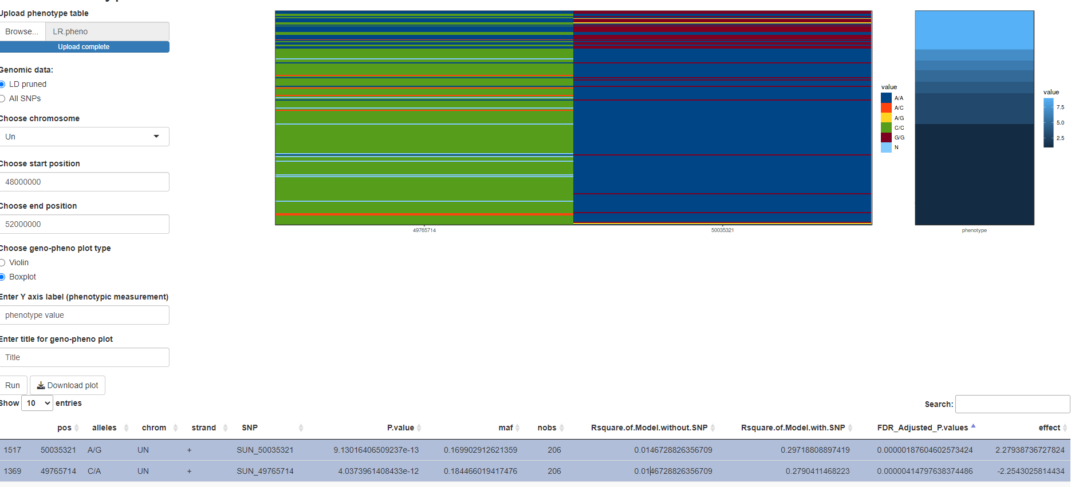Notice the connection between genotype A/A for the SNP on the left (second in the table) with genotype G/G for the SNP on the right (first in table), this could point to the LD between the SNPs. Not really sure what this plot is good for, but it sure is nice.

The table that was used for the map is now showing the genotypes of the selected SNPS:

