John’s Mistake

By Udi Michaeli

Simple Does not Mean Easy – ***Corbaett Barr***

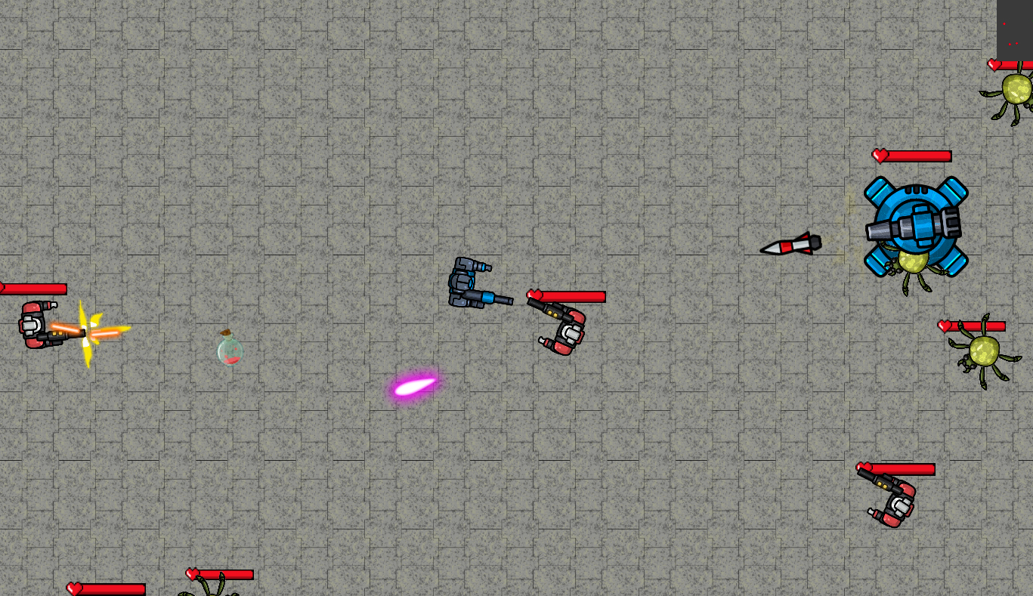

Git: <https://github.com/udimcc/JohnsMistake>

Trailer:

# Main Concept

JohnsMistake is a 2D TopDown shooter game who takes place in a weapon factory.

Three years ago, John Koba, a nuclear scientist was hired to develop the "Gladiator" - a war suite which has high defense and attack rate. The suite purpose was originally was to scare the enemies and prevent future invasions.

The project was a huge success, after a big presentation to the president another version was requested - the G2, more powerful version of the Gladiator.

A week ago, the factory was invaded by unknown entities - possibly aliens. The aliens stole many Gladiator suites. Lucky for us, it was the G1 suites.

Your mission is the get our factory back! You are equipped with the Gladiator G2.

# Gameplay

## Overview

The game starts in an arcade – pass the reception and get to the machines, pick your arcade machine and have fun!

After picking a game you will get to the level chooser scene. In total there are 3 levels. You will have to pass the previous level in order to get to the next one. More details about the scenes will be at “Scenes” section.

On JohnsMistake minigame you are equipped with the G2 suites. You have high HP and firing damage. Your goal is to get the factory back.

## Objectives

The first scene will help you achieve:

* Learn how to move
* Learn how to aim and shoot
* Learn how to control the spectator camera
* Learn how to gain back health

After that:

* Listen to the main story and understand you goal
* Clear the level and kill all the enemies
* Learn how to pass obstacles like rocks
* Get to the boss scene and clear the level

## Mechanics

The player can:

* Walk around
* Aim
* Shoot
* Switch to spectator camera to plain a strategy
* Gain health from potions

Enemies can:

* Patrol and search for the player
* Fight and attack the player

## Camera

The main camera follows the player. In addition, when the player shoots the main camera shakes.

The spectator camera can float around. It detached from the player and used to watch the enemies and plain a strategy.

The minimap can be used to check for enemies as well:

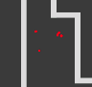

The red dots are the enemies.

## Controls

|  |  |
| --- | --- |
| Key | Action |
| WASD | Movement |
| Moving the mouse | Aim |
| Left Mouse Click | Shoot |
| C | Change Camera |
| Escape | Exit Level |

# Characters

## Player

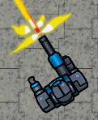

The player plays as a Gladiator G2 version – High HP and damage rates.   
Good luck clearing the levels, john did really good job with the G2 suite be do remember – YOU ARE ALL ALONE

## Spider

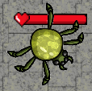

The spider is a simple alien form. Don’t let it mislead you – it is very smart. When not attacking, the spider will patrol and search for the player. The spider can see from far distance and follow the player. Its main disadvantage is the attack distance – It can only bite from short distance.

## G1 Gladiator

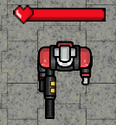

As the story says, the aliens took some of the G1 suites. Don’t let it mislead you, it is the enemy after all. The G1 can shoot from long distance. Its disadvantage is the bullets speed – If you are smart enough, you can doge.

## Chain

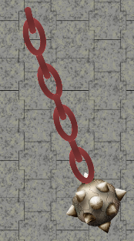

Turns out the aliens places some of those over the factory. The chain rotates at high speed. Be carful and don’t touch it. The damage is high.

## Boss

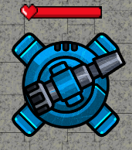

On the last level you will get to see the boss – A large stationary turret which shoots at very high speed laser at the player. Also, every few seconds it shoots missile at the player too.  
The boss has high HP and high damage rate. Good luck.

# Scenes

## The arcade

The arcade is a 3D scene which the player can choose an arcade machine and play the John’s Mistake game.

## First Level – Tutorial

The purpose of the main scene is the teach the player the controls and how to play.  
When the scene starts you will see a tutorial at the bottom of the screen. The tutorial does not refer to the story, but just teaches the player how to play.

The first scene contains few enemies so the player can practice its skills.

## Second Level

After the player learned how to play, the real game starts. The second level full of many enemies. The player probably will not succeed on the first try, and it will plain a strategy to pass the level.  
On that level the player will be introduced to the Chain enemy and the rocks.  
Some of the rocks blocks the way. The player will have to understand how to move it (Shoot and break it to little pieces).

## Boss Level

The boss level is incredibly hard. The turret has very high HP and attack damage. The turret is also surrounded with many enemies. The player will have to defeat all of them all at once.

# Project Requirements

Some of the project requirements will be explained here.

* 4 Triggers:
* Potions area
* Spider attack area
* Turret attack area
* Arcade machine play area

And some more…

* 4 Collisions:
* The G1 Gladiator’s laser collider
* The turret’s laser collider
* The turret’s missile collider
* The chain collider
* Hinge: The chains consist of hinge joints.
* Destruction: Some rocks are destructive rocks. On the second scene you will have to shoot some of them to pass a narrow hall.