**File Management System**

Project Made By-

Udbhav Naryani (RA1711003030230)

Arnav Gupta (RA1711003030221)

Mihir Sinha (RA1711003030218)

Abstract

A file management system is a computer program which provides a user with an interface to manage files and folders. When we observed that some of the file management systems were large in data size and some of them were too much complicated to use. To deal with the problem of large data size the development team did the following -

1.Chose light platform (programing language)

2. Design an algorithm whose data size is smaller.

In order to find a light platform, the team took the help of the internet we looked through different languages and finally decided to use java as it provided needed sophistication and was lighter than others. And we decided to include only a few necessary features. It includes copy, sorting of files, deleting of files and searching a particular file and a login to ensure privacy and security for the user .

To ensure that our system was able to meet the user requirements we performed testing of our system by both “Black box testing” and “White box testing”.

For providing an easier user interface we utilised “JAVA FX”. Our file manager provides a better response time.It is simple to operate so even people with less experience can easily use it and it’s advertisement free providing a better user experience.

It’s safer as compared some other file explorers or file managers .As compared to other file management systems it has a clearer and a better aesthetic look.It’s compatible for windows which provides us large user base

Introduction

File management is an integral part of any system. Without it, the system may not work, as it every program and its data are storage medium such as hard disks, SSDs, CD, DVD, floppy disks, etc.

The user performs many operations like copy, delete, move, search, etc. The user wants to perform these operations efficiently so that his/her time can be saved.

The arrangement of files is crucial as it can help to increase the life of a storage medium. It is inconvenient for an average user to keep typing many different commands which they cannot even remember.

Every function, whether it be deleting, copying, etc will be provided using picturized icons and drop down menus so that the user works with their system without any hassle.

File managing requires a GUI which an average user can easily understand by clicking directly onto the icon. Our objective is to make our project simple for user and also for developer. The files management system is being made in the language JAVA. JAVA is a widely used programming language.

File management system helps to provide alternatives to included file managers by including various other features.

Files can be shown in hierarchical or tree system.

Users in File Management system:-

1. New user
2. Old user

Objective

A File Manager is a computer program that is used to provide the user with an interface to manage the files on his system. The objective of our project is to create a File Manager that is simple, fast and secure.

We aim to make software that is easy to use and secure. These days security is a major issue, many big companies are caught stealing our precious data. In this project we have added a login feature, this means that the files on the system can only be accessed by a user having the password.

Objectives-

1. Our File Manager would be open source.
2. .It will be completely free and easily available for download.
3. It will have no advertisements.
4. It will be faster than many others.
5. It will be lightweight
6. We will also make a simple layout
7. We also aim to make it as fast as possible.
8. Another objective is to make it as secure as possible.

System Analysis

This application helps us to manage and find files necessary for the user. The information is given regarding files to help the user about actions to be taken by the user.

# System Specification

Hardware:-

* Intel core(™) i5 (Dual core processor operating at 1.6 GHz or above),
* 50 MB hard disk space or above
* 512 MB RAM or above

Software:-

* Operating System- Windows XP(™) or above.
* Language used- JAVA,JAVA FX
* IDE- Netbeans v8

Feasibility Study

**Scope:-**

This study will provide the requirement specification for the “File Manager” as per the scope defined.

**Users:-**

The File Manager software can be used by 2 types of users -

Old User-

The old user needs to login to access the data.

New User -

New user needs to first register and then log in to access the data.

**Requirements:-**

**Functional Requirements:-**

1) Keep the user data secure by using the password login option.

2) Simple and easy to understand layout.

3)An option to search for files.

4)Option to view and open files.

**Non-functional Requirements:-**

**Compatibility: -**

The system will be designed to be compatible across the Windows Operating System.

**Availability:-**

Software shall be easily available for download.

**Software updates:-**

File Management System shall be easily upgradeable to include the new features.

Modules

**A) Register-**

- The user needs to register first by filling up the basic details and create a login id and password.

**B) Login-**

- Using valid login credentials, the user can access the below-given modules.

**C) Homepage-**

- After a successful login, the user will see all the files at the homepage.

**D) Search Files-**

- The user can search a file using the search option.

**E) View Files-**

- The user can view or open files.

**F) Manage Files-**

* The user can delete

Data Flow Diagrams

Context Free Diagram-

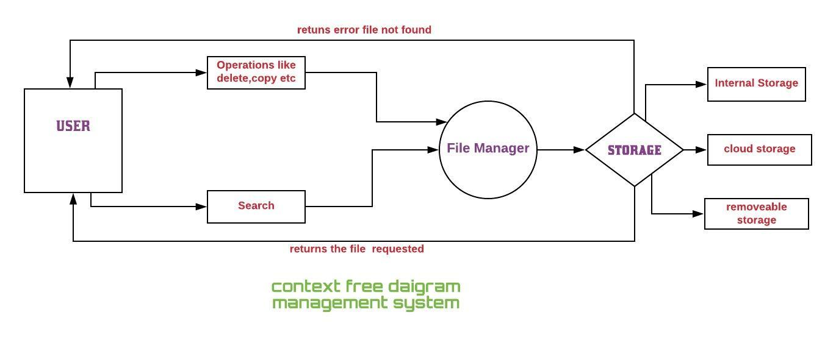

1st Level Data flow diagram-

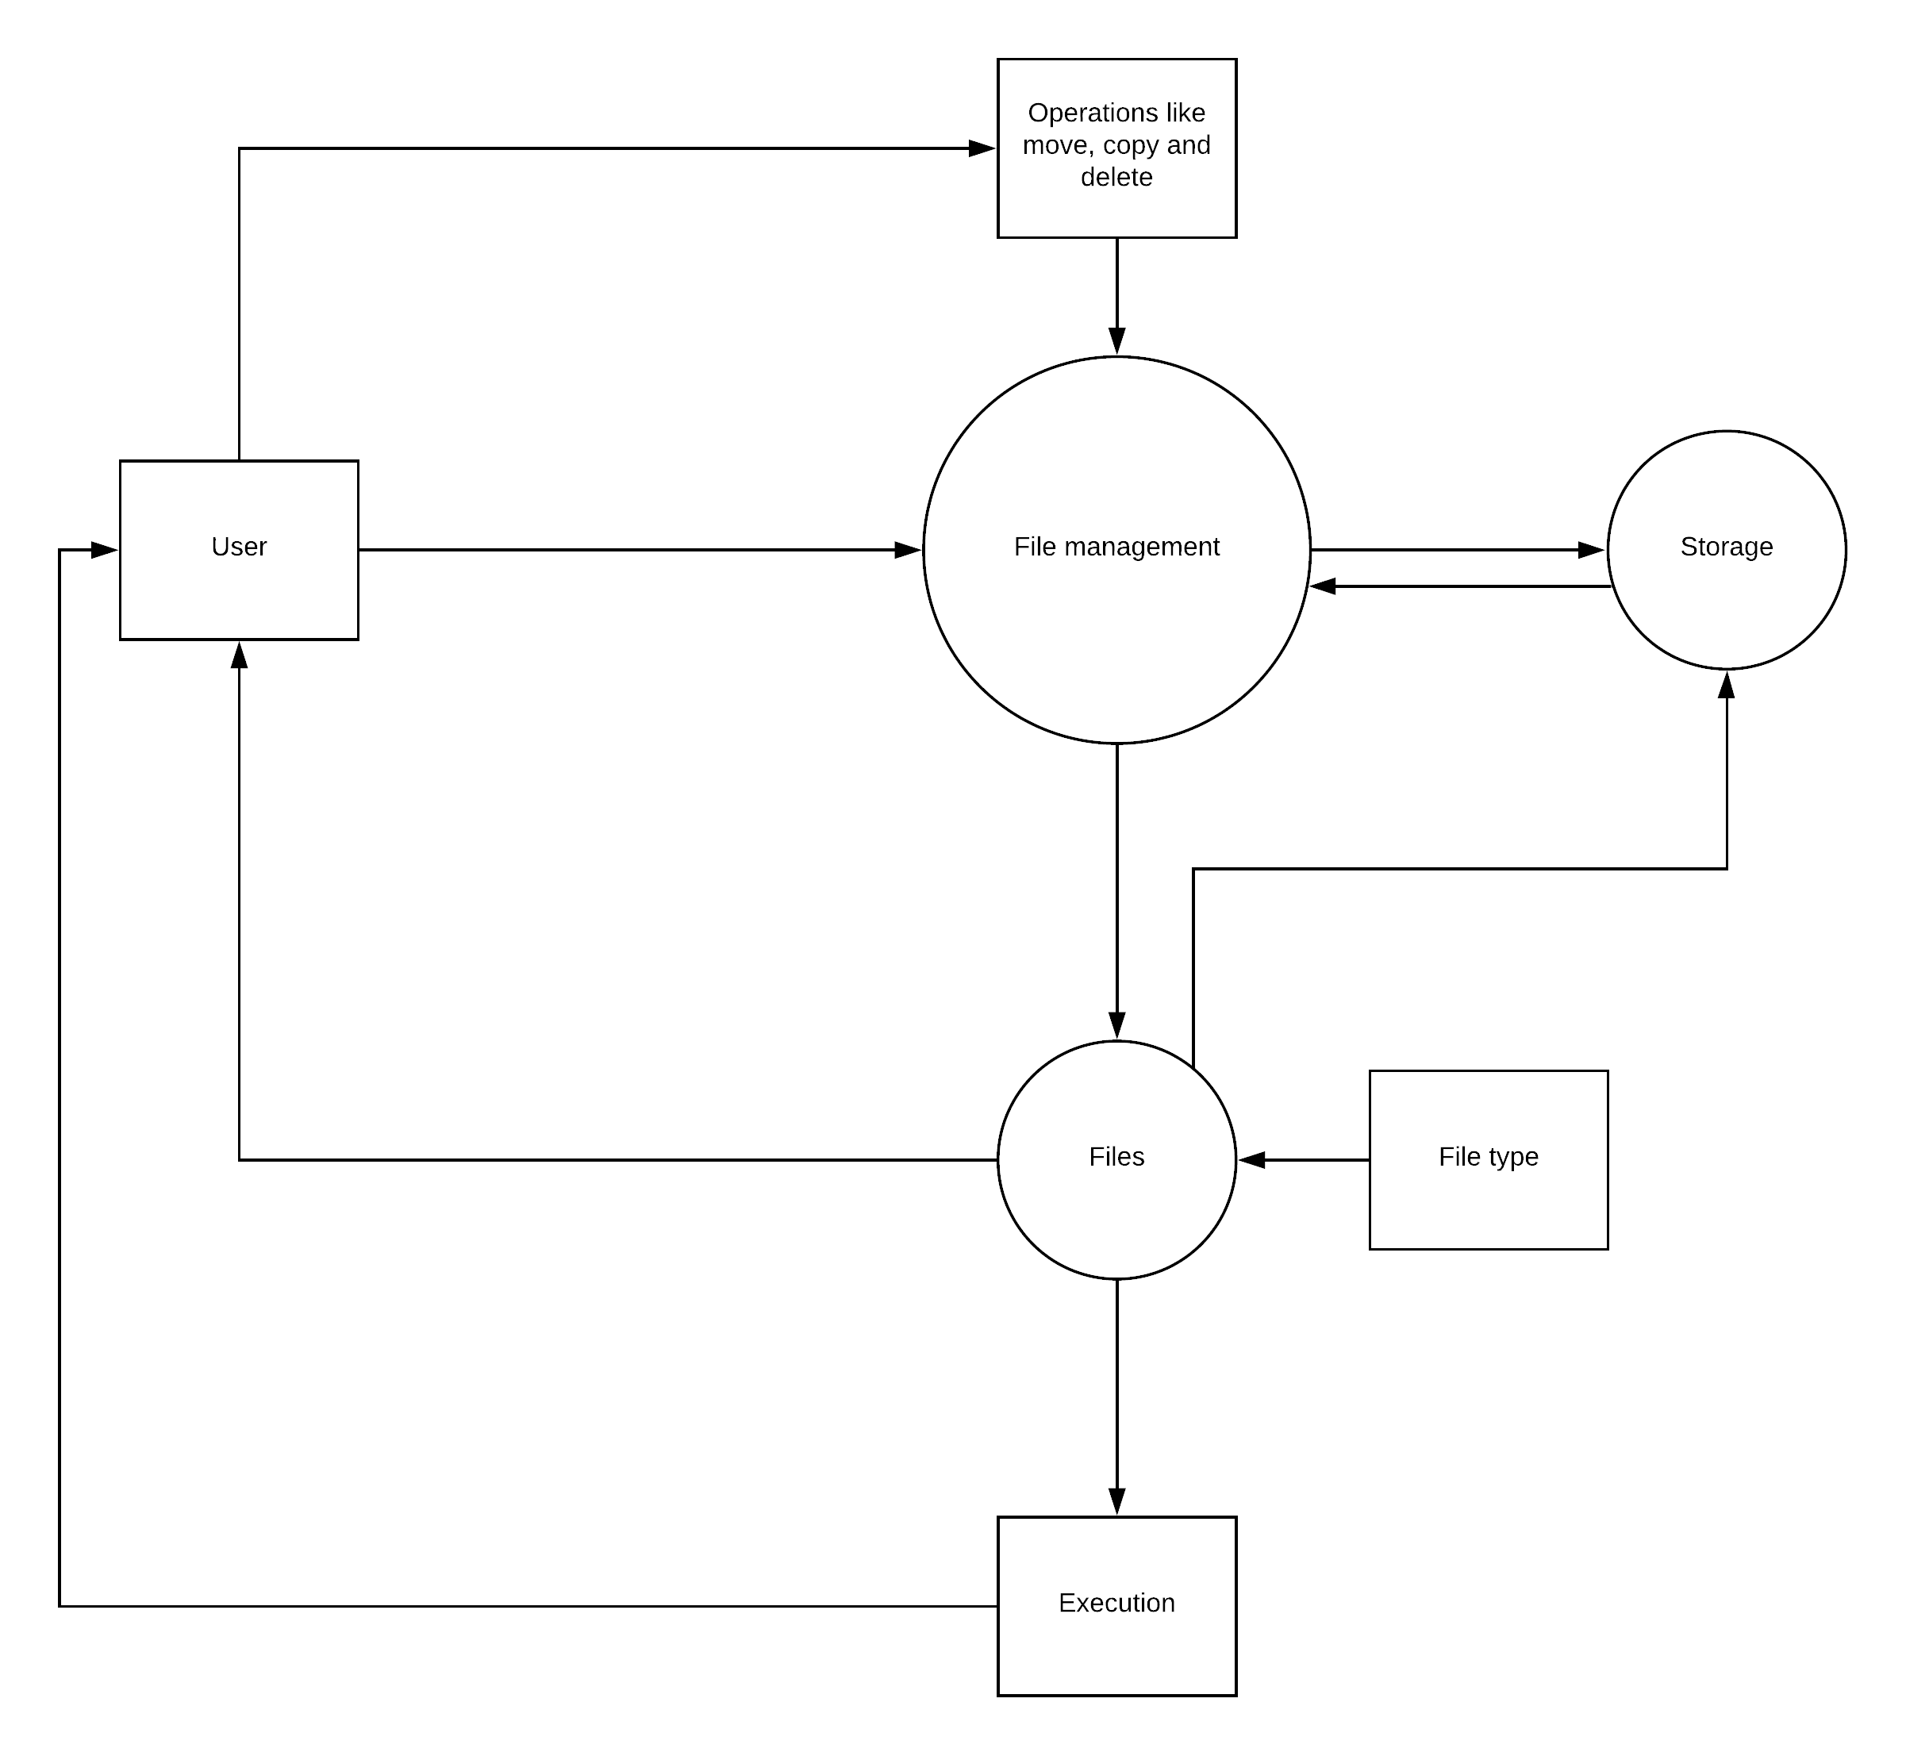

UML Case Diagrams

**UML Case Diagram for New User-**

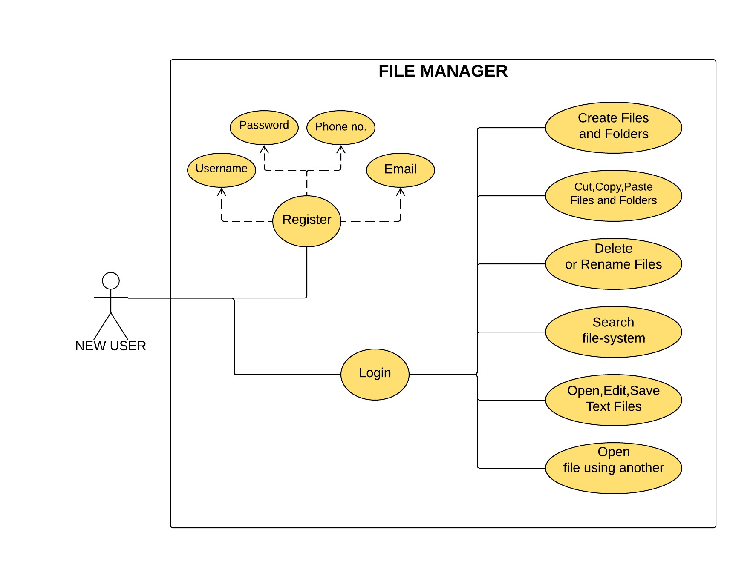

**UML Case Diagram for Old User-**

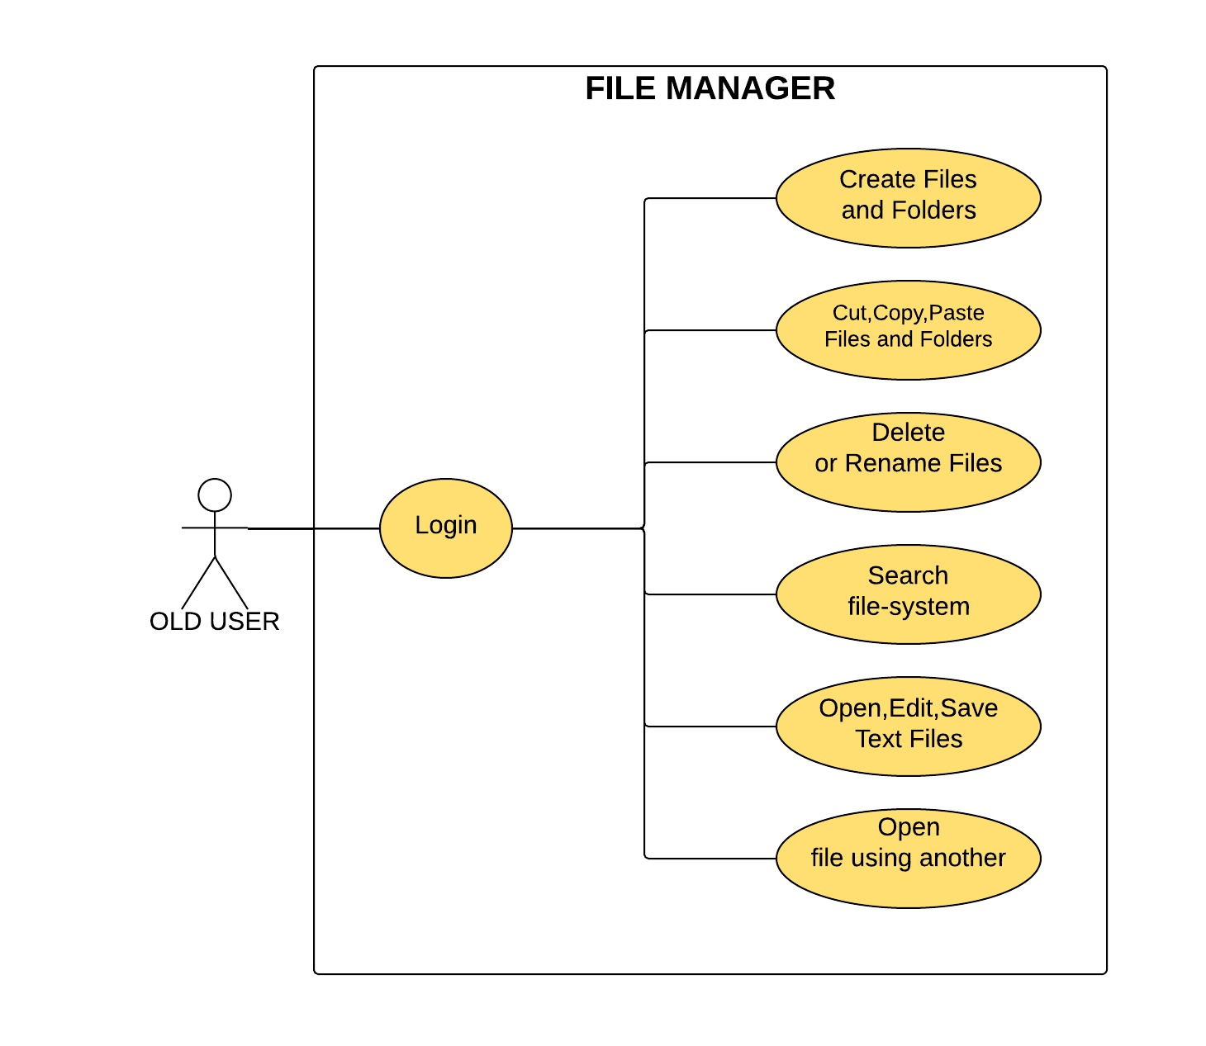

References-

Airforce Medical Service- <https://www.airforcemedicine.af.mil/MTF/Peterson/News-Events/Article/1050278/the-importance-of-file-management/>

CIO White Papers Review-

<https://whatis.ciowhitepapersreview.com/definition/file-management/>

Wikipedia-

<https://en.wikipedia.org/wiki/Document_management_system>

Geeks for Geeks-  
<https://www.geeksforgeeks.org/file-class-in-java/>