Task 4: Implementation Strategy and Code Architecture Outline
Project Title: Carbon Emission Prediction and Sustainability Modeling Framework
Internship: Virtual Machine Learning Implementation Intern
Technology: Python, Pandas, NumPy, Scikit-learn, Matplotlib and Seaborn

1. Introduction and Objective
This task defines the implementation strategy and code architecture for the carbon-emission machine learning project. The project uses country-level CO₂ and energy data from Our World in Data [1][2] and currently contains completed notebooks for data understanding, cleaning, feature engineering, exploratory analysis, regression, forecasting, evaluation, renewable-energy analysis and visualization.
The objective of the proposed architecture is to organize reusable functionality into modular Python components while keeping the existing analytical notebooks intact. Python modules and packages provide a structured way to divide functionality across reusable components [3]. The proposed design therefore separates configuration, data handling, feature engineering, model construction, forecasting, evaluation and visualization.
The src/ directory currently establishes this modular architecture through lightweight source files. The existing notebooks remain the primary implementation of the completed analytical workflows.

2. Existing Project Overview
The processed modeling dataset contains 1,817 observations covering 79 countries from 2000 to 2022. The primary regression task uses 13 predictive features and annual CO₂ emissions as the target.
The existing project contains three regression models:
- Linear Regression
- Random Forest Regression
- Gradient Boosting Regression
A separate Gradient Boosting model is used for the lag-based time-series forecasting workflow. The project also contains additional evaluation procedures, including country-grouped cross-validation, rolling-origin evaluation and persistence-baseline comparison.
The existing analytical workflow is implemented through notebooks 01–10. Notebook 10 contains supplementary experimental evaluation for the YuvaIntern assignment.
The proposed src/ architecture does not replace these notebooks at this stage. Instead, it provides a structure for gradually migrating reusable functionality from notebooks into maintainable Python modules.

3. Proposed System Architecture
The proposed architecture separates the project into components according to their responsibilities.
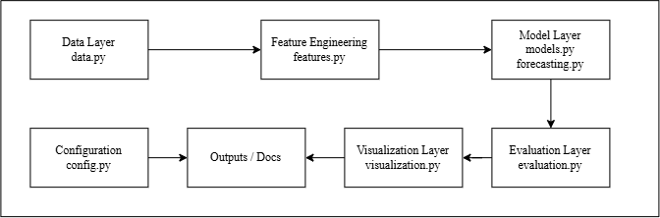
Figure 1: Proposed System Architecture
The architecture contains the following components:
- Configuration: Centralizes project paths, feature definitions, forecasting lags, random state and model parameters.
- Data Layer: Loads and validates input datasets.
- Feature Engineering: Selects model features and generates country-specific CO₂ lag features.
- Model Layer: Defines the three regression models and the forecasting model.
- Evaluation Layer: Provides evaluation metrics and is intended to contain additional evaluation procedures.
- Visualization Layer: Handles generation and saving of project visualizations.
- Pipeline: Coordinates the high-level workflow.
- Main Entry Point: Provides the execution entry point for the modular implementation.
The current architecture follows Python's module and package structure, allowing related functionality to be maintained in separate files while remaining part of a common package [3].

4. End-to-End Implementation Workflow
The planned workflow is:
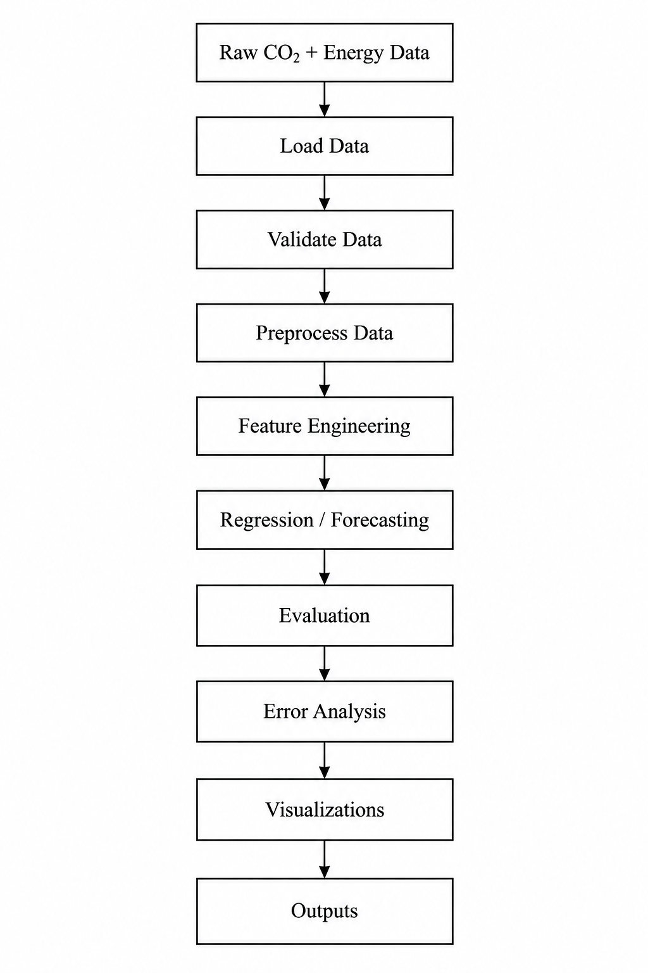
Figure 2: End-to-End Implementation Workflow
The workflow separates data preparation from model construction and evaluation. This separation allows individual components to be tested and modified without unnecessarily changing unrelated parts of the project.

5. Modular Breakdown
The current src/ directory contains the following modules.
Module | Responsibility | Current role
config.py | Stores paths, features, lags and model parameters | Implemented configuration
data.py | Loads CSV files and validates required columns and missing values | Implemented utility functions
features.py | Selects regression features and creates CO₂ lag features | Implemented utility functions
models.py | Creates Linear Regression, Random Forest and Gradient Boosting models | Implemented model definitions
forecasting.py | Creates the lag-based forecasting model | Implemented model definition
evaluation.py | Calculates MAE, RMSE and R² | Implemented metric function
visualization.py | Provides reusable plot-saving functionality | Implemented utility function
pipeline.py | Coordinates the high-level workflow | Architecture skeleton
main.py | Provides the modular execution entry point | Architecture skeleton

Centralizing configuration reduces duplication and allows commonly used parameters to be managed from one location. The use of pathlib.Path in the configuration module also provides an object-oriented approach to filesystem paths across operating systems [4].

6. Step-by-Step Implementation Strategy
Phase 1: Data Handling
The implementation begins by loading the processed modeling dataset through the data module. Required columns and missing values are checked before the data are passed to later stages.
The proposed data interface is:
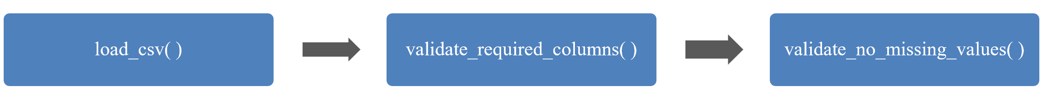
Phase 2: Feature Preparation
The feature module provides the selected regression feature set and creates country-specific CO₂ lag variables for forecasting.
The regression workflow uses the centralized feature definitions in config.py. The forecasting workflow uses the configured lag values [1, 2, 3].
Phase 3: Model Construction
The model module creates the three regression estimators using the configurations already established in the project.
Linear Regression uses a Scikit-learn pipeline containing StandardScaler and the regression estimator. Scikit-learn pipelines allow preprocessing and an estimator to be chained as one composite workflow [6].
The forecasting module separately creates the Gradient Boosting forecasting estimator.
Phase 4: Model Training
The training stage will receive prepared features and targets from the previous stages and fit the selected model.
For regression:
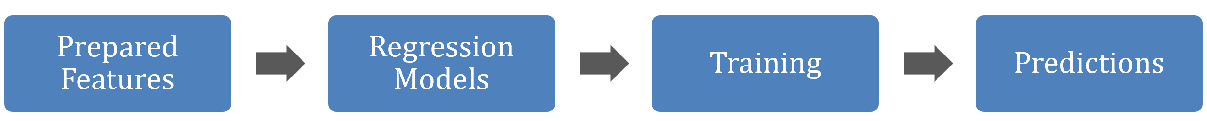
The forecasting workflow uses chronological data and country-specific lag features.
Phase 5: Evaluation
The evaluation module calculates MAE, RMSE and R² and will provide the common interface for future evaluation procedures.
The experimental evaluation performed in Notebook 10 can subsequently be migrated into reusable evaluation functions without changing the underlying methodology.
Phase 6: Visualization and Output
Evaluation and analysis results are passed to the visualization layer for generating plots. Final metrics, predictions and visualizations are stored in the appropriate project output directories.
Phase 7: Pipeline Integration
After the individual modules are validated, pipeline.py can coordinate them into a complete workflow.
The current pipeline intentionally remains a skeleton. This prevents the existing notebook implementation from being duplicated before the modular components have been individually verified.

7. Pseudocode
7.1 Main Project Workflow
FUNCTION run_project():
LOAD configuration
LOAD processed dataset
VALIDATE required columns
VALIDATE required data for missing values
SELECT regression features
CREATE CO₂ lag features when forecasting
BUILD regression models
BUILD forecasting model when required
IF regression workflow:
PREPARE training, validation and test data
TRAIN regression models
GENERATE predictions
CALCULATE evaluation metrics
SELECT model using validation procedure
EVALUATE selected model
IF forecasting workflow:
CREATE chronological data partitions
TRAIN forecasting model
GENERATE sequential predictions
COMPARE against persistence baseline
CALCULATE evaluation metrics
PERFORM error analysis
GENERATE visualizations
SAVE results
END FUNCTION
7.2 Data Validation
FUNCTION validate_data(data):
CHECK required columns
IF required columns are missing:
RAISE error
CHECK required fields for missing values
IF invalid missing values exist:
RAISE error
RETURN validated data
END FUNCTION
7.3 Model Evaluation
FUNCTION evaluate_model(actual, predicted):
CALCULATE MAE
CALCULATE RMSE
CALCULATE R²
RETURN evaluation metrics
END FUNCTION
7.4 Feature Engineering
FUNCTION create_lag_features(data):
SORT data by country and year
FOR each configured lag:
GROUP data by country
CREATE CO₂ lag feature
RETURN transformed data
END FUNCTION

8. Code Maintainability and Python Best Practices
The proposed implementation follows several Python development practices.
Modularity
Related functionality is separated into individual modules rather than placing all processing logic in a single script. Python's package structure is specifically designed to organize related modules under a common namespace [3].
Centralized Configuration
Paths, feature definitions and model parameters are maintained in config.py. This reduces repeated constants across modules and makes configuration changes easier to control.
Naming and Code Style
Functions and variables should use descriptive names and follow consistent Python naming conventions. PEP 8 provides conventions for Python source code style and readability [5].
Documentation
Modules and functions should contain concise docstrings describing their purpose, parameters and outputs. This makes reusable components easier to understand and maintain.
File Path Management
pathlib.Path is used instead of manually constructed platform-specific path strings. The Python documentation recommends Path as the standard concrete path representation for filesystem operations [4].
Preprocessing Encapsulation
Where preprocessing is required, it should remain associated with the estimator through a Scikit-learn pipeline. A pipeline can chain transformations and a final predictor while helping prevent preprocessing information from leaking across evaluation boundaries [6].
Error Handling
Invalid input data should generate clear exceptions rather than allowing later model stages to fail with unrelated errors. The existing validation functions provide the basis for this approach.
Logging
As the modular implementation grows, runtime events should use Python's logging framework rather than relying entirely on print() statements. Python provides different logging levels such as DEBUG, INFO, WARNING and ERROR for different types of runtime information [7].
Version Control
Git should be used to track changes to source code and documentation. Version control allows previous versions to be recovered and changes to be reviewed over time [8]. Separate branches can also be used when developing substantial changes without immediately modifying the main development line [8].

9. Testing Strategy
Testing should be introduced as the notebook functionality is gradually migrated into reusable modules.
Unit Testing
Individual functions should be tested independently.
Examples include:
- verifying that load_csv() loads a dataset correctly;
- checking that required-column validation detects missing columns;
- checking that lag generation creates the expected country-specific lag columns;
- verifying that the metric function returns MAE, RMSE and R².
Integration Testing
Related modules should be tested together.
For example:
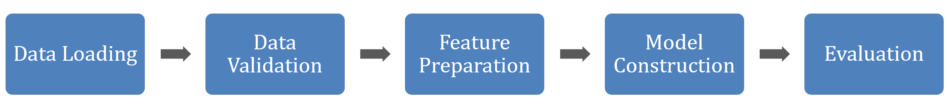
The purpose is to verify that outputs from one module are compatible with the next module.
End-to-End Testing
The complete modular workflow should eventually be executed using the same processed dataset and model configurations as the existing notebooks. The resulting outputs should be compared with known notebook results before replacing any existing workflow.
A testing framework such as pytest can provide reusable fixtures and structured test execution [9].
Regression Testing
After modular migration, previously verified model results should be retained as reference values. Changes to the implementation should not unintentionally alter established outputs.

10. Risk Assessment and Mitigation
Risk | Potential Impact | Mitigation
Notebook and module outputs diverge | Different implementations may produce different results | Compare modular outputs against existing notebook results
Feature mismatch | Models may receive different features or feature ordering | Maintain feature definitions centrally in config.py
Data leakage | Evaluation results may become overly optimistic | Keep preprocessing inside the appropriate training workflow [6]
Incorrect file paths | Execution may fail on different systems | Use centralized pathlib paths [4]
Dependency conflicts | Code may fail in another environment | Maintain requirements.txt and document the environment
Integration errors | Individual modules may work but fail when combined | Perform integration and end-to-end tests
Model configuration drift | Different modules may use different parameters | Store shared model parameters centrally
Forecasting leakage | Future information may enter the training data | Preserve chronological ordering during forecasting
Output overwriting | Existing results may accidentally be replaced | Maintain separate output locations where required
Migration errors | Refactoring may alter established behavior | Migrate one component at a time and compare results
Inadequate runtime information | Failures may be difficult to diagnose | Introduce structured logging as the modular implementation develops [7]

11. Implementation Timeline and Milestones
The implementation should proceed incrementally rather than migrating the entire project at once.
Phase | Activities | Milestone
1. Architecture | Define module boundaries and interfaces | Architecture completed
2. Data layer | Implement and validate data-loading functions | Data module verified
3. Feature layer | Implement reusable feature and lag functions | Feature module verified
4. Model layer | Implement reusable regression and forecasting model definitions | Model modules verified
5. Evaluation | Implement reusable metrics and evaluation functions | Evaluation module verified
6. Visualization | Move reusable plotting functions into the visualization layer | Visualization module verified
7. Integration | Connect modules through pipeline.py | Modular workflow integrated
8. Testing | Perform unit, integration and end-to-end testing | Implementation validated
9. Migration | Gradually replace duplicated notebook logic with reusable modules | Refactoring completed

The phases deliberately do not assign unsupported calendar dates. Each milestone depends on successful verification of the previous stage.

12. Current Implementation Status
The src/ directory currently contains the architecture skeleton and several implemented reusable functions.
The following are already represented:
- centralized configuration;
- data loading and validation;
- regression feature selection;
- country-specific CO₂ lag generation;
- regression model construction;
- forecasting model construction;
- regression metrics;
- plot-saving utility;
- high-level pipeline structure;
- main execution entry point.
The complete end-to-end migration of the notebooks into these modules has not yet been completed. The existing notebooks therefore remain the primary implementation of the completed analytical workflows.
This separation allows the architecture to be developed without disturbing the previously completed project analysis.
13. Conclusion
The proposed architecture separates the carbon-emission project into clear data, feature, model, forecasting, evaluation, visualization and orchestration components. The current src/ structure provides the foundation for this design while preserving the existing notebook-based implementation.
The implementation strategy emphasizes modularity, centralized configuration, reproducibility, testing, version control and gradual migration. These practices reduce duplication and provide a controlled path from exploratory notebook code toward reusable Python components.
The architecture is therefore designed to support future integration of the completed analytical workflows without requiring unnecessary changes to the existing project structure.

References
[1] Our World in Data. CO₂ emissions dataset: Our sources and methods. https://ourworldindata.org/co2-dataset-sources Our World in Data
[2] Our World in Data. Energy Dataset. https://catalog.ourworldindata.org/energy/owid_energy/ Our World in Data
[3] Python Software Foundation. Modules — Python Documentation. https://docs.python.org/3/tutorial/modules.html Python documentation
[4] Python Software Foundation. pathlib — Object-oriented filesystem paths. https://docs.python.org/3/library/pathlib.html Python documentation
[5] Python Software Foundation. PEP 8 — Style Guide for Python Code. https://peps.python.org/pep-0008/ Python Enhancement Proposals (PEPs)
[6] Scikit-learn Developers. Pipelines and composite estimators. https://scikit-learn.org/stable/modules/compose.html Scikit-learn
[7] Python Software Foundation. Logging HOWTO. https://docs.python.org/3/howto/logging.html Python documentation
[8] Git SCM. About Version Control and Git Branching. https://git-scm.com/book/en/v2/Getting-Started-About-Version-Control.html git-scm.com
[9] pytest Development Team. pytest Documentation. https://docs.pytest.org/en/stable/ docs.pytest.org

