Michael Stiv Verdugo Marquez
Codigo:20091025113

Practica Post_Diferencial

Vertices:

Pilastra (Base)
Auxiliar3 (Rover)
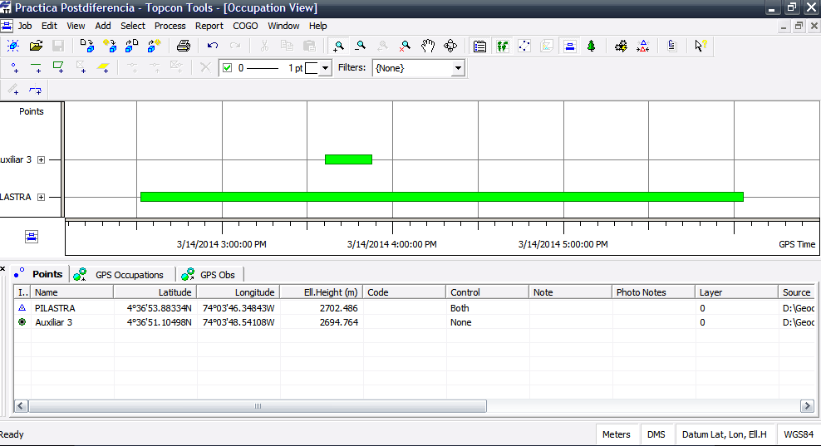
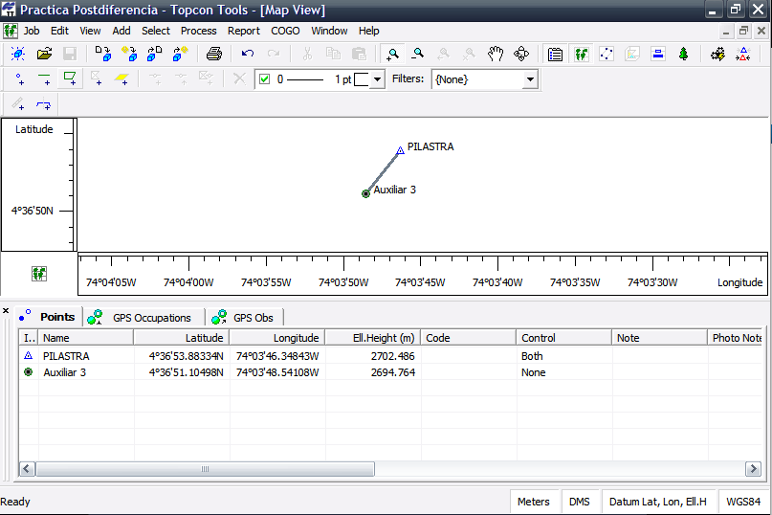
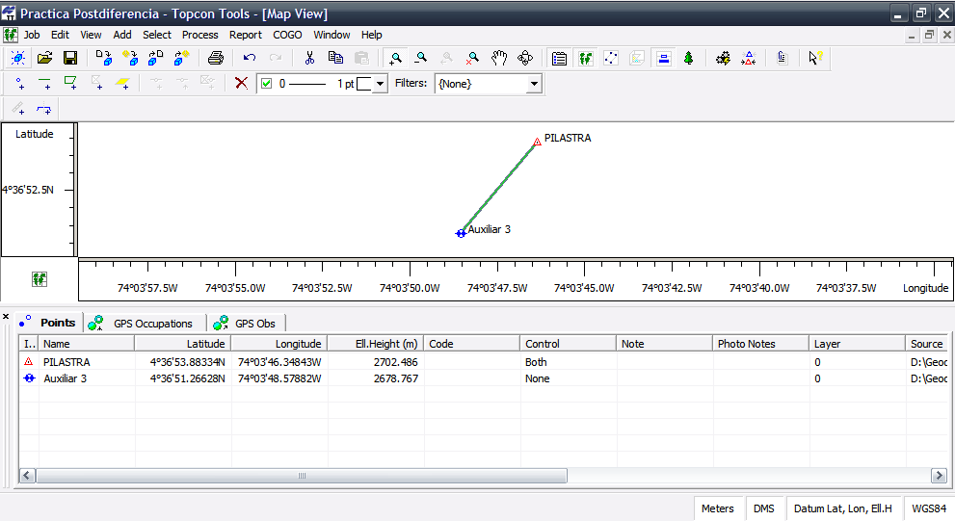

GPS Observations

Project Summary

Project name: Practica Postdiferencia.ttp
Surveyor:
Comment:
Linear unit: Meters
GPS ObservationsName dN (m) dE (m) dHt (m) Horizontal Precision (m)
Vertical Precision (m)
Auxiliar 3−PILASTRA 80.423 68.775 23.718 0.011 0.018

Adjustment

Project Summary

Project name: Practica Postdiferencia.ttp
Surveyor:
Comment:
Linear unit: Meters
Projection:
Geoid:
Adjustment Summary

Adjustment type: Plane + Height, Minimal constraint
Confidence level: 95 %
Number of adjusted points: 2
Number of plane control points: 1
Number of used GPS vectors: 1
A posteriori plane UWE: 1 , Bounds: ( 1 , 1 )
Number of height control points: 1
A posteriori height UWE: 1 , Bounds: ( 1 , 1 )

Used GPS ObservationsName dN (m) dE (m) dHt (m) Horizontal Precision (m)
Vertical Precision (m)
Auxiliar 3−PILASTRA 80.423 68.775 23.718 0.011 0.018

GPS Observation ResidualsName dN (m) dE (m) dHt (m) Horizontal Precision
(m) Vertical Precision (m)
Auxiliar 3−PILASTRA 80.423 68.775 23.718 0.011 0.018

Control PointsName Latitude Longitude Ell.Height (m) Code
PILASTRA 4°36'53.88334N 74°03'46.34843W 2702.486

Adjusted PointsName Latitude Longitude Ell.Height (m) Code
Auxiliar 3 4°36'51.26628N 74°03'48.57882W 2678.767

