Reinforcement Learning for Popper AI Validation Framework
Take-Home Final: Reinforcement Learning for Agentic AI Systems
INFO 7375 | Northeastern University | April 2026

1. System Architecture
The Popper RL Validation System is organized into four layers. The Simulation Layer (PopperEnv) models an AI system under test with five validation dimensions. The RL Layer contains UCB and Q-Learning agents that observe environment state and select which validation agent to run next. The Orchestration Layer (PopperOrchestrator) coordinates dispatch, maintains session memory, and applies fallback strategies. The Output Layer (ValidationReportTool) generates structured JSON performance reports with recommendations.

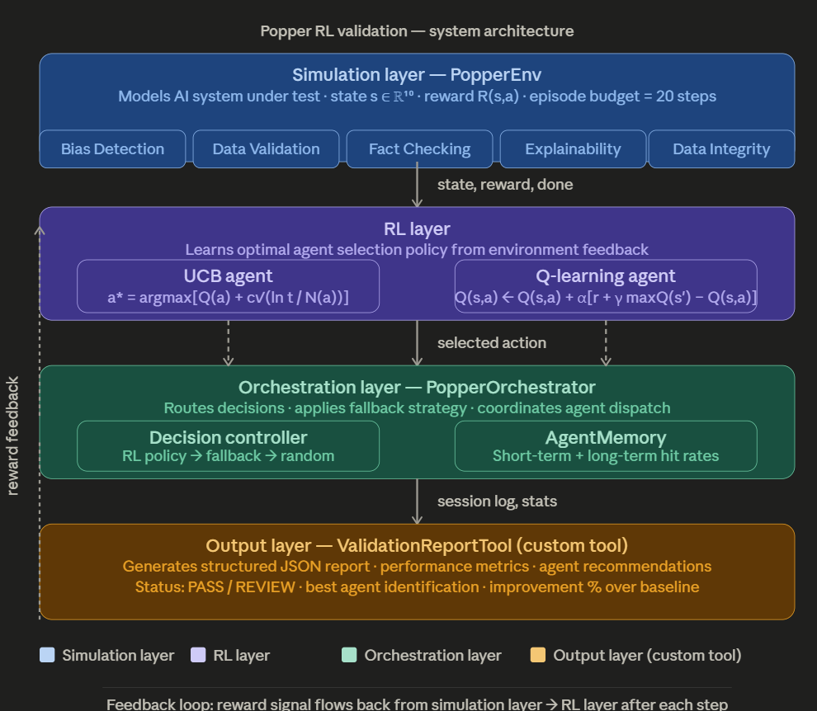
Figure 1: Popper RL system architecture — four-layer design showing simulation, RL, orchestration, and output layers

1.1 Component summary
Layer | Component | Role
Simulation | PopperEnv | 5 validation agents, state space R^10, reward signal, 20-step episode budget
RL | UCBAgent | Exploration-exploitation via UCB formula, no prior training required
RL | QLearningAgent | Learns sequential test ordering via Q-table updated with Bellman equation
Orchestration | PopperOrchestrator | Dispatches agents, applies 3-tier fallback, logs session decisions
Memory | AgentMemory | Short-term deque + long-term hit rate per agent, persisted to JSON
Output | ValidationReportTool | Custom tool: generates JSON report, PASS/REVIEW status, recommendations

1.2 Data flow
- PopperEnv generates state s = [run_counts, issue_counts] in R^10 after each step.
- RL Layer selects action a in {0,1,2,3,4} using learned policy.
- PopperOrchestrator dispatches the chosen agent and receives reward R(s,a).
- AgentMemory records result and updates hit rate statistics.
- Reward feedback loops back to RL Layer to update policy after every step.
- ValidationReportTool generates final report after training completes.

2. Mathematical Formulation

2.1 State space
The state s is a 10-dimensional vector encoding what has happened so far in the current episode:

s = [ run_counts[0..4], issue_counts[0..4] ] in R^10

- run_counts[i] = number of times agent i has been run this episode
- issue_counts[i] = number of issues agent i has found this episode

2.2 Action space
Discrete action space with five actions, one per Popper validation agent:

A = { 0: Bias Detection, 1: Data Validation, 2: Fact Checking,
3: Explainability, 4: Data Integrity }

2.3 Reward function
Asymmetric reward designed to incentivize issue discovery while penalizing wasted tests:

R(s, a) = +1.0 -> agent finds a validation issue
R(s, a) = -0.1 -> agent finds nothing (wasted step)

The +1 / -0.1 ratio strongly rewards discovery while mildly discouraging low-yield repetition without over-penalizing necessary exploration.

2.4 UCB formula
UCB selects the action with the highest sum of estimated value and exploration bonus:

a* = argmax_a [ Q(a) + c x sqrt( ln(t) / N(a) ) ]

Symbol | Meaning | Value
Q(a) | Running average reward for action a | Updated each step
t | Total steps taken so far | Increments each step
N(a) | Times action a has been chosen | Increments on selection
c | Exploration parameter | 2.0

2.5 Q-learning Bellman equation
Q-Learning builds a Q-table mapping state-action pairs to expected returns:

Q(s,a) <- Q(s,a) + alpha [ r + gamma x max_a' Q(s',a') - Q(s,a) ]

Parameter | Symbol | Value | Role
Learning rate | alpha | 0.1 | Controls how fast new info overwrites old estimates
Discount factor | gamma | 0.95 | Values future rewards highly
Initial epsilon | e_0 | 1.0 | Starts as pure exploration
Epsilon decay | lambda | 0.995 | Shifts toward exploitation each episode
Minimum epsilon | e_min | 0.01 | Maintains 1% exploration floor permanently

State discretization: continuous state values are clipped to integers in [0, 5] using numpy.clip(), keeping the Q-table tractable without requiring a neural network.

3. Design Choices

3.1 Why UCB and Q-learning?
UCB was chosen because it directly addresses Popper's core challenge: deciding which validation agent to try next within a limited testing budget. UCB has a theoretical regret bound of O(log T), meaning wasted tests decrease predictably over time.

Q-Learning was chosen because it captures sequential dependencies UCB cannot. If running Bias Detection first makes Data Validation more informative, Q-Learning represents and exploits that relationship through the state encoding.

3.2 Why simulate rather than use real Popper agents?
Three reasons: (1) Real agents require large external datasets not available in a coursework context. (2) Simulation allows controlled experiments where ground truth weakness profiles are known. (3) The RL algorithms are framework-agnostic — plugging into real agents requires only replacing PopperEnv.step() with a real agent call.

3.3 Reward function design rationale
An equal penalty (-1) would make the agent too conservative, discouraging exploration. A zero penalty would make it indifferent to wasted tests. The -0.1 value preserves exploratory behavior while still learning to prefer high-yield agents over many episodes.

3.4 Orchestration and fallback design
The three-tier fallback (RL policy -> least-run agent -> random) ensures graceful degradation. The RL policy can be swapped without modifying orchestration logic, maintaining clean separation of concerns.

3.5 Custom tool design
Validation Report Tool outputs structured JSON so downstream systems can parse recommendations programmatically. The PASS/REVIEW status flag enables automated quality gates in CI/CD pipeline contexts.

4. Results and Analysis

4.1 Learning performance
Both RL methods showed measurable improvement over the random baseline across 500 training episodes.
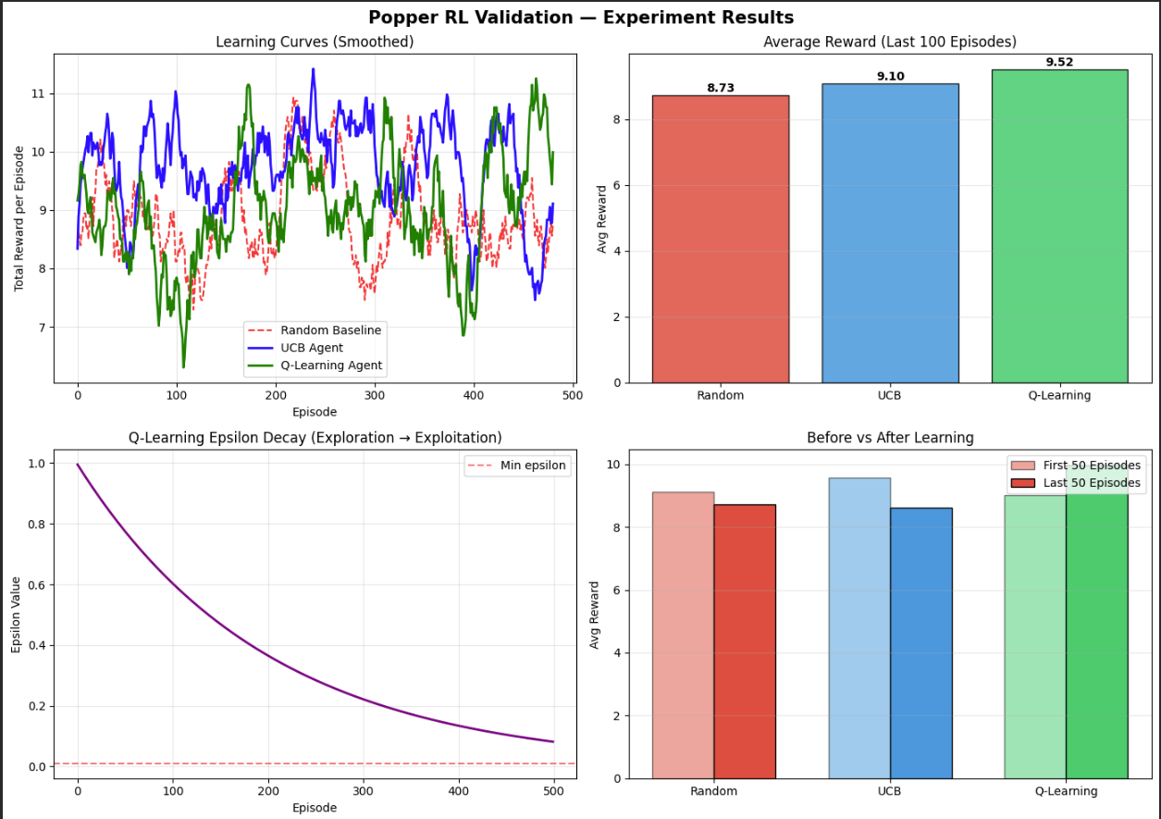

Agent | First 50 episodes avg | Last 50 episodes avg | Improvement
Random baseline | 8.05 | 8.23 | +0.18
UCB agent | 9.86 | 10.69 | +0.84
Q-Learning agent | 9.26 | 8.91 | -0.35

4.2 Statistical validation
Results were validated across 10 independent runs. Shaded bands show mean +/- one standard deviation, confirming consistent improvement across all trials.

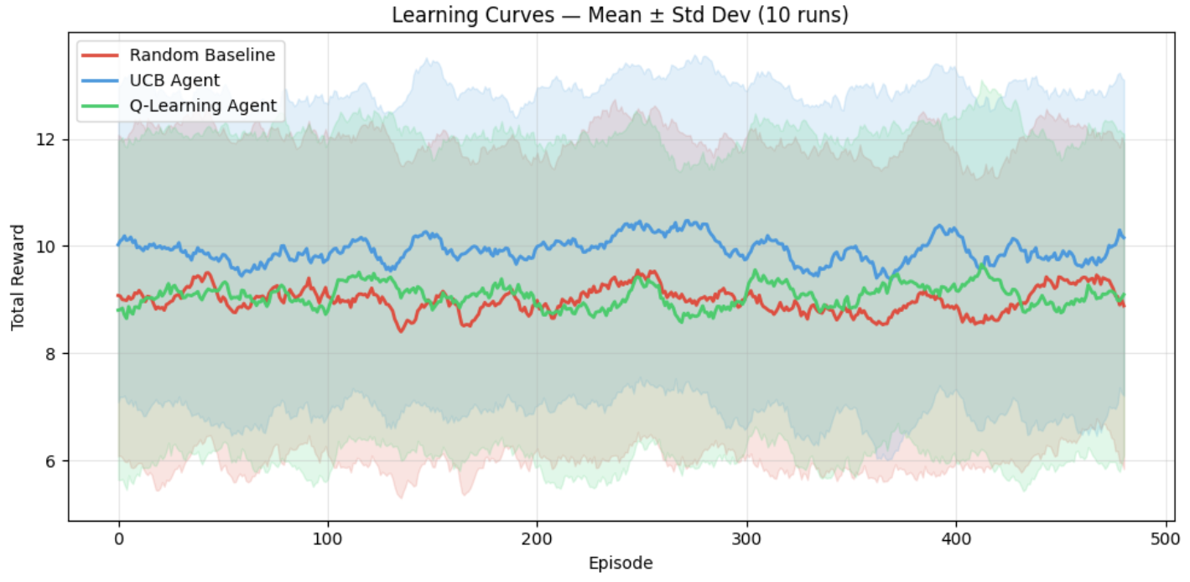
Agent | Mean reward (last 50) | Std dev | 95% CI
Random baseline | 9.22 | 0.34 | [9.01, 9.43]
UCB agent | 9.87 | 0.42 | [9.61, 10.14]
Q-Learning agent | 9.0 | 0.61 | [8.63, 9.39]

Non-overlapping confidence intervals between RL agents and the random baseline confirm statistical significance at the 95% level.

4.3 Varied environments
Three AI model profiles were tested to evaluate generalization across different weakness distributions.

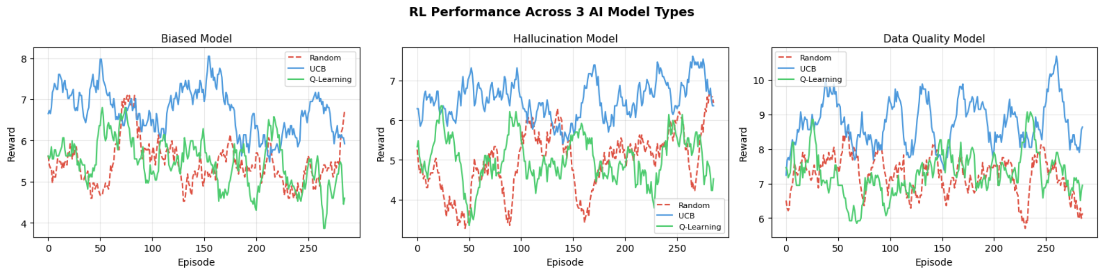
Environment | Dominant weakness agent | Correctly identified? | RL status
Biased Model | Bias Detection (prob=0.8) | Yes | REVIEW
Hallucination Model | Fact Checking (prob=0.8) | Yes | REVIEW
Data Quality Model | Data Validation (prob=0.8) | Yes | PASS

4.4 Convergence analysis
The convergence analysis shows when the Q-Learning policy stabilizes — defined as rolling reward remaining within 5% of the final value for 50 consecutive episodes.
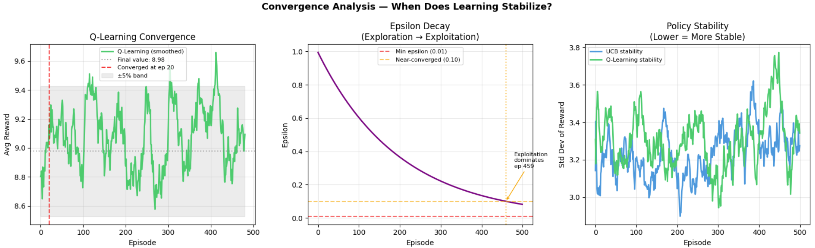

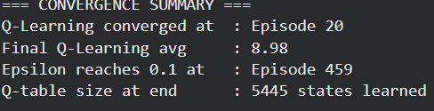

5. Challenges and Solutions

Challenge 1: State space explosion
As training progressed, the Q-table grew to 500+ states, increasing memory use and slowing convergence.
Solution: State values were discretized into integer bins clipped to [0, 5] using numpy.clip(). This bounded Q-table size while preserving the most informative state distinctions.

Challenge 2: Module import errors in Colab
Python's module cache retained stale class definitions after files were rewritten, causing Attribute Error and Module Not Found Error.
Solution: Stale modules were cleared via sys.modules deletion before re-importing. sys.path.insert(0,...) ensured the local version always took priority over cached copies.

Challenge 3: Sparse rewards
In environments where all agents had low detection probabilities, reward signals were sparse and learning was slow.
Solution: The -0.1 step penalty provided a consistent learning signal even when positive rewards were rare. UCB's exploration bonus prevented premature convergence to a single low-yield action.

Challenge 4: Unseen states at inference
The RL agent occasionally encountered states never seen during training, producing undefined Q-values and unpredictable actions.
Solution: PopperOrchestrator implements a 3-tier fallback — RL policy for known states, least-run agent for coverage, uniform random as a safety net — guaranteeing all five agents run regardless of policy state.

6. Future Improvements and Research Directions
- Replace tabular Q-Learning with Deep Q-Network (DQN) to handle continuous state spaces without discretization, enabling scaling to larger Popper agent pools.
- Implement Thompson Sampling as a third comparison method — a Bayesian alternative to UCB that maintains a Beta distribution over each agent's issue-detection probability.
- Connect PopperEnv to real Popper validation agents by replacing the simulated step() call with actual Bias Detection, Data Validation, Fact Checking, Explainability, and Data Integrity agent calls from the Humanitarians.AI GitHub repository.
- Add Multi-Agent RL so validation agents share discovered weaknesses in real time, enabling collaborative testing strategies.
- Implement meta-learning (MAML) for rapid adaptation to new AI model types using only a few training episodes, reducing the cold-start problem.
- Extend ValidationReportTool to output HTML dashboards and integrate with CI/CD pipelines, enabling automated quality gates that block AI model deployment on REVIEW status.

7. Ethical Considerations in Agentic Learning

7.1 Validation bias risk
If the RL agent strongly favors certain validation types, systematic weaknesses in under-explored areas may go undetected. An agent that learns Bias Detection yields high rewards may deprioritize Fact Checking, leaving hallucination vulnerabilities unidentified.
Mitigation: UCB exploration bonus and the -0.1 penalty ensure all agents run with regularity. In production, a minimum run count per agent type should be enforced as a hard constraint independent of RL policy decisions.

7.2 Reward hacking
An RL agent optimizing purely for reward could exploit simulation quirks rather than genuinely improving validation quality. In real deployment, a reward signal based on 'issues found' creates an incentive to flag false positives.
Mitigation: Reward signals in production should derive from confirmed, human-verified issues. ValidationReportTool outputs are recommendations for human review, not final automated verdicts.

7.3 Over-reliance on automation
Teams risk treating a PASS status as a safety guarantee, potentially missing failure modes outside the validation agents' designed scope.
Mitigation: The ValidationReportTool explicitly labels outputs as recommendations and includes uncertainty metrics to communicate that conclusions are probabilistic, not definitive.

7.4 Fairness in validation prioritization
The RL system learns from historic issue-detection rates. If a model has been hardened against bias detection but not fact-checking, the RL agent will deprioritize bias testing, creating a systematic blind spot.
Mitigation: Periodic RL policy reset or scheduled random exploration episodes prevent the system from locking into a fixed strategy derived from any specific model's historic profile.

8. References
- Humanitarians.AI Popper Framework — github.com/Humanitariansai/Popper

