Simulation based Performance Evaluation of AODV and DSDV Routing Protocols for Ad-hoc Networks

Udit Agarwal (106115089) | Joy Bhattacharya (106115035)

INTRODUCTION

Ad hoc networks are basically self organizing and self configuring multi hop mobile wireless network in which the information packets are transmitted in a store and forward manner from a source to an arbitrary destination via intermediate nodes. The main objective of this project is to performance evaluation of AODV (Ad-hoc on demand distance vector) and DSDV (Destination sequence distance vector) routing protocols on the basis of different performance metrics. In this paper, an attempt has been made to evaluate the performance of two well known routing protocols AODV, DSDV by using three performance metrics such as Average End to End Delay, packet delivery ratio and Routing overheads. The Performance evaluation has been done by using simulation tool NS2 (Network Simulator) which is the main simulator.

CLASSIFICATION OF ROUTING PROTOCOLS

Ad-hoc network routing protocols may be classified in many ways depending on their routing algorithm, network structure communication model, and state of information etc, but most of the protocols depending on their routing
algorithm,and network structure .Based on the network structure ad-hoc network classify as Flat routing, hierarchical routing, geographical position assisted routing. Flat routing covers two types of routing protocols based on routing algorithm. Based on the Routing algorithms, routing protocols are classified as Proactive routing protocols and Reactive Routing protocols.

•Proactive Routing:DSDV (Destination Sequence Distance Vector Routing)

•Reactive Routing: AODV (Ad-hoc on-demand distance vector routing protocol), DSR (Dynamic source routing)

DSDV:-DSDV destination sequenced distance vector routing protocol is a table driven algorithm based on the classical Bellman –Ford routing mechanism. The
improvement is made include freedom from loops in routing tables. Every mobile
node in the network maintains a routing table for all possible destinations within
the network and the number of hops to each destination node. Each entry is
marked with a sequence number, number assigned by the destination node Routing
table updates are periodically transmitted throughout the network in order to maintain table consistency. Large amount of network traffic, route updates can
employ in two types of packets they are first is the “Full Dump” and second is the
“Incremental routing”. A full dump sends the full routing table to the neighbors and
could cover many packets whereas, in an incremental update only those entries
from the routing table are sent that has a metric change since the last update and
it must fit in a packet. When the network is relatively stable, incremental updates are sent to avoid extra Traffic and full dump are relatively infrequent. In a fast
changing network, incremental packets can grow big, so full dumps will be more frequent .

AODV: The AODV is a Reactive on demand ad-hoc distance vector routing
algorithm. AODV is an improvement on DSDV because it typically minimizes the
number of required broadcasts by creating routes on demand basis as opposed to
maintaining a complete list of routes, as in the DSDV algorithm. When a source
node desires to send a message to some destination node and does not already have a valid route to that destination, it initiates a path discovery process to locate the destination. In AODV each router maintains route table entries with the destination IP address, destination sequence number, hop count, next hop ID and lifetime. RREQs route requests and RREPs route replies are the two message types
defined by the AODV. When a route to a new destination is needed, the node uses a broadcast RREQ to find a route to destination. A route can be determined when the
request reaches either the destination itself or an intermediate node with a fresh route to the destination. The route is made available by unicasting a RREP back to the source of RREQ. Each node maintains its own broadcast id, sequence number. The broadcast ID is incremented for every RREQ packet. Since each node receiving the request keeps track of a route back to the source of the request, the RREP reply can be unicast back from the destination to the source, or from any intermediate
node that is able to satisfy the request back to the source .

SIMULATION BASED ANALYSIS

This section described the simulation tool, network setup, Simulation parameters and simulation results. The performances of proactive and reactive routingprotocols
are evaluated on the basis of three performance metrics: Average End to End Delay, Packet delivery ratio, Routing overhead.

a) Simulation Tool

In this project simulation of AODV and DSDV routing protocols are done using Network Simulator tool (NS2).NS2 preprocessing provides traffic and topology generation and post processing provide simple trace analysis.

Java program is written to analyse the trace files.
Python scripts are used for graph plotting from the simulation results.

b) Network setup and Simulation parameters

There are a total of five simulation tests are performed with varied number of nodes in the network ranging from 5 – 25. Both AODV and DSDV is simulated to calculate the Average end to end delay, Normalized routing load and and packet deliver ratio .

Table 1 :Simulation Parameters

Propagation | Propagation/Two ray groud
Network Interface | Phy/WirelessPhy
NS version | NS-allinone-2.35
MAC | Mac/802_11
CBR Packet size | 512 bytes
Interface Queue | Queue/Droptail/PriQueue
Link layer | LL
Antenna | Antenna/Omni Antenna
Interface Queue Length | 50
Simulation area size | 500*500
Simulation Duration | 200 second
Routing Protocols | AODV, DSDV
No of nodes | 5 - 25
Max node movement Speed | 10 m/s
Connection Link protocol | UDP

c) Performance Metrics

The following metrics are used in this paper for the performance analysis of AODV, DSDV Routing protocols. These are:

i.Packet delivery ratio: It is the ratio of the number
of data packets received by the destination node
to the number of data packets sent by the
source mobile node.

ii.Routing Overhead:The number of control packets generated by each routing protocol.

iii.Average end to end delay.

d) Simulation Results

The simulation results are shown in the following section in the form of graphs and charts. In this project an attempt has been made to evaluate the performance of
two well knownrouting protocol DSDV, AODV according to his simulation results. The simulation results are genrated through the Matplotlib(Python) graphs according to above mentioned criteria shown in table.
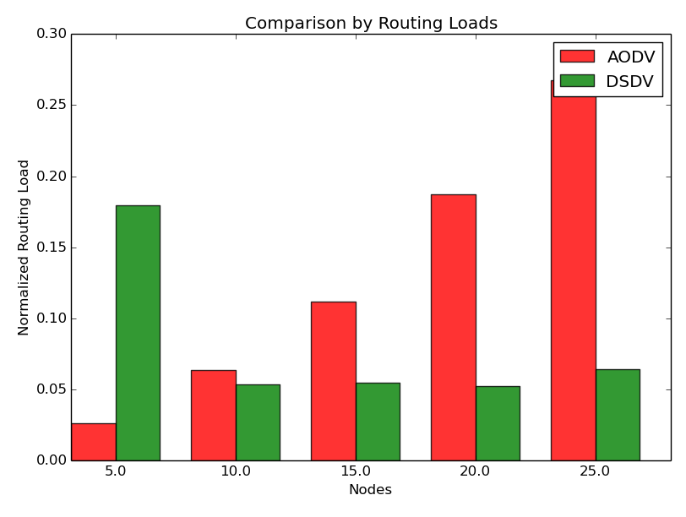
Fig 1: Comparison Based on Routing overhead

According to Fig.1 , it is evident that the as the network density increases , the routing overhead increases in AODV as compared to DSDV. As AODV is a reactive protocol , in high density networks a large amount of packets are trasmitted to discover the route from source to destination.

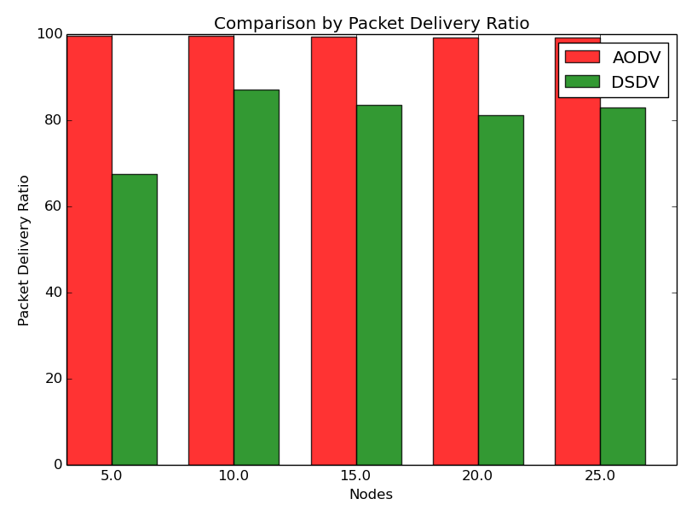
Fig 2: Comparison Based on Packet Delivery Ratio

AODV dominates DSDV when the performance is evaluated in terms of Packet deliver ratio. Packet Delivery Ratio is the ratio between the number of packets received by destination to the number of packets sent.

Packet Delivery = (Packets sent / Packets received)*100%

In DSDV there is a greater number of packet losses as compared to AODV.
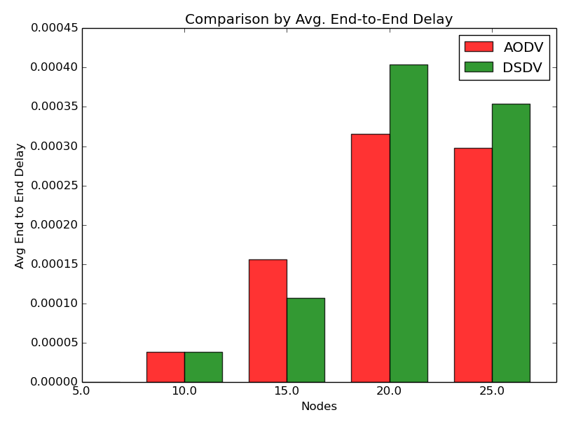
Fig 3: Comparison Based on Avg. End to End Delay

As the network size increases the average end to end delay increases more in DSDV routing protocol as compared to AODV routing protocol. It is so because in larger mobile networks the shortest path between source and destinatination changes dynamically and it is very fast. AODV can adapt to changes much faster than DSDV , hence end to end delay is reduced in AODV.

CONCLUSIONS

In this project , the performance evaluation of AODV and DSDV routing protocols is done in the above mentioned criteria. The simulation results of all
Matplotlib graphs provide the information that if the number of nodes increases in the transmission then the Average end to end delay increases. Fig. 1 shows that
DSDV is better than AODV in terms of routing overhead because of his proactive nature. Fig. 2 shows that AODV has higher packet delivery efficiency than DSDV. Fig . 3 shows that AODV is better than DSDV when the network size increases.

Overall, AODV performs better than DSDV

References

1.”Performance Evaluation of AODV and DSDV Routing Protocols for Ad-hoc Networks” By - Er. Abhishek Senger & Er. Sandeep Shrivastav (Electronics and Communication College of Science and Engineering Jhansi, India)
2.Tutorial for Simulation-based Performance Analysis of MANET Routing Protocols in ns-2By Karthik sadasivam

3.”Ad hoc On-Demand Distance Vector (AODV) Routing” By - C. Perkins Nokia Research Center

4.”Comparative Performance Analysis of DSDV, AODV and DSR Routing Protocols in MANET using NS2” By – Asma Tuteja (2010 International Conference on Advances in Computer Engineering)

5.Nsnam web pages: http://www.isi.edu/nsnam/ns/

.

